Data Activity: Student Handout

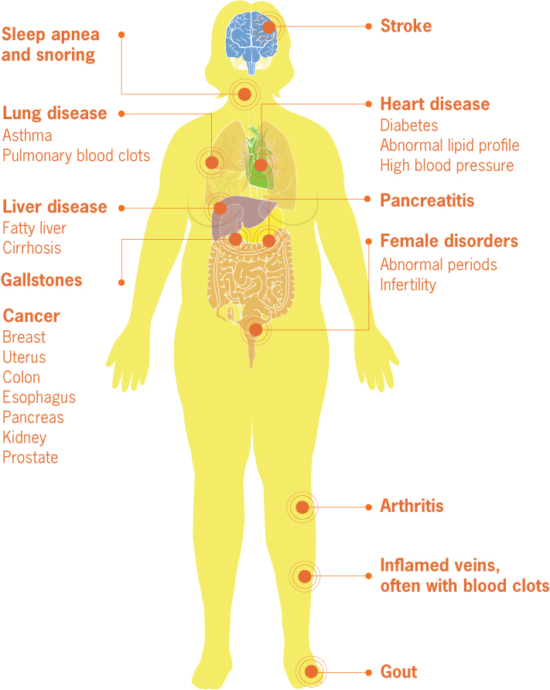
Introduction
Obesity is a challenge to one's health. Not only can it make day to day activities more challenging but obesity also places individuals at a greater risk of disease and death associated with non-communicable diseases. Specifically, obesity leads to conditions such as cardiovascular diseases, cancer, respiratory diseases, and type II diabetes mellitus (“Non Communicable Diseases” 2018), as seen in the figure to the right that displays the medical complications of obesity (“Adult Obesity Infographics” 2010). These comorbidities add to annual employer costs through direct medical costs and indirect costs associated with increased worker absenteeism and reduced overall productivity (“Workplace Health Promotion” 2016). Ultimately, extreme obesity and its related comorbidities may reduce one’s lifespan by as much as 20 years (Kitahara et al. 2014). In addition to the concerns associated with the health consequences of obesity and its comorbidites in adults, childhood obesity rates are rising and many believe that obese children are likely to become obese adults (“Childhood Obesity Facts” 2019).

With the aforementioned consequences and challenges associated with obesity you might expect that we have easy, replicable measures to determine obesity and a strong handle on its causes. Unfortunately, neither of these is currently true. Body Mass Index (BMI) is often used to indicate whether an individual has a healthy, overweight, or obese weight status. However, BMI is less than an ideal measure of obesity because it does not differentiate between muscle and fat mass. Additionally, BMI was developed from studies of white male populations and therefore the utility of BMI as a measure of female or non-white male health is currently only marginally accurate (Moharram et al., and Appropriate Body-Mass Index for Asian Populations and Its Implications for Policy and Intervention Strategies 2004).

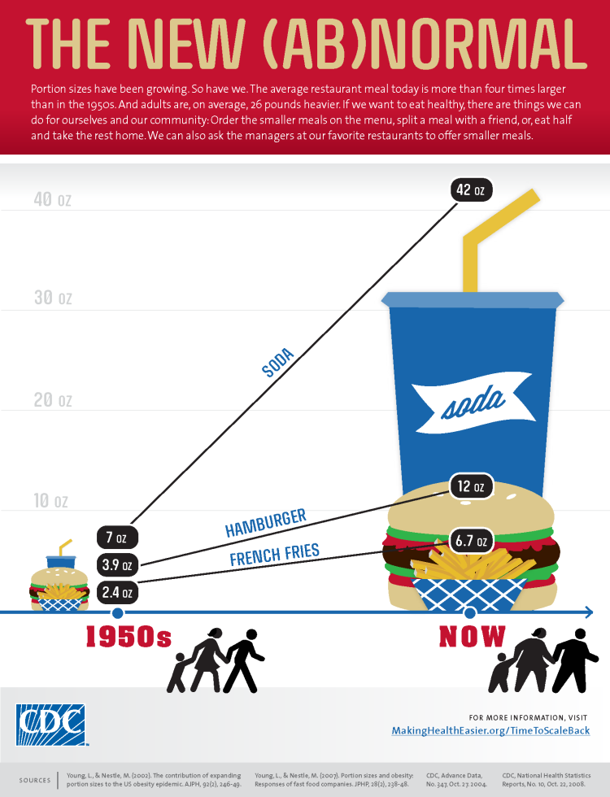
What do we know about the causes of obesity? A primary contributor to the development of obesity is excess caloric consumption in the presence of a sedentary lifestyle. The rise of processed food has reduced the cost and quality of foods and there is evidence that this processed food is a major contributor to the obesity epidemic (“Poor Nutrition,” 2020). As demonstrated in the infographic, The New(AB)normal, portion sizes have increased substantially in the past 50 years (“Infographics-The New (Ab)Normal” 2017 ).

Finally, few individuals get the recommended amount of physical activity per week (strength training 2X/week and moderate aerobic activity for 150 minutes OR vigorous aerobic activity for 75 minutes) and most get considerably less (“Physical Activity Guidelines for Americans” 2017). However, obesity is more complex than this simple energy budget would suggest and other factors, especially food environment and socioeconomic status, must be considered (“Adult Obesity 2020) .
Low-income neighborhoods that lack access to fresh produce and other high quality foods, based on a low abundance of grocery stores or farmer’s markets, often have disproportionately high obesity rates. These areas have been dubbed ‘food deserts.’ However, recent studies have demonstrated that food deserts may not drive obesity and that the lack of demand for fresh produce and healthy, high quality foods leads to the lack of supply (Allcott et al. 2019). ‘Food swamps’ complicate the food environment issue. Food swamps are also used to describe the food environment surrounding low-income neighborhoods. These areas have modest access to healthy food options but are overwhelmingly dense with fast- and junk-food options (Cooksey-Stowers et al. 2017).

These high calorie, low nutrient food options are less expensive and become the mainstay of residents in these areas. The socioeconomic status (SES) of residents of low-income neighborhoods impacts, and is impacted by, numerous facets of life including education and income levels. Each of these factors influence the food that is available for purchase and the food choices that one makes. All of these factors therefore influence one’s likelihood of becoming obese and developing comorbidites associated with obesity.

Background (OPTIONAL)
Obesity is a challenging medical condition that can lead to numerous other conditions called comorbidities. A number of factors may contribute to the development of obesity, including diet & physical activity levels, genetics, and environmental factors (socioeconomic status as well as exposure to endocrine disrupting chemicals). Obesity is studied in an effort to provide a better quality of life for obese individuals by preventing the development of comorbid diseases that further challenge the healthcare and life quality of the individual.

Procedure/Questions
Understanding the terminology
From the background reading and following the short in class discussion, define the following terms:
- Obesity
- Comorbidity
- Body Mass Index (BMI)
- Food Desert
- Food Swamp

Activity 1 - Understanding Obesity (7 questions):
Use the Center for Disease Control and Prevention’s resources on obesity to learn how obesity is defined and categorized.
https://www.cdc.gov/obesity/adult/defining.html
Based on the CDC website answer the following questions:
- What two factors are used to determine Body Mass Index (BMI)?
- What are the limitations of using BMI to predict obesity in various groups? Why do you envision BMI is used despite the known shortcomings?
- BMI measurements are an indirect measure of body fat. Write a statement about why BMI is considered useful even though it does not directly measure fat.
- What categories do BMI values place an individual into?
- Follow the link provided on the resource website to the Adult Obesity Causes and Consequences site (panel at top left).
  - List three contributing factors to obesity that an individual may have control over:
  - Next list three contributing factors to obesity that an individual likely does not have control over:
  - Do contributing factors in your lists overlap?
  - Compare your responses with another student and discuss why the factors that contribute to obesity make it particularly challenging to manage.
- Recall the comorbidities that are linked to obesity. Use the Google DataSet search tool (https://datasetsearch.research.google.com/) to find databases related to one of the comorbidities and obesity.
  - Are there few or many databases for comorbidities and obesity?
  - Are there government databases, such as the CDC or NIH (National Institutes of Health), for comorbidities and obesity?
- At the bottom of the Adult Obesity Causes and Consequences site review the information related to economic, societal and military implications provided. Based on this information:
  - What challenges, related to obesity, do you envision we might face as a country during your lifetime?
  - Does this information surprise you?

Activity 2 - Sorting the data (14 steps/questions)
There are numerous data sets available from the CDC. You will be working with a specific dataset that provides information related to obesity and characteristics such as education level, income level, and race/ethnicity. This dataset is based on telephone interviews where individuals respond to a scripted set of questions. Although this data set was built from responses to numerous questions, the data you will be considering relates to one specific area, ‘Percent of adults aged 18 years and older who have obesity.’
Data are provided for all U.S. states for the years 2011 and 2018.

Directions for sorting and organizing the Nutrition, Physical Activity, and Obesity - Behavioral Risk Factor Surveillance System Dataset

Follow the steps below to obtain the dataset and place it in your Google DRIVE:
1. Download the curated dataset from the HHMI website.
2. Save the curated dataset to the Google DRIVE and open the file using Google SHEETS.

Follow this link (https://www.youtube.com/watch?v=QoZnJQLEywo&t=216s) to learn how to sort the dataset. Next, complete the following tasks:
3. Open the dataset and Insert a new tab by clicking on the plus sign at the bottom left.
4. Rename your new tab by double clicking on the tab name and inserting your state name
5. Go back to the initial tab, given below, and scroll to locate your state data. (Nutrition__Physical_Activity__and_Obesity_-_Behavioral_Risk_Factor_Surveillance_System)
6. Highlight all rows that include your state’s data; for most states this will be ~56 rows (28 for the 2011 data and 28 for the 2018 data).
7. Copy the data from 2011 to 2018 for your state of choice (ctrl - C) and paste the data into your tab by clicking in cell A1 and hitting ‘ctrl-V’
8. Evaluate your data and note that it is not organized beyond the second column which designates year.
9. Highlight the first row in your tab and right click to choose ‘insert 1 above.’ This will insert a row above your state’s data.
10. Go back to the initial tab and copy the first row by highlighting it and hitting ctrl - C. Next, paste the column labels in your tab’s row 1 by highlighting the row and hitting ctrl-V.
11. Below your final row, in ~row 58, highlight the row and fill with a color using the inkwell tool. This serves as a visual separation between the unsorted data (above) and the sorted data that will be generated (below) the colored row.
12. In the first cell below your colored row, A59 in this example, type in a formula to sort by column 1. Does your data look different when comparing to the unsorted data above the colored row?
13. Add more sorting commands to your formula so that the data are sorted by rows 1, 7, 8, 9, 10, and 11. Does your data look different when comparing to the unsorted data above the colored row?
14. Study your data and note that the information to fill in the data tables below should now be readily accessible. See the example for New York state below.

Activity 3 - Analyzing the Data Table and Graphs (11 questions)
Using the sorted dataset generated in Activity2, choose a state and sort the data to allow for graphing and comparison of graphs between states. Example data for New York state is provided below.
Percent of adults that are 18 years old or older who have obesity: Education Level
State and region of U.S.  New York, Northeast | less than high school | high school graduate | some college or technical | college graduate
2011 | 27.5 | 26.9 | 27.1 | 18.2
2018 | 31.6 | 31.2 | 29 | 22.1

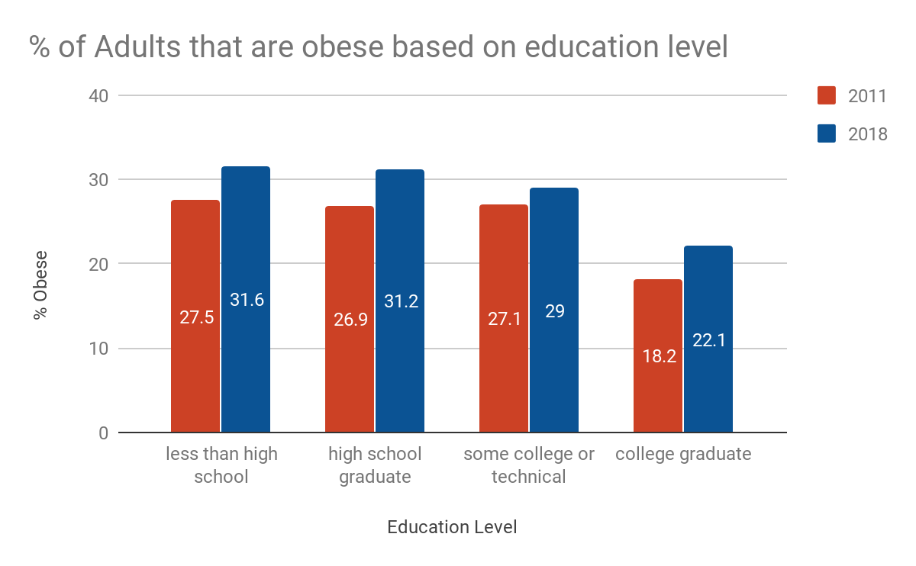

Using the sorted dataset that you generated in Activity 2, fill in the table below for the state you have chosen or been assigned.

Percent of adults that are 18 years old or older who have obesity: Education Level
State and region of U.S. | less than high school | high school graduate | some college or technical | college graduate
2011
2018

To generate a graph in Google Sheets, first watch the following video (https://www.youtube.com/watch?v=-x_mBMkB9KQ&feature=youtu.be). Next, follow the steps below to graph the information from your data table. Finally, insert the graph you have generated below the data table.
- After you have added the values from the dataset to your data table, copy the entire data table from Google Docs and paste the data table into cell A1 in a new tab in Google Sheets
- Remove the ‘State and region of U.S.’ text information in the first cell
- In Google Sheets, highlight the cells that contain your data. The highlighted cells should include the column labels and the data below them. Do NOT highlight the year column
- Click on the ‘Insert Chart’ button
- Using the Chart Editor, make the following changes or adjustments to your chart:
  - Ensure your chart type is ‘column chart’
  - Choose ‘Customize” and do the following:
    - Add an X-axis label, a Y-axis label, and a chart title that depict your data
    - Go to ‘Series’ and check the box next to ‘data labels.’ Next, choose the position of the data label (center in the examples provided).
    - Go to ‘Series’ and choose ‘column 1’ to change the color. Choose a color to represent column 1 data. Repeat this step for the other column.
    - Go to ‘Legend’ and adjust the position of the legend (right in the examples provided).
    - Double click on the first bar’s color in the legend at the right. Type in 2011 to indicate that data in that color represents the data from 2011. Repeat for the second bar and label it 2018. Your figure legend should now match your data columns. Confirm this by evaluating the data in your data table and ensuring the numbers are consistent.
    - Close the chart editor
- Go back to your Google Doc and place the cursor where you would like to insert the graph. Click ‘Insert’ and choose ‘Chart’ from ‘Sheets.’
- Choose the appropriate Sheets file, choose the appropriate graph from the Sheet if there are more than one and choose ‘Import.’
- Note that you can keep the graph linked to the sheet or choose to de-link them. Changes made in a linked file will be updated in the Google Doc graph only after you choose to ‘Update.’

Analysis of Data Table and Graph for Obesity and Education level:
1. Is there an apparent relationship between obesity and education level? Explain.
2. Does obesity prevalence among those with different education levels differ between years?
  - Which education levels tend to fare the best, regardless of year?
  - Which education levels tend to fare the worst, regardless of year?
3. Compare your graph with one from another region of the U.S. and discuss with your classmate the trends you notice.
4. Write a statement to demonstrate your understanding of the relationship between education level and obesity.

Percent of adults that are 18 years old or older who have obesity: Income Level
State and region of U.S.  New York, Northeast | less than $15,000 | $15,000 - $24,999 | $25,000 - $34,999 | $35,000 - $49,999 | $50,000 - $74,999 | $75,000 or greater
2011 | 27.3 | 26.5 | 26 | 28.5 | 26.8 | 20.1
2018 | 33.7 | 30.7 | 30.8 | 30.9 | 30.5 | 24.3

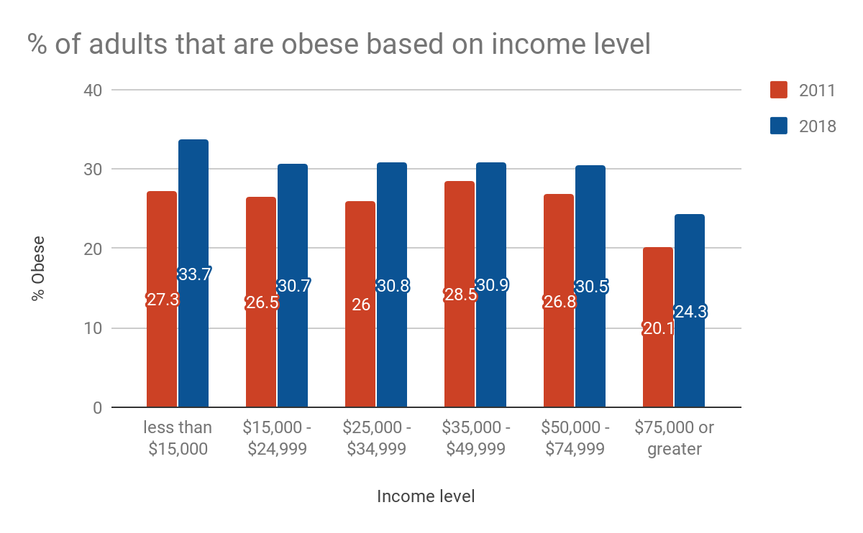

Using the sorted dataset that you generated in Activity 2, fill in the table below for the state you have chosen or been assigned.

Percent of adults that are 18 years old or older who have obesity: Income Level
State and region of U.S. | less than $15,000 | $15,000 - $24,999 | $25,000 - $34,999 | $35,000 - $49,999 | $50,000 - $74,999 | $75,000 or greater
2011
2018

See the directions provided above for how to generate a graph in Google Sheets.

Analysis of Data Table and Graph for Obesity and Income level:
5. Does obesity prevalence among those with different income levels differ between years? Explain.
6. Compare your graph with one from another region of the U.S. and discuss with your classmate the trends you notice.
7. Write a statement to demonstrate your understanding of the relationship between income level and obesity.

Percent of adults that are 18 years old or older who have obesity: Race/Ethnicity
State and region of U.S. | two or more races | American Indian/Alaska Native | Asian | Hispanic | Hawaiian/Pacific Islander | Non-Hispanic White | Non-Hispanic Black | Other
2011 | 36.1 | 0 | 9.9 | 26.3 | 0 | 23.6 | 32.5 | 0
2018 | 32.4 | 32.1 | 12.4 | 31.4 | 34.9 | 27.4 | 33.1 | 24
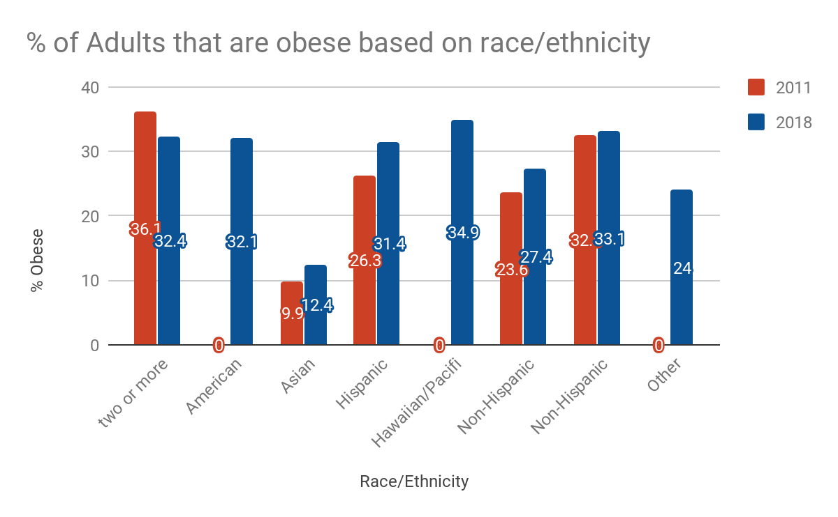

Using the sorted dataset that you generated in Activity 2, fill in the table below for the state you have chosen or been assigned.

Percent of adults that are 18 years old or older who have obesity: Race/Ethnicity
State and region of U.S. | two or more races | American Indian/Alaska Native | Asian | Hispanic | Hawaiian/Pacific Islander | Non-Hispanic White | Non-Hispanic Black | Other
2011
2018

See the directions provided above for how to generate a graph in Google Sheets.

Analysis of Data Table and Graph for Obesity and Race/Ethnicity:
8. Is there a trend for obesity based on Race/Ethnicity? Explain.
9. Do some groups appear to higher or lower obesity levels between years?
  - Which groups have lower obesity levels in each year?
  - Which groups have lower obesity levels in each year?
10. Compare your graph with one from another region of the U.S. and discuss with your classmate the trends you notice.
11. Evaluate the three graphs side by side.
  - Based on your evaluation of two states does it appear that different regions of the country have variable levels of obesity between 2011-2018 when education level is considered?
  - Based on your evaluation of two states does it appear that different regions of the country have variable levels of obesity between 2011-2018 when income level is considered?
  - Based on your evaluation of two states does it appear that different regions of the country have variable levels of obesity between 2011-2018 when race/ethnicity is considered?

