Scenario 1: A researcher wants to estimate the size of snails in a pond near Radford University, so she randomly samples 100 snails from the pond. She finds that shell diameter of the 100 snails is approximately normally distributed, with an average shell diameter of 10.1 mm, and an estimated standard deviation of 1.1 mm. This is the list of 100 snail shell diameters that she measured, sorted from the smallest to the largest snail:

7.7
8.1
8.5
8.5
8.6
8.7
8.7
8.8
8.8
8.8
8.8
8.9
8.9
9.0
9.0
9.0
9.1
9.2
9.2
9.2
9.2
9.2
9.3
9.3
9.4
9.4
9.4
9.4
9.4
9.4
9.4
9.5
9.5
9.5
9.6
9.6
9.6
9.6
9.7
9.8
9.8
9.8
9.8
9.8
9.9
9.9
9.9
9.9
9.9
9.9
9.9
9.9
10.0
10.0
10.0
10.0
10.0
10.0
10.0
10.0
10.0
10.1
10.1
10.2
10.2
10.2
10.2
10.2
10.3
10.3
10.4
10.4
10.4
10.4
10.5
10.5
10.6
10.6
10.6
10.7
10.8
10.8
10.8
10.8
10.9
10.9
10.9
11.0
11.0
11.1
11.2
11.2
11.2
11.6
11.6
11.7
11.8
11.8
11.9
11.9

- In Scenario 1, the population of interest to the researcher is…
  - All snails in the pond
  - All snails in all ponds near Radford University
  - The 100 snails she measured
  - All snails

- In Scenario 1, the 95% confidence interval for snail shell diameter in the pond is roughly…
  - 9.9mm to 10.3mm
  - 7.9mm to 12.3mm
  - 7.7mm to 11.9mm
  - 9.0mm to 11.1mm

- In Scenario 1 and Question 2, the correct interpretation of the 95% confidence interval is…
  - If the researcher repeated her random sampling procedure 100 times and re-calculated the 95% confidence interval 100 times, the true population mean would be within the 95% confidence interval 95 out of 100 times.
  - If the researcher re-calculated the 95% confidence interval for the same 100 snails 100 times, the true population mean would be within the 95% confidence interval 95 out of 100 times.
  - The researcher can be 95% sure that the true population mean is within the 95% confidence interval.
  - There is a 5% chance that the true population mean is not within the 95% confidence interval.

- Which of these is false?
  - Snail shell diameter is a discrete variable.
  - Snail shell diameter is a continuous variable.
  - Snail shell diameter is a random variable.
  - Snail shell diameter cannot be less than zero.
- In Scenario 1, the measures of central tendency for shell diameter of the 100 sampled snails are…
  - Mean=10.1mm, Mode=10.0mm, Median=9.9mm
  - Mean=10.1mm, Mode=10.1mm, Median=10.0mm
  - Mean=9.9mm, Mode=10.0mm, Median=10.1mm
  - Mean=10.1mm, Mode=10.1mm, Median=9.9mm

- In Scenario 1, the researcher can infer that…
  - Snails in the pond probably have an average shell diameter close to 10.1mm; an average shell diameter of 6mm or 13mm would be very unlikely in this pond.
  - 95% of the snails in the pond have shell diameters within the 95% confidence interval calculated in Question 3.
  - No snails in the pond have shell diameters larger than 11.9mm.
  - Snails in Virginia ponds are unlikely to have shell diameters of 6mm or less.

- In Scenario 1, which of these could not explain variability in the shell diameter amongst the 100 measured snails?
  - The researcher’s sampling method was biased.
  - The calipers that the researcher uses cannot measure snails perfectly (e.g., sometimes a 10.1mm is measured as 10.0mm or 10.2mm), so there is some observation error in the measurements.
  - There is natural variability in snail shell diameter because the snails are all slightly different ages, and older snails are bigger.
  - Snails in some spots in the pond have more food to eat and are bigger than snails in spots with poor quality food resources.

Scenario 2: After estimating snail sizes in one pond, the researcher decides that she would like to sample snails in many ponds, to determine whether snails in ponds on farms with cows (“cow ponds”) are bigger than snails in ponds that are not on farms with cows (“non-cow ponds”) are bigger. She thinks that snails might be bigger in cow ponds because the increased Nitrogen and Phosphorous input from cow poop should increase algae growth, resulting in more food for snails.

- In Scenario 2, which of these represent the researcher’s null and alternative hypotheses?
  - H₀: the mean shell diameters in the cow ponds and non-cow ponds are the same. H_{a}: the mean shell diameter in cow ponds is bigger than the mean shell diameter in non-cow ponds
  - H₀: the mean shell diameter in cow ponds is bigger than the mean shell diameter in non-cow ponds. H_{a}: the mean shell diameters in the cow ponds and non-cow ponds are the same
  - H₀: the mean shell diameter in cow ponds is smaller than the mean shell diameter in non-cow ponds. H_{a}: the mean shell diameter in cow ponds is bigger than the mean shell diameter in non-cow ponds
  - H₀: the mean shell diameter in cow ponds is bigger than the mean shell diameter in non-cow ponds. H_{a}: the mean shell diameter in cow ponds is smaller than the mean shell diameter in non-cow ponds
- In Scenario 2, the researcher considers randomly sampling 100 snails from one cow pond and randomly sampling 200 snails from one non-cow pond, and then comparing the mean shell size from the two ponds to decide whether snails from all cow ponds are bigger than snails from all non-cow ponds, on average. Which of these statements best describes the replication in this study design?
- There is inadequate replication because there is only one pond in each treatment or comparison group.
- There is adequate replication because the sample sizes are >20 snails from both ponds.
- There is inadequate replication because the sample sizes from the two ponds are different.
- There is adequate replication because she is sampling at least 100 snails.

- In Scenario 2, the researcher realizes that non-cow ponds can be pretty different: some are tiny alpine ponds on mountain tops, some are big puddles on bedrock in national parks, some are man-made ponds in backyard gardens, etc. Which of these would not improve her study design?
  - She should only sample snails from alpine ponds, to reduce the variability in her estimates of shell sizes in non-cow ponds.
  - She should try to sample snails from all types of non-cow ponds, to capture the full natural variability of snail sizes in non-cow ponds in her analysis.
  - If her research interest is about nutrient availability and how it affects snail size, she should measure nutrient availability in all of the ponds that she samples and use it as her predictor variable, instead of using pond type (cow pond vs. non-cow pond) as a categorical predictor variable.
  - She should try to find alpine ponds, backyard ponds, and national park ponds that do and do not have cows pooping near them, and sample snails from all pond types with and without cows.

- In Scenario 2, the researcher’s boss tells her that he will only pay for the gas to drive the field vehicle all over Virginia to sample snails if she can design a study with high statistical power. Which of these would increase the probability that she would successfully reject the null hypothesis, if the alternative hypothesis was true?
  - She could increase her sample size of cow ponds and non-cow ponds.
  - She could increase her Beta (increase Type II error rate).
  - She could decrease her alpha from 0.05 to 0.001 (reduce Type I error rate).
  - She could sample just a few snails from alpine ponds, which are harder to get to in the field car, and sample many snails from cow ponds, which are easy to get to in the field car.

- In Scenario 2, the researcher decides that she really wants to make inferences about all of the snails in the United States, so she cannot only sample ponds in Virginia. She downloads a list of every pond in the United States and randomly selects one cow pond and one non-cow pond from each state to sample. She samples each of those ponds in a single summer, which is a LOT of driving. Because she is tight on time, she quickly samples 50 snails from each pond by tossing a handful of 10 ping pong balls into the pond from the shore, wading into the pond, and picking up the first 5 snails that she sees near each of the floating ping pong balls. Her sampling method for ponds is _______________ and her sampling method for snails within ponds is _______________.
  - stratified random; haphazard
  - simple random; haphazard
  - cluster; random
  - stratified random; cluster

Scenario 3: After sampling snails from many ponds, including some alpine ponds, the researcher realizes one day that she might be noticing a trend where snails from ponds at higher elevations are smaller. She wants to test this idea, so she samples 100 snails each from three ponds at each of the following elevations: 0 ft above sea level, 100 ft above sea level, 1000 ft above sea level, 2000 ft above sea level, and 5000 ft about sea level. She runs a regression analysis which produces the output below.

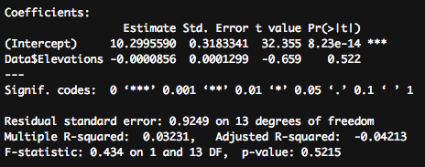

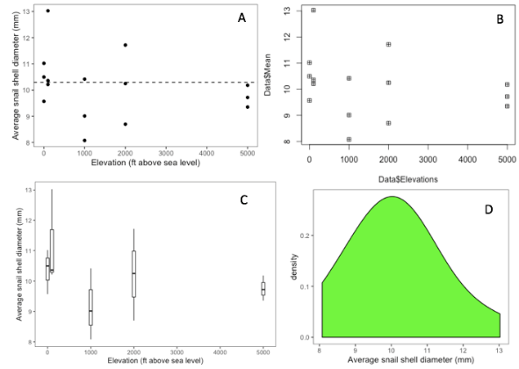
- In Scenario 3, the researcher plots her data to visualize the relationship. Which of these plots would she have made with this code chunk?
ggplot(data=Data, aes(x=Elevations, y=Mean)) +
geom_point() +
theme_bw() +
geom_abline(intercept = 10.3, slope=0, linetype="dashed") +
xlab("Elevation (ft above sea level)") +
ylab("Average snail shell diameter (mm)") +
theme(panel.grid = element_blank())

- Based on the model output in Scenario 3, the researcher must…
  - Fail to reject the null hypothesis; there is not a significant relationship between elevation and snail size.
  - Reject the null hypothesis; there is a significant positive relationship between elevation and snail size.
  - Reject the null hypothesis; there is a significant negative relationship between elevation and snail size.
  - Reject the null hypothesis; the mean shell diameter across ponds is significantly different from 10.3mm.

- In Scenario 3, the researcher wants to predict what the average shell diameter would be in a pond at 3500 ft, an elevation she did not sample at. What kind of prediction is she making and what value would she predict based on her model output?
  - Interpolation; 10.3mm
  - Interpolation; 9.5mm
  - Extrapolation; 9.5mm
  - Extrapolation; 10.3mm

- In Scenario 3, the researcher wants to ensure that her research can be reproduced by someone in the future; either her future self or a different researcher. Which of these is the best way to make sure her research is reproducible?
  - Publish her study results in an open access journal; do her data cleaning and analyses using open source coding software; archive her data and her statistical analyses in an online repository.
  - Do her data cleaning and statistical analyses with Excel; put a statement in her published paper saying that she’ll share her data with anyone who requests it.
  - Keep her data and analysis files on a flashdrive in her office and avoid sharing them with people who might use them in the wrong way.
  - Back up her data to the cloud, so she can’t lose it; have one of her friends check over her whole statistical analysis to make sure there are no errors.

Scenario 4: In a paper published in the journal Ecology Letters, Milutinović et al. (2020) considered how ant grooming affected ant fungal diseases. Ants can groom themselves when they have fungal spores on their cuticles, and they can also groom other ants (“allogrooming”). Milutinović et al. (2020) wanted to know how effective allogrooming was at reducing fungal disease, and they hypothesized that it might be an important form of “social immunity” for ants against fungal disease. Below are two figures showing some of their results.

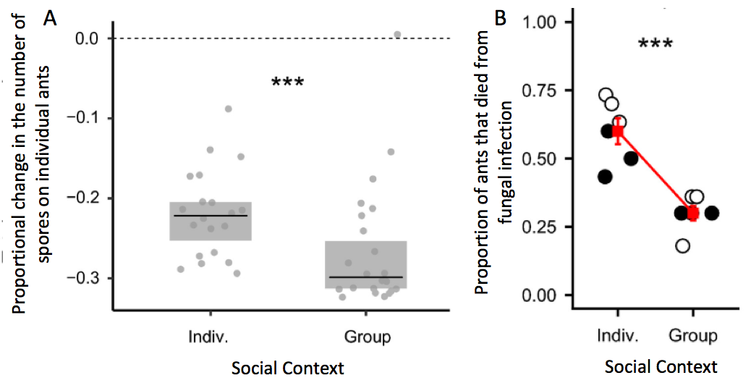

- In Scenario 4, which of these is not an appropriate interpretation of the figure on the left (panel A)?
  - The ants in the group social context all had bigger proportional changes in the number of spores on their cuticles than the ants in the individual social context, so allogrooming was always better at reducing fungal disease than individual grooming.
  - During the experiment, all but one ant had a reduction in the total number of spores on its cuticle, regardless of whether the ants were in the individual or group social context treatments.
  - On average, allogrooming in the group social context reduced the total number of spores on ants more than individual grooming when ants were alone in the individual social context.
  - There was variability in how much the total number of spores were reduced in the individual and group social context treatments; some ants experienced bigger reductions in spores than others within a given treatment group.

- In Scenario 4, what type of variable is social context?
  - Categorical/nominal
  - Continuous
  - Quantitative
  - Ordinal

- In Scenario 4, which of these steps would not improve the data visualization in the figure on the right (Figure B)?
  - Use a bar graph or “dynamite plot” instead of a dot plot showing all of the data points and variation, to make the figure simpler.
  - Add a legend to explain why some points are white and some points are black
  - Remove the red line connecting the treatment means, because it is unnecessary and potentially misleading.
  - Add an informative figure caption.

- In Scenario 4, the researchers report that the proportion of ants that died varied from 0.4 to 0.75 across replicates in the individual social context treatment. This is not an example of…
- Inferential statistics
- Natural variability in a population
- Descriptive statistics
- A continuous quantitative variable

Scenario 5: You’re watching the national news and hear about a new study. Researchers surveyed 60,000 Americans who drank coffee every day. They surveyed these Americans by visiting Starbucks coffee shops in 50 major cities. The researchers conclude that the more cups of coffee an American drinks per day, the higher their annual salary, on average. The news anchors are excited and announce that increasing your coffee consumption by one cup per day can increase your salary by about $10,000 per year and encourage people who don’t drink coffee to start as soon as possible.

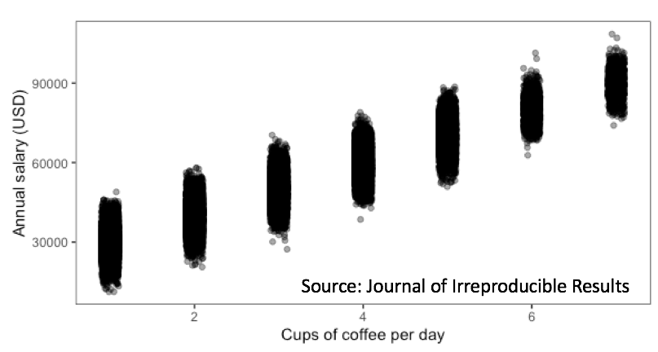

- In Scenario 5, the population that the researchers and news anchors want to make inferences about is…
  - Americans who drink coffee
  - All people who drink coffee
  - The 60,000 surveyed Americans who drink coffee
  - All Americans

- In Scenario 5, which distribution would be best to use when modeling annual salary?
  - Normal distribution
  - Poisson distribution
  - Binomial distribution
  - Exponential distribution

- In Scenario 5, which of these is not a problem with the study design or the news anchors’ conclusion?
  - Large variance in reported annual salaries
  - Confusing correlation with causation
  - Biased, non-random sampling of the population (only sampling coffee drinkers who visit Starbucks)
  - Making inappropriate inferences about a population (people who do not drink coffee) that was not sampled for the study

- In Scenario 5, which of these assumptions should not be made when modeling the relationship between annual salary and cups of coffee drunk per day?
  - Heteroskedasticity: there is more variation in annual salaries when people drink many cups of coffee per day
  - Homogenous variance: the amount of variability in annual salaries is roughly constant across cups of coffee per day
  - Independent observations: the salary of one surveyed coffee drinker does not depend on the salary of another surveyed coffee drinker
  - Normally distributed errors: the residuals of annual salaries are approximately normally distributed around 0 for any given value of cups of coffee per day

- In Scenario 5, the researchers wanted to know the average salary of sampled people who drank 4 cups of coffee per day. Which of these code chunks could not calculate that average?
  - mean(Salary, Cups==4, data=Data, na.rm=T)
  - mean(Data$Salary[Data$Cups==4])
  - Data %>%
filter(Cups==4) %>%
summarise(MeanSalary=mean(Salary, na.rm=T))
  - Data2<-Data[Data$Cups==4,]
mean(Data2$Salary, na.rm=T)

