Data Activity: Student Handout
The Hidden Kingdom: Island Biogeography with Fungi
Background
As humans, the origins of many gene functions come from a group of organisms in the kingdom most closely related to Animalia. These gene functions include genes that are responsible for circadian rhythms, sexual reproduction, cell cycle and cytoskeletal structures. Members of this kingdom also behave in interesting ways. For example, this vegetative group can attack other animals and change its behavior, even becoming predatory and consuming other animals for nutrients. We sometimes see members of this normally subterranean and hidden kingdom emerge as fruiting bodies when it is time to reproduce, revealing an incredibly diverse and beautiful array of puffballs, toadstools, and mushrooms. These organisms are the fungi. Often overlooked by people, quite literally because they often are found living under ground or within other species, but often glanced at in textbooks as “uninteresting.”
This eukaryotic, heterotrophic kingdom is composed of diverse and fascinating species. Fungi have a 900 million year history on the planet and over 99,000 described known species (and estimated 1.5 million member representation to 6 million species estimated; Main 2013). Living often in soil and rotting vegetation, these organisms’ cells have cell walls made of chitin and are known for their role as decomposers in the environment, helping to recycle important nutrients back to the soil.
When it is time to sexually reproduce, fungi need to unite their typical haploid cells together in order to form diploid structures that can then undergo meiosis to produce spores. And by doing so, fungi can disperse to new habitats. How far a distance does an organism or a spore have to travel in order to successfully establish themselves? Is the new environment hospitable or are there barriers, such as competitors or poor resource availability? Is the size of the habitat big enough to accommodate a new arrival? Such considerations are studied through island biogeography theory, where “island” distance and size from a mainland is considered. Islands can be a land mass surrounded by water, but it can also be any isolated habitat such as a mountaintop or a park reserve surrounded by development. This theory states that close “islands” are easier to disperse to than further islands and initially immigration will be high as individuals move to the islands. Additionally, large “islands” will have more niche space and resources than smaller islands, so larger islands will contain more species than smaller islands. Competition between species will increase as more species arrive at the island and therefore extinction will rise over time. The theory predicts that there will be a balance between immigration and extinction and this will determine the number of species that the island can support (Fig 1). Scientists have tested whether the number of fungal species increased with pine tree size, the “island”, and distance of these trees from the mainland forest in a subalpine basin in Yosemite National Park. Support was found for the prediction that fungal species diversity would increase with tree volume (that is “island” size) and decrease as the pine trees were further away from the mainland forest (Glassman et al. 2017).
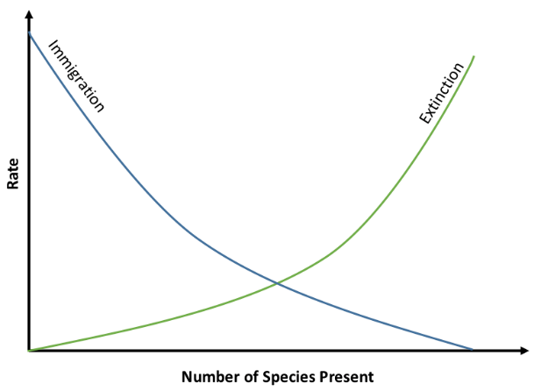
Figure 1. Island Biogeography Theory. Notice how immigration and extinction lines overlap one another and the point of intersection represents the number of species that the island can support.
By Marcus Lapeyrolerie - Own work, CC BY-SA 4.0, https://commons.wikimedia.org/w/index.php?curid=69800719
Procedure/Questions
In order to be successful, fungi, like all living organisms, need to utilize energy to grow and maintain themselves, reproduce, and adapt to their environment. Stimuli, such as nutrient availability, may help trigger all these processes, providing the cues for sexual reproduction, fruiting body and spore production, and dispersal to new habitats. To study this, a species of fungus can be examined more closely using different concentrations of nitrogen and different habitat patches.
Predict the following:
- How will a fungus respond when extra nutrients are provided to its environment? Justify your answer.
- Will all islands be equally suitable for colonization? You should be able to list/discuss at least 3 points.

The fungus Phacidium lacerum
The fungus Phacidium lacerum is common throughout the United States, Western and Eastern Europe, South Africa, Australia, and India. It is associated with rotting wood, conifer needles, and sometimes the leaves of hardwood trees and belongs to the Ascomycota group of fungi. When it comes time to disperse quickly, P. lacerum can produce fruiting bodies called pycnidial conidiomata (or pycnidia) on the surface of infected plant material (Crous et al. 2014). These are capsules that contain asexual conidia that can be released into the environment.
Scientists studied the behavior of the fungus when different sized petri dish islands, with different growth-medium nutrient concentrations, were used as new habitat for dispersal (Chan et al 2020). They used small Petri dishes (9 cm diameter) and large Petri dishes (14 cm diameter) for their new habitats that contained either low resource (0.1% malt extract agar media nutrient), medium nutrients (0.5%), or high resource treatment (1% nutrient) for a total of 36 treatment plates and an additional 12 plates with water agar.
The fungi were allowed to establish themselves on the water agar for seven days, serving as the stock/initial population. After that time and in order to simulate dispersal to petri dish “islands,” scientists took a 5 mm diameter plug from the stock and inoculated it onto the center of the newly “dispersed to” petri dish habitat. For a total of 20 days, every 24 hours, the scientists measured fungal growth rate on the new habitat plates for colony size and calculated colony relative growth rate (RGR) as the proportional or log difference in colony area. This measurement allowed the scientists to consider dispersal success by the fungus. If the fungus was able to grow on the new plate, its dispersal was considered successful to that new habitat. Scientists noticed new pycnidia fruiting bodies emerging after 5 days of the fungus establishing itself in the new habitat. After these fruiting bodies appeared, production and numbers were recorded every 12 hours (over the course of the 20 day experiment). Pycnidia densities were determined as the number of pycnidia per colony area.

Predict the following:
- Given the methods described, what would be considered the independent variable in this experiment? What would the dependent variable be?

- Using these independent and dependent variables predict the relationship you expect to find when considering dispersal success (as measured by colony establishment) and pycnidia fruiting body production? Create two sketches of graphs predicting these outcomes (rather than writing your answer in words).

After sketching your figure, answer the following questions:
  - Why did you choose this particular plot type/figure?
  - What variables did you compare and why?

Scientists found the following means for the different habitats (Chan et al 2020). These data include two replicates (out of the total 6).
Petri Dish Habitat | Fungal Colony Size (mm²) with  1 replicate only | Fungal Colony Size (mm²) with  2 replicates considered
Small Dish, Low Nutrient Concent. | 159.231 | 297.173
Small Dish, Medium Nutrient Concent. | 209.595 | 425.438
Small High Nutrient Concent. | 271.121 | 567.850
Large Dish, Low Nutrient Concent. | 140.126 | 288.819
Large Dish, Medium Nutrient Concent. | 194.840 | 409.191
Large Dish, High Nutrient Concent. | 250.916 | 558.394

- What do these data tell you? Does nutrient availability seem to be connected to fungal success? What about habitat size and fungal success?

- What else would you like to know to be sure of your statement from above?

We are going to analyze data Chan et al. (2020) used in their study (available from Dryad Data repository). Migrate to Data Explorer or Excel and choose the Fungi Island Biogeography set. The data file has various data such as fungal colony size, growth rate, density and pycnidia counts.
- Looking at the data set, what serves as a control group? Why? Why are control groups in general important?

- Choose a condition of interest to you and consider how the variable changes over time. Construct a line graph representing this relationship by selecting the “visualize” tab on the top (Data Explorer) or “insert” (Excel) and then select the type of graph you want. After making the graph, write a one-sentence statement of what the graph is telling you.
- Consider Fungal Colony Relative Growth Rate (RGR). How could you analyze these data to determine if island biogeography theory predictions hold true? Write down the different ways you can do this (you will have several). Click on “Analyze” tab (Data Explorer) or “Formulas” and then “more functions” and then “statistical” (Excel) and then examine the types of tests available. Conduct these calculations.

Examining data sets through the use of statistical analysis can help you determine if any differences you find between groups is biological real (statistically significant) or if those differences are due to chance (not statistically significant). In general, statistical tests are considering if the null hypothesis is supported or refuted. A null hypothesis states there is no difference between groups. The alternative hypothesis states there is a difference between the groups. After running your statistical test, if you accept the null, you would conclude there is no difference between the groups. If you reject the null in favor of the alternative hypothesis (typically when the p-value is 0.05 or less that is the probability-value of you being incorrect with your conclusion at 5%), you would conclude there is something of biological significance between the groups.

Such statistical tests will use means and standard deviations to compare groups to one another. Common tests employed include t-tests when comparing two groups that are smaller in size, X² tests when comparing categorical group data, and ANOVA tests when comparing three or more groups. Review the statistical descriptions below if you want more information on these tests.

- Consider Growth Rate. What is the difference in this parameter compared to RGR? Calculate the means for the different treatments and then calculate the standard deviation.

- Of the statistical tests discussed above, which would be appropriate to further analyze your data comparing fungi on large petri dishes with medium and large nutrient concentrations on them? If so, do the test and report your results.
- Consider Pycnidia Count as well as Pycnidia Added. What do you notice about these data? What does that tell you? What might a next question and/or test be to further your understanding of fungi and pycnidia?
- Examine the Density column, which is in reference to the number of pycnidia per colony area. How can you study the data descriptively? Make the calculations/run the statistical tests and state what these tell you.
- Consider what you have learned from this study and activity. Summarize the main message in two sentences only. Note that this can be a difficult task – work to get your point concise and be patient with arranging things so the words ultimately have the impact you would like.
- What are some long-term impacts you can envision based on this study? Explain your logic.
- What would a next likely question to ask stemming from these results and this study? In other words, what would you like to investigate further? Elaborate.

Additional Activity/Idea: Watch the HHMI BioInteractive video “From Ants to Grizzlies: A General Rule for Saving Biodiversity”. It is about 18 minutes long.
While you watch the video, answer the following:
- As EO Wilson was studying the number of ant species on each island in the South Pacific, what did he find?
- What observation was seen with reptiles and amphibians on these islands?
- How could EO Wilson test this “rule of thumb?”
- Describe the experiment that EO Wilson and his graduate student Simberloff conducted in the Florida Keys.
- What were the results from this Florida Keys experiment? What was the conclusion?
- Describe what scientists found when they carved out different sized patches in the Amazon rainforest. What type of species were more negatively affected compared to others and why?
- Are American national parks large enough in size? Elaborate.
- Describe some conservation techniques that scientists use to help connect habitats to one another.
- Based on this video and in your own words, describe what island biogeography theory predicts.
- How does the fungus research of this module connect with island biogeography theory?

References
Chan, JY, Bonser, SP, Powell JR, and WK Cornwell. 2020. Environmental cues for dispersal in a filamentous fungus in simulated islands. OIKOS 00: 1-9.
Crous, PW, Quaedvlieg W, Hansen K, Hawksworth DL, and JZ Groenewald. 2014. Phacidium and Ceuthospora (Phacidiaceae) are congeneric: taxonomic and nomenclatural implications. IMA Fungus 5: 173-193.
Glassman SI, Lubekin KC, Chung JA, and TD Bruns. 2017. The theory of island biogeography applies to ectomycorrhizal fungi in subalpine tree “islands” at a fine scale. Ecosphere 8 (2): e01677. https://doi.org/10.1002/ecs2.1677

Review: Statistical Testing of Biological Data
Standard deviations are important parameters to consider when studying data. Standard deviation is a measure of the amount of variation or dispersion of the data around the mean. If you consider the mean and how individual data are spread out around that mean, you have an indication of the standard deviation. The closer all the individual points are to the mean, the smaller the deviation and the more spread out and further dispersion of individual points around the mean, the larger the deviation. Many statistical tests use the standard deviation to help determine if two samples are different enough from each other to show a real biologically significant difference (as opposed to seeing any difference due to chance alone).
To calculate standard deviation you need to know the population size, N, and the mean 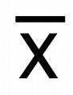 for the population as well as each individual data point x_{i}.
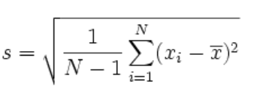
There are different types of statistical tests to run based on what kind of data you collect. If you are comparing the data between two groups, a t-test can be useful. For example, if you are comparing one group that received treatment X to another group that received treatment Y and you wanted to know if the difference you detected between these groups was actually due to the treatment, you could apply a t-test. There are actually three types of t-tests: an independent samples t-test comparing the means for two groups, a paired sample t-test to compares means from the same group at different times (e.g. different months), and a one sample t-test which tests the mean of a single group against a known mean. Often when people say t-test, they often mean the independent samples t-test. Here we find the following formula:

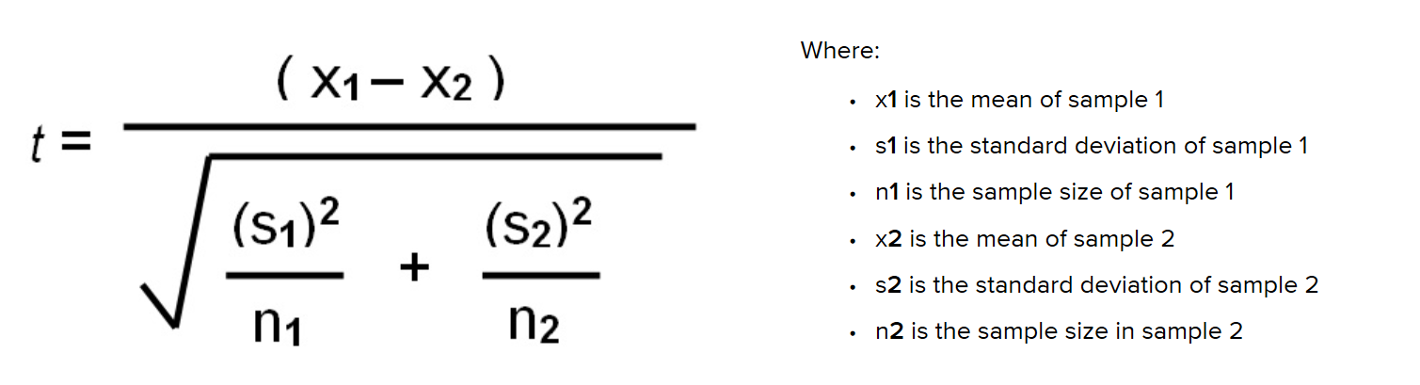

If you are comparing two groups to one another that fall into categories a X² test (Chi-square test) is helpful. Let’s say you have two categories like female and male and you are trying to determine if the differences you see in the means of these groups (e.g. height) is different enough that there is a real biological difference present, you could use a X² test. Here we find the following formula:
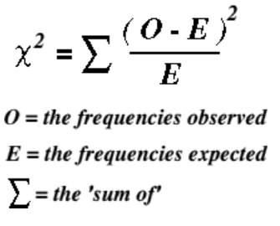

If you have more than two groups, the ANOVA test (Analysis of Variance test) can be most helpful. This test has variations to it (just as the t-test does), but a common one is the one-way ANOVA. Here, the means between groups are compared to one another to determine if they are different enough to say there is a real difference between groups. This one-way version of ANOVA is looking at only one independent variable (e.g. fertilizer brand) and is useful when comparing two groups to one another. The two-way ANOVA is more complex and looks at two independent variable (e.g. fertilizer brand and type of plant) and is helpful when looking at one group that you are double-testing. The commonly used ANOVA test formula compares the means (sums of squares) between groups, means (sums of square) within groups, incorporates standard deviation and uses all these data to obtain a F-value. This test statistic, F, shows the MS_{group} or the mean squared error of between-group variance and the MS_{error}, the mean squared error of within-group variance, and compares it in the following formula:

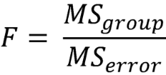
After you run these tests, you will find a p-value, or probability value that will help you make the decision of whether to accept or reject the null hypothesis. This p-value tells the person the likelihood that the test is true and the likelihood, by default, that you might be making a mistake in interpreting the data. The most widely accepted p-value is 0.05 which means there is a 5% probability that the data you think are really different due to biological reasons (e.g. there is a real difference between treatment X and Y) is not correct. There is a 5% chance you are wrong with your interpretation, but a 95% chance you are correct in that there is a real difference between these groups. If you run a statistical test and your p-value is 0.05 or less you would reject the null in favor of the alternative hypothesis and conclude there is a real difference between groups of your data.

