**Data Activity: Educator Guide**

**Student Learning Targets**

* Understand the roles that fungi play in the environment
* Summarize how fungi sexually reproduce and disperse their spores
* Identify the diversity in fungi groups and in relationships with other organisms
* Apply island biogeography theory
* Construct graphs to illustrate predictions for an experiment
* Analyze data to compare different treatment results
* Calculate means and standard deviations
* Make claims based on scientific evidence and use scientific reasoning to support the claims

**The Hidden Kingdom: Island Biogeography with Fungi**

**Background**

As humans, the origins of many gene functions come from a group of organisms in the kingdom most closely related to Animalia. These gene functions include genes that are responsible for circadian rhythms, sexual reproduction, cell cycle and cytoskeletal structures. Members of this kingdom also behave in interesting ways. For example, this vegetative group can attack other animals and change its behavior, even becoming predatory and consuming other animals for nutrients. We sometimes see members of this normally subterranean and hidden kingdom emerge as fruiting bodies when it is time to reproduce, revealing an incredibly diverse and beautiful array of puffballs, toadstools, and mushrooms. These organisms are the fungi. Often overlooked by people, quite literally because they often are found living under ground or within other species, but often glanced at in textbooks as “uninteresting.”

This eukaryotic, heterotrophic kingdom is composed of diverse and fascinating species. Fungi have a 900 million year history on the planet and over 99,000 described known species (and estimated 1.5 million member representation to 6 million species estimated; Main 2013). Living often in soil and rotting vegetation, these organisms’ cells have cell walls made of chitin and are known for their role as decomposers in the environment, helping to recycle important nutrients back to the soil. Fungi can form symbiotic relationship with other species. For example, mycorrhizae is really the joint relationship of fungi and plants, sometimes referred to as “fungal” roots. Because plants can obtain a lot more water and nutrients as a result of this relationship, many evolutionary biologists believe plants would not have been able to establish themselves on land successfully without fungal interactions. Fungi can also share their digestive services with animals, such as helping to break down plant material in the guts of cows. Fungi can be parasitic on or inside of animals, including humans. For example, fungi cause ringworm and athlete’s foot in humans. Fungi, such as corn smuts and tar spot fungi, can also attack food crops and other plants.

Fungi can also cause even more devastation to major groups of species. Indeed, fungi has also been implicated in the widespread decline of a major taxonomic group: amphibians. The fungus *Batrachochytrium dendrobatidis*, commonly referred to as Bd, infects the skin of amphibians, causing chytridiomycosis, which prohibits the amphibians from regulating osmosis properly. This fungal threat is so problematic that it has become known as the most deadly pathogen known to science, with connections to the population decline of 500 species of amphibians, including 90 extinctions in the past 50 years (Zimmer 2019).

Many species of fungi, however, do not cause such problems and live in the soil and rotting logs of the forest. They can grow for miles and live a long time. For example, a single individual fungus in Oregon spans over 3 square miles and is estimated to be at least 1,900 years old! (And may be as old as 8,650 years old; Adams 2015). While underground, they are decomposing material and releasing nutrients to the soil. In this way, they help with nutrient cycling, but if they cannot gain even nutrients themselves from breaking down organic matter, they may need to resort to actively seeking out nematode worms. By manipulating their hyphae into lassos and emit a pheromone into the soil, the fungi attract these worms. When the worms move through the lasso traps, the fungus constricts down on the worm and releases digestive enzymes into the worm in order to gain access to valuable nitrogen. The fungus traps the worm and slowly draws nutrients from it as the worm eventually dies.

The diversity we find among fungi groups is just as impressive as the behaviors highlighted above (Fig 1). The Fungi Kingdom is divided into five main groups of phyla, which have the ending “mycetes” in their name. This is in reference to the mycelium body structure of fungi. Typically, fungi live in the ground with their cells lined up end to end as a strand we call “hyphae”, but when all the hyphae come together collectively we use the term “mycelium”. The **Chytridiomycota** are the most simple groups and among the oldest on the planet and these fungi are aquatic. The Bd fungi mentioned above belongs in this group. The mycelium of the group called the **Basidiomycetes** can clump together during the sexual stage of their life cycle to form the familiar club-like structures like mushrooms, toadstools and puffballs. The **Glomeromycetes** are important fungi in that they are the ones that form symbiotic relationships with plant roots to produce mycorrhizae. The **Zygomycetes** form zygospores that can give rise to a fruiting body that looks like lollipops waving in the air when the mycelium come together for sexual reproduction. Bread molds are a good example of this type of fungus, but in general, this is a smaller group of fungi with less than 100 species represented. And finally, the **Ascomycetes** produce sacs that contain 8 spores from their combined mycelium to help them disperse in nature. There are more than 30,000 species of fungi here (the largest group of fungi) and lots of diversity in body style when the mycelium come together. One common example is the morel and other sac fungi. The unicellular yeast is also found within this phylum.

[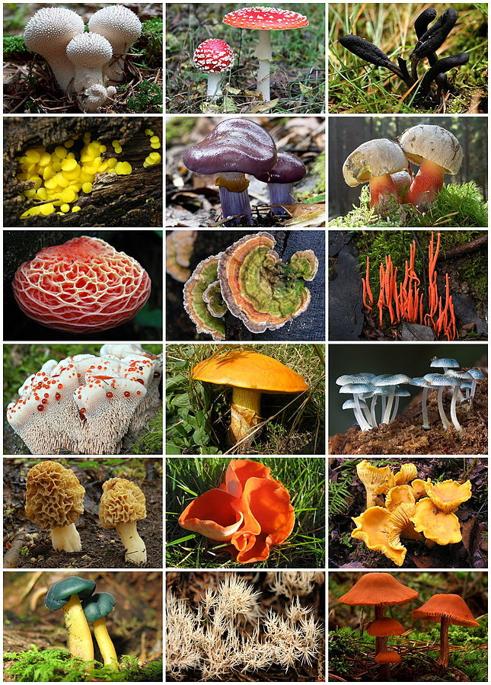](https://upload.wikimedia.org/wikipedia/commons/d/da/Fungi_Diversity.jpg)

**Figure 1. Diversity of Fungi Fruiting Bodies.**   
*By TermininjaMarkusHagenlocher (File:Flaschenstäubling.jpg)Stu&#039;s Images (File:Amanita muscaria UK.JPG)James Lindsey (File:Elaphocordyceps ophioglossoides - Lindsey 2.jpg)Paul Derbyshire (Twizzler) (File:Bisporella citrina 59079.jpg)JJ Harrison (File:Cortinarius archeri.jpg)Walter J. Pilsak (File:Schoenfussroehrling.jpg)Dan Molter (File:Rhodotus palmatus2.jpg)Ecornerdropshop (File:Stumpfungus.jpg)JJ Harrison (File:Clavulinopsis corallinorosacea.jpg)Amadej Trnkoczy (Amadej) (File:Hydnellum ferrugineum 59267.jpg)Szabi237 (File:Suillus grevillei2.JPG)JJ Harrison (File:Mycena interrupta.jpg)Andreas Kunze (File:2011-04-30 Morchella esculenta.jpg)Arz (File:Aleuria aurantia.JPG)Strobilomyces (File:Chanterelle Cantharellus cibarius.jpg)John Carl Jacobs (JCJacobs) (File:Leotia viscosa 57215.jpg)James Lindsey (File:Pterula.subulata.-.lindsey.jpg)Zonda Grattus (File:Lacc.lacc.jpg) - Agaricaceae(Lycoperdon perlatum)Amanitaceae(Amanita muscaria)Geoglossaceae(Geoglossum umbratile)Helotiaceae(Bisporella citrina)Cortinariaceae(Cortinarius archeri)Boletaceae(Boletus calopus)Physalacriaceae(Rhodotus palmatus)Polyporaceae(Trametes versicolor)Clavariaceae(Clavulinopsis corallinorosacea)Bankeraceae(Hydnellum ferrugineum)Suillaceae(Suillus grevillei)Mycenaceae(Mycena interrupta)Morchellaceae(Morchella esculenta)Pyronemataceae(Aleuria aurantia)Cantharellaceae(Cantharellus cibarius)Leotiaceae(Leotia viscosa)Pterulaceae(Pterula subulata)Hydnangiaceae(Laccaria laccata), CC BY-SA 3.0, https://commons.wikimedia.org/w/index.php?curid=23848535*

When it is time to sexually reproduce, fungi need to unite their typical haploid cells together in order to form diploid structures that can then undergo meiosis to produce spores. Sexual reproduction is important to help ensure genetic diversity to an ever-changing environment and the only way to accomplish that is through the process of meiosis. So it’s interesting to think about an organism uniting its cells very briefly only to engage in meiosis, but without meiosis, populations would not be as capable of responding to their environment.

These typical haploid cells are in hyphal form in the soil usually. We refer to the cells that come together from different hyphae as ‘+ strain” and “- strain”. When the + mating strain and the – mating strain unite, they become diploid and will form a structure that will typically pop out of the ground or stand erect in some way. Within these now diploid structures, meiosis will begin so unique haploid spores can be produced. These spores will be released based on certain cues, like pressure or temperature, and float through the air, landing eventually on a new substrate. They will then germinate into a new hyphal strand for the process to begin again (Fig 2). This part of the fungi’s life cycle is analogous to a tree and its fruit. The fungal structure (such as a mushroom or toadstool) is full of spores, much like a fruit is full of seeds. And much like a tree, it is beneficial to spread its spores as far as possible so new “offspring” or fungal hyphae don’t compete with the original “parent” for nutrients. Fungi rely on wind currents and water. For example, if we focus on a mushroom, water vapor is released which cools the air around the structure. Since this cooler air is more dense than the warmer air buffering it, a lift is created. This lift can carry spores up to 4 inches horizontally and vertically (Dressaire et al. 206; Main 2013). Additionally, such mushroom spores in droplets of water can evaporate and once airborne can stay as raindrops in humid air, potentially promoting rainfall in areas that support large populations of fungi (Hassett et al. 2015). How cool is that?!

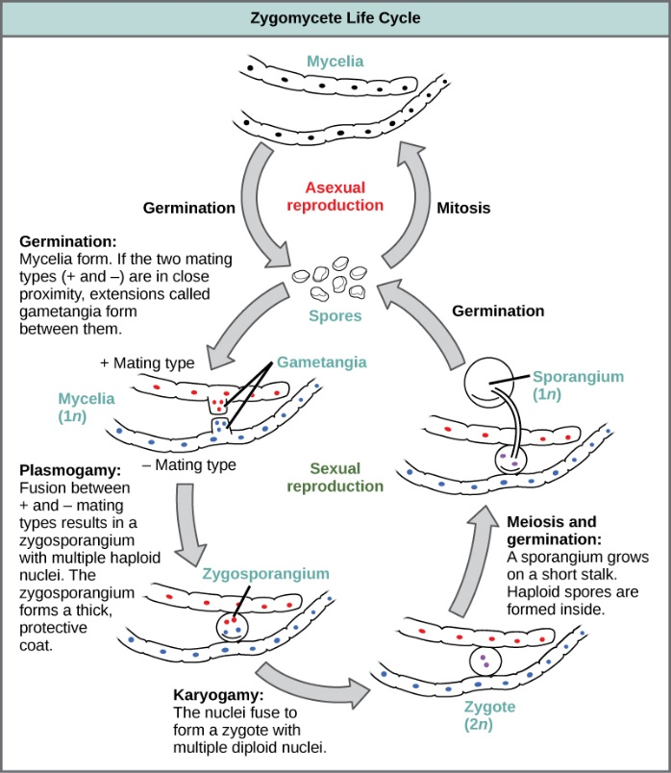

**Figure 2. Life Cycle of a fungi from the Zygomycota phylum. Notice both sexual and asexual reproduction occurs.**   
*By CNX OpenStax - http://cnx.org/contents/GFy_h8cu@10.53:rZudN6XP@2/Introduction, CC BY 4.0, https://commons.wikimedia.org/w/index.php?curid=49931412*

Dispersal is important not only for fungi, but for all organisms. New habitats can be found, populations can grow and more resources can be exploited. Establishing yourself and gaining an advantage in a new location is part of this equation. How far a distance does an organism or a spore have to travel? Is the new environment hospitable or are there barriers, such as competitors or poor resource availability? Is the size of the habitat big enough to accommodate a new arrival? Such considerations are studied through **island biogeography theory**, where “island” distance and size from a mainland is considered. Islands can be a land mass surrounded by water, but it can also be any isolated habitat such as a mountaintop or a park reserve surrounded by development. This theory states that close “islands” are easier to disperse to than further islands and initially immigration will be high as individuals move to the islands. Additionally, large “islands” will have more niche space and resources than smaller islands, so larger islands will contain more species than smaller islands. Competition between species will increase as more species arrive at the island and therefore extinction will rise over time. The theory predicts that there will be a balance between immigration and extinction and this will determine the number of species that the island can support (Figure 3). Scientists have tested whether the number of fungal species increased with pine tree size, the “island”, and distance of these trees from the mainland forest in a subalpine basin in Yosemite National Park. Support was found for the prediction that fungal species diversity would increase with tree volume (that is “island” size) and decrease as the pine trees were further away from the mainland forest (Glassman et al. 2017).

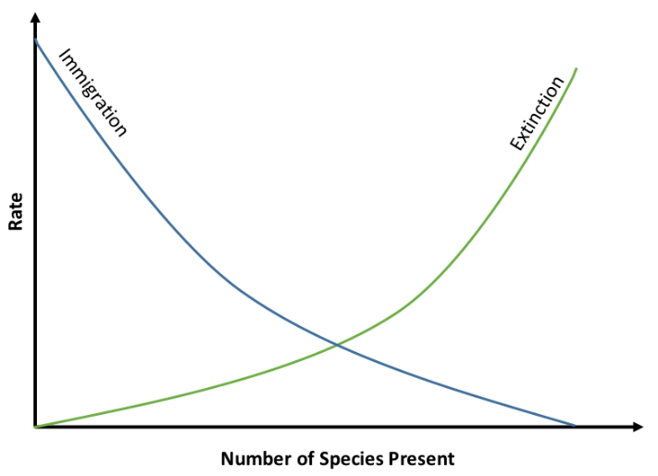

**Figure 3. Island Biogeography Theory. Notice how immigration and extinction lines overlap one another and the point of intersection represents the number of species that the island can support.**    
*By Marcus Lapeyrolerie - Own work, CC BY-SA 4.0, https://commons.wikimedia.org/w/index.php?curid=69800719*

**Procedure/Questions**

In order to be successful, fungi, like all living organisms, need to utilize energy to grow and maintain themselves, reproduce, and adapt to their environment. Stimuli, such as nutrient availability, may help trigger all these processes, providing the cues for sexual reproduction, fruiting body and spore production, and dispersal to new habitats. To study this, a species of fungus can be examined more closely using different concentrations of nitrogen and different habitat patches.

*Predict the following:*

1. How will a fungus respond when extra nutrients are provided to its environment? Justify your answer.
2. Will all islands be equally suitable for colonization? You should be able to list/discuss at least 3 points.

The fungus *Phacidium lacerum*

The fungus *Phacidium lacerum* is common throughout the United States, Western and Eastern Europe, South Africa, Australia, and India. It is associated with rotting wood, conifer needles, and sometimes the leaves of hardwood trees and belongs to the Ascomycota group of fungi. When it comes time to disperse quickly, *P. lacerum* can produce fruiting bodies called pycnidial conidiomata (or pycnidia) on the surface of infected plant material (Crous et al. 2014). These are capsules that contain asexual conidia that can be released into the environment.

Scientists studied the behavior of the fungus when different sized petri dish islands, with different growth-medium nutrient concentrations, were used as new habitat for dispersal (Chan et al 2020). They used small Petri dishes (9 cm diameter) and large Petri dishes (14 cm diameter) for their new habitats that contained either low resource (0.1% malt extract agar media nutrient), medium nutrients (0.5%), or high resource treatment (1% nutrient) for a total of 36 treatment plates and an additional 12 plates with water agar.

The fungi were allowed to establish themselves on the water agar for seven days, serving as the stock/initial population. After that time and in order to simulate dispersal to petri dish “islands,” scientists took a 5 mm diameter plug from the stock and inoculated it onto the center of the newly “dispersed to” petri dish habitat. For a total of 20 days, every 24 hours, the scientists measured fungal growth rate on the new habitat plates for colony size and calculated colony relative growth rate (RGR) as the proportional or log difference in colony area. This measurement allowed the scientists to consider dispersal success by the fungus. If the fungus was able to grow on the new plate, its dispersal was considered successful to that new habitat. Scientists noticed new pycnidia fruiting bodies emerging after 5 days of the fungus establishing itself in the new habitat. After these fruiting bodies appeared, production and numbers were recorded every 12 hours (over the course of the 20 day experiment). Pycnidia densities were determined as the number of pycnidia per colony area.

*Predict the following:*

1. Given the methods described, what would be considered the independent variable in this experiment? What would the dependent variable be?
2. Based on this specific experimental design, what specific differences do you expect to find when considering dispersal success (as measured by colony establishment) and pycnidia fruiting body production? Create two sketches of graphs predicting these outcomes (rather than writing your answer in words).

After sketching your figure, answer the following questions:

* 1. Why did you choose this particular plot type/figure?
  2. What variables did you compare and why?

Scientists found the following means for the different habitats (Chan et al 2020). These data include two replicates (out of the total 6).

|  |  |  |
| --- | --- | --- |
| **Petri Dish Habitat** | **Fungal Colony Size (mm2) with**  **1 replicate only** | **Fungal Colony Size (mm2) with**  **2 replicates considered** |
| **Small Dish, Low Nutrient Concent.** | 159.231 | 297.173 |
| **Small Dish, Medium Nutrient Concent.** | 209.595 | 425.438 |
| **Small High Nutrient Concent.** | 271.121 | 567.850 |
| **Large Dish, Low Nutrient Concent.** | 140.126 | 288.819 |
| **Large Dish, Medium Nutrient Concent.** | 194.840 | 409.191 |
| **Large Dish, High Nutrient Concent.** | 250.916 | 558.394 |

1. What do these data tell you? Does nutrient availability seem to be connected to fungal success? What about habitat size and fungal success?
2. What else would you like to know to be sure of your statement from above?

We are going to analyze data Chan et al. (2020) used in their study (available from Dryad Data repository). Migrate to Data Explorer or Excel and choose the Fungi Island Biogeography set. The data file has various data such as fungal colony size, growth rate, density and pycnidia counts.

1. Looking at the data set, what serves as a control group? Why? Why are control groups in general important?
2. Choose a condition of interest to you and consider how the variable changes over time. Construct a line graph representing this relationship by selecting the “visualize” tab on the top (Data Explorer) or “insert” (Excel) and then select the type of graph you want. After making the graph, write a one-sentence statement of what the graph is telling you.
3. Consider Fungal Colony Relative Growth Rate (RGR). How could you analyze these data to determine if island biogeography theory predictions hold true? Write down the different ways you can do this (you will have several). Click on “Analyze” tab (Data Explorer) or “Formulas” and then “more functions” and then “statistical” (Excel) and then examine the types of tests available. Conduct these calculations.

HHMI has Mathematics and Statics in Biology Guide which is very helpful. It can be found [here](https://www.biointeractive.org/sites/default/files/media/file/2019-05/Statistics-Teacher-Guide.pdf) (Strode & Brokaw. 2015). For this exercise, students need to understand standard deviation and the use for and differences between t-tests, ANOVA and X2 tests. Standard deviations are important parameters to consider when studying data. **Standard deviation** is a measure of the amount of variation or dispersion of the data around the mean. If you consider the mean and how individual data are spread out around that mean, you have an indication of the standard deviation. The closer all the individual points are to the mean, the smaller the deviation and the more spread out and further dispersion of individual points around the mean, the larger the deviation. Many statistical tests use the standard deviation to help determine if two samples are different enough from each other to show a real biologically significant difference (as opposed to seeing any difference due to chance alone).

To calculate standard deviation you need to know the population size, N, and the mean  for the population as well as each individual data point xi.

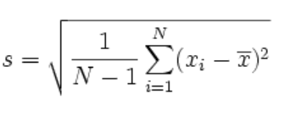

Standard deviation is useful when examining data sets and comparing groups to one another to see if there is a real difference between these groups. In general, statistical tests are considering if the null hypothesis is supported or refuted. A null hypothesis states there is no difference between groups. The alternative hypothesis states there is a difference between the groups. After running your statistical test, if you accept the null, you would conclude there is no difference between the groups. If you reject the null in favor of the alternative hypothesis, you would conclude there is something of biological significance between the groups. After you run these tests, you will find a p-value, or probability value that will help you make the decision of whether to accept or reject the null hypothesis. This p-value tells the person the likelihood that the test is true and the likelihood, by default, that you might be making a mistake in interpreting the data. The most widely accepted p-value is 0.05 which means there is a 5% probability that the data you think are really different due to biological reasons (e.g. there is a real difference between treatment X and Y) is not correct. There is a 5% chance you are wrong with your interpretation, but a 95% chance you are correct in that there is a real difference between these groups. If you run a statistical test and your p-value is 0.05 or less you would reject the null in favor of the alternative hypothesis and conclude there is a real difference between groups of your data.

There are different types of statistical tests to run based on what kind of data you collect. If you are comparing the data between two groups, a **t-test** can be useful. For example, if you are comparing one group that received treatment X to another group that received treatment Y and you wanted to know if the difference you detected between these groups was actually due to the treatment, you could apply a t-test. There are actually three types of t-tests: an independent samples t-test comparing the means for two groups, a paired sample t-test to compares means from the same group at different times (e.g. different months), and a one sample t-test which tests the mean of a single group against a known mean. Often when people say t-test, they often mean the independent samples t-test. Here we find the following formula:

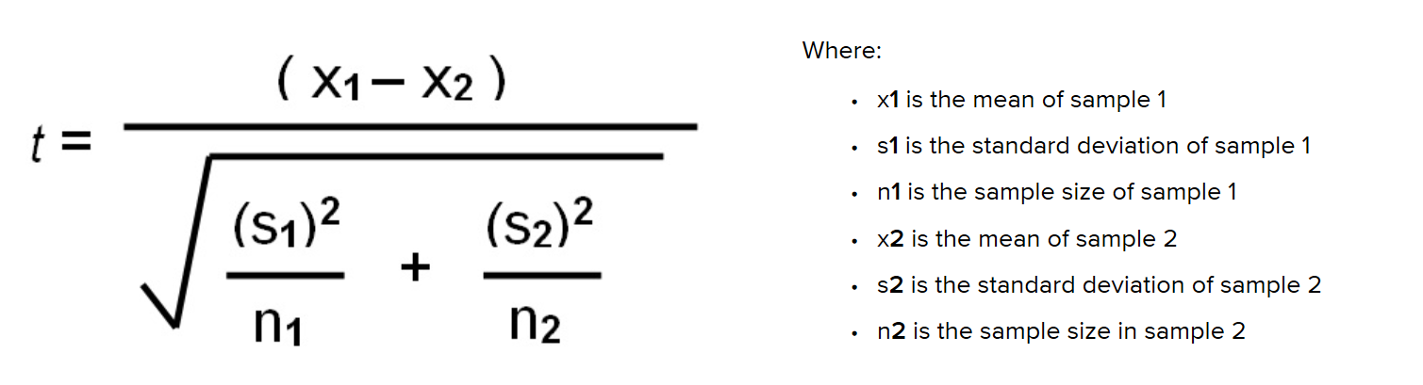

If you are comparing two groups to one another that fall into categories a **X2 test (Chi-square test)** is helpful. Let’s say you have two categories like female and male and you are trying to determine if the differences you see in the means of these groups (e.g. height) is different enough that there is a real biological difference present, you could use a X2 test. Here we find the following formula:

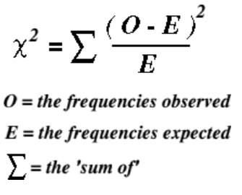

If you have more than two groups, the **ANOVA** test (Analysis of Variance test) can be most helpful. This test has variations to it (just as the t-test does), but a common one is the one-way ANOVA. Here, the means between groups are compared to one another to determine if they are different enough to say there is a real difference between groups. This one-way version of ANOVA is looking at only one independent variable (e.g. fertilizer brand) and is useful when comparing two groups to one another. The two-way ANOVA is more complex and looks at two independent variable (e.g. fertilizer brand and type of plant) and is helpful when looking at one group that you are double-testing. The commonly used ANOVA test formula compares the means (sums of squares) between groups, means (sums of square) within groups, incorporates standard deviation and uses all these data to obtain a F-value. This test statistic, *F*, shows the *MSgroup* or the mean squared error of between-group variance and the  *MSerror*, the mean squared error of within-group variance, and compares it in the following formula:

[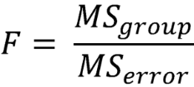](http://sites.utexas.edu/sos/files/2015/07/anova-formula.png)

1. Consider Growth Rate. What is the difference in this parameter compared to RGR? Calculate the means for the different treatments and then calculate the standard deviation.
2. Of the statistical tests discussed above, which would be appropriate to further analyze your data comparing fungi on large petri dishes with medium and large nutrient concentrations on them? If so, do the test and report your results.
3. Consider Pycnidia Count as well as Pycnidia Added. What do you notice about these data? What does that tell you? What might a next question and/or test be to further your understanding of fungi and pycnidia?
4. Examine the Density column, which is in reference to the number of pycnidia per colony area. How can you study the data descriptively? Make the calculations/run the statistical tests and state what these tell you.
5. Consider what you have learned from this study and activity. Summarize the main message in two sentences only. Note that this can be a difficult task – work to get your point concise and be patient with arranging things so the words ultimately have the impact you would like.
6. What are some long-term impacts you can envision based on this study? Explain your logic.
7. What would a next likely question to ask stemming from these results and this study? In other words, what would you like to investigate further? Elaborate.

**Additional Activity/Idea**

Watch the HHMI BioInteractive video “From Ants to Grizzlies: A General Rule for Saving Biodiversity”. It is about 18 minutes long.

While you watch the video, answer the following:

1. As EO Wilson was studying the number of ant species on each island in the South Pacific, what did he find?
2. What observation was seen with reptiles and amphibians on these islands?
3. How could EO Wilson test this “rule of thumb?”
4. Describe the experiment that EO Wilson and his graduate student Simberloff conducted in the Florida Keys.
5. What were the results from this Florida Keys experiment? What was the conclusion?
6. Describe what scientists found when they carved out different sized patches in the Amazon rainforest. What type of species were more negatively affected compared to others and why?
7. Are American national parks large enough in size? Elaborate.
8. Describe some conservation techniques that scientists use to help connect habitats to one another.
9. Based on this video and in your own words, describe what island biogeography theory predicts.
10. How does the fungus research of this module connect with island biogeography theory?

**Answers**

*Predictions*

1. More nutrients should allow for more hyphal growth, fruiting body development, and spore production. Alternatively, more nutrients may favor hyphal growth, and lack of nutrients may trigger spore production (to help move the fungus to a “better” habitat). There are definitely life history tradeoffs in play here that may favor one strategy (bang-bang) over another (bet-hedging)
2. Fungi may disperse differently to different habitats or patches based on distance from point of origin (think island biogeography theory) and size of habitat. If there are already established populations of fungi in a new habitat, the dispersing fungus will have more trouble establishing itself there due to competition and niche availability. In this way, timing needs to be considered as well. How quickly spores can be produced will make a difference for the sooner spores are released, the sooner a fungus might become established in a new habitat, giving it a competitive edge.
3. The independent variables would be the size of the petri dish “islands” as well as the nutrient concentration. The dependent variables would be the growth of the fungus on these “islands” and the fruiting bodies produced.
4. Students will likely predict a positive correlation between nutrient availability and fungal colony density/colony establishment and a positive correlation between pycnidial density and fungal colony density. A line graph with nutrient availability on the X-axis and fungal colony density on the Y-axis would be one figure. A second line graph with fungal colony density on the X-axis and pycnidial density on the Y-axis would be useful. A discussion about dependent and independent variables should occur.
5. The data show that more nutrient availability seems to be related to higher fungal density. The habitat size does not support more fungi as habitat size increases. If you look at the large petri dish islandcompared to the small petri dish environments, they have less fungal density at each treatment when only examining one set of data. When including two replicates, there seems to be no real big difference between habitat size and fungal density. This is a reminder of how important sample size is when examining data and trying to understand patterns.
6. It would be helpful to include all of the replicates from the data set to see if this trend is still upheld. There are 6 replicates and the chart includes only 2 of these. With two replicates examined, it appears that there is no real difference in habitat size and fungal colony size; however, with all the data included in set, would we start to see the island biogeography theory prediction upheld and find more fungi with the larger petri dishes?
7. The control groups are the petri dishes that contain no nutrients and only water. When you look at the fungi’s ability to grow on these dishes, you will notice they are unsuccessful. Nutrients are necessary for fungi to thrive. Control groups are important in general because they allow for comparisons to be made between these “known” outcome controls and the unknown treatment petri dishes. If the control does not behave as expected (e.g. fungi were growing on the water only petri dishes), we could be alerted that there is a problem with the experiment.
8. There are many relationships that would be of interest to students. They may consider graphing nutrient concentration against pycnidia added during days 11 – 20. They could graph growth rate based on petri dish size or nutrient availability, etc.
9. RGR at different sized islands (petri dishes) would be one calculation. RGR with different nutrient concentrations (for resource availability) could be another.
10. You will have different results depending on which treatments you choose to examine. You may want to assign groups of students treatments and then put data on board to share.
11. You could conduct a ANOVA test to examine these relationships. If this is too advanced for your specific student audience, you could also engage in a X2-test.
12. A lot of the results for these two variables are “0”; however, you do start to see pycnidia for the large petri dishes (e.g. L1.1-L1.6). In some cases, these two variables are consistently the same values; however, in some cases you will notice larger numbers of pycnidia count over pycnidia added (since this is in reference to daily counts over the total pycnidia counter overall). Further questions to ask about this relationship might be “why are some petri dish environments condusive to pycnidia production and others are not?” or “is this a relationship between nutrients and pycnidia added?”
13. You can consider island/petri dish size and nutrient availability as it relates to density. You could also compare density to RGR and Colony Size to consider patterns.
14. Students should consider nutrients and petri dish size and how they correlate to fungal success. They could convey this in a variety of ways. They may also want to mention island biogeography theory if it helps strengthen their argument.
15. Since fungi can be beneficial or harmful, students could focus on either aspect. It’s possible this study can help with nutrient cycling if we consider dispersal. It’s possible this can help us understand how to limit the spread of harmful pathogens.
16. Answers will vary here, but having a class discussion after groups contribute their questions would be a good idea.

**References**

Adams, C. 2015. Six bizarre things about fungi. BBC Earth. http://www.bbc.com/earth/story/20150202-six-bizarre-things-about-fungi

Chan, JY, Bonser, SP, Powell JR, and WK Cornwell. 2020. Environmental cues for dispersal in a filamentous fungus in simulated islands. OIKOS 00: 1-9.

Crous, PW, Quaedvlieg W, Hansen K, Hawksworth DL, and JZ Groenewald. 2014. *Phacidium* and *Ceuthospora* (Phacidiaceae) are congeneric: taxonomic and nomenclatural implications. IMA Fungus 5: 173-193.

Dressaire E., Yamada L, Song B, and R Roper. 2016. Mushrooms use convectively created airflows to disperse their spores. Proc Natl Acad Scie 113 (11): 2833-2838.

Glassman SI, Lubekin KC, Chung JA, and TD Bruns. 2017. The theory of island biogeography applies to ectomycorrhizal fungi in subalpine tree “islands” at a fine scale. Ecosphere 8 (2): e01677. https://doi.org/10.1002/ecs2.1677

Hasssett, MO, Fisher, MWF, and NP Money. 2015. Mushrooms as rainmakers: how spores act as nuclei for raindrops. PLoS ONE 10 (10): e0140407. https://doi.org/10.1371/journal.pone.0140407

Main, D. 2013. Mushrooms make wind to spread spores. Scientific American. Found at <https://www.scientificamerican.com/article/mushrooms-make-wind-to-spread-spores/>

Strode, P, and A. Brokaw. 2015. Using BioInteractive Resources to Teach Mathematics and Statistics in Biology. Found at <https://www.biointeractive.org/sites/default/files/media/file/2019-05/Statistics-Teacher-Guide.pdf>

Zimmer, C. 2019. The plague killing frogs everywhere is far worse than scientist thought. The New York Times. Found at <https://www.nytimes.com/2019/03/28/science/frogs-fungus-bd.html>