S-JEDI Learning group resource Appendix

Table of Contents
S-JEDI Learning group resource Appendix
Week 0 - Pre-homework:
Week 1: Introductions
Read the following before meeting
Agenda
Week 2: Language/Awareness of S-JEDI and Social Justice as a Framework
Readings/videos to read/watch in advance
Activities to prepare for meeting:
Agenda
Week 3: S-JEDI within OER
Please read before meeting
Activities to prepare for meeting
Agenda
Week 4: S-JEDI within OEP
Please read/watch the following before meeting
Activities to prepare for meeting
Agenda
Week 5: Analyzing one’s own organization under a critical lens
Please read the following before meeting
Activities to prepare for meeting
Agenda
7/27 - Week 6: What are your next steps?
Activities to prepare for meeting
Agenda

Week 0 - Pre-homework:

Post the following on the forum/shared document:

“This peer learning community will focus on examining social justice, equity, and race/racism in open education resource organizations. This group will be specifically geared to organizational leaders in open education interested in a peer learning community around race, racism, and STEM education.

Ahead of our first meeting, please introduce yourself and include:
- Name
- Organization
- Contact information
- A picture that represents you
- Your answer to the following questions:
- What do you or your organization do currently to address Justice. Equity, Diversity and Inclusion?
- What do you want to gain from this JEDI network?

In preparation for the first meeting, please read: White Academia: Do Better by Jasmine Roberts

We look forward to this opportunity to work with each other!”

Week 1: Introductions

Read the following before meeting
- White Academia: Do Better by Jasmine Roberts

Agenda
- (10 min) Welcome and Ground in, explain why this group came to be
- (10 min) Introductions - each participant shares in one or two sentences why they are here
- (5 min) Explain administrative details: community notes, assign weekly reflection
- (20 min) Set community agreements for discourse:
  - We are all collaborating on this agreement/agree on a set of principles for discourse.
  - What tends to happen in these types of discussions...P word, privilege seems to be a particular place where we get defensive.
  - We’ve been socialized into being comfortable with this inequity, and undoing that comfort will feel (and should feel) uncomfortable. Share diagram on becoming an anti-racist and discuss. (Will revisit the norms discussion next discussion)

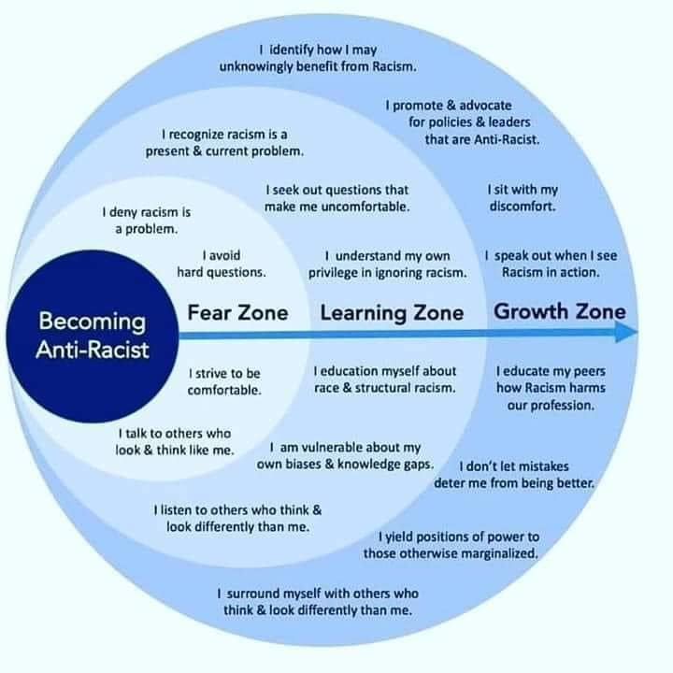

- (10 min) Discuss reading - Reflection Questions:
  - In what ways did this article resonate with what you know or what did you learn?
  - Although the article was related to the academy, how can the suggestions be applied to your organization, relative to where your organization is on its journey?
- (5 min) Wrap up, set tasks for next time

Week 2: Language/Awareness of S-JEDI and Social Justice as a Framework

Readings/videos to read/watch in advance
- Leading Courageous Conversations on Race Equity
- Anti-Racism Defined - Alberta Civil Liberties Research Centre
- Understanding Structural Racism - Luiza Lodder (video)
- Re-envisioning Diversity in High Education: From Raising Awareness to Building Critical Consciousness Among Faculty - Dana M. Stachowiak
- Read #BlackInTheIvory on Twitter

Activities to prepare for meeting:
- Reflect on your current definitions of social justice, equity, diversity and inclusion and write out your own definition to share with the group
- Consider the meanings and implications of the follow images
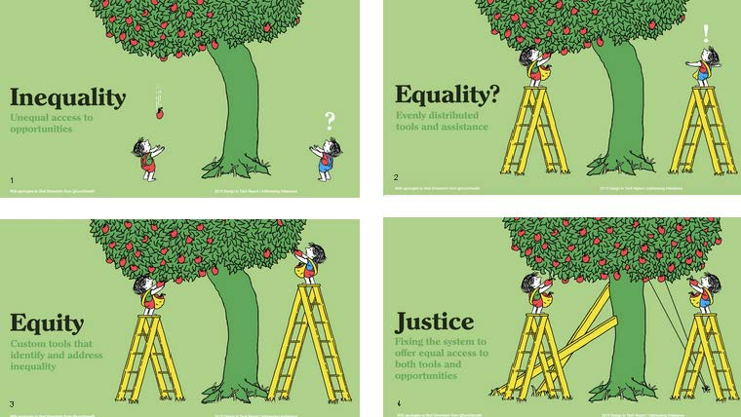

Agenda
- (5 min) Check in and assign individuals to write the week’s reflection
- (15 min) Discuss community discourse agreement
  - In particular, how much space you take up in discussion relative to your privilege and & how to handle mistakes.
  - Discuss the role of facilitators - discuss managing conversations (not just about participant conduct, but also moderator conduct). Ask, does anyone have a preference for how they receive criticism.
- (10 min) Debrief from last week’s reading/things you have been thinking about after last week’s discussion.
- (5 min) Share S-JEDI definitions
- (20 min) Share and discuss what enacting S-JEDI principles/being anti-racist might mean for your organization.

Week 3: S-JEDI within OER

Please read before meeting
- Open to What? A Critical Evaluation of OER Efficacy Studies
- UDL on Campus - Universal Design for Learning in High Education
- Changing our (Dis)Course: A Distinctive Social Justice Aligned Definition of Open Education
- Textbook Broke: Textbook Affordability as a Social Justice Issue

Activities to prepare for meeting
- For each framework, where are you as an organization? Complete a self-assessment and be ready to share a sentence for each framework.
  - Critical Pedagogy criteria - Cost and action, pedagogical practice, and academic labor
  - UDL Connection - Multiple means of engagement, action and expression, representation
  - Social Justice OER - Redistributive Justice, restorative justice, representational justice

Agenda
- (5 min) Check-in and assign individuals to write a short reflection
- (10 min) Debrief from last week’s reading/things you have been thinking about after last week’s discussion.
- (15 min) Self-assessment share
- (15 min) Breakout rooms - pick one of the items and talk about what you could work on and how.
- (15 min) Share out to larger group and discussion

Week 4: S-JEDI within OEP

Please read/watch the following before meeting
- Embracing Open Pedagogy
- Whose Knowledge is Reliable? - Siko Bouterse Part of OpenCon 2017's Diversity, Equity and Inclusion in Open Research and Open Education panel.
- Open Pedagogy Notebook
- Academia isn’t a Safe Haven

Activities to prepare for meeting
- Review the three definitions of redistributive, recognative, representational. Audit your current organization in terms of these three aspects, and be ready to share (this is part of an activity from last week that we didn’t quite finish).
- What parts of open pedagogy does your organization already support?

Agenda
- (5 min) Check in and assign individuals to write a short reflection
- (20 min) Revisit the three social justice definitions: redistributive, recognative, representational. What questions do you still have about this framework/definitions? Finish discussion about these particular aspects and reflection after last week’s discussion.
- (20 min) What questions do you have about open pedagogy, particularly as it relates to social justice?
- (10 min) As a result of the readings last week on social justice and the readings this week on open pedagogy, what one action might you take in your organization or classroom? For example, what policy change could you implement and how does that relate to a social justice framework?
- (5 min) Other resources to share related to your world/sphere?

Week 5: Analyzing one’s own organization under a critical lens

Please read the following before meeting
- Why So Many Organizations Stay White - Victor Ray
- What Black scientists want from colleagues and their institutions - Virginia Gewin
- Reprise - White Academia: Do Better - Jasmine Roberts

Activities to prepare for meeting
- Reflect: What organizations are you affiliated with? What is your sphere of influence and what agency do you have in this to make changes within each organization? Which reading/video over the last several weeks was particularly influential or provided meaningful ideas for your particular organization?
- Engage someone else or a group in your organization (who are the key people?) in those reading/ideas. Be ready to share back with the group one insight from the reading that applies to your organization. (And if you don’t have this space to discuss yet, can you create this space?)

Agenda
- (5 min) Check-in and assign individuals to write a short reflection
- (20 min) Homework share: Which organization did you pick to do this exercise? What space do you have or are you creating to share these ideas? What did you talk about in your organization(s)?
- (15 min) Reflecting on the readings for this week, what challenges did you recognize for your organization and what opportunities do you see for change?
- (15 min) What is the mission of your organization? What policy change could you implement, how does that relate to a social justice framework, and how does that relate to the mission of your organization?
- (5 min) Other resources to share related to your world/sphere? For next week - think about what your organization's pledge might be - perhaps even part of a broader statement/pledge.

7/27 - Week 6: What are your next steps?

Please note that this week there are no readings and only activities, which will take advance time to discuss and prepare.

Activities to prepare for meeting
- The SCORE mission statement is below. Analyze this mission statement. Critique it. What action plans could be added to this? Be prepared to discuss this.

“The mission of the SCORE-UBE Network is to help our Network participants achieve their sustainability and broader impact goals by working together to amplify the value and reach of open education in STEM and to align our resources and practices with the principles of anti-racism, equity, social justice, and inclusion. In particular, we see open education as an approach and mindset to transform teaching and learning to center the needs of underrepresented and marginalized learners and instructors who have been systematically excluded from the benefits of traditional educational systems.”

- During our last discussion we discussed policy changes you could implement, how they relate to a social justice framework, and how a social justice framework relates to the mission of your organization.
  - Bring this conversation back to your organization and discuss action items for you and your group to move social justice forward within your organization.
  - Draft an organizational pledge statement to share with this group (or depending on where your organization is in the process, this could be a personal pledge statement, a personal action plan, an organizational action plan, etc).

Agenda
- (5 min) Check-in and assign individuals to write a short reflection
- (15 min) Discuss the SCORE mission statements.
- (20 min) Share your draft organizational S-JEDI pledge with the rest of the group.
- (15 min) What are the next steps moving forward for your organization with respect to S-JEDI. How can SCORE support this work moving forward?
- (5 min) Wrap up - What are you most excited about from this reading/learning group moving forward?

