Accession Number Exercise

Learning Goals:

- Become familiar with searching using accession numbers.
- Become familiar with the information present in the NCBI protein databases.

Go to the NCBI website at www.ncbi.nlm.nih.gov

In the dropdown menu, next to the NCBI logo, select protein.

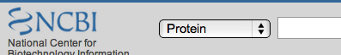

In the search bar enter your accession number.

You will be directed to a new page with a flat file with a header that looks something like this:

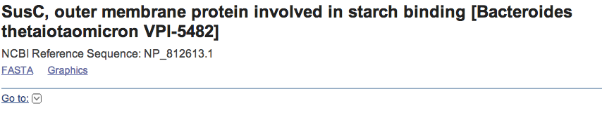

Explore the file to answer the questions below.

- How long is your protein? 646 amino acids
- What is the academic citation (Title, Journal and Authors) associated with this sequence?
Tisza,M., Buck,C., Pastrana,D., Welch,N. and Peretti,A.
Uncovering a Universe of Circular DNA Viruses in Animal Metagenomes, Unpublished

- Can you identify any conserved domains? (Hint: see the options on the right-hand side of the page under ‘Analyze this sequence’)
a family of phage capsid proteins
- Can you view the co-ordinates of the conserved domains with reference to the entire sequence? (Hint: click the ‘Graphics’ options under the protein name)
- What other information can you glean from this page that might be useful?
organism, taxonomy

