Overview of Activity
In this activity students will use linear regression to analyze real data on vector-borne diseases and explore how environmental factors such as climate change or population density influence the transmission of these diseases. The activities are designed for face-to-face instruction and may be adapted for an online classroom.

Learning Outcomes
MathLearning Objectives
- Perform data organization and analysis to produce descriptive statistics.
- Explain the relationship between two variables.
- Use technology to assist in the solution of both abstract and contextual problems.
Biology Learning Objectives
- Investigate the relationship between two variables using graphical and statistical methods (specifically linear regression).
- Assess limitations of the data set and data analysis methods.
- Discuss the human health and environmental implications based on the data.

Instructions for Opening Activity
- Provide students with the Opening Activity document. Have students independently read the Background information (on the first page) and then work in pairs to complete the Introduction Questions. (10 minutes) Note that to save time in class, you can provide this document the day before and ask students to read it and be ready to discuss it the next day.
- Discuss the solutions to the Introduction Questions as a class. (5 minutes)
- Provide students with the Student Guide for Statistics document. Complete the Graphing and Data analysis questions as a class using the Student Guide for Statistics. (20 minutes)
- Have students complete the Conclusion Questions in pairs. (5 minutes)
- Discuss the solutions as a class. (5 minutes)

Instructions for Student Activity
- Students should be divided into 6 or more groups of 2 to 3 students.
- Each group will receive one of the temperature/disease or rainfall/disease activities.
- Groups complete the activity using the Opening Activity and Student Guide for Statistics documents to guide them. (20 minutes)
- Pair up the groups with the same disease. Ask each of the new (larger) groups to compile a list of similarities and differences between rainfall and temperature based on their findings from their activities. (5 minutes)
- Have a class discussion on the similarities and differences between the diseases. Identify which group had the strongest linear relationship. Discuss the conclusion questions from each of the activities. (10 minutes)

BIOLOGY BACKGROUND
Vector-borne diseases are illnesses caused by parasites, bacteria, and viruses that are spread by other organisms such as blood-sucking insects. The insects that spread the disease are referred to as vectors. Vector-borne diseases such as malaria, Lyme disease, dengue, yellow fever, West Nile, and Zika tend to be more burdensome in tropical regions. It is in these regions where we often find poverty-stricken communities most heavily affected by vector-borne disease. Identifying the mode of transmission, the way a pathogen travels from a source to its host, helps to understand disease spread. Zoonotic diseases are vector-borne illnesses that can be specifically transferred to humans from other animals. Rabies, SARS, and swine flu have been transmitted to humans from other mammals, and are considered to be zoonotic. Aside from the obvious public health impacts, these diseases can also heavily impact the economy and environment of a given area by impacting animal products and food web relationships of species that are infected.

Deer Ticks and Lyme Disease
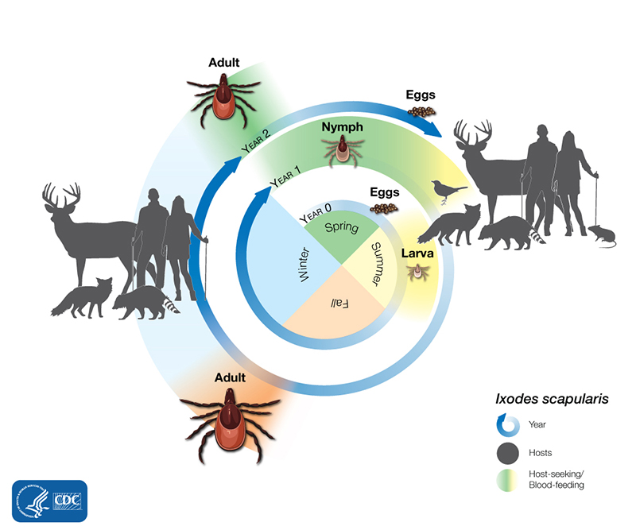
Lyme disease is a zoonotic illness that is transmitted by multiple species of ticks in the genus Ixodes in both Europe and North America. Ticks are arthropods in the class Arachnida along with spiders, scorpions, and mites. These eight-legged parasites will go through a number of stages in their life cycle, and require the blood of other organisms to complete each stage. Ticks of all sizes and life stages will use their piercing mouthparts to penetrate the skin of vertebrates to obtain the blood they need, sometimes engorging themselves and expanding their abdomens 2-3 times, then dropping off when sufficiently full after 3-5 days (Drummond 2004). This vampiric behavior thus contributes to the transmission of zoonotic diseases to humans that are bitten.

In the eastern United States, the deer tick (Ixodes scapularis) is the most prominent vector of Lyme disease. They are most active from spring through the fall, and can be found throughout the eastern states, with the most cases of Lyme occurring in the northeast US where human populations are densest (CDC 2019). They go dormant in the winter, but are capable of withstanding fairly cold temperatures; they are usually some of the first invertebrates to awaken in the spring and the last to go into winter dormancy. They do live up to their namesake and feed on deer blood, but will also attach to smaller mammals, birds, reptiles, and of course, humans (Drummond 2004). The deer tick has a simple 2-year life cycle during which it will go through three stages (larva, nymph, and adult), requiring blood at each stage (Drummond 2004). Adult ticks will spend one season accumulating blood, then overwinter. The following year, females will proceed to lay hundreds of eggs that hatch in the same year. The larvae take a full year to reach the nymph stage, and another year to reach the adult stage.

Lyme disease itself is caused by a bacterium in the genus Borrelia. Interestingly, the ticks do not acquire the bacterium from deer, but from rodents, another prominent host for the tick.Ticks can acquire Borrelia from these host animals and subsequently transmit the bacteria to humans through a tick bite (CDC 2019). Within the first month of infection, a person may develop initial symptoms of Lyme disease such as fatigue, headache, fever, joint pain, and a bullseye skin rash (CDC 2019). Without treatment, Lyme disease may progress with more serious consequences for the cardiovascular, skeletal, and nervous systems (CDC 2019).

Like many other invertebrates, tick populations are generally controlled by climate and seasonal changes. As fall turns into winter and temperatures drop, many ticks either die or go into dormancy. This is a form of natural control that keeps the ticks populations from growing exponentially. Recent research suggests that phenological spring is arriving earlier over the past few decades, and that the fall season is lasting longer and longer. As the active season for the ticks lengthens, and as the winter season begins to mellow, more ticks survive and thus have more chances to pass Borrelia to humans (Brownstein et al 2005). In this way, climate change poses a public health threat by increasing the active period of Lyme disease.

Mosquitoes and Malaria
There are numerous species of mosquito found throughout the warmer regions of the world, many of which carry zoonotic diseases that are transferred to humans, but perhaps none have been more widespread and impactful than that of Malaria on the African continent. Carried and transmitted by members of the genus Anopheles, malaria is caused by single-celled parasites in the Plasmodium group.

A mosquito may ingest the Plasmodium parasites during a blood meal. Inside the mosquito, the parasites mate and reproduce before the offspring are introduced to another person. After Plasmodium is introduced to the blood of a person, the parasites travel through the bloodstream to reach the liver. The parasite reproduces inside of the liver cells and then infects the red blood cells. After more cycles of reproduction inside of the red blood cells, the parasites lyse the red blood cells and escape into the bloodstream where they are able to infect even more red blood cells. It is the infection and destruction of the red blood cells that contributes to many of the harmful symptoms of malaria.

Once a person is infected with a Plasmodium parasite, they may experience symptoms such as joint pain, headache, vomiting, and fever. The fever may be accompanied by waves of cold/shivering and hot/sweating, depending on the type of Plasmodium that is causing the infection. Some individuals experience mild symptoms of malaria, but others can experience serious symptoms. In serious cases of malaria, severe anemia, neurological malfunctions, and multiple organ failure may lead to death. After months or years without symptoms, a person may experience recurring symptoms as the result of a relapse. A relapse occurs after dormant parasites reactivate and begin a new cycle of infection. Alternatively, a person may be reinfected with malaria after another encounter with an Anopheles mosquito.
Anopheles mosquitoes are quick and prolific breeders wherever there is a standing water source. Females lay up to 200 eggs at one time in the water that quickly hatch into larvae, and pupate before turning into an adult. The metamorphosis process takes roughly 1-2 weeks depending on the region. As adults, male mosquitoes only live for about a week, feeding only on nectar (making them important pollinators) and seeking females with which to mate. Females also dine on natural sugars, but require a blood meal to produce eggs. After they feed, they lay one set of eggs, then repeat the mating/feeding/egg-laying process until the end of her lifespan, which could last a few weeks. It is during the feeding process that malaria can be passed to humans. While temperate areas usually have seasonal changes that control the population growth of mosquitoes, tropical areas that remain warm for most of the year also have mosquitoes that are active year-round, which allows for mosquito-borne diseases like malaria to become more of a public health issue for human populations in those areas.

For as big of a problem that malaria is in some parts of the world, there are a few environmental factors that could perhaps make these effects more severe and increase the prevalence of malaria and other mosquito-borne diseases worldwide. While mostly being associated with temperature fluctuations, large-scale events like climate change can also impact precipitation patterns. As surface temperatures increase in certain areas across the globe, so do evaporation rates and the water-holding capacity of the atmosphere, leading to increases in atmospheric moisture (Trenberth 1998). This could heavily impact the water cycle by influencing both the amount and frequency of precipitation, and perhaps contribute to the creation of powerful storms in the process (Trenberth 1998). As the number of rain events becomes more intense and the amount and duration of moisture and standing water increases, mosquitoes have more of an opportunity to breed and increase their already rapidly growing numbers. In turn, there is more of a chance that diseases like malaria, Zika, and others could become more prevalent, especially in the tropics where storms and sea-level rise are the most severe.
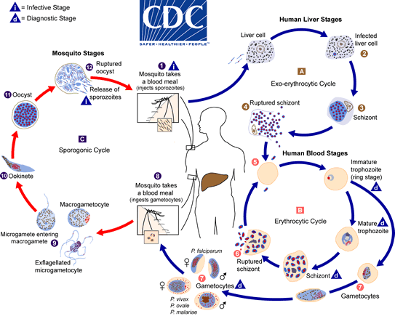

Mosquitoes and La Crosse Virus
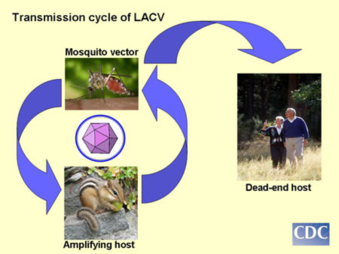
https://www.cdc.gov/lac/tech/transmission.html

Note that for La Crosse Virus, humans are dead-end hosts, meaning a mosquito can transmit this virus to a human, but that human cannot transmit this virus to other humans or mosquitoes.
Mosquitoes can transmit this virus to other mosquitoes, and small mammals can transmit this disease to mosquitoes.

Life cycles for Ae. aegypti and Ae. albopictus mosquitoes
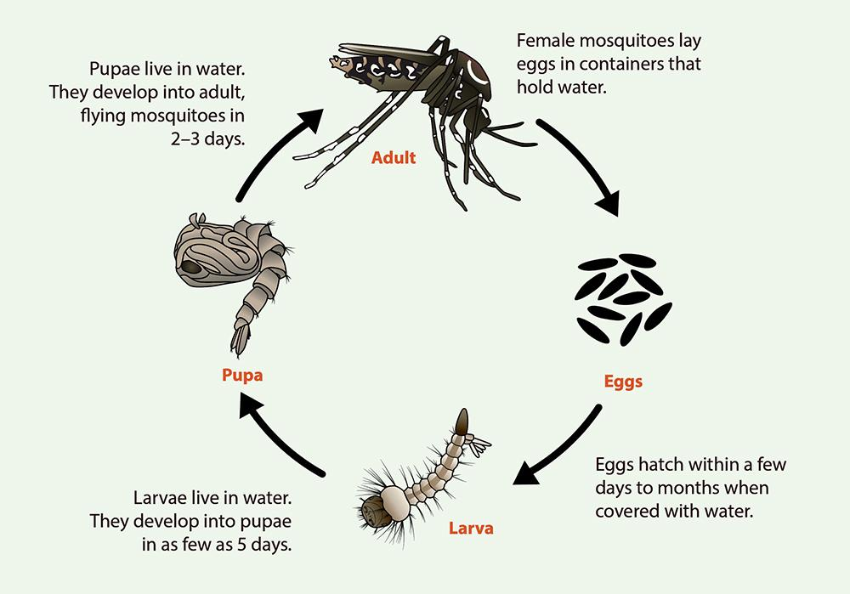
https://www.cdc.gov/mosquitoes/about/life-cycles/aedes.html

Resources:

Brownstein, J.S., Holford, T.R. & Fish, D. 2005. Effect of Climate Change on Lyme Disease Risk in North America. EcoHealth 2: 38–46. https://doi.org/10.1007/s10393-004-0139-x
Center for Disease Control. Lyme Disease: What you need to know. (15 August 2019). Retrieved July 6, 2020, from https://www.cdc.gov/lyme/resources/brochure/lymediseasebrochure-P.pdf
Drummond, R. 2004. Ticks and What You Can Do About Them. Wilderness Press.
Trenberth, K.E. 1998. Atmospheric Moisture Residence Times and Cycling: Implications for Rainfall Rates and Climate Change. Climatic Change 39: 667–694. https://doi.org/10.1023/A:1005319109110

Co-Authors (Alphabetical): Andy Adams, Jessica Adams, John Bray, Tami Imbierowicz, Suzanne Lenhart, Breonna Martin. All co-authors contributed equally. This material is based upon work supported by the National Science Foundation under Grant No. 1919613. Any opinions, findings, and conclusions or recommendations expressed in this material are those of the author(s) and do not necessarily reflect the views of the National Science Foundation.

