Opening Activity

Introduction Questions
- Describe the mode of transmission for Lyme disease.
Lyme disease is transmitted to humans by a tick that is infected with the bacteria Borrelia. The tick would have likely acquired the bacteria from a bird or small mammal.
Summary process:
Small mammal (reservoir) → tick (vector) → human
- Describe the habitat and optimal environmental conditions for the vector that carries Lyme disease.
The tick (vector) requires humid environments with ample vegetation. The vegetation helps to protect them from the sun.
- Describe environmental conditions that could contribute to transmission of Lyme disease to humans. Explain your reasoning.
Humidity - helps ticks survive in hot climates, and prevents them from drying out.
Shade from vegetation - helps protect them from the sun
Warm temperatures - encourages activity of their prey
- Before viewing the data below, come up with a hypothesis regarding the relationship between Lyme disease occurrence and temperature. Explain your reasoning.
Examples:
Increases in temperature cause increases in Lyme disease occurrence because of increased outdoor host (human) activity.
Increases in temperature cause increases in Lyme disease occurrence because of increased vector (tick) survival.

Graphing and Data Analysis
Table 1. Historical data on temperature and Lyme disease cases in Baltimore, MD. https://www.cdc.gov/lyme/stats/maps.html
Month | Average High Temp (F)  Baltimore, MD | Lyme Disease Cases
January | 41.2 | 3
February | 44.8 | 2
March | 53.9 | 2
April | 64.5 | 4
May | 73.9 | 5
June | 82.7 | 15
July | 87.2 | 22
August | 85.1 | 13
September | 78.2 | 6
October | 67.0 | 5
November | 56.3 | 4
December | 46.0 | 1

- You will create a scatter plot for the data above. Before doing so, answer the following questions.
  - What is the dependent variable in this data set? Lyme disease cases
  - What is the independent variable? Temperature
  - What variable will you use on the X-axis? Temperature
  - What variable will you use on the y-axis? Lyme Disease cases
- After discussing your responses for the question above, make a scatterplot of the data. Describe the relationship between the data.
Strong, positive linear relationship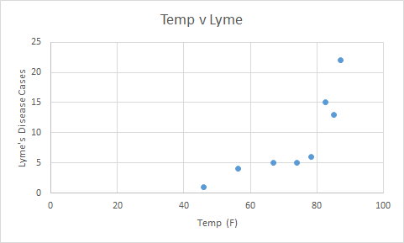

- Calculate the correlation coefficient.
r = 0.8177
- What does the value of the correlation coefficient suggest about the relationship between these two variables? Discuss the strength and direction of the correlation.
There is a strong, linear relationship between the variables. As the temperature increases, there is an increase in the number of Lymes disease cases.
- Calculate the line of best fit.
y = 0.401x - 19.364 or Lyme disease cases = 0.401(temperature) - 19.364
- Interpret the slope from the model.
For every degree in Fahrenheit increase, there is a 0.401 increase in Lyme disease cases. (Or) For every 10 °F increase in temperature, there is a 4.01 increase in Lyme’s disease cases.
- Is it possible to interpret the y intercept from the model? Why or why not?
No, there cannot be a negative number of Lyme disease cases
- How many Lyme disease cases should there be if the temperature is 91.2? Is this an example of extrapolation or interpolation?
y = 0.401(91.2) - 19.362
Lyme disease cases = 17.2 cases
This is an example of extrapolation
- What should the temperature be if there are 10 cases of Lyme disease?
10 = 0.401x - 19.362, x = 73.2 °F
- What is the residual of the cases of Lyme disease in August?
Observed = 13
Predicted = 0.401(85.1) - 19.32 = 14.8
Residual = observed - predicted = 13 - 14.8 = -1.8 cases

Conclusion Questions
- Does the data appear to support your hypothesis? Explain your reasoning
Yes, as the temperature increased, so did the number of Lyme disease cases
- Are there any other environmental factors that could influence Lyme disease occurrence? List them and describe how.
Yes, for example:
Rainfall - decreased rainfall may affect the survival of the reservoir animals. A decrease in reservoir animals would likely decrease transmission of Lyme disease.
Humidity - Ticks are less likely to survive in dry climates, so Lyme disease transmission is likely to decrease in dry climates
- How could climate change influence the habitat or location of the ticks (and, thus, the occurrence of Lyme disease)?
Changes in regional temperatures could cause the range of the ticks to expand. This expansion could lead to an increase in Lyme disease cases.
- There are many other human health issues that could be exacerbated by climate change. Provide an example.
Other vector-borne diseases such as malaria, west nile virus, leishmaniasis, etc. could increase as a result of climate change.

Malaria and temperature

Introduction Questions
- Describe the mode of transmission for Malaria to humans.
Mosquitoes can transmit the Plasmodium parasite to humans through a mosquito bite
- Describe the habitat and optimal environmental conditions for the vector that carries Malaria.
The Anopheles mosquito thrives in warm or hot weather with sufficient rainfall.
- Describe environmental conditions that could contribute to the transmission of Malaria to humans. Explain your reasoning.
Warm and wet weather conditions could increase Anopheles mosquito populations and could contribute to the transmission of Malaria.
Additionally, any environmental conditions that would encourage outdoor human activity where Anopheles mosquito populations exist could contribute to the transmission of Malaria to humans.
- Before viewing the data below, come up with a hypothesis regarding the relationship between the occurrence of Malaria and temperature. Explain your reasoning.
An example: Increasing temperatures cause an increase in malaria cases because the increased temperatures support Anopheles mosquito survival and reproduction.

Graphing and Data Analysis
- You will create a scatter plot for the data above. Before doing so, answer the following questions.
  - What is the dependent variable in this data set? Malaria cases
  - What is the independent variable? Temperature
  - What variable will you use on the X-axis? Temperature
  - What variable will you use on the Y-axis? Malaria cases
- After discussing your responses for the question above, make a scatterplot of the data. Describe the relationship between the data.

Strong negative linear relationship
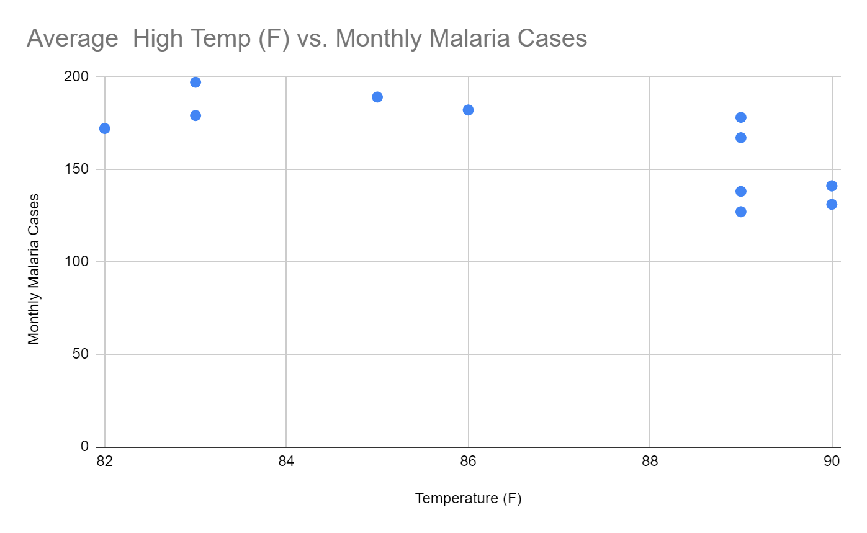
- Calculate the correlation coefficient.
r = -0.749
- What does the value of the correlation coefficient suggest about the relationship between these two variables? Discuss the strength and direction of the correlation.
The correlation of -0.74945 suggests that the relationship between temperature and Malaria cases is strong and negative. As the temperature increases, the number of Malaria cases decreases.
- Calculate the line of best fit.
Y = 682.12 - 5.975(x) or Malaria Cases = 682.12 - 5.975 (Temperature)
- Interpret the slope from the model.
For every 1 °F the temperature increases, the monthly Malaria cases decreases by 5.975 cases.
- Is it possible to interpret the y intercept from the model? Why or why not?
For this example, it is not meaningful to interpret the y-intercept. In this case, the y-intercept (0,682.12), there are 682 cases of Malaria when the temperature is 0 °F.

- How many Malaria cases should there be if the temperature is 87.6? Is this an example of extrapolation or interpolation?
y = 682.12 - 5.975(87.6)
Malaria cases = 158.71
This is an example of interpolation
- What should the temperature be if there are 150 cases of Malaria?
150 = 682.12 - 5.975(x)
If temperature is X, then Temperature = 89.06°F
- What is the residual of the cases of Malaria in August?
Observed cases in August = 172 cases
Predicted cases in August = 682.12 - 5.975(82) = 192.17
Residual = observed - predicted = 172 - 192.17 = -20.17

Conclusion Questions
- Does the data appear to support your hypothesis? Explain your reasoning
No, these data do not appear to support the initial hypothesis. These data display a negative linear trend where the number of malaria cases decrease as the temperature increases.
- Are there any other environmental factors that could influence the occurrence of Malaria? List them and describe how.
Yes, anything in the environment that could cause an increase or decrease in the mosquito population such as predators, a disease, or weather patterns affecting the mosquitoes could influence the occurrence of malaria.
- How could climate change influence the life stages (development) and habitat of the mosquitos (and, thus, the occurrence of Malaria)?
According to the trend in this data set, climate change would have an overall decrease on the occurrence of Malaria. However, this data set is limited and it would be useful to investigate multiple large data sets to better understand the potential impact of climate change on Malaria.
In general, changes in regional temperatures could cause a shift in the range of the mosquitoes. If the range exposes the mosquitoes to more humans, this could lead to an increase in cases of Malaria. .
- There are many other human health issues that could be exacerbated by climate change. Provide an example.
Other vector-borne diseases such as malaria, west nile virus, leishmaniasis, etc. could increase as a result of climate change.

Malaria and Precipitation

Introduction Questions
- Describe the mode of transmission for Malaria to humans.
Mosquitoes can transmit the Plasmodium parasite to humans through a mosquito bite
- Describe the habitat and optimal environmental conditions for the vector that carries Malaria.
The Anopheles mosquito thrives in warm or hot weather with sufficient rainfall.
- Describe environmental conditions that could contribute to the transmission of Malaria to humans. Explain your reasoning.
Warm and wet weather conditions could increase Anopheles mosquito populations and could contribute to the transmission of Malaria.
Additionally, any environmental conditions that would encourage outdoor human activity where Anopheles mosquito populations exist could contribute to the transmission of Malaria to humans.
- Before viewing the data below, come up with a hypothesis regarding the relationship between the occurrence of Malaria and rainfall. Explain your reasoning.
An example: Increasing rainfall cause an increase in malaria cases because the increased rainfall support Anopheles mosquito survival and reproduction.

Graphing and Data Analysis
- You will create a scatter plot for the data above. Before doing so, answer the following questions.
  - What is the dependent variable in this data set? Malaria cases
  - What is the independent variable? Rainfall
  - What variable will you use on the X-axis? Rainfall
  - What variable will you use on the Y-axis? Malaria cases
- After discussing your responses for the question above, make a scatterplot of the data. Describe the relationship between the data.
Strong, positive linear relationship
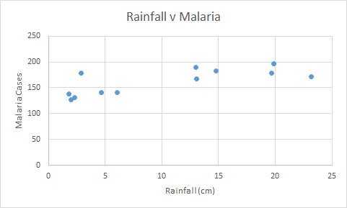
- Calculate the correlation coefficient.
r = 0.760
- What does the value of the correlation coefficient suggest about the relationship between these two variables? Discuss the strength and direction of the correlation.
There is a strong, positive linear relationship. As the rainfall increases, there is an increase in Malaria cases.
- Calculate the line of best fit.
y = 141.402 + 2.136x or Malaria cases = 141.402 + 2.136(rainfall)
- Interpret the slope from the model.
For every 1 cm in rainfall, there is a 2.136 increase in Malaria cases
- Is it possible to interpret the y intercept from the model? Why or why not?
Yes, because the y intercept is positive. It suggests that even at 0 cm of rainfall, there would still be a baseline of 141 cases of malaria.
- How many Malaria cases should there be if the monthly rainfall is 20 cm? Is this an example of extrapolation or interpolation?
y = 141.402 + 2.136 (20)
Malaria cases = 184.12
This is an example of interpolation
- What should the amount of rainfall be if there are 175 cases of Malaria?
175 = 141.402 + 2.136(x)
If temperature is X, then Temperature = 89.06°F
- What is the residual of the cases of Malaria in August?
Observed cases in August = 172 cases
Predicted cases in August = 141.402 + 2.136(23.2) = 190.957
Residual = observed - predicted = 172 - 190.957 = -19 cases

Conclusion Questions
- Does the data appear to support your hypothesis? Explain your reasoning
Yes, these data appear to support the initial hypothesis. These data display a positive linear trend where the number of malaria cases increases as the temperature increases.
- Are there any other environmental factors that could influence the occurrence of Malaria? List them and describe how.
Yes, anything in the environment that could cause an increase or decrease in the mosquito population such as predators, a disease, or weather patterns affecting the mosquitoes could influence the occurrence of malaria.
- How could climate change influence the life stages (development) and habitat of the mosquitos (and, thus, the occurrence of Malaria)?
In general, changes increases in atmospheric moisture and precipitation events could support increasing mosquito populations. This could lead to an increase in Malaria cases, if the mosquito populations grow in regions where humans are present.
- There are many other human health issues that could be exacerbated by climate change. Provide an example.
Other vector-borne diseases such as malaria, west nile virus, leishmaniasis, etc. could increase as a result of climate change.

Zika and Temperature

Introduction Questions
- Describe the mode of Zika virus transmission to humans.
The virus is transmitted through a Aedes mosquito bite
- Describe the habitat and optimal environmental conditions for the vector that carries Zika virus.
Mosquitoes thrive in warm/hot and moist environments
- Describe environmental conditions that could contribute to the transmission of Zika virus. Explain your reasoning.
Environments with sufficient rainfall and temperatures that allow mosquitoes to reproduce successfully would contribute to the transmission of Zika virus.
- Before viewing the data below, come up with a hypothesis regarding the relationship between the occurrence of Zika virus and temperature. Explain your reasoning.
As temperature increases, Zika virus occurrence will also increase because the Aedes mosquitoes will be able to reproduce and thrive more.

Graphing and Data Analysis
- You will create a scatter plot for the data above. Before doing so, answer the following questions.
  - What is the dependent variable in this data set? The rate of Zika cases in the population
  - What is the independent variable? temperature
  - What variable will you use on the X-axis? temperature
  - What variable will you use on the Y-axis? The rate of Zika cases
- After discussing your responses for the question above, make a scatterplot of the data. Describe the relationship between the data.
There is a moderately positive linear correlation between temperature and Zika virus rate in a country’s population.
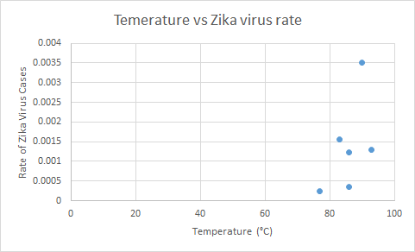
- Calculate the correlation coefficient.
r = 0.535
- What does the value of the correlation coefficient suggest about the relationship between these two variables? Discuss the strength and direction of the correlation.
This is a positive correlation. Therefore, as temperature increases, Zika virus rate also increases. The correlation is moderate.
- Calculate the line of best fit.
y = 0.000114x - 0.00839 or The rate of Zika = 0.000114(temperature) - 0.00839
- Interpret the slope from the model.
For each degree Celsius of temperature increase, the rate of Zika increases by 0.000114 or 0.0114% of the population.
- Is it possible to interpret the y intercept from the model? Why or why not?
No, because there cannot be a negative rate of Zika virus cases in the population.
- What should the rate of Zika cases be if the temperature is 95℃? Is this an example of extrapolation or interpolation?
y = 0.000114(95) - 0.00839 = 0.00244.
The rate of Zika cases = 0.00244 or 0.244% of the population
This is an example of extrapolation
- What should the temperature be if there are 10,000 cases of Zika virus in a country with a population of 6 million people?
If the rate = 10,000/ 6,000,000 = 0.00167. Then, x = (0.00167 + 0.00839)/0.000114 = 88.2 So, the temperature might be 88.2 ℃ .
- What is the residual of the cases of Zika in Guatemala?
Observed = 0.000251 = 0.0251% of the population
Predicted = y = 0.000114 * 77 - 0.00839 = 0.000388 = 0.0388% of the population
Residual = observed - predicted = 0.000251 - 0.000388 = -0.000137 = -0.0137% of the population

Conclusion Questions
- Does the data appear to support your hypothesis? Explain your reasoning.
Yes, the data appears to support the hypothesis. As the temperature increases, the rate of Zika virus in the population also increases.
- Are there any other environmental factors that could influence the occurrence of Zika? List them and describe how.
Yes, anything in the environment that could cause an increase or decrease in the mosquito population such as predators, a disease, humidity, rainfall, or other factors affecting the mosquitoes could influence the occurrence of Zika.
- How could climate change influence the life stages (development) and habitat of the mosquitos (and, thus, the occurrence of Zika)?
Changes in climate, especially increasing temperatures in adjacent regions could expand the range of the mosquitos and cause an increase in Zika virus.
- There are many other human health issues that could be exacerbated by climate change. Provide an example.
Other vector-borne diseases such as malaria, west nile virus, leishmaniasis, etc could increase as a result of climate change.

Zika and Precipitation

Introduction Questions
- Describe the mode of Zika virus transmission to humans.
The virus is transmitted through a Aedes mosquito bite
- Describe the habitat and optimal environmental conditions for the vector that carries Zika virus.
Mosquitoes thrive in warm/hot and moist environments
- Describe environmental conditions that could contribute to the transmission of Zika virus. Explain your reasoning.
Environments with sufficient rainfall and temperatures that allow mosquitoes to reproduce successfully would contribute to the transmission of Zika virus.
- Before viewing the data below, come up with a hypothesis regarding the relationship between the occurrence of Zika virus and rainfall. Explain your reasoning.
As rainfall increases, Zika virus occurrence will also increase because the Aedes mosquitoes will be able to reproduce and thrive more.

Graphing and Data Analysis
- You will create a scatter plot for the data above. Before doing so, answer the following questions.
  - What is the dependent variable in this data set? The rate of Zika cases in the population
  - What is the independent variable? Rainfall
  - What variable will you use on the X-axis? Rainfall
  - What variable will you use on the Y-axis? The rate of Zika cases
- After discussing your responses for the question above, make a scatterplot of the data. Describe the relationship between the data.
There is a somewhat negative linear correlation.

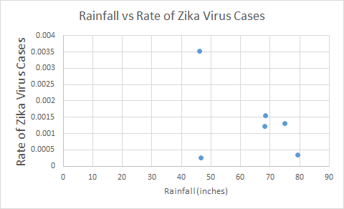
- Calculate the correlation coefficient.
r = -0.42
- What does the value of the correlation coefficient suggest about the relationship between these two variables? Discuss the strength and direction of the correlation.
There is a weak negative linear correlation. There is a value that may be an outlier affecting the strength of the correlation.
- Calculate the line of best fit.
y = -0.000035x + 0.00359 or the rate of Zika cases = - 0.000035(rainfall) + 0.00359
- Interpret the slope from the model.
For every inch of rain increase, there is a 0.000035 (or 0.0035%) decrease of the rate of Zika virus in the population.
- Is it possible to interpret the y intercept from the model? Why or why not?
Yes, because the y intercept is a positive value. It suggests that even if there is 0 inches of rain, the Zika virus rate would be 0.00359 (or 0.359% of the population). However, there are confounding factors that could oppose this conclusion.
- What should the rate of Zika cases be if there was an average of 81 in. of rainfall? Is this an example of extrapolation or interpolation?
y = -0.000035 * 81 + 0.00359 = 0.000755
The rate of zika cases = 0.000755 or 0.0755% of the population
This is an example of extrapolation
- What would the average rainfall be if there are 10,000 cases of Zika virus in a country with a population of 6 million people?
If the rate = 10,000/ 6,000,000 = 0.00167. Then, x = (0.00167 - 0.00359) /-0.000035 = 54.9 So, the amount of rainfall might be 54.9 inches.
- What is the residual of the cases of Zika in Guatemala?
Observed = 0.000251
Predicted = y = -0.000035 * 46.7 + 0.00359 = 0.00196
Residual = observed - predicted = 0.000251 - 0.00196 = -0.00171

Conclusion Questions
- Does the data appear to support your hypothesis? Explain your reasoning
No, these data do not support my hypothesis. These data suggest that as rainfall increases, the rate of Zika virus in the population decrease. Nevertheless, there is a weak linear correlation in the data. Since these data are limited, it would be useful to analyze a larger data set.
- Are there any other environmental factors that could influence the occurrence of Zika? List them and describe how.
Yes, anything in the environment that could cause an increase or decrease in the mosquito population such as predators, a disease, humidity, temperature, or other factors affecting the mosquitoes could influence the occurrence of Zika.
- How could climate change influence the life stages (development) and habitat of the mosquitos (and, thus, the occurrence of Zika)?
Changes in climate, especially increasing temperatures in adjacent regions could expand the range of the mosquitos and cause an increase in Zika virus.
- There are many other human health issues that could be exacerbated by climate change. Provide an example.
Other vector-borne diseases such as malaria, west nile virus, leishmaniasis, etc could increase as a result of climate change.

La Crosse and Temperature

Introduction Questions
- Describe the mode of transmission for La Crosse Virus to humans.
Transmission to humans is by a bite from a mosquito with the virus.
- Describe the habitat and optimal environmental conditions for the vector that carries La Crosse Virus.
Mosquitoes need warm temperature to progress in life stages and also need precipitation for reproduction (to oviposit eggs in water). Small mammals need to survive in the habitat also. Heavy rain storms may decrease the movement of mosquitoes affecting reproduction and growth.
- Describe environmental conditions that could contribute to the transmission of La Crosse Virus to humans. Explain your reasoning.
Warm and rainy conditions could contribute to transmission by creating an ideal environment for mosquito populations to thrive.
- Before viewing the data below, come up with a hypothesis regarding the relationship between the mosquito population level and temperature. Explain your reasoning.

As temperature increases, the mosquito level will increase because mosquitoes rely on warm weather to survive and reproduce.

Graphing and Data Analysis
- You will create a scatter plot for the data above. Before doing so, answer the following questions.
  - What is the dependent variable in this data set? mosquito population
  - What is the independent variable? temperature
  - What variable will you use on the X-axis? temperature
  - What variable will you use on the Y-axis? mosquito population
- After discussing your responses for the question above, make a scatterplot of the data. Describe the relationship between the data.
. The relationship looks to be increasing and roughly linear
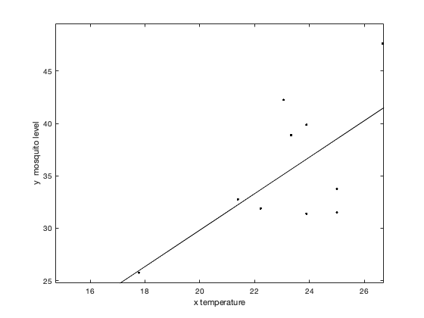
- Calculate the correlation coefficient.
r = 0.83
- What does the value of the correlation coefficient suggest about the relationship between these two variables? Discuss the strength and direction of the correlation.
This is a strong, positive linear relationship
- Calculate the line of best fit.
y = 1.74x - 5.01 or Mosquito level = 1.74x - 5.01(temperature)
- Interpret the slope from the model.
The slope 1.74 is positive which goes with an increasing relationship. It suggests that as the temperature increases 1 °C, the mosquito population increases by 1.74 (number of mosquitoes).
- Is it possible to interpret the y intercept from the model? Why or why not?
The negative intercept -5.01 cannot be interpreted, since population levels should be non-negative.
- What is the expected mosquito population level when the temperature is 20 Celsius? Is this an example of extrapolation or interpolation?
y = 1.74*20-5.01= 29.79
The mosquito population level = 29.29 (number of mosquitoes)
This is an example of interpolation
- What should the approximate temperature be if the mosquito population level is 30?
30 = 1.74x - .5.01
The approximate temperature or x = 20.12 °C
- What is the residual of the mosquito population level when the temperature is 23.06?
Observed = 42.25
Predicted = 1.74(23.06) - 5.01= 35.11
Residual = observed - predicted = 42.25 - 35.11 = 7.14

Conclusion Questions
- Does the data appear to support your hypothesis? Explain your reasoning.
Yes, the correlation is positive and high.
- Are there any other environmental factors that could influence the occurrence of La Crosse virus? List them and describe how.
Humidity may be important. The amount of vegetation and insects may be important to small mammals. Male mosquitoes eat nectar from plants. Female mosquitoes take blood meals.
- How could climate change influence the life stages (development) and habitat of the mosquitos (and, thus, the occurrence of LaCrosse virus)?
Mosquitoes need warm temperatures and precipitation to progress in life stages and to reproduce. Due to increasing temperatures, the available suitable habitat may increase.
- There are many other human health issues that could be exacerbated by climate change. Provide an example.
Human diseases of many types may be on the rise. With the rise in sea level, other pathogens may be more common and there may be some shortage of usable land.

La Crosse (Precipitation)

Introduction Questions
- Describe the mode of transmission for La Crosse Virus to humans.
Transmission to humans is by a bite from a mosquito with the virus.
- Describe the habitat and optimal environmental conditions for the vector that carries La Crosse Virus.
Mosquitoes need warm temperature to progress in life stages and also need precipitation for reproduction (to oviposit eggs in water). Small mammals need to survive in the habitat also. Heavy rainstorms may decrease the movement of mosquitoes affecting reproduction and growth.
- Describe environmental conditions that could contribute to the transmission of La Crosse Virus to humans. Explain your reasoning.
Warm and rainy conditions could contribute to transmission by creating an ideal environment for mosquito populations to thrive.
- Before viewing the data below, come up with a hypothesis regarding the relationship between the mosquito population level and accumulated precipitation. Explain your reasoning.
As precipitation increases, the mosquito level will increase because mosquitoes require standing water to reproduce.

Graphing and Data Analysis
- You will create a scatter plot for the data above. Before doing so, answer the following questions.
  - What is the dependent variable in this data set? mosquito population
  - What is the independent variable? precipitation
  - What variable will you use on the X-axis? precipitation
  - What variable will you use on the Y-axis? Mosquito population
- After discussing your responses for the question above, make a scatterplot of the data. Describe the relationship between the data.
. The relationship looks to be slightly decreasing and not clearly linear.
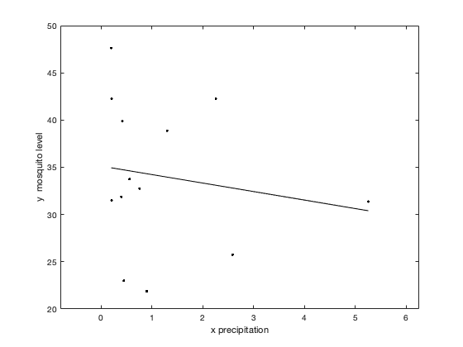
- Calculate the correlation coefficient.
r = -0.17
- What does the value of the correlation coefficient suggest about the relationship between these two variables? Discuss the strength and direction of the correlation.
This decreasing and linear relationship is not strong. Note a low coefficient of determination means a weak correlation between the two features being considered. In some ecological data, weak correlations can often occur, but even a weak correlation can be important. Sometimes a feature with a weak correlation can be combined in a regression with another feature and corresponding observed output to obtain a stronger correlation.
- Calculate the line of best fit.
y = -0.90x + 35.13 (Note: Depending on rounding of the mosquito data, one might get -0.91 for the slope, which affects the other answers.)
- Interpret the slope from the model.
The slope -0.90 is negative which indicates with a decreasing relationship. As the precipitation increases by 1 inch, the mosquito population decreases by 0.90 mosquitos.
- Is it possible to interpret the y intercept from the model? Why or why not?
The intercept 35.13 can be interpreted as the population level with no precipitation on that day.
- What is the expected mosquito population level when the precipitation level is 2.0? Is this an example of extrapolation or interpolation?
y = -0.90(2.0) +35.13 = 33.33
The mosquito population in 33.33
This is an example of interpolation
- What should the approximate precipitation level be if the mosquito population level is 30?
30 = -0.90x + 35.13
The approximate precipitation level or x = 5.70 inches.
- What is the residual of the mosquito population level when the precipitation level is 1.3?
Observed = 38.875
Predicted = y = -0.90(1.3) +35.13 = 33.96
Residual = observed - predicted 38.875 - 33.96 =4.915

Conclusion Questions
- Does the data appear to support your hypothesis? Explain your reasoning.
The hypothesis was not valid for this data. Maybe there was too much fluctuation in rainfall.
- Are there any other environmental factors that could influence the occurrence of La Crosse virus? List them and describe how.
Humidity may be important. The amount of vegetation and insects may be important to small mammals. Male mosquitoes eat nectar from plants. Female mosquitoes take blood meals.
- How could climate change influence the life stages (development) and habitat of the mosquitos (and, thus, the occurrence of LaCrosse virus)?
Mosquitoes need warm temperatures and precipitation to progress in life stages and to reproduce. Due to increasing temperatures, the available suitable habitat may increase.
- There are many other human health issues that could be exacerbated by climate change. Provide an example.
Human diseases of many types may be on the rise. With the rise in sea level, other pathogens may be more common and there may be some shortage of usable land.

Co-Authors (Alphabetical): Andy Adams, Jessica Adams, John Bray, Tami Imbierowicz, Suzanne Lenhart, Breonna Martin. All co-authors contributed equally. This material is based upon work supported by the National Science Foundation under Grant No. 1919613. Any opinions, findings, and conclusions or recommendations expressed in this material are those of the author(s) and do not necessarily reflect the views of the National Science Foundation.

