Attract or Defend?
Secondary Compounds among tissues in two species of Lupine (Fabaceae)
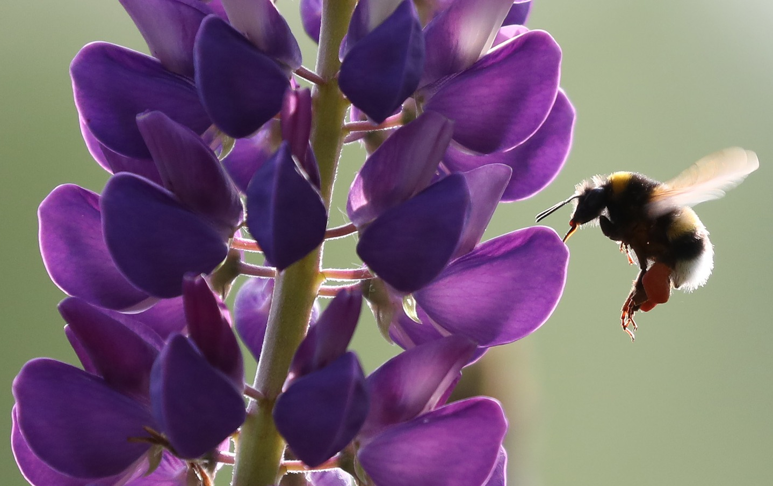

Introduction
In this activity, you will consider possible roles of secondary compounds in plants and hypothesize about how the presence of such compounds relates to interactions between the plant and its environment. After making hypotheses and predictions about the relative presence of defensive compounds among tissues within an individual, you will analyze data to test your hypotheses.
Figure 1: Lupinus sp. and visiting Bombus sp.

This activity will build on your basic understanding of plant secondary compounds and how plants interact with the world around them. Additionally, you will practice your skills of figure design, data analysis, and data interpretation to make a statement about whether and why certain chemicals differ in concentration among tissues. The last portion of the activity provides an opportunity for you to conduct some independent research.

Key Concepts
- Plant trade-offs among essential life processes
- Secondary compounds in plant: purposes and variation among tissue types
- Organizing data in bar figures
- Analyzing data through visualization and statistical inference (ANOVA)

Background
Unlike most animals, the vast majority of plants are stationary and thus have unique ways of defending themselves against enemies and attracting attention from allies. So-called secondary compounds have important roles in these interactions. Although the plant as a whole is subject to the general action of natural selection, different plant parts may have different vulnerabilities, roles, and interactions with the local environment. Thus, we might expect different compounds to be more or less present in certain tissues.

Pre-Activity Questions
1. All organisms face similar requirements for success in an evolutionary context. Namely, organisms need to survive (at least for a little while) and reproduce in order to contribute to the next generation. Consider the specific, unique challenges that a plant might face in terms of survival and reproduction (in contrast to, say, animals).
What factors have likely influenced the evolution of most plants? List four or five possible factors and star the 2-3 that you think are most important and universal among plants.

2. Reflect on what you have learned so far about plant secondary compounds (or, do some independent research).
Generally, what are secondary compounds, and why might plants produce them? In the context of plants, what are alkaloids and how do most herbivores respond to them?

2b. Consider a group of “pollen-rewarding” plant species, like the genus Lupinus. These plants are pollinated by bees and reward visiting bees with pollen that is consumed. The presence of edible pollen ensures continued visits to the plant’s many flowers. In terms of secondary compounds, what might you expect about the pollen in one of these species relative to its other tissues?

3a. Based on what you know so far, do you think that levels of certain secondary compounds are likely to differ among tissue types within a single plant?
State a hypothesis related to your educated guess.

3b. Based on your hypothesis above, state a prediction related to the question posed in 3a.
A prediction states a specific expected outcome, so your prediction should mention what the secondary compound is or does and what specific differences are expected among tissue types (stems, leaves, flowers, pollen).
Example: The hormone oxytocin will be found at higher concentrations in brain tissue.

3c. Provide a justification for your prediction in 3b. Why do you think your prediction is reasonable?
Example: Oxytocin is produced in the brain, so that is probably where most of it is used.
Note: your prediction may or may not be accurate! We need an experiment to test it. In the case of oxytocin, this prediction is not quite right.

Data Exploration and Analysis
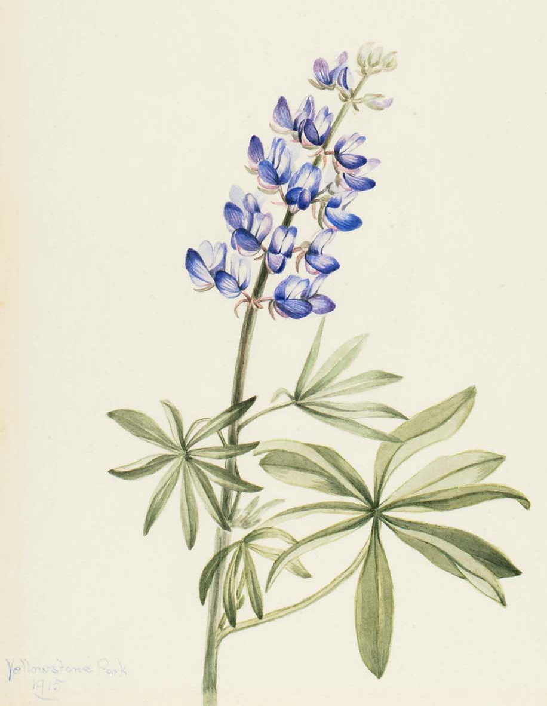
Hopefully, your considerations of plant secondary compounds and plant-animal interactions led you to a few key points. Plants can’t run away, so they need alternative ways to defend themselves from herbivores. At the same time, many plants rely on their interactions with animals. Further, it is possible that the costs and benefits of certain interactions will differ among parts of an individual plant.
Lupinus is a genus of flowering plants in the pea family (Fabaceae). Lupines are nectarless and pollinated by medium and large bees that collect and consume pollen as their reward. Plants must present copious pollen to attract these pollinating insects. These plants are also subject to herbivory by lycaenid butterfly larvae and small mammals.
Keep all of this in mind as you follow the steps below to analyze data related to secondary compound concentrations among tissue types in two species of pollen-rewarding Lupine.
Figure 2: Blue Lupine (Lupinus argenteus) by Mary Vaux Walcott
About the Data
These data come from a published scientific study of alkaloid concentrations in species of Lupine (Heiling et al. 2019). We will consider two species: L. argenteus Pursh (silvery lupine) and L. sulphureus Douglas ex Hook (sulphur lupine).
For each species, multiple individuals from 4 sites were assessed. Tissue samples were collected from flowers, leaves, pollen, and stems of each plant. Gas chromatography was then used to assess for levels of 15 alkaloid compounds in each sample. Your summarized data set reports an average concentration among 14 alkaloids known to deter herbivores as well as the raw concentration of caffeine (also an alkaloid) in each tissue sample.

Follow the steps below for your assigned species: L. argentus or L. sulphureus

1. Open the Data File “Secondary compounds in plant tissues.xlsx” in Microsoft Excel and consider the first worksheet. Take a few minutes to familiarize yourself with the data.
- What variables are present?
Are they continuous (if so, what are the units?) or discrete (if so, what are the categories)?
- Brainstorm comparisons that you could make using these data. List two or three of these possible comparisons below.

2. Visualizing Data
- Familiarize yourself with the data by making and briefly considering the following figures:
  - Histogram for Average Alkaloid Concentration.
- Select the Column containing “Average Alkaloid Concentration (ug/g)”
- Under Insert/Charts, Choose Histogram (it’s in the center)
- You might want to change the x-axis categories: Right click the axis, choose “Format Axis” Under “Bins” choose the “Number of Bins” option, and enter a larger value for the number of categories.
    - Do the data have a bell-shape: a peak and lower values on either side? Are there any points that seem like outliers? Note: we can’t just delete outlying values from our data set! But, it can be useful to make note when they exist.

  - Boxplot relating Average Alkaloid concentration (y) and Caffeine Concentration (x) among tissue types
- Select the columns containing Tissue type and Caffeine concentrations
- Under Insert/Charts, Choose Box and Whisker (center)
- Repeat for Tissue types and Alkaloid concentrations
    - Do you notice any differences (in magnitude or variation) among tissue types or between defensive alkaloids and caffeine? If so, what do you see?

- Reconsider your question, hypothesis, and prediction from Pre-activity question #3. What independent variable did you identify (is it discrete or continuous)?
What dependent variable did you identify (is it discrete or continuous)?
What figure type is appropriate to address your hypothesis?

We will first visualize, then analyze, data related to the following questions.
You should have the background to make an informed prediction about defensive-alkaloid concentrations in plant tissues, but you might be unsure about the expectation for caffeine. That’s OK.
For each hypothesis below, state a specific prediction:
- Alkaloid concentrations differ significantly among tissue types (flower, leaf, pollen, stem).
Prediction:

- Caffeine concentrations differ significantly among tissue types (flower, leaf, pollen, stem)..
Prediction:

- Make a Column figure showing Average Alkaloid Concentration in each tissue type for your species.
In the “Data for ANOVA” worksheet in the MS Excel file, calculate the average and standard error for alkaloid concentration (yes, and average of an average…) within each tissue type in your assigned species.
The function for average is “=average(data range)”
The function for standard error is “=STDEV(data range)/SQRT(COUNT(data range))”
  - The x-axis should be set as our discrete, independent variable, tissue type.
  - The y-axis should be set as our continuous, dependent variable, average alkaloid concentration.
  - Add custom error bars above and below each bar using the standard error values.
  - Make sure your figure includes axis labels

- What does your figure suggest about the relative alkaloid concentrations among tissue types in your species? Is this consistent with your hypothesis?

- Repeat the steps from c., above, to construct a new column figure for Caffeine Concentration among tissue types in your species.

- What does your figure suggest about the relative caffeine concentrations among tissue types in your species? Is this consistent with your hypothesis?

3. Analyze
When your visual representations suggest that a pattern might be present in the data, the next logical step is to conduct a statistical analysis to determine whether the apparent trend or difference among groups is significant. That is, given the variation among samples/individuals, is the difference between groups large enough for us to say that the groups are different in a meaningful way? If we collected more samples in each group, would our group averages/distributions begin to merge or stay separate? Analyses that answer these questions are the real foundation for addressing your research question.
After some exploration of the data, it is important to think about the data analysis questions you want to “ask,” and then find the appropriate test for that purpose. Our questions ask about differences in a continuous dependent variable with noticeable variation (e.g., alkaloid concentration, μg/mg) among more than two discrete categories (the four tissue types). For that kind of statistical question, we will use an analysis of variance (ANOVA). The ANOVA has some underlying assumptions; rest assured that our data set sufficiently meets those assumptions.
Use the “Data for ANOVA” worksheet in the MS Excel file to complete an ANOVA that compares average alkaloid levels among samples from different tissues.
- In the Data tab, click “Data Analysis” and choose “ANOVA: Single Factor”
  - For Data Range select all four columns corresponding to one compound/species data set. Select the tissue type headers in your selection and check the box “Labels in First Row”
  - Choose a cell below the data as your “Output range” then select OK
- Fill in the table below for your analysis (these averages should be identical to what you calculated when you made your bar figure)
- Repeat the analysis steps from a. for the dependent variable Caffeine Concentration. Then, add this information to the table below.

Table 1: Average alkaloid and Caffeine concentrations in each tissue type within the species L. ______________
Tissue type | Average Alkaloid Concentration (ug/g), N | Average Caffeine Concentration (ug/g), N
flower
leaves
pollen
stem
p-value for comparison among tissues
4. Summarize your findings
Now that you have visualized and analyzed data related to our question, we can make well-supported statements to address our hypothesis and prediction.
- Does alkaloid concentration differ significantly among tissues (consider ANOVA)?
  - If so, what specific differences exist (refer to column figure with error bars).

  - To what extent are your results consistent with the hypothesis you generated in section 2d?

- Does caffeine concentration differ significantly among tissues(consider ANOVA)?
  - If so, what specific differences exist (refer to column figure with error bars).

  - To what extent are your results consistent with the hypothesis you generated in section 2d?

- What possible explanations exist for the pattern you observed for alkaloid concentrations among tissue types? In your answer, consider the role of alkaloids in plants as well as how the tissues differ in their interactions with other organisms.

- What possible explanations exist for the pattern you observed for caffeine concentrations among tissue types? In your answer, consider the role of caffeine in plants as well as how the tissues differ in their interactions with other organisms.

5. Collaborate and Compare
Find another group working on the other species. Share and compare your results
- Are the major findings the same between species? If not, how do they differ?

To visualize the answer to this question, let’s make two new column figures formatted to compare alkaloid and caffeine concentrations across tissues and between species.
- To do this, you will probably need to reorganize your data into a table with tissue types as column headers, and each species’ values as a single row.
- Then, select all of the data for either alkaloids or caffeine (row/column headers and values for each tissue and species), and insert a column figure as before.
  - The default figure will likely pair tissue types between species (four groups, each with two bars).
To change that, click on the figure, then choose “Switch Row/Column” under Chart Tools / Design in the banner menu. You should now have a figure that nests tissue type within species (two groups of four bars).
  - Repeat these steps for the compound (defensive alkaloid or caffeine)

- What between-species differences do you notice here?

- Generate one testable hypothesis that would account for the difference you noted between species.

6. Post-Activity questions
As an extension to this activity, consider one or more of the following.
- Conduct some outside research to help explain your findings related to caffeine levels in pollen. Why is caffeine production higher in the pollen when other alkaloids are lower?
- Research alkaloids both generally and in the context of plants. Briefly describe the function of alkaloid compounds and how your findigins make sense in light of this information.
- Return to your figures from 5b. and compare alkaloid levels within tissues between species. Identify one or more tissues for which there is a large disparity between species (i.e., where one species concentration appears significantly greater than the other). Based on your knowledge of secondary compounds, generate a hypothesis to explain this inter-specific difference.

References
Heiling, Jacob M.; Cook, Daniel; Lee, Stephen T.; Irwin, Rebecca E. Data from: “Attract or defend? Pollen and vegetative secondary chemistry of three pollen-rewarding lupines.” Dryad, May 7, 2019, Dataset. https://doi.org/10.5061/dryad.586f011

Heiling, Jacob M.; Cook, Daniel; Lee, Stephen T.; Irwin, Rebecca E. “Pollen and vegetative secondary chemistry of three pollen‐rewarding lupines.” American Journal of Botany, no. 106 (2019): 643-655. https://doi.org/10.1002/ajb2.1283

Credits
Data curated by Rebecca Penny Humphrey, Aquinas College, Michigan, USA
Text written by Rebecca Penny Humphrey, Aquinas College, Michigan, USA

Figure 1 Image Credit, catazul via Pixabay license https://pixabay.com/photos/bee-lupine-flower-insect-spring-2338555/
Figure 2 Image Credit “Mary Vaux Walcott - Blue Lupine (Lupinus argenteus) - 1970.355.99 -” by Smithsonian American Art Museum, used under Public Domain https://americanart.si.edu/artwork/blue-lupine-lupinus-argenteus-25889

