Mammal Skulls, Teeth, Bones, Dichotomous Keys*, and Homologies

*Information taken from the Animal Diversity Web (https://animaldiversity.org/accounts/Mammalia/) and Mammalogy Techniques Lab Manual by Dr. James Ryan.

There are more than 5,000 living species of mammals. Because many species (especially species of small mammals) appear similar to the untrained eye, scientists have developed dichotomous keys to facilitate identification of species. Dichotomous keys are pairs of statements that allow the user to easily identify an unknown organism. The keys are arranged in “couplets” consisting of two statements that ask the user to make a choice about the presence, absence, or aspect of a particular characteristic of their unknown organism. That choice leads the user to a new couplet in the key, and the process repeats until a couplet choice leads to the name of the organism (or the group to which it belongs).

Most dichotomous keys use scientific terminology to describe features. Thus, it is often important to familiarize yourself with basic anatomical terminology before attempting to use a key. Mammal skulls and teeth are often used in keys to identify species. However, mammal skulls are complex structures made up of numerous bones, processes, holes, and teeth (usually). Each feature is important and has been shaped by natural selection. For example, the diverse feeding habits of mammals are reflected in their teeth and jaw morphology. Teeth may be specialized for grasping, crushing, or grinding; the position and structure of the teeth often provide valuable clues to the animal’s diet. Below are figures that will help you learn to recognize identifying features of mammal skull, teeth, and bones, and these will help you work through dichotomous keys and address a variety of questions.

Useful terms:
Diphyodonty – 2 sets of teeth (milk teeth and adult teeth)
Lingual – toward the tongue
Labial – toward the lip or cheek
Occlusal Pattern – way teeth mesh together
Diastema – Space between teeth
Dentary – bone of the lower jaw
Foramen (or foramina) = hole in bone (nerve or blood vessel passes through this hole)
Fenestra = many small holes in a region of bone
Fossa = depression in bone (usually site of muscle attachment)
Process = a boney projection
Condyle = a process on one bone that articulates with another bone
Bulla (bullae) = bone(s) that cover the middle ear ossicles
Postorbital bar = bone behind the orbit
Anterior = towards the nose
Posterior = towards the back of the skull
Ventral = underside
Dorsal = topside
Canal = tunnel-like hole in bone (oftentimes 2 foramen connected)
Meatus = the opening into a canal

Examine the labeled skulls on the powerpoint and get familiar with the highlighted bones

Practice labeling your own bones here:

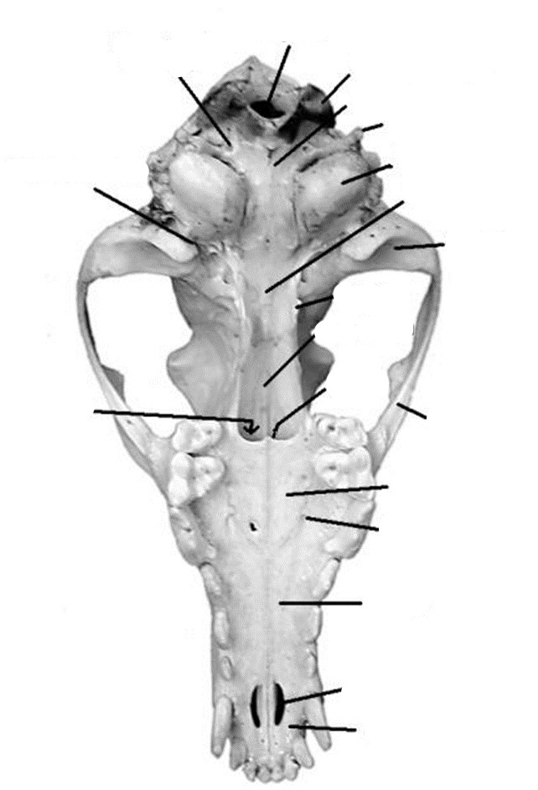
Teeth!

Mammals have four types of teeth: Incisors (I), Canines (C), Premolars (PM), and Molars (M). -Teeth restricted to 3 bones: premaxilla, maxilla, and dentary. Premolars and Molars indicate diet and age (wear on the tooth); molars only come in as adults. Premolars and molars combined are often referred to as cheekteeth.

Tooth Formulas:
Upper Incisor/Lower Incisor, Upper Canine/Lower Canine, Upper Premolar/Lower Premolar, Upper Molar/Lower Molar X 2 (both halves of the skull)

Marsupial mammals: 5/4, 1/1, 3/3, 4/4 = 50 maximum
Placental mammals: 3/3, 1/1, 4/4, 3/3 = 44 maximum
Tooth formulas shown above is for ½ of the jaw. Be sure to double everything to get the final number of teeth after the “=” sign! Note, sometimes premolars and molars are hard to tell apart.

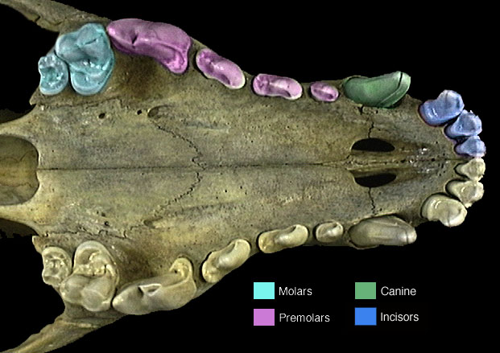
Figure 4. Major tooth types on a mammal skull. This specimen has heterodont dentition (more than one kind of tooth). This is in contrast to homodont dentition (only one type of tooth; all the teeth look the same).

For your assignment (see below), you will need to use a dichotomous key to identify specimens to orders. Here are some videos covering how to use a dichotomous key:
https://www.youtube.com/watch?v=M51AKJqx-7s AND https://www.youtube.com/watch?v=peMiaDhw9sc

Dichotomous Key
1.a. Incisors 1/1 or 2/1 (second upper incisor peglike and set directly behind the first);
broad diastema between incisors and cheekteeth; first upper incisor enlarged,
evergrowing, modified for gnawing ………………………………………………..……………..…go to 2

1.b. Incisors variable (never 1/1 or 2/1) to absent; if incisors present both above and
below, no diastema, or only a modest diastema, in toothrow; first upper incisor,
if present, usually not noticeably enlarged, not evergrowing, not modified for gnawing…………....go to 3

2.a. Incisors 2/1; maxillary fenestration(s) present………………..…………..…Order LAGOMORPHA

2.b. Incisors 1/1; no maxillary fenestrations…………………………………...………Order RODENTIA

3.a. Incisors lacking; cheekteeth peglike, lacking enamel…………………..….……Order CINGULATA

3.b. Incisors present in at least lower jaw; cheek teeth not peglike,
composed partly of enamel……………………………………………………………………..….…go to 4

4.a. Incisors 5/4; angular process of dentary distinctly inflected…………...Order DIDELPHIMORPHIA

4.b. Incisors never more than 3/3; angular process of dentary not inflected……………..………..…go to 5

5.a. Upper incisors sometimes absent; upper canine absent or, if present, separated from
cheekteeth by modest diastema; postorbital bar present…….....…………Order CETARTIODACTYLA
(terrestrial forms)

5.b. Upper incisors present; upper canine present and not separated from cheekteeth
by diastema; postorbital bar absent…………………………………………….……………..………go to 6

6.a. Greatest length of skull less than 45 mm; Molars 3/3, last upper molar never
dumbbell-shaped (careful, molars and premolars can look alike!); cheek teeth often
> 4/4; number of incisors variable………………………………………….………………..…….…go to 7

6.b. Greatest length of skull usually more than 45 mm (if less, then last upper molar is dumbbell shaped); upper incisors always 3 in number; Molars rarely 3/3 (careful, molars and premolars can look alike!); cheek teeth often 3/3 or 4/4……………………………………………………….…Order CARNIVORA

7.a. Canine poorly to moderately developed, never largest tooth in anterior part
of toothrow; dorsal profile of skull flattened; braincase not much higher than rostrum…………………………………………………..................……………Order EULIPOTYPHLA

7.b. Canine well developed, largest tooth in anterior part of toothrow; total number
of teeth never more than 38; dorsal profile of skull not flattened, braincase noticeably
higher than rostrum (there are a few exceptions)………….……...……………..…Order CHIROPTERA

Lab Assignment – Part 1

1. Use the skull and teeth information above and the dichotomous key below to identify the specimens in the powerpoint to order.

Specimen A: ____________________________________

Specimen B: ____________________________________

Specimen C: ____________________________________

Specimen D: ____________________________________

Specimen E: ____________________________________

Homologies Among Bones

The skeletal structures of forelimbs in various vertebrate animals showing the homologies among bones. Comparative anatomists realized that although these vertebrates evolved in different directions, with changes in size, shape, and function, they all used common bone elements, as well as homologous nerve systems, blood circulatory systems, and other organ systems, indicating a common vertebrate ancester.

As Darwin noted, “What can be more curious than that the hand of man formed for grasping, that of a mole, for digging, the leg of a horse, the paddle of a porpoise and the wing of a bat, should all be constructed on the same pattern and should include similar bones and in the same relative positions?” Thus, in contrast to teleological explanations that emphasize design for a particular function, the vertebrate forelimb uses a common underlying ancestral structure for different functions.

Recall definitions of homology and analogy here: https://evolution.berkeley.edu/evolibrary/article/evo_09

And here:
https://evolution.berkeley.edu/evolibrary/article/0_0_0/homology_01 (scroll through and read all of the pages by clicking the “next” button at the bottom of each page)

And here:
https://evolution.berkeley.edu/evolibrary/article/0_0_0/similarity_ms_01 (scroll through and read all of the pages by clicking the “next” button at the bottom of each page)

Lab Assignment – Part 2

Using the links above (especially the last link), answer the following questions about homology and analogy:

1. Explain the difference in homology and analogy.

2. List the similarities that tetrapod limbs share:
A.

B.

3. Why do whales, lizards, humans, and birds have the same basic limb structure?

4. What does an evolutionary tree show?

5. What are homologous structures? List examples of homologous structures found in nature.

6. What are analogous structures? List an example.

7. How do analogous structures evolve?

In terms of forelimb homologies, be familiar with the sharded bones below: humerus, ulna, radias, carpals, phalanges (phalanges are in red in the figure below)

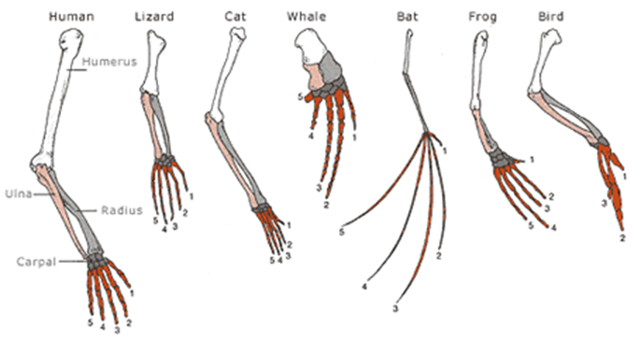

Lab Assignment – Part 3

1. Examine homologies on this website (and play! Zoom in and out):
Wheel of forelimb morphology: https://sketchfab.com/3d-models/wheel-of-forelimb-homology-vertebrate-classes-81ebf9ee17ef4cb19d3b2ae49b8a1799

Describe morphological changes that you see depending on vertebrate “class” or large taxonomic group. What major trends do you see within and between taxonomic groups?

2. Examine homologies on this website (and play! Zoom in and out):
Two worlds, one forelimb: https://sketchfab.com/3d-models/wheel-of-homology-two-worlds-one-forelimb-d26e5f9c3f544cc78e75bfe4df195acc

Describe morphological changes that you see depending in which “world” the animals are located in. In your response, be sure to examine the different taxonomic groups (click on the numbers near the forelimbs) and describe how reptiles, birds (other reptiles), and mammals differ in their mophologies.

3. Examine homologies on this website (and play! Zoom in and out):
From A to Chimpanzee: https://sketchfab.com/3d-models/wheel-of-homology-from-a-to-chimpanzee-13f0aad153744dc1b37592d10869aad3

Looking at each species in this homology wheel, what type of locomotion do you think each species exhibits and why?

1.
2.
3.
4.
5.
6.
7.
8.
9.
10.
11.
12.
13.
14.
15.
16.
17.
18.
19.
20.
21.
22.
23.
24.
25.

More images here: https://sketchfab.com/ufherps/collections/forelimb-homology
Mammal forelimbs: https://sketchfab.com/3d-models/mammals-on-the-move-forelimb-adaptations-edc963a36388486ab3f27f1a2b92b267

