Open Education Resources/Open Pedagogy
By Karen Cangialosi and Ellen Bledsoe

Open Educational Practices
- can be defined as the set of practices that accompany either the use of OERs or the adoption of open pedagogy (Open Pedagogy)
- constitute the range of practices around the creation, use, and management of open educational resources with the intent to improve quality and innovate education (Hegarty 2015, Educational Technology)

Open Access
The free, immediate, online availability of research articles combined with the rights to use these articles fully in the digital environment. (SPARC)

Open Education
Encompasses resources, tools and practices that are free of legal, financial and technical barriers and can be fully used, shared and adapted in the digital environment. (SPARC)

Open Educational Resources (OER)
Teaching, learning, and research resources that are free of cost and access barriers and which also carry legal permission for open use. (SPARC)

Defining the "Open" in Open Content and Open Educational Resources
The terms "open content" and "open educational resources" describe any copyrightable work that is either (1) in the public domain or (2) licensed in a manner that provides users with free and perpetual permission to engage in the 5R activities: (SPARC)
- Retain - the right to make, own, and control copies of the content (e.g., download, duplicate, store, and manage)
- Reuse - the right to use the content in a wide range of ways (e.g., in a class, in a study group, on a website, in a video)
- Revise - the right to adapt, adjust, modify, or alter the content itself (e.g., translate the content into another language)
- Remix - the right to combine the original or revised content with other material to create something new (e.g., incorporate the content into a mashup)
- Redistribute - the right to share copies of the original content, your revisions, or your remixes with others (e.g., give a copy of the content to a friend)

Open source
A term denoting that a product includes permission to use its source code, design documents, or content. It most commonly refers to the open-source model, in which open-source software or other products are released under an open-source license.

Open Data
is research data that: (SPARC)
- Is freely available on the internet;
- Permits any user to download, copy, analyze, re-process, pass to software or use for any other purpose; and
- Is without financial, legal, or technical barriers other than those inseparable from gaining access to the internet itself.

Another definition by Javiera Atenas and Leo Havemann:
“Open Data is an umbrella term describing openly-licensed, interoperable, and reusable datasets which have been created and made available to the public...”

Creative Commons licenses
Retain copyright while allowing others to copy, distribute, and make some uses of their work. Every Creative Commons license also ensures licensors get the credit for their work they deserve.

Open science
The movement to make scientific research (including publications, data, physical samples, and software) and its dissemination accessible to all levels of an inquiring society, amateur or professional. Open science is transparent and accessible knowledge that is shared and developed through collaborative networks.

Open Science
by Dan Gezelter:
- Transparency in experimental methodology, observation, and collection of data
- Public availability and reusability of scientific data
- Public accessibility and transparency of scientific communication
- Using web-based tools to facilitate scientific collaboration

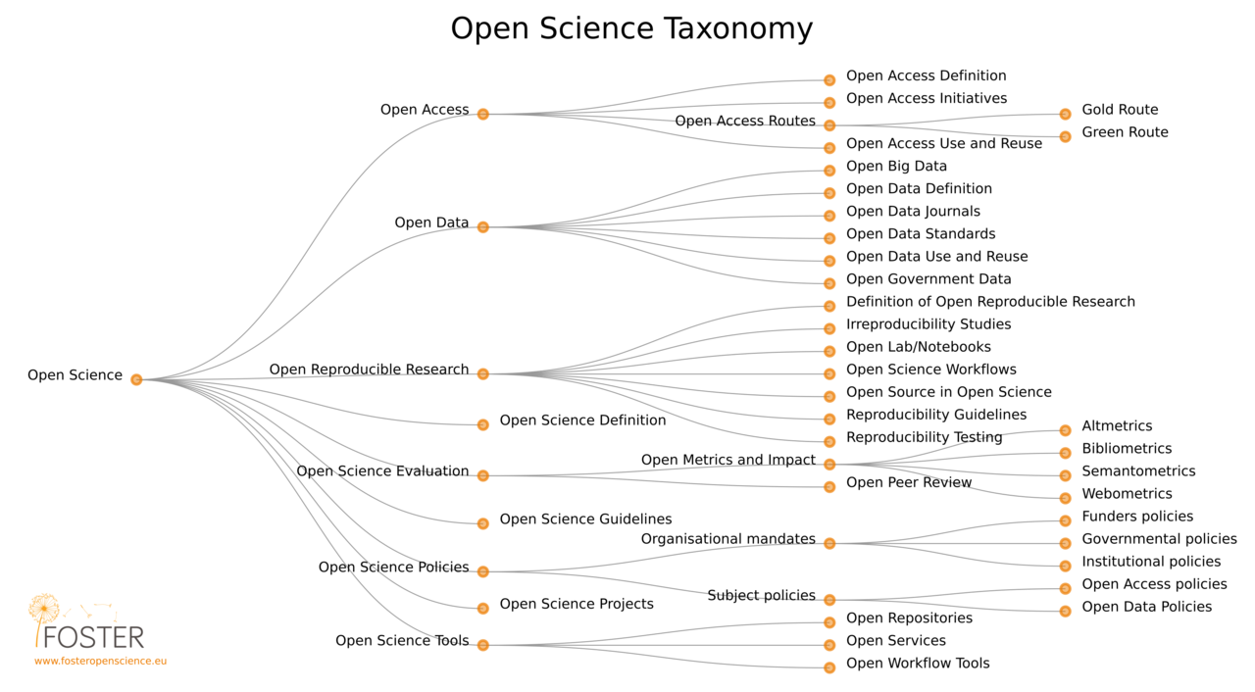
https://www.fosteropenscience.eu/

Open Science Taxonomy
- Open Science
  - Open Access
    - Open Access Definition
    - Open Access Initiatives
    - Open Access Routes
    - Open Access Use and Reuse
  - Open Data
    - Open Big Data
    - Open Data Definition
    - Open Data Journals
    - Open Data Standards
    - Open Data Use and Reuse
    - Open Government Data
  - Open Reproducible Research
    - Definition of Open Reproducible Research
    - Irreproducibility Studies
    - Open Lab/Notebooks
    - Open Science Workflows
    - Open Source in Open Science
    - Reproducibility Guidelines
    - Reproducibility Testing
  - Open Science Definition
  - Open Metrics and Impact
    - Altmetrics
    - Bibliometrics
    - Semantometrics
    - Webometrics
  - Open Peer Review
  - Open Science Evaluation
    - Open Science Guidelines
  - Open Science Policies
    - Organisational mandates
      - Funders policies
      - Governmental policies
      - Institutional policies
    - Subject policies
      - Open Access policies
      - Open Data Policies
  - Open Science Projects
  - Open Science Tools
    - Open Repositories
    - Open Services
    - Open Workflow Tools

Open Pedagogy
An access-oriented commitment to learner-driven education. It is also a process of designing architectures and using tools for learning that enable students to shape the public knowledge commons of which they are a part.
Open pedagogy in practice can include creating, adapting, or updating OER with students, building course policies, outcomes, assignments, rubrics, and schedules of work collaboratively with students, or facilitating student-created and student-controlled learning environments such as Domain of One’s Own or students writing/editing Wikipedia articles.
(This is a short description of open pedagogy by Rajiv Jhangiani at Kwantlen Polytechnic University, modified slightly by Karen Cangialosi)

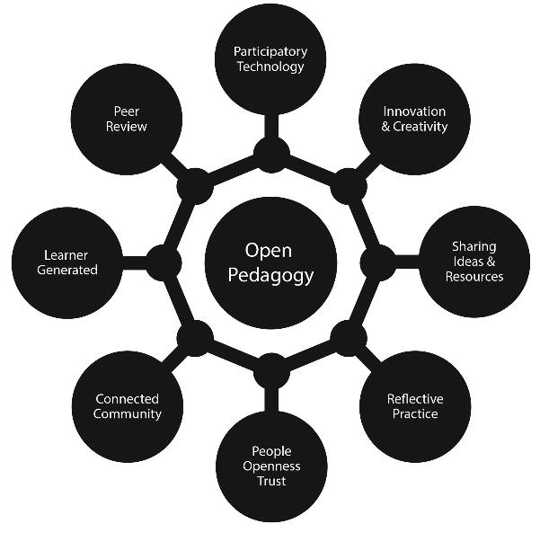
Figure 1. Eight attributes of Open Pedagogy, by Bronwyn Hegarty, based on Conole (2013).

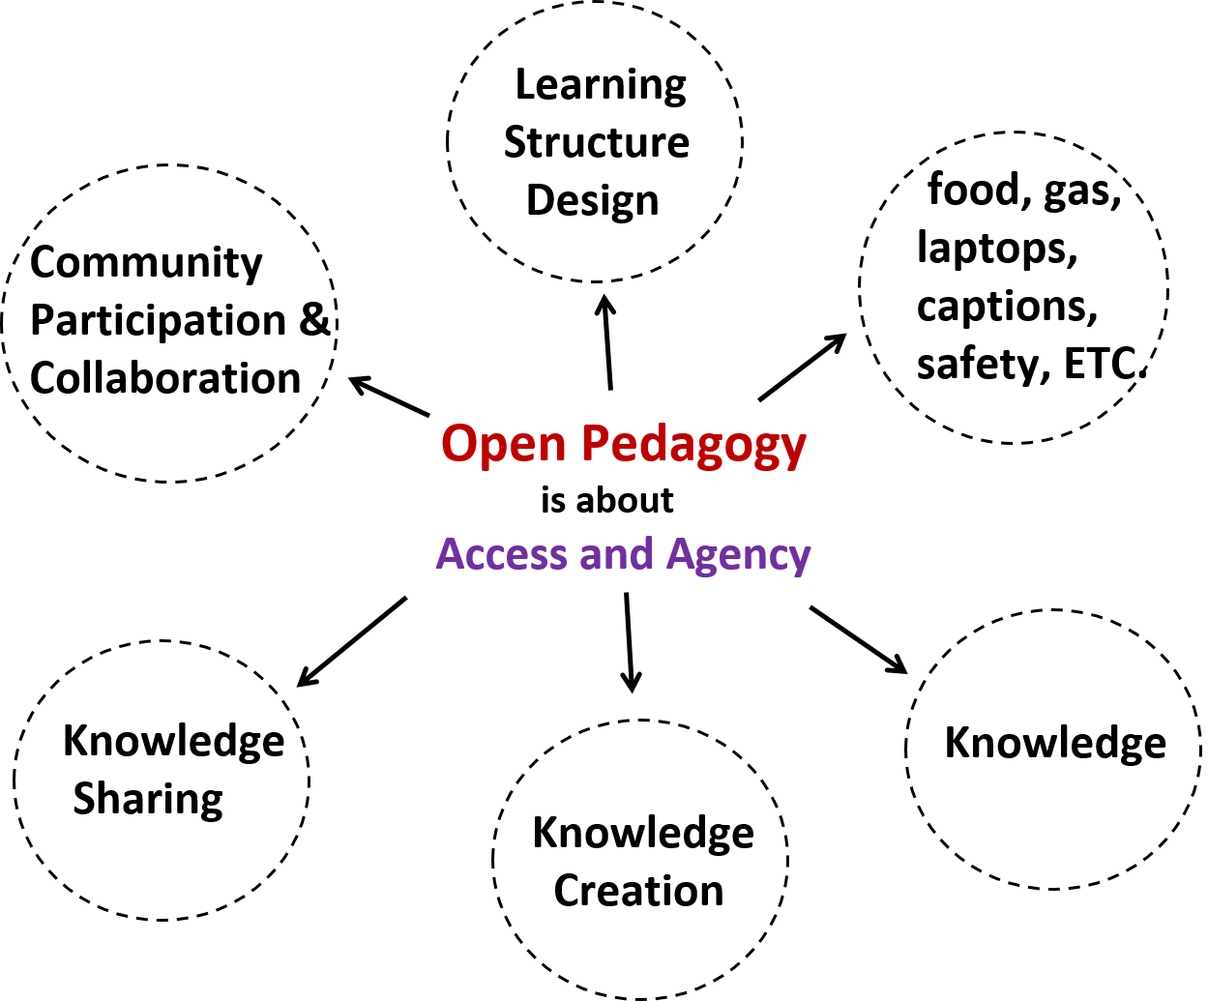
Open Pedagogy figure by Karen Cangialosi [CC BY 4.0] https://upload.wikimedia.org/wikipedia/commons/c/ca/Ed_Tech_Hegarty_2015_article_attributes_of_open_pedagogy.pdf

Sources:
SPARC - https://sparcopen.org/ (primary source)
Open Pedagogy - http://openpedagogy.org/
Wikipedia - “open source,” “open science”
Creative Commons - https://creativecommons.org/

