Resources to Adapt for Background Knowledge:
Algebra

Stats

Biology

Algebra topics that students should know prior to activity:
- Graphing points in a rectangular coordinate plane
- Slope-intercept form of a linear equation: $y=mx+b$
- Independent and dependent variables

Project Outline for a Stats Course
The project is designed to reinforce students' understanding of linear regression.

Learning Outcomes for the activity:
- Using linear regression to solve a real life problem.
- Have a basic understanding of osmosis.
- Interpret the results in a way that would make sense in biology.

Prior knowledge needed:
- Independent and dependent variables
- Data Types
- Experiment vs Observation
- Treatment, Experimental Unit, and Lurking Variable
- Scatter Plot
- Linear Correlation
- Testing for Linear Correlation
- Lines, Slopes, and Y-intercept
- Regression Line
- Making Predictions

Part 1: Developing a basic understanding of osmosis.
Before students can begin their in class activity, they need to develop a basic understanding of osmosis. This part of the project can be done outside of class through the use of discussion boards or entry tickets.

Have students read the Math Activity Guide to read the description on osmosis, watch the video on osmosis, and watch the experiment video. Then, have them complete the checking for understanding questions and summarize the experiment video. You could have them answer these questions and post their summary in a discussion board before class for the project or have them submit their answers to these questions and summary as an entry ticket for the activity day. If you choose to have them submit an entry ticket, you do need to budget about 15 or 20 minutes of class time to discuss the checking for understanding questions. .

(Rules for entry ticket) Students cannot enter the class until they have completed the requirements for the entry ticket. This strategy forces students to be prepared for class.

Part 2: Exploring linear regression for a real life problem.
The activity is designed to be completed in a computer lab through the use of excel or outside of class. If you don’t have access to a computer lab, you can have students watch the excel tutorial outside of class and complete some of the calculations outside of class. The project was designed to be completed in pairs or groups of 3.

Part 3: Summary, Reflection, and Peer Review
Students could wrap up the activity by summarizing what they have learned, explain how they can expand what they learned to other real life problems, and complete the peer review for their partners. The peer review could account for 10% of the students’ grades. See activity for peer review and rubrics. You could have students post their summaries and explanations in a discussion board.

Project Outline for a Biology Course

This laboratory experiment will be used to demonstrate the important physiological concept of osmosis how it relates to the tonicity of cells. Students will also learn how to apply mathematical concepts using statistical principles and linear regression to their collected data.

Biology topics that students should be familiar with prior to activity:
- Structure and function of the plasma membrane of a cell.
- How passive transport follows a concentration gradient.
- What osmosis is and how it relates to cell tonicity.
- How to use metric units and use a gram scale (balance or electric).

Part 1: Building the foundation for understanding cell tonicity
Prior to the activity, the most important concept for students to know is how osmosis relates to cell tonicity. A natural science instructor should ensure that the student understands the structure and function of the plasma membrane, passive transport, concentration gradients, diffusion and osmosis, and cell tonicity. Some example problems from the assessment guide are a good idea prior to the start of the activity to check for understanding. Students should review the experimental plan prior to coming into the laboratory, and answer prediction questions regarding whether each bag will gain weight, lose weight, or stay the same, while providing the rationale behind each decision. Ideally, the predicted responses should be discussed in student groups or with the instructor prior to beginning the activity.
Note for instructors with limited classroom time: To save class time, you could have students do the check for understanding questions and post to a discussion board before the next class period. If you are unable to do the experiment in class, you can have the students watch the videos and use the provided data set to find linear regression and answer the questions in the assessment guide.

Expected Outcomes

0.9% Beaker
- 0.9% - will neither gain nor lose weight
- 10% - will gain weight until equilibrium is achieved
- 20% - will gain weight until equilibrium is achieved

20% Beaker
- 0.9% - will lose weight until equilibrium is achieved
- 10% - will lose weight until equilibrium is achieved
- 20% - will neither gain nor lose weight

Part 2: Instructor Laboratory Preparation:
In order for this laboratory to run smoothly, the instructor will need to do some preparation in the laboratory prior to the beginning of the class.

Experiment Supplies for instructors:
Dialysis tubing, scissors, string/clips to secure bags, electronic balances, 2 400 mL beakers per table, table sugar or NaCl, graduated cylinder, food coloring
Instructor set-up:

-Prepare 300 mL each of the following solutions 2 hours - 1 week* in advance of the laboratory : 0.9 % NaCl, 10% NaCl, 20% NaCl. Place red food coloring in 0.9% NaCl solution, blue coloring in the 10% Sucrose solution, and no food coloring in the 20% Sucrose beaker. Amounts prepared will vary based on class size.

-Prepare 2 liters each of the following solutions 2 hours - 1 week* in advance of the laboratory: 0.9% Sucrose (no coloring), 20% sucrose (no coloring).

- Prior to students entering the laboratory, fill 2 beakers per each student group with 0.9 % Sucrose (no coloring) and with 20% Sucrose (no coloring). Ensure each beaker is labeled properly.

-Cut 6-inch long strips of dialysis tubing and soak strips in a beaker of water for a minimum of 3 minutes prior to experiment.

*Rationale for timing: 2 hours gives the solutions time to cool from boiling so the rate of diffusion is not affected by a warm temperature. Because of the high concentrations of sucrose, solutions prepared over a week in advance can easily develop bacteria and molds.

Laboratory set-up:

- Per table (student group): 1 electronic balance, 2 400 mL beakers, paper towels, timer (or students may use cell phones)

- Front desk/common table: dialysis tubing in strips, soaking in a beaker of water (6 strips per group should be cut), colored sucrose solutions prepared in advance, plastic pipettes for colored solution, extra 0.9% sucrose and 20% sucrose solutions for refills

Conducting the Experiment:
- Follow the instructions provided in the student guide. Have the students fill out the table provided by measuring the weight of each bag at 20 minute intervals.

Part 3: Relating the concept to mathematics
Instructors may choose to have the students review the student guide prior to coming to the laboratory. Either before or after the laboratory experiment, the instructor should ensure that the students understand linear regression and its significance to the project. The instructor should take care to let students know that while the slope (m) is describing a constant rate of change, osmosis will reach equilibrium at some point. The rate of change for osmosis is therefore not constant, and extrapolation beyond recorded values is not valid. Students should be given the example problem to review prior to class. Video examples of graphing in excel are included for students to do their work outside of the classroom. Graphs and statistical results can be submitted electronically and reviewed in student groups with help from the instructor during the following class period. If the instructor wishes to take the activity further, the information below can be used to determine if there is sufficient evidence to claim there is linear correlation between two variables. To do this, we must conduct a formal hypothesis test for linear correlation (see testing for linear correlation, below in instructor guide).
Introductory Statistics from OpenStax
Regression Video
A scatter plot is a graph that shows the relationship between two quantitative variables measured on the same individual. Each individual in the data set is represented by a point in the scatter plot. The independent or explanatory variable is plotted on the horizontal axis, and the dependent or response variable is plotted on the vertical axis.
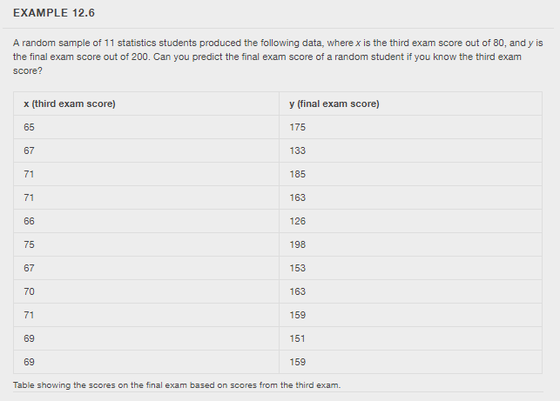
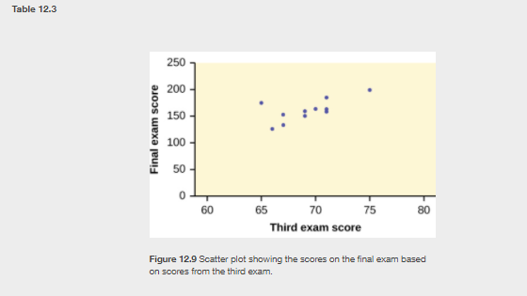
For this example, the points on the scatter plot would be the following (65, 175), (67,133), (71,185) and so on. Below is a picture of the scatter plot.
The Independent or explanatory variable is the third exam score and the dependent or response variable is the final exam score for the example.

Testing for Linear Correlation
To determine if there is sufficient evidence to claim there is linear correlation between two variables, we must conduct a formal hypothesis test for linear correlation.

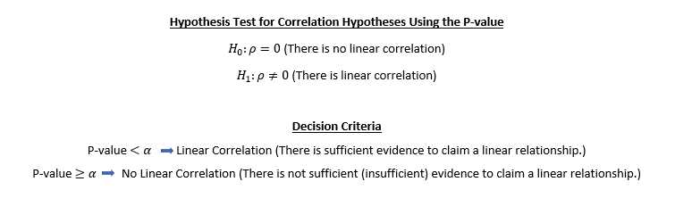
The linear correlation coefficient r for the above data set is r = .663 (rounded to three decimal places). .
Using a 0.05 significance level, determine whether there is linear correlation between third exam score and final exam score.
Solution: Since 0.0262 < 0.05, we can conclude that there is sufficient evidence to claim a linear relationship between third exam score and final exam score.
Using a 0.01 significance level, determine whether there is linear correlation between third exam score and final exam score.
Solution: Since 0.0262 > 0.01, we can conclude that there is not sufficient evidence to claim a linear relationship between third exam score and final exam score.
Note: The predicted value for bags A and F may have different answers on the biology and math activity. Bags A and F will not have a linear relationship since the variables are independent. The regression equation will be a constant function. The best predicted value will be the mean of the y values for both bags. However, the constant function will give you a close prediction as well.
Graphing the data from this activity (data file located ) - Scatter plot showing the weight of each bag over time and the trendlines for each. Equations and R² values for each trendline are included. Note: the R² values are very low for bags A and F, but these trend lines show what we want to demonstrate, this is a good example of why more replications are always better in science.
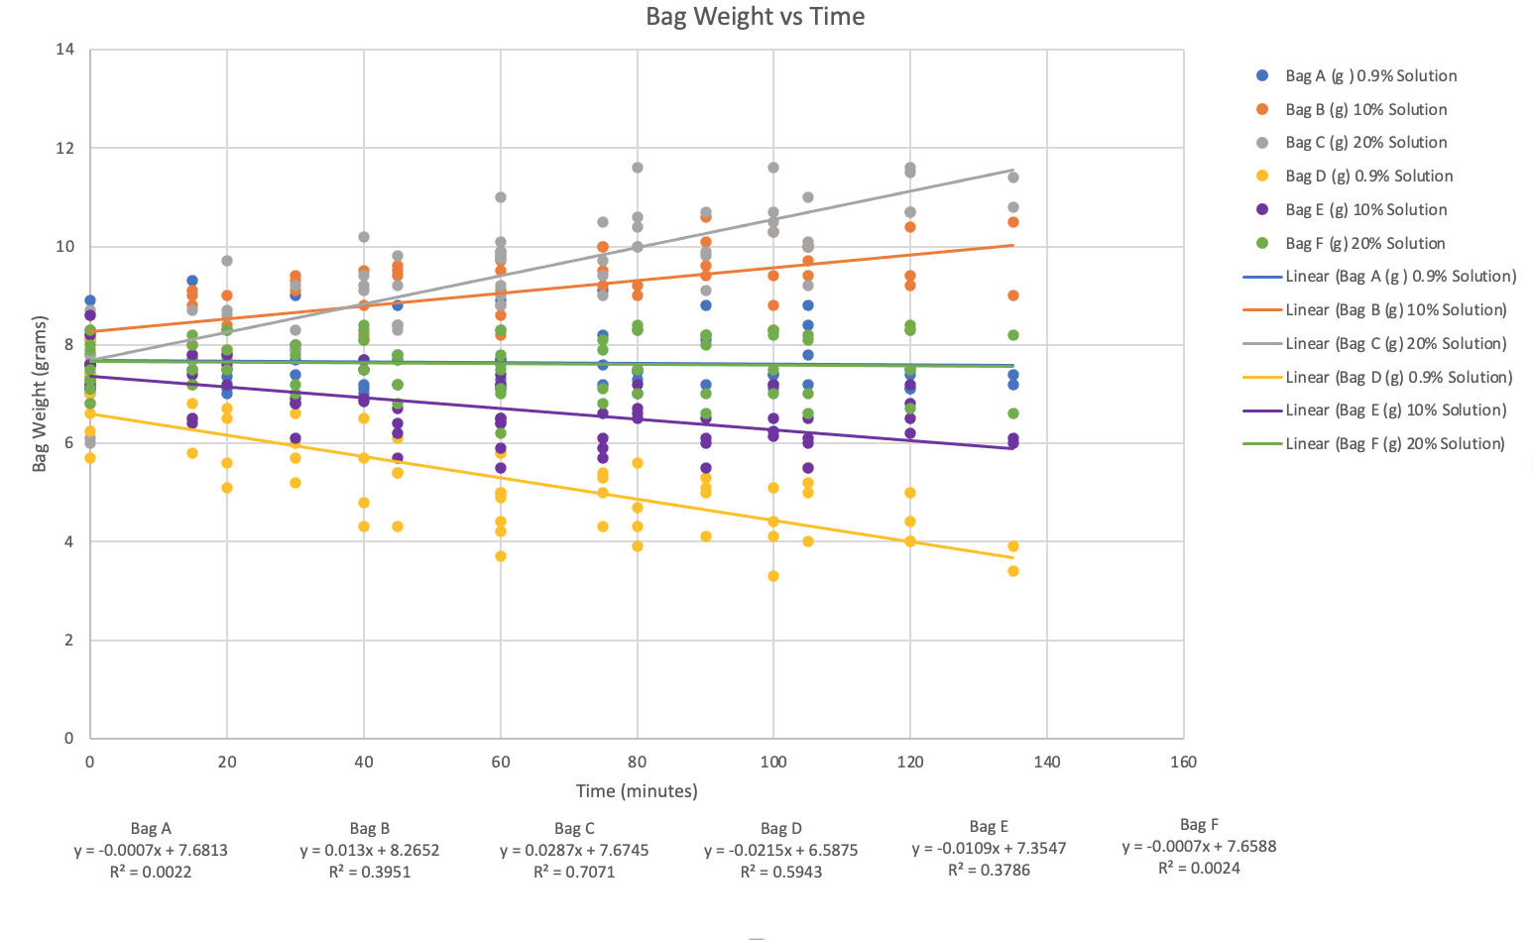

Making Predictions
Steps for Making Predictions:
- Plot the scatter plot.
- Perform a formal hypothesis test for linear correlation. Note: If the “Significance f” cell contains “#NUM!,” then there is no correlation between the variables. This situation may occur with bags A and F because their weights should be constant which means that the check for independence fails. This outcome should make sense because the weight of the bags being constant means that time has no effect on the weight of the bag.
- Determine if you use the regression equation to predict or the mean of the y’s.

Decision Making Flow Chart

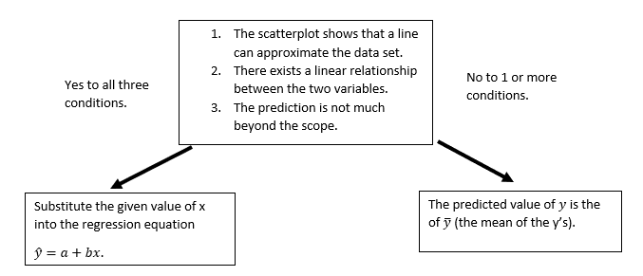

What does it mean for the value to be outside the scope? Basically, we do not want to predict too far into the future. If we had a data set with x-values: 2,3,6,7 and 8, we would not want to predict for an x-value for 75 because that would be too far in the future and outside the scope of the data set.

Important Note: If the significance level is not given, use alpha = 0.05.

Examples:
- Find the predicted final exam score for a student who scored a 66 on the third exam using example 12.6 and significance level 0.05.

Checking for linear correlations:
Using a significance level 0.05, we know that there is linear correlation based on the example in the testing for linear correlation section.

Score:
Note that the range for the values of x is from 67 to 75. Therefore, 66 is not outside the scope of the data set.

Prediction:
Since we know there is linear correlation between the variables and the 66 is not outside the score, we can use the regression equation to make the prediction.

-173.51+4.83(66)=145.27
Thus, 145.27 is the predicted final exam score if the student made a 66 on the third exam.
- Find the predicted final exam score for a student who scored a 66 on the third exam using example 12.6 and significance level 0.01.

Checking for linear correlations:
Using a significance level 0.01, we know that there is no linear correlation based on the example in the testing for linear correlation section.

Score:
Note that the range for the values of x is from 67 to 75. Therefore, 66 is not outside the scope of the data set.

Prediction:
Since we know there is no linear correlation between the variables, we can use the mean of the y’s to make the prediction.

mean of the y’s =160.45
Thus, 160.45 is predicted final exam score if the student made a 66 on the third exam.
Source: OpenStax Stats

BIOLOGY DEFINITIONS
Aqueous Solution - a liquid mixture in which the solid particle (solute) is dissolved and evenly distributed within liquid water (solvent).
Solute- the solid particle dissolved in water. Ex: NaCl is the solute in a 25% NaCl + water mixture.
Hypertonic - hyper (meaning in above or higher than). A solution that has a higher concentration of dissolved solutes when compared to another solution. Ex: A solution with 25% NaCl is hypertonic to a solution with 10% NaCl.
Hypotonic - hypo (meaning below or lower than). A solution that has a lower concentration of dissolved solutes when compared to another solution. Ex: A solution with 10% NaCl is hypotonic to a solution with 25% NaCl.
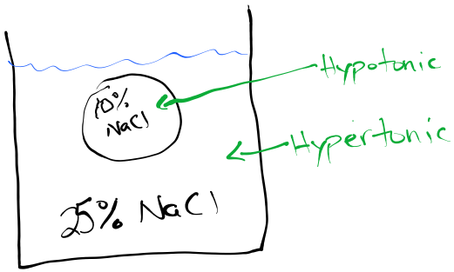
Isotonic - iso (meaning equal to). A solution that has equal concentrations of dissolved solute when compared to another solution. Ex: A solution with 10% NaCl is isotonic to another solution that also has 10% NaCl.
