Osmosis and Tonicity
The plasma membrane of the cell is made up of a phospholipid bilayer with membrane proteins embedded throughout. This structure of the plasma membrane is very important as it allows for it to be selectively permeable, which means it allows some things to pass through but not others. The membrane allows small nonpolar molecules such as oxygen, carbon dioxide, and small steroid hormones to pass through easily, whereas water soluble molecules and ions (charged particles) cannot pass freely through the membrane. Integral proteins may serve as transport channels for water soluble molecules and ions to pass through the membrane. Transporting substances across the plasma membrane may be categorized into passive processes and active processes. Active processes require energy from the cell, whereas passive processes use the energy from a concentration gradient and do not use cellular energy. One example of a passive transport process is osmosis, which is the movement of water across the membrane from where water is in a high concentration to where water is in a low concentration. During osmosis, water will move from the side of the membrane with less dissolved solute to the side with a higher solute concentration. When the relative concentrations of water to solute are equal on both sides of the membrane, the net movement of water ceases and the concentrations are said to be at a state of equilibrium.

If the inside of a cell and the extracellular fluid surrounding it are at equilibrium, the cell is said to be an isotonic environment. Isotonic means that both concentrations are equal on either side of the membrane. If a cell is placed in an environment with less dissolved solute in the extracellular fluid than inside of the cell, the environment is said to be hypotonic to the cell. Since water flows toward the higher solute concentration during osmosis, water will flow into the cell in a hypotonic environment and the cell will swell. If a cell is placed in an environment with more dissolved solute in the extracellular fluid than inside of the cell, that environment is said to be hypertonic to the cell. In a hypertonic environment, water will flow out of the cell and the cell will shrink.

https://www.youtube.com/watch?v=rMa9MzP19zI

Experiment Supplies
Dialysis tubing, scissors, string/clips to secure bags, electronic balance, _ beakers, table sugar or NaCl, graduated cylinder, food coloring

Set up

Prepare the following solutions: 0.9 % NaCl, 10% NaCl, 20% NaCl. Place red food coloring in 0.9% NaCl solution, blue coloring in the 10% NaCl solution, and no food coloring in the 20% NaCl beaker
Fill 2 beakers per each student group with 0.9 % NaCl (no coloring) and with 20% NaCl (no coloring)
Cut 6-inch long strips of dialysis tubing and soak strips in a beaker of water for 3 minutes.

Procedure

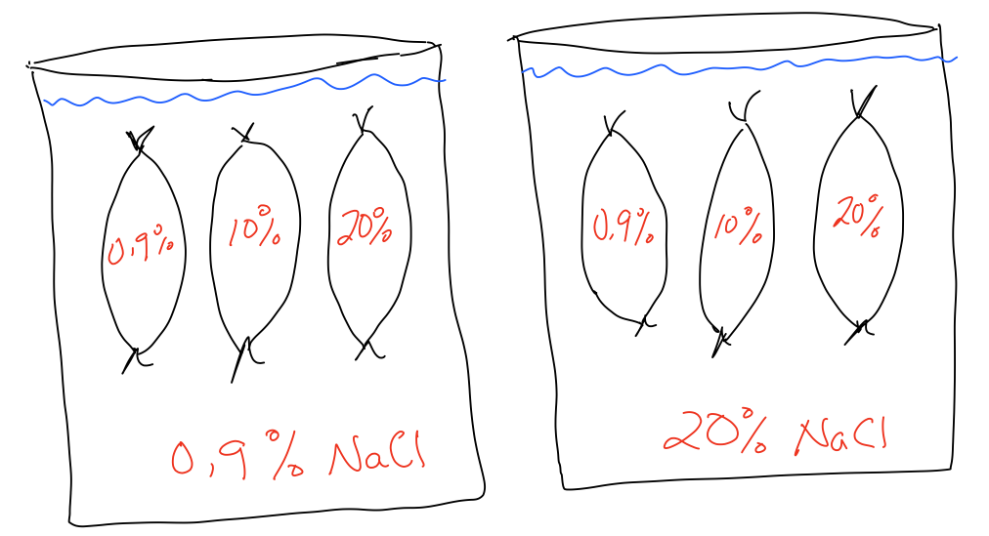

- Tie one end of the dialysis strip with string (or clip).
- Fill dialysis bags according to the above diagram and tie the other end securely.
- Weigh each dialysis bag and record the initial weight.
- Remove and gently pat bags (do not place on paper towel) and weigh according to time table below.
- Refresh the solution in each beaker after each time period.
- Make sure you record each measurement in the table!

Expected Outcomes

0.9% Beaker
- 0.9% - will neither gain nor lose weight
- 10% - will gain weight until equilibrium is achieved
- 20% - will gain weight until equilibrium is achieved

20% Beaker
- 0.9% - will lose weight until equilibrium is achieved
- 10% - will lose weight until equilibrium is achieved
- 20% - will neither gain nor lose weight

Chart to Record Data
Data collected by one group

Beaker | Bag |  | Time
 |  | Initial  Weight | 15 mins | 30 mins | 45 mins | 60 mins | 75 mins | 90 mins
0.9% | A
 | B
 | C
20 % | D
 | E
 | F

