Biology Experiment
Osmosis and Tonicity
The plasma membrane of the cell is made up of a phospholipid bilayer with membrane proteins embedded throughout. This structure of the plasma membrane is very important as it allows for it to be selectively permeable, which means it allows some things to pass through but not others. The membrane allows small nonpolar molecules such as oxygen, carbon dioxide, and small steroid hormones to pass through easily, whereas water soluble molecules and ions (charged particles) cannot pass freely through the membrane. Integral proteins may serve as transport channels for water soluble molecules and ions to pass through the membrane. Transporting substances across the plasma membrane may be categorized into passive processes and active processes. Active processes require energy from the cell, whereas passive processes use the energy from a concentration gradient and do not use cellular energy. One example of a passive transport process is osmosis, which is the movement of water across the membrane from where water is in a high concentration to where water is in a low concentration. During osmosis, water will move from the side of the membrane with less dissolved solute to the side with a higher solute (solid particle, i.e., sugar) concentration. When the relative concentrations of water to solute are equal on both sides of the membrane, the net movement of water ceases and the concentrations are said to be at a state of equilibrium.

If the inside of a cell and the extracellular fluid surrounding it are at equilibrium, the cell is said to be an isotonic environment. Isotonic means that both concentrations are equal on either side of the membrane. If a cell is placed in an environment with less dissolved solute in the extracellular fluid than inside of the cell, the environment is said to be hypotonic to the cell. Since water flows toward the higher solute concentration during osmosis, water will flow into the cell in a hypotonic environment and the cell will swell. If a cell is placed in an environment with more dissolved solute in the extracellular fluid than inside of the cell, that environment is said to be hypertonic to the cell. In a hypertonic environment, water will flow out of the cell and the cell will shrink.

OER OpenStax Biology 2E (further reading)

Link to video describing osmosis and tonicity: Tonicity Explanation

Experiment

The purpose of this experiment will be to observe osmosis in 3 different concentrations of dialysis bags in 2 different bathing solutions. Before the experiment begins, you should read over this procedure and predict one of the following outcomes for each of your dialysis bags: will it gain weight, lose weight, or stay the same weight over the course of the experiment?

Procedure
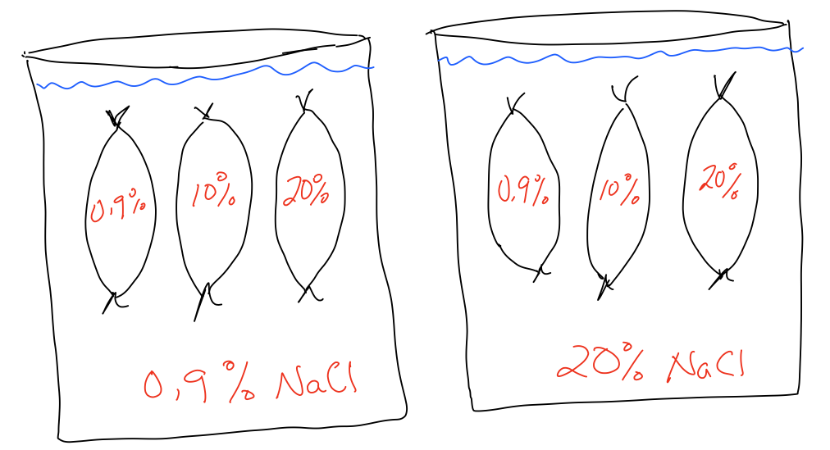

- Obtain a 6 inch dialysis bag from a beaker of water and tie one end of the dialysis strip with a piece of string (or a clip).
- Fill dialysis bags according to the above diagram and tie the other end securely. Each group will have 2 bags with a 0.9% concentration, 10% concentration, and a 20% concentration.
- Weigh each dialysis bag and record the initial weight in your chart. Please do not forget to record the weights!
- Place one group of dialysis bags (0.9%, 10%, 20%) in the 0.9% beaker and the remaining bags in your 20% beaker.
- After 15 minutes have passed, remove and gently pat bags (do not place on paper towel) and weigh the bags on the electronic balance. Be sure to record your new weight in the chart. After weighing the bags, place bags back in the beaker.
- Pour out the solutions in the 0.9% and 20% beakers and replace with new solution for each recorded weight.
- Repeat steps 5 and 6 until 90 minutes is reached (or whatever your class period will allow for). Make sure you record each measurement in the table!

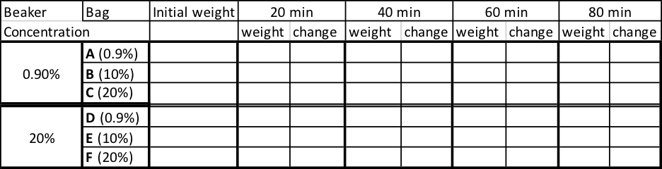

Math Activity

Introductory Statistics from OpenStax

Video: Regression

The mathematics activity will involve plotting the change in weight on the y-axis versus the time on the x-axis.The goal of plotting these points on a graph is to determine if a linear correlation exists between the two variables. A linear correlation exists between two variables when a straight line can be drawn through the plotted points.
Figure 12.6 (a) has strong linear correlation since we can easily draw a line that is close to the given points. In particular, the line drawn near the points would have a positive slope, meaning the data set would have positive linear correlation.
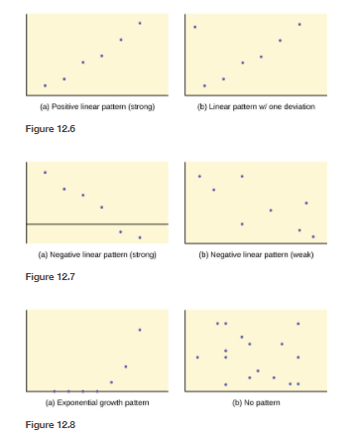
For figure 12.6 (b), we can draw a line that would be close to most of the given points in the scatterplot. However, this picture does have an outlier (the point in the top left corner). Due to the outlier, we would need to do a formal test for linear correlation to determine if it exists for this given example.

Figure 12.7 (a) has strong linear correlation since we can easily draw a line that is close to the given points. In particular, the line drawn near the points would have a negative slope meaning the data set would have negative linear correlations.

For figure 12.7 (b), we can draw a line that would be close to most of the given points in the scatterplot. However, we would have several points that would be far from the line. So, we would need to do a formal test for linear correlation to determine if it exists for this given example.

Figures 12.8 (a) & (b) would have no linear correlation since it would be difficult to find a line that would be near most of the points in the scatter plot. However, we would need to conduct a formal test for linear correlation to confirm.

Regression Line:
A least-squares regression line is simply a line that fits the plotted points best. The regression line minimizes the vertical distances between the data values and the regression line. Fortunately, we do not have to do these calculations by hand. There are plenty of technology options including Excel, Google Sheets, or TI-84 calculators. You will also be given an r value, the correlation coefficient, when you plot your data and get your regression line. Your r value tells you how strong your correlation is. The linear correlation coefficient r measures the strength of a linear relationship between the variables. The closer r is to 1 or -1, stronger the relationship is between the variables. If r is positive, the line will be increasing. If r is negative, the line will be decreasing. The closer r gets to 0, the less likely there is a linear relationship.

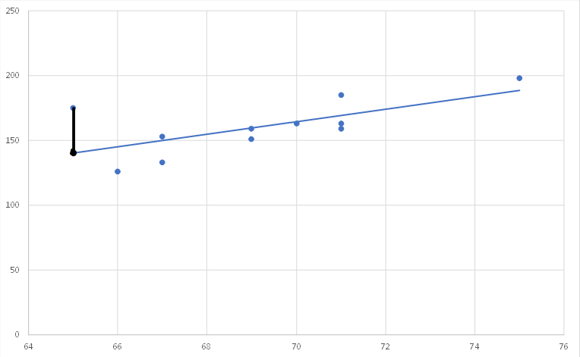

Residual = |observed value – predicted value|
observed value
predicted value

Next step: Use y = mx + b to calculate the slope of each line and compare. Then determine if results are statistically significant to show differences in rates of osmosis.
The equation of the line generated above can be written as $y=mx+b$ where y is the dependent variable (vertical axis (change in weight)) and x is the independent variable (horizontal axis (time)). The initial value of the dependent variable is b which is where the graph crosses the vertical axis. The quantity m is called the slope and it describes the constant average rate of change. The slope can be found by finding the change in the dependent variable per a certain change in the independent variable.

For instance, in the example graph below, the equation of Bag A: y = 0.0054x + 10.301
The slope (m) of the line is 0.054 g/min. This means that the bag gains weight at an constant average rate of 0.0054 g per minute up to the point of equilibrium.
This line crosses the vertical axis at 10.301g.
The higher the number representing (m), the steeper the slope is. In this activity, the steeper the slope, the faster osmosis is occurring due to a higher gradient between concentrations of sucrose.

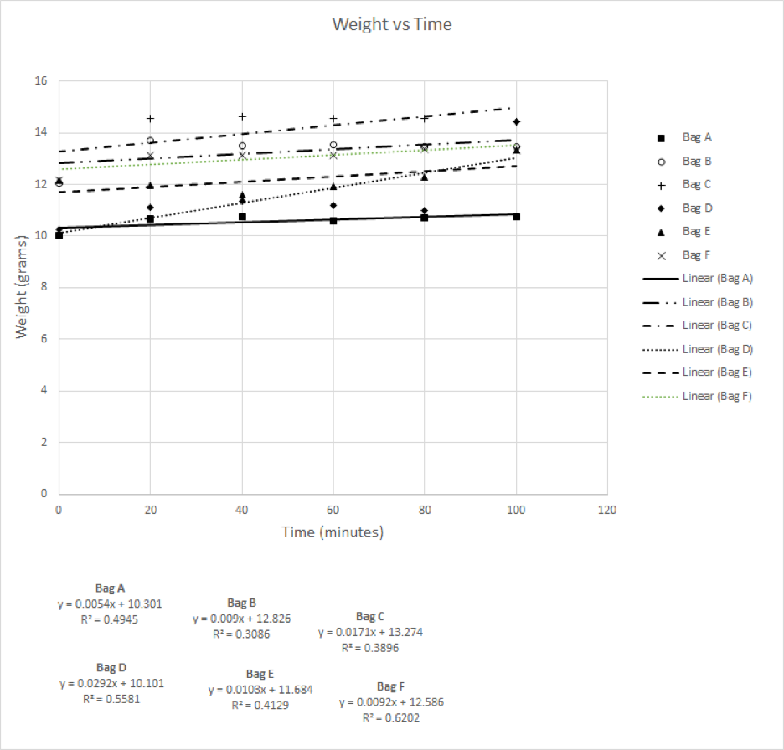

Statistical Analysis
A hypothesis test can be run in excel to determine if the data provides sufficient evidence to claim there is a true linear correlation between the variables. See instructor guide if you wish to run a hypothesis test to determine linear correlation.

How to use Excel to find the linear correlation coefficient and p-value:

P Value Test for Linear Correlation in Microsoft Excel
Graphing Least-Squares Regression Lines in Microsoft Excel with Multiple Data Sets on One Graph
How to Fix Wrong Axes on Graph

