The Evolution (and Coevolution) of Flowering Plants Virtual Classroom | 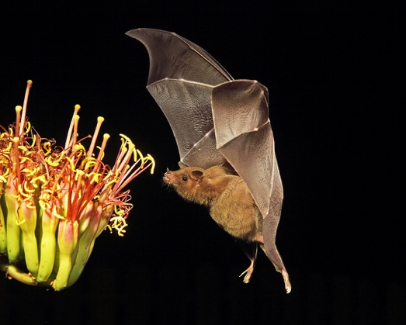

Objectives

Upon completion of this module, each student should be able to:
- Describe the role of flowers in angiosperm reproduction.
- Identify the parts of a flower.
- Explain the role of pollinators in the life history of angiosperms.
- Define coevolution and identify selection pressures that exist between pollinators and the plants they pollinate.
- Predict pollinator/plant pairs based on morphological traits.
- Collect data from a digitized natural history collection.
- Analyze spatial co-occurrence data for pollinators and the plants they pollinate.
- Tools of Biology: Discuss how data from natural history collections can be used to investigate scientific questions with large temporal or spatial scales.

- Introduction to Angiosperm Reproduction

The angiosperms (Phylum Anthophyta) are unique compared to the rest of the plant phyla in that they produce flowers and fruits as part of their sexual reproduction. Since plants are immobile, they are not able to travel in order to seek mates, copulate, and disseminate their offspring. As a result, plants have evolved a number of novel strategies in order to accomplish these tasks. Flowers and fruits are modified in a variety of ways in order to facilitate pollination and seed dispersal, both by biotic and abiotic means.

In this lab, you will explore the diversity of flower and fruit adaptations that have evolved to accomplish pollination and seed dispersal and you will investigate the coevolution of angiosperms and their pollinators. In addition, you will be introduced to another “tool” that biologists use to study life… Natural History Collections.

- Flower Structure

A "flower" is a shoot (stem and leaves) modified for reproduction. Flowers can arise singly or in a cluster called an inflorescence. A stem-like structure called a peduncle supports an inflorescence or a solitary flower. Pedicels are the structures that support individual flowers of an inflorescence. The end of the peduncle is often expanded to form a receptacle to which the floral parts attach. Flowers can have up to 4 whorls of flower parts. From the outside working in, the parts that make up those whorls include:

  - Sepals - often leaflike and green; protect the flower during the bud stage. Some sepals are modified to look nearly identical to the petals, but they are located to the outside of the actual petals. The collective whorl of sepals is referred to as a calyx.

  - Petals - found to the inside of the calyx (if present) and are often pigmented and showy in order to visually attract pollinators. Petals may be separate or fused; together, they are collectively referred to as a corolla. If the calyx and corolla are both "petal-like", combined they are called the perianth.

  - Stamens - consist of a stalk-like filament supporting a pollen-producing anther. The collective arrangement of stamens represents the male part of the plant and is referred to as the androecium ("house of men").

  - Carpels - female floral parts; lie to the inside of the androecium. A carpel consists of 3 parts: a) ovary - the broadened base of the carpel which contains the ovules, b) style - an elongated structure extending from the top of the ovary and through which the pollen tubes will grow in order to deliver sperm to the egg, and c) stigma - the often sticky terminal end of the style which receives and adheres pollen grains. The carpels are referred to collectively as the gynoecium ("house of women").

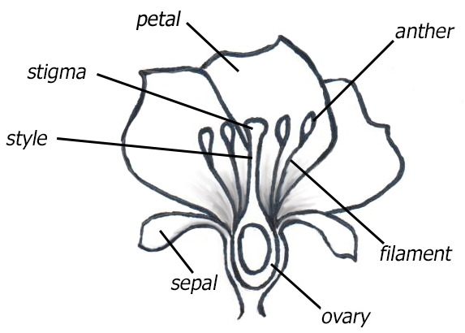

Figure 1. Flower Structure.

A flower is considered "complete" if all four whorls are present and "incomplete" if one or more whorls are absent. "Perfect" flowers have both male and female parts present; "imperfect" flowers are either male or female.

When looking at a whole flower, if the floral parts can be arranged so that any cross section of the flower has a mirror image, it is called radially symmetric. If the flower only has only one cross section that produces a mirror image, the flower is described as having bilateral symmetry.

Is this statement true or false? “All complete flowers are perfect.” Explain your answer.

Examine this picture of a flower. Label all the flower parts you see.
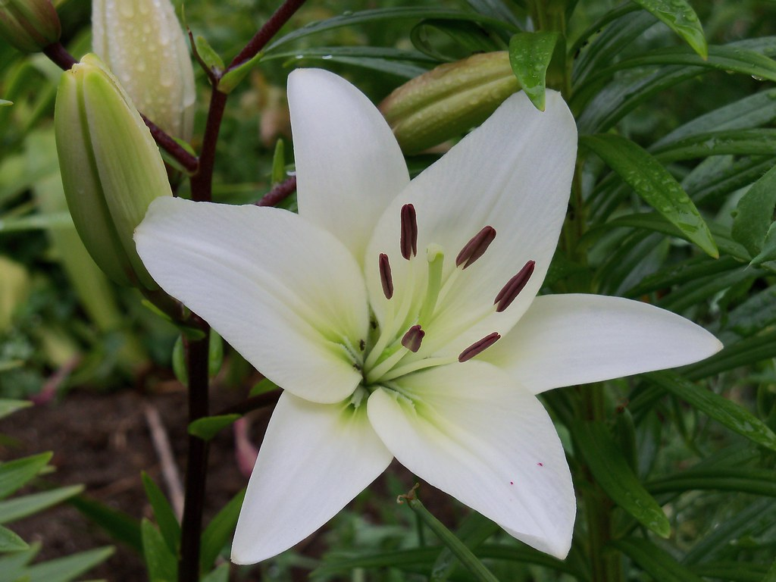

Is the flower complete or incomplete?

Is the flower perfect or imperfect?

Is the flower radially or bilaterally symmetrical?

- Pollinators and Pollination Syndromes

In angiosperms, pollination refers to the transfer of pollen from an anther to a stigma. Pollination is distinct from fertilization, which occurs when male and female gametes fuse to form a zygote. Because plants are immobile, they are unable to seek out and physically interact with a mate to carry out sexual reproduction. As a result, they must rely on other means to bring the male and female gametes together. In some cases, abiotic (non-living) agents such as wind and water are responsible for pollen transfer. However, many plants have biotic (living) pollinators, such as birds and insects, that move from flower to flower (often gathering food) and transfer pollen that has stuck to their bodies. Flowers have evolved many different ways to attract pollinators and facilitate pollen transfer. Some cues are visual, like flower color and pattern, flower size, and showy petals and sepals. Some flowers use scents to attract pollinators and foods like nectar and protein-rich pollen to reward them for the visit. Other flowers use pure trickery to attract pollinators under false pretenses.

The suite of characters exhibited by a plant that is associated with a specific pollination vector is called a Pollination Syndrome. Often you can infer the pollinator of a plant based on its floral morphology. Read the material on this website and fill in as much of Table 1 as you can, based on the information provided. http://www.fs.fed.us/wildflowers/pollinators/What_is_Pollination/syndromes.shtml

Table 1: Pollination syndromes

Pollinator | Color | Scent | Flowering time | Corolla | Reward | Examples
Beetle | Green or white | Various but often strong | Day and night | Enclosed or open | Nectar and pollen | Magnolia and Spice Bush
Fly (reward) | Light | Faint | Day | Radial symmetry; shallow flower | Nectar and pollen | Wild Radish
Bee
Butterfly
Moth
Fly (carrion)
Bird
Bat
Wind

Complete the matching game on this website and write/type your matched sets below.

http://www.pbs.org/wgbh/nova/nature/pollination-game.html

a.

b.

c.

d.

e.

f.

g.

- Coevolution Case Study [using Natural History Collection Data]

Any trait that increases the frequency of pollen transfer should increase a plant’s fitness and will be favored by natural selection. Likewise, any trait that the pollinator possesses that increases its feeding efficiency on the nectar and/or pollen can increase the pollinator's fitness. The plant and its pollinator, then, act as selection pressures on each other. This reciprocal selection is called coevolution. In fact, the great diversity in angiosperms is thought to be largely a result of this coevolution with biotic pollinators, such as animals, and insects in particular. About 150 million years ago there was a rapid increase in the diversity of flower-visiting insects. This correlates with a rapid increase in angiosperm diversity and is hypothesized to be the primary factor driving angiosperm evolution.

You are going to examine the coevolution of agave and their bat pollinators. You will be using data from digitized natural history collections. These are online databases that provide access to the data from natural history collections such as museums and herbaria (collections of preserved plant specimens). Natural history collections are found all over the world and contain a vast archive of valuable biodiversity information that chronicles changes in the distribution and morphology of species over time. Scientists believe we have up to 6 billion specimens archived in natural history collections. First you will learn a little about these data resources, then you will explore the biology of agave and bat pollinators, and finally, you will complete a series of exercises where you will examine real data and analyze this complex relationship.

Data Resources

iDigBio Portal: www.idigbio.org/portal (iDigBio tutorial)

The iDigBio (Integrated Digitized Biocollections) Portal is a data aggregator for digitized natural history collection data. The name iDigBio stands for Integrated Digitized Biocollections. All data in this portal is linked to a specimen in a natural history collection and can thus be independently verified. New data is being uploaded to the iDigBio Portal every day. Look at the webpage, how many specimens are in the iDigBio portal today?

GBIF Portal: www.gbif.org (GBiF tutorial)

The GBIF (Global Biodiversity Information Facility) portal is a data aggregator for all types of biodiversity occurrence data. The GBIF aggregator includes observation-only data (not linked to a specimen preserved in a natural history collection) in addition to specimen-based natural history collection data. Observation records can come from sources such as citizen science data collected by volunteers (e.g. Christmas Bird Counts), as well as observations made by researchers in ecological field studies. Look at the page that shows the number of occurrence records currently on GBIF. What is that number today?

Agave, Bats and Tequila!
Tequila is made from the plant Agave tequilana, a large plant with a blue green coloration and spikey fleshy leaves arising in a rosette. Agave can take 5 years or more to flower. When A. tequilana flowers, it produces a single flowering stalk that can be up to 15 feet high and has a large inflorescence. Once pollinated, the plant can produce thousands of seeds and then it dies. Agave tequilana is an "at risk" species due to both the fragmentation of native habitat and the harvesting of young A. tequilana before they mature and set seed. Agaves are chiropterophilous or bat-pollinated. Using what you already know, describe what you would predict to be the characteristics of the Agave tequilana flowers?

Multiple bat species pollinate the agave species. This is not surprising as the nectar is particularly rich in both sugar (~20%) and protein (~50%). The bats are not completely dependent on a specific species of plant. The bats that pollinate Agave tequilana can also pollinate several other species of Agave as well as some cactus species. All of these bat-pollinated species must attract the bats and the bats must all be able to reach the rich nectar the plants provide. Look at the images provided of flowers from these three bat pollinated plants. What characteristics do you think the bats must possess to pollinate these cacti or agave?

The Mexican long-nosed bat (Leptonycteris nivalis) and the lesser long-nosed bat (Leptonycteris curasoae) are the primary pollinators of Agave tequilana. Therefore, Tequila Agave is dependent on these two species. These bat species both migrate every spring over 1000 miles moving from Mexico into the southwestern US. In this scenario, how would you predict the distribution of the pollinator species to compare to the distribution of the plant species? Pick from one of the examples below:

- Distribution of Agave tequilana will overlap completely with the bat pollinators

- Distribution of Agave tequilana will be more extensive than the bat pollinators

- Distribution of the bat pollinators would be more extensive than the Agave tequilana.

Explain your choice:

Go to the iDigBio portal and input these three species. [iDigBio tutorial] How many records can be found for each species? What do you note about their distribution?

Species | Number of records | Distribution
Leptonycteris nivalis
Leptonycteris curasoae
Agave tequilana.

Go to the GBIF portal and input these three species. [GBiF tutorial] How many records can be found for each species? What do you note about their distribution?

Species | Number of records | Distribution
Leptonycteris nivalis
Leptonycteris curasoae
Agave tequilana.

How does the distribution of individual species differ when using data from the different portals, GBIF and iDigBio? Why would this be the case?

What did you observe for distribution of Agave tequilana relative to the bat pollinators?

- Distribution of Agave tequilana overlaps completely with the bat pollinators

- Distribution of Agave tequilana is be more extensive than the bat pollinators

- Distribution of the bat pollinators is more extensive than the Agave tequilana.

How would you explain the observed distributions?

When the Mexican long-nosed Bat and the lesser long-nosed bat migrate they are dependent on the flowering cactus and agave plants for the sugar and protein-rich nectar along the route. The bats are not species specific in their nectar foraging but instead can feed on several types of paniculate agaves (e.g., Agave angustifolia and agave tequilana) and columnar cacti (e.g., Carnegiea gigantea). Go to the iDigBio portal and input these three species. How many records can be found for each group? What do you note about their distribution?

Group | Number of records | Distribution
Carnegiea gigantea
Agave angustifolia
Agave tequilana

Click on some of the individual records for Agave tequilana. Some records include images of the specimens. Look at some of these images. In what months were this species collected in the US? Mexico? In which month are they flowering in the US? Mexico?

Look at images of Carnegiea gigantea specimens. In what months were this species collected in the US? Mexico? In which month are they flowering in the US? Mexico?

The lesser long-nosed bat (Leptonycteris curasoae) is one of only three species of bat nectarivores that have substantial long-distance migration (up to 1800 km). Migrating from central Mexico, the northernmost roosting sites are just across the border into the southwestern part of the US. Lesser long-nosed bats form spring maternity roosts in northern Mexico and the southern US. Southern migration occurs in late summer and early fall. From October to December, males and females congregate in southern/central Mexico to mate.

What food source do the lesser long-nosed bats use in May?

What food source do the lesser long-nosed bats use in August?

What food source do the lesser long-nosed bats use in December?

Humans have a long history of fear associated with bats. Vampire bats have a particularly bad reputation, as they feed on blood from cattle and sheep sleeping at night and can carry disease and promote infection that can spread to other livestock and even humans. Ranchers use a variety of tactics to kill the vampire bats. The kill practices are often targeted at roosts in caves and can wipe out most of the bats in a cave. Go to the iDgBio portal and input the three species of vampire bats listed in the table below. How many records can be found for each group? What do you note about their distribution?

Group | Number of records | Distribution
Desmodus rotundus
Diphylla ecaudata
Diaemus youngi

Look at the distribution of the three species of vampire bats. How does that compare to the distribution of Mexican and lesser long-nosed bats?

Based on the distribution and preferred roosting sites, does the cave-wide mass extermination of vampire bats appear to pose a risk to Mexican and lesser long-nosed bats? Explain your answer.

Examine the pictures of the two nectarivorous and three blood-eating (hematophagus) bats provided. What features of each group of bats are well adapted to their food source?

Species | Food source | Morphological adaptation to food source
Diphylla ecaudata
Diaemus youngi
Diphylla ecaudata
Leptonycteris nivalis
Leptonycteris curasoae

- Fruit

Once a flower is successfully pollinated, the sperm cells released from the pollen make their way to the egg in the ovule, which is inside the ovary. The ovule develops into a seed, which contains the plant embryo and food supply, surrounded by a tough coat that protects the embryo and prevents water loss. The surrounding ovary develops into a fruit. The ovary wall becomes variously modified in fruits and is called the pericarp. The pericarp has three parts: exocarp. mesocarp and endocarp. Exocarp is the outer wall of the fruit. Mesocarp is the middle wall of the fruit; often it becomes fleshy. Endocarp is the inner wall of the fruit; it may be papery or hard and bony.
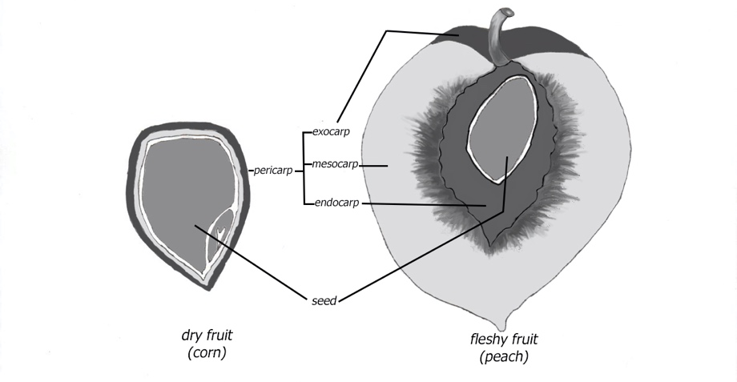
Figure 2. Fruit Structure.

In some cases, ovaries develop into fruits without fertilization. This kind of fruit development is called parthenocarpy. Because fertilization is required in order to produce a viable seed, parthenocarpic fruits do not have seeds. Many of the "seedless" varieties of fruits found in the supermarket (e.g., watermelons, grapes, bananas, cucumbers) are the result of parthenocarpy.

The arrangement of the carpels in the flower determines the type of fruit that develops. Multiple fruits result when the gynoecia from multiple flowers come together to form one fruit. Aggregate fruits occur when separate carpels from the same gynoecium become part of the same fruit. Simple fruits arise from one (or a few) carpels. Simple fruits are the most common and there are several different categories of simple fruits.

Categories of Simple Fruits:

- Fleshy fruits are soft when ripe. This category includes most of the fruits and many “vegetables” we eat. There are different types of fleshy fruits, distinguished by their structure, texture, and seed number and placement.
  - Berries - the inner wall is soft and fleshy; contain many seeds
  - Hesperidium – berry-like with a tough, aromatic rind; contain many seeds
  - Pomes - the inner wall is thin and papery; contain many seeds
  - Drupes – the inner wall is stony; contain a single seed

- Dry Fruits are woody or papery when mature. The ovary wall may break open at maturity, dispersing the seeds. In this case, the fruits are called dehiscent fruits. If the fruit remains intact with the seeds inside, the fruits are indehiscent. There is variation within both groups.

Dehiscent Fruits
  - Follicles – single ripened ovary; ovary wall only breaks along a single seam
  - Legumes – single ripened ovary; ovary wall breaks at two seams
  - Silliques – single ripened ovary; ovary wall breaks at two seams; a papery membrane (septum) remains intact between the two halves
  - Capsules – composed of multiple ripened ovaries; each ovary wall splits longitudinally or seeds are released through holes
Indehiscent Fruits
- Achenes – contain a single, small seed that is attached to the ovary wall at only one point.
- Samaras – achenes that have the adaptation of “wings” that assist in wind dispersal
- Caryopsis – the fruit wall and the seed are fused together
- Cypsela – similar to achene, but the fruit includes a modified calyx, called a pappus, that is often feather-like and aids in wind dispersal
- Nuts – like an achene with a stony fruit wall
- Schizocarps – composed of multiple carpels that break apart into pieces containing seeds

- Seed Dispersal

The evolution of fruits in angiosperms improved the efficiency of seed dispersal. In fruits, the seeds are protected during dispersal by a carpel composed of tissue from the parent. The different types of fruits have various structures that aid in dispersal. Fleshy fruits have soft walls and lots of sugars and are brightly colored at maturity. These features attract various animals that eat the fruits and later disperse the seeds in their feces. Other fruits have adaptations that help fruit attach to animals. This is more common in small, dry fruits. Adaptations that aid in this attachment include the barbs and, hooks, as well as the production of sticky substances.

Some fruits do not rely on animals for their dispersal at all. Fruits can be dispersed by both water and wind. In some species the fruits are small enough to be dispersed directly by the wind without the aid of any specialized structures. Other wind-dispersed species may have wing-like appendages that help catch the breeze. For water dispersal, fruit tissues may contain trapped air that provides buoyancy for floating as the water carries them away.

Some plants have evolved adaptations that allow the plant to actively disperse its own seeds. For example, as the fruit dries out, the wall of the fruit may shatter, tossing the seeds out some distance from the parent. In mistletoe, water pressure builds up in the fruit and shoots the seeds up to 15 meters away.

Table 2. Use the information above and the internet to compete the table below for the six types of fruits listed.

Example Plant | Simple |  | Aggregate | Multiple | Fruit  Classification | Predicted  Dispersal Mode
 | Fleshy | Dry
 |  |  |  |  | Berry
 |  |  |  |  | Drupe
 |  |  |  |  | Legume
 |  |  |  |  | Nut
Strawberry
Pineapple

References:

White Lily image: "White Lily" by Wylie-Young is licensed under CC BY 2.0
Lesser long-nosed bat and agave image. Photo by John Hoffman: https://images.app.goo.gl/GcNgBbEfybYvd2jz6
Pollination Syndromes: http://www.fs.fed.us/wildflowers/pollinators/What_is_Pollination/syndromes.shtml
Pollinator matching slides:
http://www.pbs.org/wgbh/nova/nature/pollination-game.html

