Using Semi-log Graph to Demonstrate Bacterial Cell Growth

Learning Objectives
After completing this activity, students will be able to:
- explain microbial growth and binary fission in bacterial cells.
- summarize the events occurring in the lag, log, stationary, and death phases in the bacterial culture growth curve.
- demonstrate bacterial growth using generation time for a given dataset.
- graph given values on arithmetic and semi-logarithmic graphs.
- compare and contrast plotted data on arithmetic and semi-logarithmic graphs.
- discuss the x- and y-axes scaling on arithmetic and semi-logarithmic graphs.
- state the domain and range of a table or graph, as well as the independent and dependent variables.
- relate math skills to science by graphing exponential functions using equations with formulas written with subscripted variables similar to what they might see in a scientific textbook or journal and also identifying domain and range of a scientific problem.

Introduction
In this activity, you will explore the concept of binary fission, generation time, microbial growth and bacterial growth curves, with an emphasis on the log phase. You will plot bacterial cell growth using both semi-logarithmic (semi-log) and linear scaled graphs. You will use select mathematical skills in addressing biological questions.

Concept: Binary Fission
Binary fission is a form of asexual reproduction occuring in prokaryotic cells. In order to divide and reproduce, parent cells increase their number of cellular components and replicate their DNA to ultimately form 2 new cells (1 cell becomes 2 daughter cells). Binary refers to one cell becoming two cells, while fission means the act of dividing into 2 parts. Binary fission is a relatively simple process and can occur in as quickly as 20 minutes in some bacteria if given the proper nutrients and environment.

Generation time is the average amount of time for a cell in a population to complete a binary fission cycle. Generation time is often referred to as doubling time as it is the amount of time needed for both a single cell, or population of cells to double. The relationship between the number of generations and the concept of a cell doubling can be modeled by the equation N = N₀ x 2^{x}, where N represents the number of viable cells, N₀ represents the number of viable cells at the beginning of growth, and x represents the number of generations. For example, let’s compute the number of viable cells for a single bacterial cell that has a generation time of 20 minutes after a 40-minute time period. Let’s begin by plugging in the numerical values to the equation above, where N₀ = 1 because this example starts with a “single bacterial cell.” If the cell divides every 20 minutes, then a 40-minute time frame should yield 2 divisions. Therefore, x = 2. The values are plugged into the equation as seen below. There would be 4 cells produced after two generations.
N = N₀ x 2^{x}
N = 1 x 2²
N = 1 x 4
N = 4

These numerical values are plotted on mathematical scales, arithmetic (linear) and logarithmic, to demonstrate bacterial growth over time. Arithmetic scales show linear relationships between the x- and y-axes. However, exponential growth occurs in bacterial cells during binary fission. Exponential growth occurs when numerical values increase rapidly over a period of time, and generates a curve similar to an exponential function. As a result, semi-log graphs can be used to display an increase or decrease in the range values (y-axis) when those changes are easier to see on a scale of a factor of 10. Semi-log graphs are useful because one axis is linear and the other axis is logarithmic. Notice that typically, the y-axis on the semi-log graph is logarithmic while the x-axis remains linear.

Part 1: Comparing arithmetic and semi-log graphs.
- Answer the following questions:
  - What occurs during binary fission? ____________________________________

- Use the arithmetic graphing paper to plot y= 4^{x} when x = -2, -1, 0, 1, 2, 3, 4, 5, 6, 8, and 10.
  - Complete Table for x/y values.

X | Y
-2
-1
0
1
2
3
4
5
6
8
10

  - Retrieve a sheet of graphing paper with the arithmetic scale. Plot the values.

- Use the semi-log graphing paper to plot y= 4^{x} when x = -2, -1, 0, 1, 2, 3, 4, 5, 6, 8, and 10.
  - Using the table above, plot the same values on the semi-log graphing paper.

- What are some similarities between the graphs from questions 2b and 3a?

- What are some differences between the graphs from questions 2b and 3a?

- Using the equation, N = N₀ x 2^{x}, if a bacterial species has a generation time of 15 minutes, how many cells would a single cell produce after an hour?

Concept: Bacterial Growth Curves
Bacterial growth curves exhibit four phases: lag phase, log phase, stationary phase, and death or decline phase. Lag phase occurs immediately after the media is inoculated with the bacterial culture. The cells in lag phase are either spending their energy producing enzymes needed to metabolize the new media or are so sparse in number that sampling methods do not detect significant numbers of them. Log phase describes the growth period of exponential cell division due to binary fission. The generation time (the time of a complete binary fission cycle) of a specific bacteria is determined during log phase growth as it is the fastest of the phases. Once waste products of the bacterial culture begin to build up and nutrients begin to run out, the culture enters a stationary phase. During the stationary phase, the number of new cells produced due to cell division is equal to the number of cells dying, thus generating a stable population. This is followed by the death phase of growth once limiting factors of growth generate more cells dying than are dividing with a subsequent decline in population. The graph below shows the stages of bacterial growth over time.

Typically, cell density is displayed as a representation of the cell population over time, generating the curve on a graph.

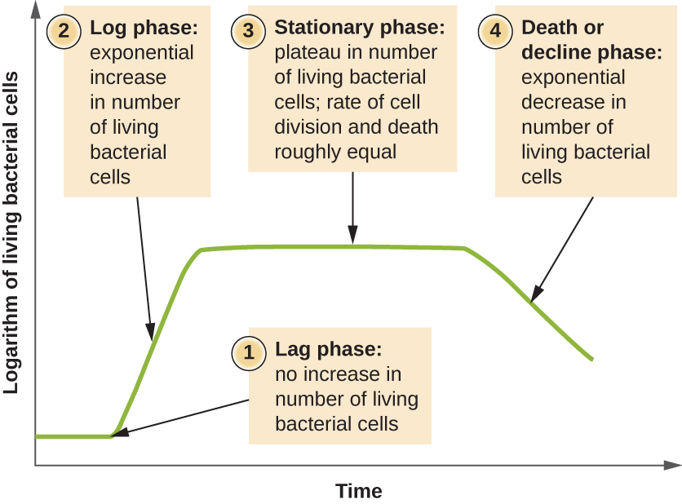
Source: https://openstax.org/books/microbiology/pages/9-1-how-microbes-grow

Part 2: Compare and contrast the role of graphing in mathematics and science contexts.
In science, the independent variable in an experiment is the occurrence that is not the object of study. For example, most experiments are conducted over time or demonstrate a phenomena occurring based on a known quantity. These values are the independent variables and are plotted along the x-axis (domain). The value of the dependent variable varies depending on the independent variable. In our sample problem, the number of living bacterial cells (dependent variable) varies over time (independent variable). Typically, dependent variables in an experiment are the phenomena being studied and are plotted along the y-axis (range). The bacterial growth curve shown above has time on the x-axis and the logarithm of living bacterial cells on the y-axis.

Graphically, the domain is the set of x-values represented on the graph and the range is the set of y-values represented on the graph.

- Answer the following questions:
  - During which phase will the number of bacterial cells be at equilibrium?

  - Which two phases show an inverse relationship? Explain.

  - Why is the log phase the focal point of this activity?

  - Which of the following is the best definition of generation time?
    - The duration of log phase
    - The time needed for nuclear division
    - The length of time needed for a cell to divide
    - The length of time needed for lag phase

  - From the equation in part 1, y= 4^{x}, the domain includes all numbers from negative infinity to positive infinity (all possible numbers along the x-axis). Find and state the range of y= 4^{x}. In other words, what are the y-axis values of y= 4^{x} ?

- Think of how math and science are similar and different in graphing. Use the Venn Diagram to compare and contrast graphing in math and science contexts.

Concept: Putting Biology into Perspective - Growth of Staphylococcus aureus
Staphylococcus aureus is a gram-positive bacterium that inhabits the surface of the skin. The term Staphylococcus refers to the circular or spherical morphology (shape) of the bacteria and individual cells divide into formations of clusters rather than form a linear chain. As the bacteria live in the healthy microbial flora of the human skin, it is considered commensal.

Commensalism is a type of species relationship in which one member, in this case, S. aureus, benefits, while the other member is neither benefited or harmed. Typically, S. aureus inhabits the outer skin of humans without causing harm. Occasionally, if a person experiences lowered immune defenses due to illness, S. aureus can become an opportunistic pathogen and cause an infection in a compromised host. Due to this, understanding the growth rate of S. aureus bacteria is important for human health. Researchers have found that the generation time of a typical S. aureus colony is 27 minutes.

Typically, the growth rate is represented by the equation: $N_{0}*2^{x}=N$, where $N_{0}$represents the number of viable cells at the beginning of growth, x represents the number of generations, and $N$represents the number of viable cells in the colony at a specific x. While this equation has no time variable, it is often represented graphically over time by calculating the time required for each generation (generation time). This equation represents the cell growth over a given number of generations and would look the same for all bacteria since it is comparing cell count to a number of generations. Observing the generation time between different bacterial species allows for a comparison between the different amounts of elapsed time that are needed for a culture to double.

It is important to note the semi-log graphs are an estimation of the number of viable cells over time. In a real-world application, the numbers can vary. Also, bacterial species have varying generation times as seen below in Table 2.

Table 2: This table shows the maximal growth rates (as stated in generation time) for select microorganisms from the work of M. M. Mason.

Organism | Generation Time (in minutes)
Streptococcus lactis (grown in milk and peptone) | 37
Escherichia coli (grown in broth) | 17
Salmonella enteritidis | 21.5
Clostridium botulinum | 35
Serratia marcescens | 37

Part 3: Plotting Staphylococcus aureus growth.
In this activity, we will compare the viable cell count as it relates to the generation time for S. aureus. By looking at the graph of generation time versus cell count, you would be able to compare differences in doubling times for different bacteria which would be modeled by a different exponential growth formula that you may have studied in college algebra.

Complete the table below before answering the questions.

Table 3: This table shows the maximal growth rates of S. aureus over the time it takes to complete a binary fission cycle.

Maximal Growth Rates of Staphylococcus aureus
Number of Generations | Time (Min) | Viable Cell Count
 | 0 | 1
 | 27 | 2
 | 54 | 4
 | 81 | 8
 | 108 | 16
 | 135 | 32
 | 162 | 64
 | 189 | 128
 | 216 | 256
 | 243 | 512
 | 270 | 1024
 | 297 | 2048
 | 324 | 4096
 | 351 | 8192
 | 378 | 16384

Answer the questions below:
- Referring to both arithmetic and semi-log graph paper:
  - What will be the x-axis label on your graph?

  - What will be the y-axis label on your graph?

- How are the x-axis and y-axis scales in the semi-log graph different from the arithmetic graph? Explain.

- Use the data table above to plot the growth of Staphylococcus aureus on both arithmetic and semi-log graph paper.

Additional Questions
- What do you estimate the number of viable S. aureus cells to be after 20 generations?

- Compare the number of cells from the calculated generation time in Part 1 to the viable cell count values from the growth of Staphylococcus aureus in Part 3.

- Think about decisions scientists often must make concerning data. What do you perceive the benefits to be of graphing on a semi-log graph vs. a linear (arithmetic) graph?

Extension
- Scientists have isolated an unknown microorganism that doubled every 75 minutes in 13 generations. There were 16,384 viable cells produced.
  - What was the initial number of cells?

- Assume scientists have a mixed culture of S. aureus (generation time of 27 minutes) and Escherichi coli (generation time of 20 minutes). There are two initial cells of each bacterial species. How many viable cells should be present after 3 hours and nine minutes?

