Plants in the Human-Altered Environment (PHAE) Research Project

Module 2: Characterize your study site’s climate

You can easily obtain a wealth of information on the climatic and geographic characteristics of your study site online. These characteristics vary across the continent (and globe) and influence the potential for plant growth. For example, note the patterns in mean annual temperature and precipitation (Figure 1) for the 30-year period from 1981-2010 in the United States.
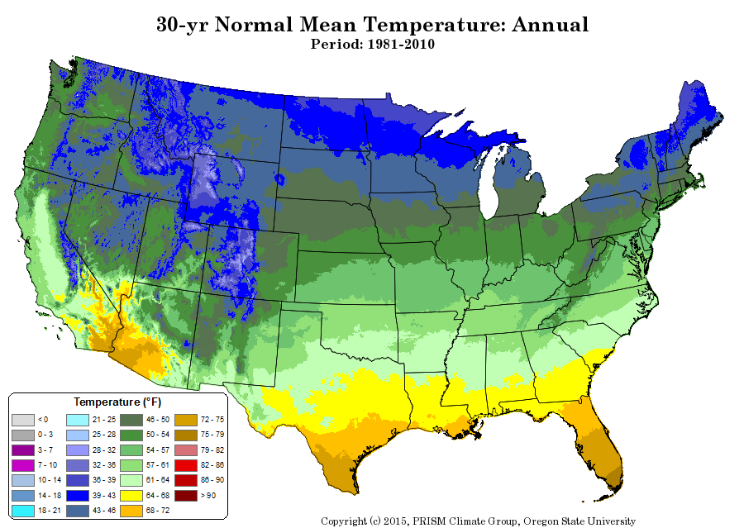

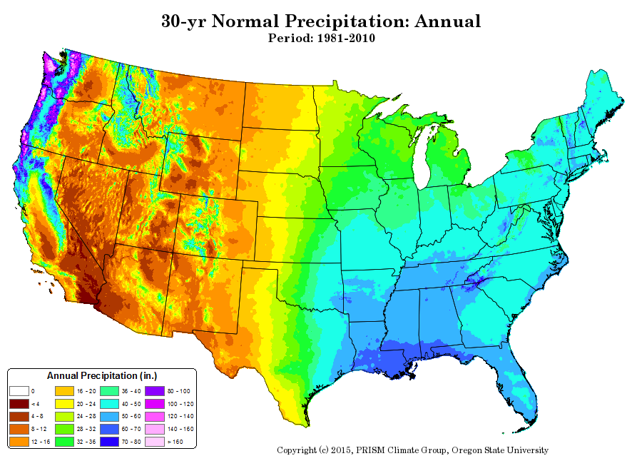

Figure 1. Mean annual temperature (top) and precipitation (bottom) (1981-2010) for the contiguous U.S. Map is from Northwest Alliance for Computational Science & Engineering (NACSE), Oregon State University.
Questions:
- What pattern(s) do you see in mean annual temperature and precipitation (Figure 1)?

- How are these patterns similar/different, and how do they relate to each other? Does one affect the other or vice versa? Why?

Questions:
- What effects might the combinations of these patterns have on the length of the growing season for plants?

- What kinds of adaptations might you see in plants as a result of the combinations of these patterns of mean annual temperature and precipitation?

We typically use the most recent 30-year average for temperature and precipitation variables to get “mean annual” values. You can find the most recent set of these data, called 1981-2010 U.S. Climate Normals, from the National Centers for Environmental Information (NCEI), a service of the National Oceanic and Atmospheric Administration (NOAA) of the US government. This dataset contains daily, seasonal, and monthly Normals of temperature, precipitation, snowfall, heating and cooling degree days, frost/freeze dates, and growing degree days calculated from observations at approximately 9,800 stations operated by NOAA’s National Weather Service.

Part 1: Find a weather station near your study site
Go to the 1981-2010 U.S. Climate Normals website. Select “Search Tool” then the “Annual/Seasonal Normals” tab. Locate the state and then the city closest to your study site. You should get a table similar to what you see in Figure 2.

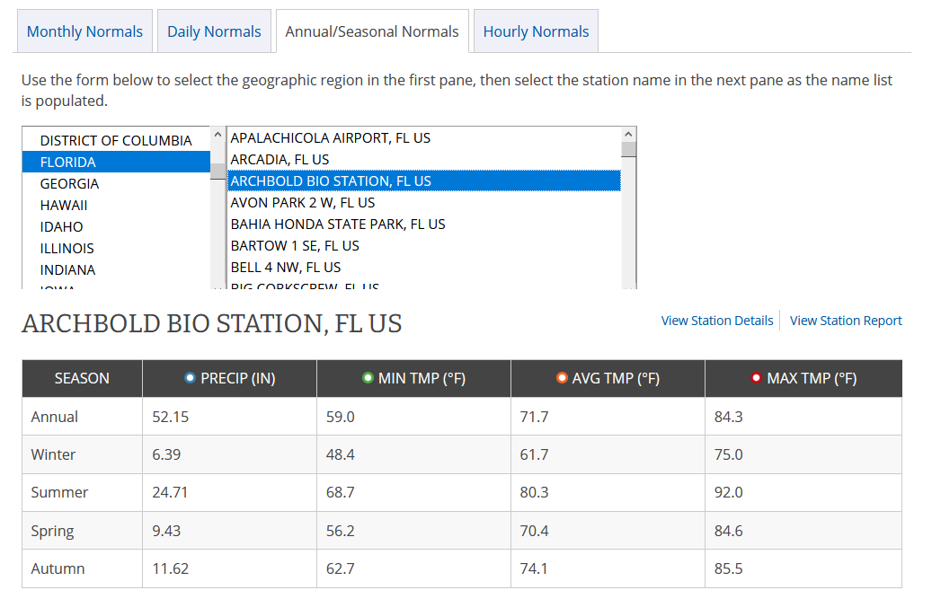

Figure 2. Mean annual and seasonal climatic variables from 1981-2010 U.S. Climate Normals for the Archbold Biological Station weather station

You can learn more about that particular weather station by clicking “View station details” and more information about the growing season (i.e., freeze-free season) by clicking “View station report”. Enter the weather station information for your site into the box below.

Questions:

- The name of your closest weather station:

- The ID of the station:

- The elevation of the station:

- The latitude of the station:

- The longitude of the station:

Part 2: Find climate data for your study site
Once you have entered the weather station information from the station details page, go back to the previous page (table like Figure 2) to get the climate information. We will be looking at the Annual values (first row of the table). These values are averages from 1981 – 2010 (so the “minimum temperature” is the average of all the minimum temperatures in each of those years, etc.). These data are presented in US (Imperial) units (precipitation in inches, temperatures in Fahrenheit). First, convert those values to metric units:

- precipitation (multiply the value in inches by 25.4 to get the value in mm)
- temperature (subtract 32 from the value in ° F, then multiply by 5/9, to get the value in ° C).

List both the original and converted values below:

Questions:

- Mean annual precipitation (inches):

- Mean annual precipitation (mm):

- Mean annual minimum temperature (“MIN TMP”) (° F):

- Mean annual minimum temperature (“MIN TMP”) (° C):

- Mean annual temperature (“average”) (“AVG TMP”) (° F):

- Mean annual temperature (“average”) (“AVG TMP”) (° C):

- Mean annual maximum temperature (“MAX TMP”) (° F):

- Mean annual maximum temperature (“MAX TMP”) (° C):

Part 3: Find the growing season length for your study site

The growing season length is limiting to the types of and biomass production by vegetation and is generally regarded as that period during the growing season after which the last frost occurs in the spring and before the first frost in the fall (Figure 3). However, like most environmental factors, the growing season length is changing, with a 6-10-day increase in eastern North America and 16-19-day increase in western North America since 1991, relative to earlier in the 20th century (Walsh et al. 2014).
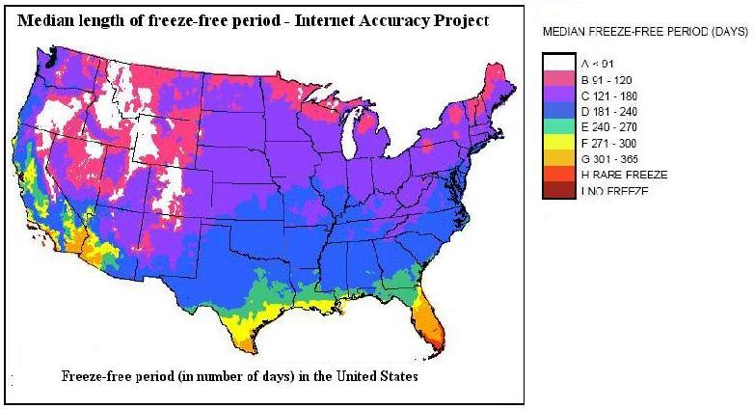
Figure 3. Median length of freeze-free period in the U.S. Map is based on National Weather Service data and produced by Internet Accuracy Project.

Question:
18) What factors drive the spatial patterns that you see in growing season length in Figure 3?

We can obtain an approximate length of the growing season from several sources, including from, surprisingly, Dave’s Garden, which uses National Weather Service data to interpolate an estimated frost-free growing season length. Once you are on the website, type in the ZIP code nearest your study site. This gives you a lot of information about dates when you can expect frost, but also an overall number of days you will almost definitely not get frost – the “frost-free growing season”.

Question:
19) What is the frost free growing season for your study site?

