Plants in the Human-Altered Environment (PHAE) Research Project

Module 6: Identify and measure woody plants in the plot

To complete this module, you will need to visit your plot. We will focus on collecting data about the woody plants in your plot.

Part 1: Map and number your trees

First, assign a number to each of the trees in your plot. Each living woody plant stem that is at least 1.0 cm in diameter (about the width of your finger) at breast height (DBH) will get a number. This is a small diameter – it will include all trees and saplings, but exclude small seedlings of woody plants. Any tree or shrub that does not reach your chest height or does not have a stem of at least 1.0 cm at that height will not count. Note that many tree and shrub species have more than one stem; identify and count only the main stem of each plant.

- Use the provided map (Figure 1) to identify roughly where in your plot each woody plant that will be counted (> 1.0 cm DBH) is located; draw or mark at circle approximately where each occurs. If a stem leans into your plot but is not rooted there, do not count it.

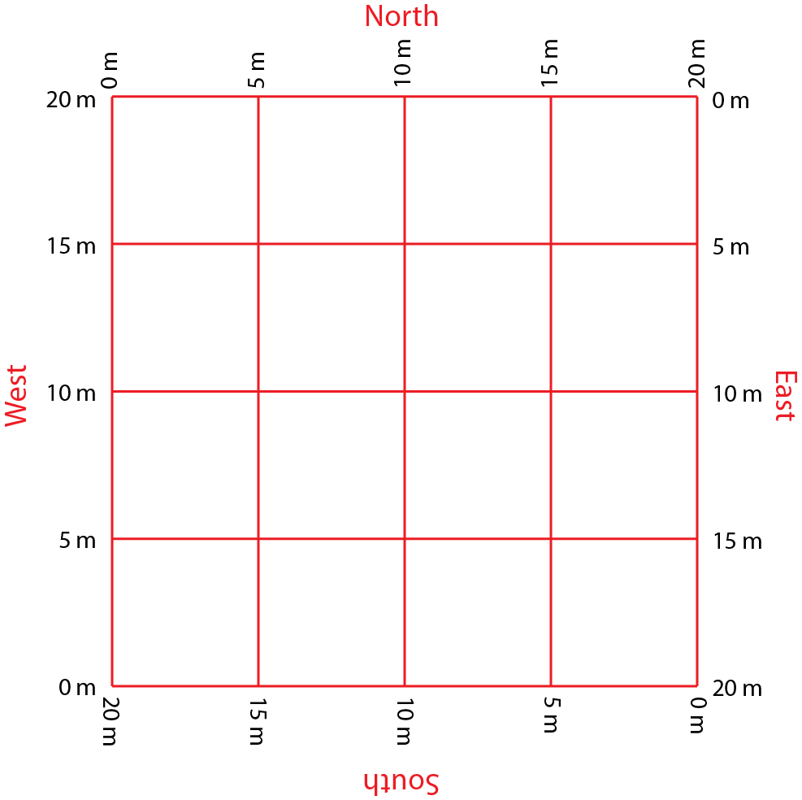
- Number each plant that will count.

Figure 1: Map for marking locations of woody plants in your plot.

Copy your completed map (photo if hand-drawn) here:

Part 2: Identify and describe your trees
Now you need to identify and describe each of the plants that you numbered.
- Record the species name of each of woody plant to count. There are numerous apps and websites that can help with identification (iNaturalist, Seek, and PictureThis are good apps for plant identification; https://gobotany.nativeplanttrust.org/simple/woody-plants/ provides an excellent key). You can use any identification tool or resource that works best for you (field guides, ask a professor or groundskeeper, etc.).

- This project follows the classification of woody plants as described by NEON. Use the flow chart on the next page (Figure 2) to determine the growth form of each woody plant; this is essentially what type of tree or shrub each individual is.

If you have a lot of stems tangled together, and you can’t tell whether it is one plant or many plants close together, call it a “shrubGroup” growth form. (This is common for hedge shrubs planted in a row – it’s hard to tell where one individual plant starts and the next one stops.)
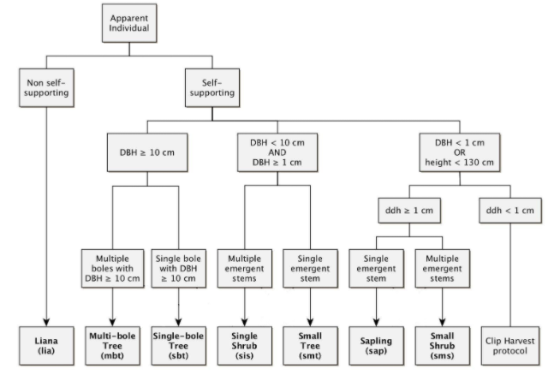
Does not count

Figure 2: Flowchart to determine woody plant growth form based on the diameter and number of stems the plant has. Bole is another word for trunk. 130 cm is roughly average chest or shoulder height.

Part 3: Measure your trees
Next you will measure the diameter of your trees. Trunk diameter is a standard measure for tree size and tracking growth. DBH is the standard, as tree trunk diameter tends to vary across a tree’s height. While this is not a precise measure (we use 130 cm when we need better precision and consistency), it is generally a reliable method.

- Diameter is the line through the middle of a circle (through the tree trunk), so it is easier to calculate than measure directly if you don’t have equipment specifically designed to measure DBH. Circumference is far easier to measure on a tree trunk, and we can derive the diameter from that with a simple calculation (Figure 3). A soft measuring tape (with centimeters as units) is the ideal tool for this, but you can also use a string or piece of cloth to wrap around the tree and then measure. There are also numerous printable tape measures available online.

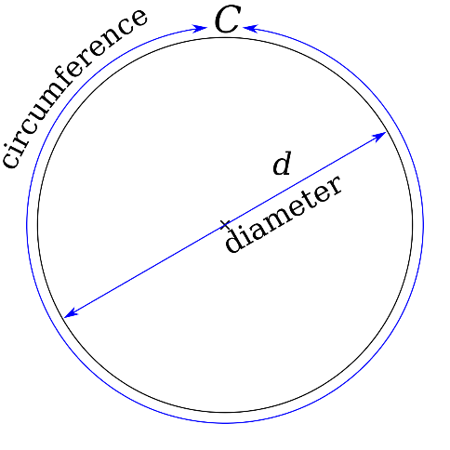
Wrap your measuring tape around the trunk of the tree. Record the circumference (C).
To calculate the diameter, divide C by 3.14.
Example: A tree with a circumference of 20 cm. 20/3.14 = 6.4 cm diameter.
If you are measuring in inches, please convert to centimeters.
Example: A tree with a circumference of 10 inches.
10/3.14 = 3.2 inches diameter. 3.2 x 2.54 = 8.1 cm.

Figure 3: Relationship between circumference and diameter, and formula to calculate diameter.

- For each of your trees, record the circumference in centimeters, and calculate the diameter in centimeters.

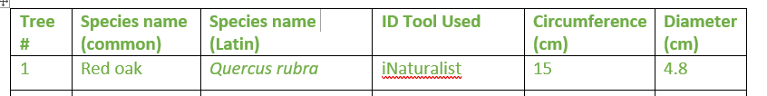
Figure 4: Example table entry for one tree

Enter your data from Parts 2 and 3 in a table like this:
Tree # | Species name (common) | Species name (Latin) | ID Tool Used | Growth form | Circumference (cm) | Diameter (cm)

