Plants in the Human-Altered Environment (PHAE) Research Project

Module 8: Data Comparisons

Lastly, we will compare our class data to the national dataset to get an understanding of our contribution to the broader research project. Our methods were consistent with the National Ecological Observatory Network (NEON) project, so we can compare our data to other plots in the network.
NEON has 81 field sites across the United States, spread across 20 different ecoclimatic domains. Many ecological variables are monitored at each site – the woody plant vegetation structure is just one component.
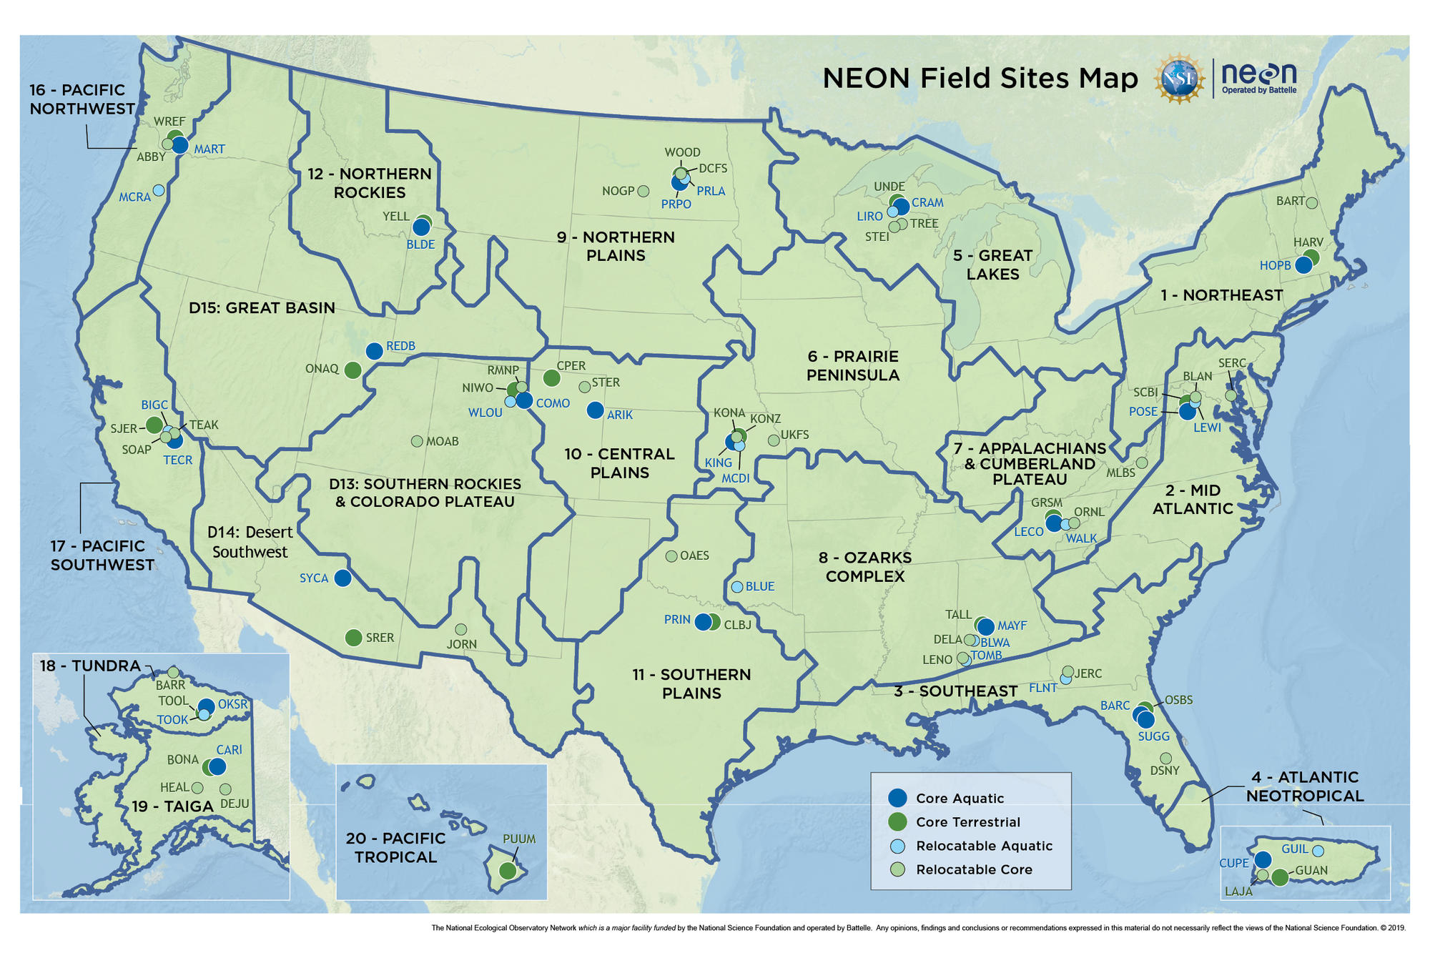
Figure 1: Map of NEON field sites

We will be analyzing woody plant data from the core terrestrial site from each ecoclimatic domain (except tundra, since there are no trees there to analyze). There are many plots within each domain – we’ll be working with average values from each domain. Just like our data, these values represent woody plants found within 400m² plots (for NEON, all 20m x 20m).
The table below provides summary statistics for the NEON data – how many plots were measured in each ecodomain, and average values of richness and woody plant abundance (# individual plants) within each ecodomain. Note that the values are averages of the 20 x 20 m plots – it isn’t the overall richness for an entire ecodomain, but for the average plot within that domain. Therefore, these values are comparable with the data we collected, even though they have many more plots.
Table 1: Summary of NEON woody vegetation plots across ecoclimatic domains
Site Name | Plots | Land Cover Type | Richness |  | Abundance
Northeast | 42 | Deciduous Forest | 10.29 | 174.40
Mid Atlantic | 34 | Deciduous Forest | 13.44 | 139.59
Southeast | 39 | Evergreen Forest | 5.31 | 119.64
Atlantic Neotropical | 40 | Evergreen Forest | 23.43 | 157.68
Great Lakes | 40 | Deciduous Forest | 8.93 | 106.15
Prairie Peninsula | 33 | Grassland/Herbaceous | 4.39 | 69.15
Appalachians & Cumberland Plateau | 40 | Deciduous Forest | 15.85 | 116.18
Ozarks Complex | 40 | Deciduous Forest | 15.70 | 97.13
Northern Plains | 14 | Cultivated Crops | 1.29 | 32.50
Central Plains | 13 | Grassland/Herbaceous | 1.15 | 20.77
Southern Plains | 47 | Deciduous Forest | 7.30 | 59.66
Northern Rockies | 22 | Shrub/Scrub | 2.23 | 41.82
Southern Rockies & Colorado Plateau | 38 | Shrub/Scrub | 2.82 | 59.79
Desert Southwest | 38 | Shrub/Scrub | 8.50 | 74.50
Great Basin | 47 | Shrub/Scrub | 2.02 | 81.45
Pacific Northwest | 39 | Evergreen Forest | 6.97 | 80.05
Pacific Southwest | 36 | Shrub/Scrub | 2.89 | 18.03
Taiga | 19 | Shrub/Scrub | 4.89 | 83.95
Pacific Tropical | 24 | Evergreen Forest | 8.00 | 65.58

The datasheet for this lab contains the following information for each of the NEON ecoclimatic domains. We will treat our class data as its own ecodomain for this module, even though it will eventually become part of the Southeast ecodomain, because it will be interesting to compare our class data with the larger dataset.
- Environmental data: land cover, mean temperature, precipitation
- Woody plants data: richness, abundance (# individual plants)

Part 1: Plot the data
First, refer back to our class google sheets with the complete dataset. Calculate the average for each of the above values to get the values for our “ecodomain.” You can average the averages from module 7 to get our ecodomain values for species richness and abundance per plot.
Using the NEON ecodomain data and our class data, create four scatter plots to visualize the data:
      - temperature vs. richness
      - precipitation vs. richness
      - temperature vs. abundance
      - precipitation vs. abundance
Make sure to include the trendline and R-square value. Follow the formatting instructions from module 7 to label appropriately.
Mark our class data point in each graph: look for our value on both the x- and y-axis, and label that spot in some way (you can change the point’s color or size, add a circle or star, etc.).
Paste your scatter plots here.

Part 2: Answer the questions below.

Describe the relationships observed between climate conditions (precipitation, temperature) and woody plant communities (richness, abundance of individuals). Would you characterize the relationships as strong? Why or why not?

How does our class ecodomain compare with the national dataset? How does it compare with the Southeast ecodomain?

Consider all of the data that you collected for this project. What are three additional comparisons that you think would be interesting to investigate across ecodomains and why?

How could this data be used specifically to address questions about conservation and biodiversity?

