Forest Ecology, Spring 2021
Lichen Project – Final Analyses and Wrap-Up

DUE: By the start of lab on Tuesday, 2-March. (30 points – see rubric at bottom)

Part 1: Statistical Approaches for Student Field Collections of Lichens
In this final portion of the project, we will look at how to statistically examine the data that you collected in the field. You can find the data on the Excel File ‘Completed Data’ on the first tab ‘Lichen Field Data’. Choose one of the hypotheses below to explore or create your own. Remember, you may have to clean up some of the data entries in Excel before moving on to analyses. For instance, Total Lichen Abundance = the sum of all 4 measurements taken on an individual tree. What you will be responsible for turning in:
- Describe the relationship between variables: what relationship do you expect to see and WHY
- Pick the appropriate statistical analysis and explain why you chose that test
- Perform the statistical analysis, provide output, and interpret results
- Create a figure to illustrate the relationship between variables

Potential Hypotheses to Test:
- Lichen abundance will differ between different tree species
- Lichen abundance will differ between different sized trees
- Tree pH will influence lichen abundance or air quality index
- Canopy cover will impact lichen abundance or air quality index
- Lichen abundance will differ between cardinal directions on a tree
NOTE: the instruction below cover a chart type for visualizing these results. If you choose to make a radar chart, make sure that N,S,E, and W are in the appropriate directions. They are incorrect in the example!!

Radar Charts
- One last type of specialized chart is the Radar Chart. This for our purposes, will focus on examining the relationship between cardinal direction (i.e. sunlight levels) and lichen abundance. To do this, enter in the following data:

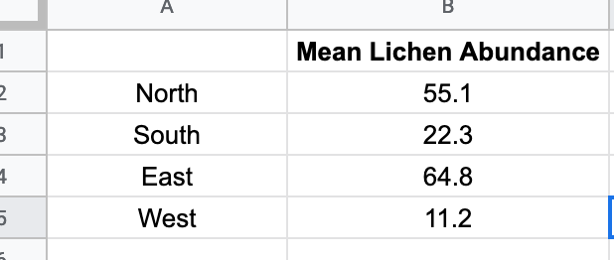

- Once these have been entered in, highlight all of the data including the headers and then select insert and chart. This will likely not automatically take you to the radar chart, so you’ll have to select chart type and then scroll down and select radar chart (it is near the bottom in the other category and looks like this:

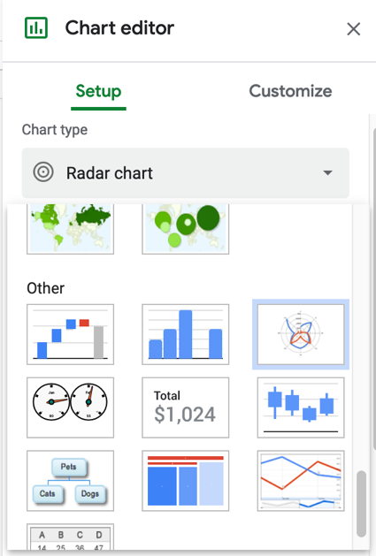

- Once you have selected this, you should end up with a graph that looks like this:

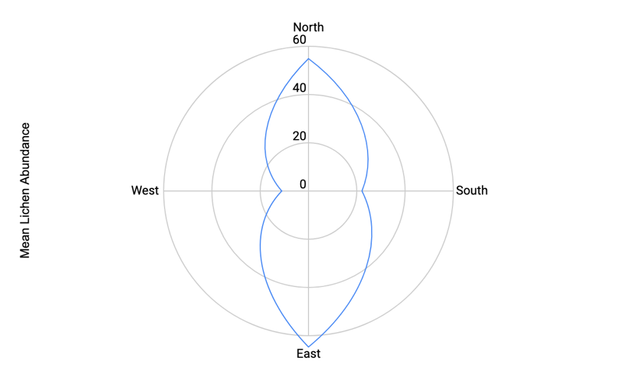

- This chart is harder to interpret in some ways, but provides a cool visual reference for where lichens grow on individual trees or on average across sites.

Part 2: Exploring NEON Lichen Data
The National Ecological Observatory Network (NEON) is a public and freely available clearinghouse of biological, ecological, and environmental data that has been collected from field sites across the United States. You can find NEON data on the Excel spreadsheet on the second tab, ‘NEON data’.

This data tab includes information on lichens percent cover, canopy cover, and a variety of other environmental variables including wet deposition of nitrogen, phosphorus, and sulfate. These last three columns each serve as a proxy for air pollution such that higher amounts of N, P, or S = higher air pollution.

Choose one of the hypotheses below to explore or create your own. Remember, you may have to clean up some of the data entries in Excel before moving on to analyses. It also may be easier to sort the data and copy/paste to a new tab in the Excel file. To do this, click on the ‘+’ symbol next to the tab names at the bottom of the worksheet. This will be especially helpful if you plan on comparing your data to NEON data.
What you will be responsible for turning in:
- Describe the relationship between variables: what relationship do you expect to see and WHY
- Pick the appropriate statistical analysis and explain why you chose that test
- Perform the statistical analysis, provide output, and interpret results
- Create a figure to illustrate the relationship between variables

Potential Hypotheses to Test:
- Increasing air pollution levels (wet deposition) will decrease lichen abundance. Note: this can only be tested using the NEON data.
- Lichen abundance will vary between communities. Compare our field sites to a NEON site with a different community. Alternatively, compare our field data to NEON data with the same community.
- Lichen abundance will vary between sites with different biomes (domains). Compare our field sites to a NEON site with a different domain.
- Canopy cover will impact lichen abundance. Combine our data with the NEON data.

Grading Rubric

Content | Pts
Background/Rationale (pics lichen, air pollution image, etc.) | 5
Hypothesis Statement | 3
Appropriate Statistical Test Used | 5
Pics of field sampling | 2
Results and Graphs (axes labeled, informative) | 10
Interpretation of Results | 5
Total Pts | 30

