Module Title: Exploring EnvironmenATL Justice with Data Analytics and Visualization
Module Developed By: Dr. Ethell Vereen, Jr.

SCHOLARLY ACTIVITY WORKSHEET

NAME:

DIRECTIONS
Alone or with a group, complete this worksheet using information and links found throughout the worksheet. All students must submit an individual worksheet for grading, even if you work with a group to complete the worksheet. Save the information gathered and the understanding you gain with this worksheet as you plan out and complete the environmenATL justice module.

Part I: What is environmental justice?
1. What comes to mind when you see the word “Justice”? Write a short response:

2. Now write down what you think “Environmental Justice” means.

3. What would you expect/want in terms of the environment around you and the impact on your life? Write a short response:

The U.S. Environmental Protection Agency defines environmental justice as “the fair treatment and meaningful involvement of all people regardless of race, color, national origin, or income with respect to the development, implementation, and enforcement of environmental laws, regulations and policies. EPA states, “this goal will be achieved when everyone enjoys:
- The same degree of protection from environmental and health hazards, and
- Equal access to the decision-making process to have a healthy environment in which to live, learn, and work.”
See www.epa.gove/environmentaljustice
History of Environmental Justice
The environmental justice movement emerged in the late 1980s when a blistering report exposed massive disparities in the burden of environmental degradation and pollution facing minority and low-income communities. Championed primarily by African-Americans, Latinos, Asians and Pacific Islanders, and Native Americans, the environmental justice movement addresses a statistical fact: People who live, work, and play in America's most polluted environments are commonly people of color and the poor. Environmental justice advocates have shown that this is no accident. Communities of color, which are often also low-income, are routinely targeted to host facilities that have negative environmental impacts—say, a landfill, dirty industrial plant, or truck depot. The statistics provide clear evidence of what the movement rightly calls "environmental racism." Communities of color have been battling this injustice for decades.
Environmental racism refers to the institutional rules, regulations, policies or government and/or corporate decisions that deliberately target certain communities for locally undesirable land uses and lax enforcement of zoning and environmental laws, resulting in communities being disproportionately exposed to toxic and hazardous waste based upon race.

To understand environmental justice, it's worth looking back at the events that helped launch the movement in the first place. Many point to 1982, when North Carolina had announced a plan to move soil contaminated with PCBs from alongside 210 miles of the state's roadsides to a landfill located in Warren County, one of only a few counties in the state with a majority black population. The decision triggered a wave of protests, one of which resulted in the arrest of a U.S. congressman and dozens of other activists who tried to block the PCB-laden trucks at the entrance to the landfill.

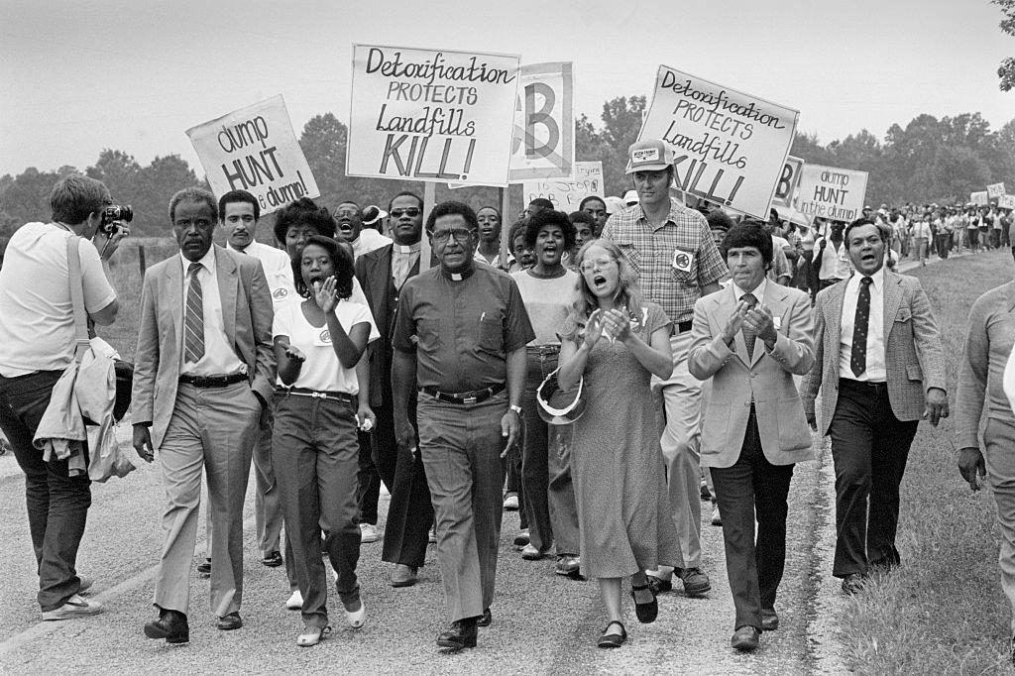
Protestors led by Reverend Joseph Lowery march against a proposed toxic waste dump in Warren County, North Carolina, in October 1982.
Bettman/Getty Images

Environmental advocates lost that battle—North Carolina ultimately buried the PCBs in Warren County—but the controversy crystallized the idea that the nation's environmental problems disproportionately burden its low-income people of color. This incident and others sparked research into the environmental and health burden born by these communities, culminating with the publishing of the study Toxic Waste and Race in 1987.

Delegates to the First National People of Color Environmental Leadership Summit held on October 24-27, 1991, in Washington DC, drafted and adopted 17 Principles of Environmental Justice. Since then, the Principles have served for many as a defining document for the growing grassroots movement for environmental justice.

Learn more about the history of environmental justice here:
The History of Environmental Justice in Five Minutes from the NRDC (Natural Resources Defense Council)
https://www.nrdc.org/stories/history-environmental-justice-five-minutes
A Brief History of Environmental Justice YouTube video from ProPublica
https://youtu.be/30xLg2HHg8Q

4. What is the difference between environmental racism and environmental justice? Write a short response:

Example of environmental injustice: Flint, Michigan Water Crisis
The Flint water crisis was a public health crisis that started in 2014 after the drinking water for the city of Flint, Michigan was contaminated with lead and Legionella bacteria. Learn more about this water crisis here:
- www.nrdc.org/stories/flint-water-crisis-everything-you-need-know
- www.globalonenessproject.org/library/photo-essays/fall-flint

5. What is the Flint Michigan water crisis? Write a short response:

What has been the impact of this water crisis on the people of Flint?

Why is this an example of environmental injustice?

Example of environmental injustice: Redlining
In the 1960s, sociologist John McKnight coined the term "redlining" to define the discriminatory practice of avoiding investment in communities with unfavorable or high-risk demographics, typically with large minority populations. Learn more about redlining here:
- https://storymaps.arcgis.com/stories/0f58d49c566b486482b3e64e9e5f7ac9
- https://www.npr.org/2017/05/03/526655831/a-forgotten-history-of-how-the-u-s-government-segregated-america

6. What is redlining? Write a short response:

7. Choose one city from the Not Even Past project to explore.
Not Even Past: Social Vulnerability and the Legacy of Redlining
https://dsl.richmond.edu/socialvulnerability/

Click on either the map of the rectangles on the chart to select an area in the past or today to view more details. At the top will appear selections from the HOLC area description for the selected area showing the HOLC's description of the area's population and character. Please take a screen capture or print preview of the city and map that you are viewing. Briefly interpret what you observe from the interactive map.

Worksheet Sources
Bullard, R. D. (2005). The quest for environmental justice: Human rights and the politics of pollution.
Dimick, A. S. (2012). Student empowerment in an environmental science classroom: Toward a framework for social justice science education. Science Education, 96(6), 990-1012.
National Academies of Sciences Engineering and Medicine. Environmental Justice. Design for the Future: A toolkit for Change. Environmental Engineering for the 21st Century.
Peloso, J. (2007). Environmental justice education: Empowering students to become environmental citizens. Penn GSE Perspectives on Urban Education, 5(1), 1-14.

