BIOL 533: GIS Applications in Landscape Ecology
Course Project

Comparative Landscape Ecology Project

Overview
For our course project, we will be utilizing the National Science Foundation’s National Ecological Observatory Network (NEON) data as a means of comparing ecological data between different regions within the United States. We will be utilizing the “Remote Sensing Plants in R” lab as a means of acquiring analytical details for these NEON regions, and incorporating online research of variables that may influence these regions into a narrated presentation. Please review the instructions below and contact me should you need further clarification of the project.

Instructions
The workflow of this project is as such:

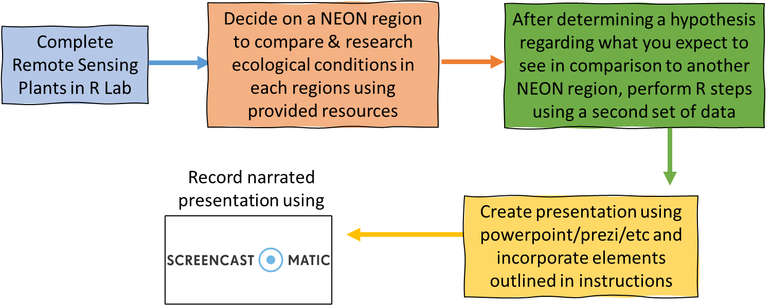

These are the general steps associated with accomplishing your project:

- If you haven’t already, complete the Remote Sensing Plants in R (Lab 5) Activities as you will be utilizing the outputs from this process as half of the data in your comparative assessment. You will be utilizing the maps that are generated from these activities as well as correlation coefficient outputs for topographic metrics that you wish to compare.
- You will next search within the available NEON data for a region you would like to compare the Lab 5 data to. The data from our lab exercises were collected in 2018 from the Sierra Nevada mountains in California in a region called Soaproot Saddle. You are provided data from a range of other NEON sites in the folder labeled “all_neon_data.zip.” This is a zipped folder meaning you will have to extract it after downloading the data to your computer. You can do this by double clicking on the folder and selecting the “Compressed Folder Tools” and then selecting “Extract All”

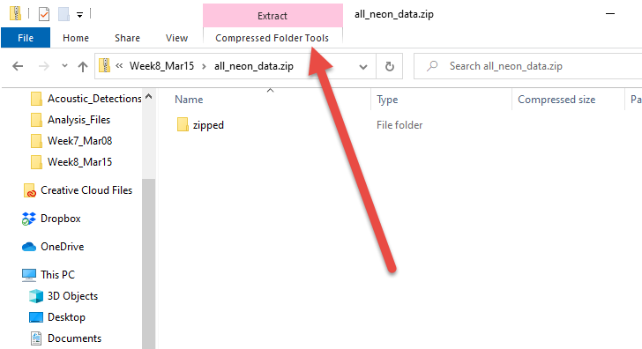

You should then be able to find all of the files associated with the various NEON sites. Using the Explore NEON Sites web page, find a region you would like to compare California to. This would ideally be one where you expect to see a difference in the landscape patterns.

You will be using resources and information regarding the state of the ecosystems within your two comparative regions in order propose what type of differences you expect to see in the data. For instance, if I were to compare our site in the Sierra Nevada mountains to one in the chapparal of Southern California, I would expect to see a difference in the correlation between the metrics such as slope and vegetation height given there is less of an influence of altitude on plant growth in these coastal ecosystems. You can also incorporate information on drought, invasive species and natural populations and other landscape characteristics in your rationale. Be sure to outline a comparison of the two regions, and then state how you expect the correlations between topographic metrics to compare BEFORE you proceed with the next step. Possibly online resources to inform your evaluation are found below under “Data Sources” and you can also utilize the NEON website.

- Next you will run the data for your second region to obtain maps and correlation coefficients data. The first step will be to upload the UNZIPPED NEON data files to your RStudio Cloud. You can accomplish that by a) selecting the “Upload” button in the bottom right “Files” section of R Studio and then b) selecting the three tif files available in the folder of the region you selected (ending in _DSM, _DTM, and _NDVI).

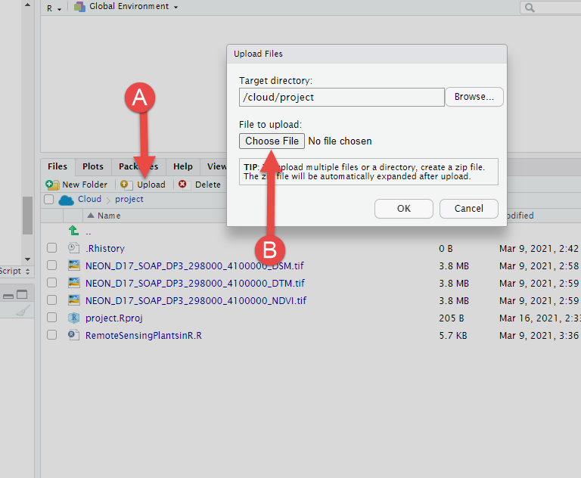

Now you will need to clear the Environment you had been working with in the previous activities for Lab 5. If ever you need to get this information again, you can just run the code as you did, but for now we want to make sure we are not mixing in any data from our Lab 5 activities. In the bottom left console, type rm(list=ls()) and you will see that the Environment (upper right) will be cleared:

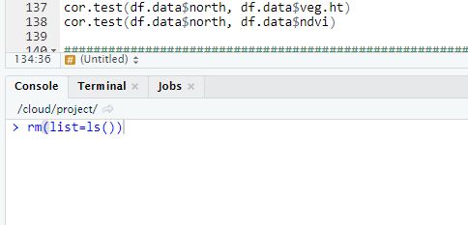

Next you will just need to make a few small changes to the r code to make sure it is accessing the correct files. For lines 20 (A), 23 (B) and 26 (C), change the name of the .tif files to match the ones you just uploaded. There should have been three files uploaded, each corresponding to a DTM, DSM and NDVI file.

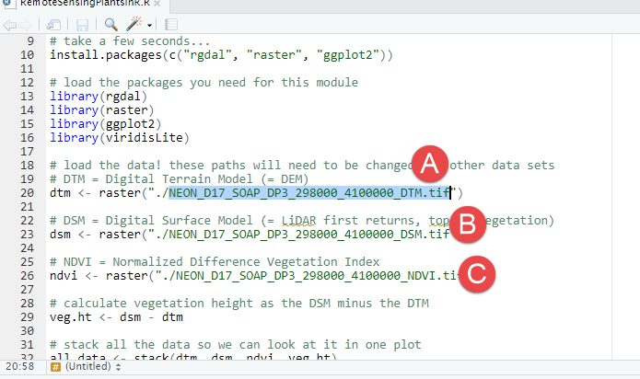

Now you can run through all the steps as you did with the California data in the lab in order to obtain maps and correlation coefficient values.

- Now that you have all of the information you need, create a slide show using whatever format you prefer (prezi, powerpoint, etc.) that includes these two elements in your assessment:
  - compare and contrast topographic metrics derived from the R-based analysis (e.g slope, aspect, etc.) mentioning any trends found in the figures and
  - compare the correlation coefficients between two regions and relate to your expectations based on research
This doesn’t have to be a master’s thesis, just a short, but comprehensive evaluation of two regions. If you need another example of interpreting the correlation coefficient, here’s a great resource.

- Record your presentation using a free screen recorder (e.g. screencast-o-matic) and make sure that you are narrating it (camera optional !

Be sure your final presentation is no shorter than three (3) minutes and no longer than five (5) minutes!

Data Sources
Here are some options for resources you can use to obtain information on how your two regions might compare. You should utilize a minimum of TWO resources to inform your presentation. Remember, they are data from 2018, so keep that in mind if you are looking into things like drought, etc.
- NEON Field Sites
- EPA EnviroAtlas
- Any of the ArcGIS Online data (just search a topic of interest and you will find a bunch of data pop up!)
- Drought Monitor
- Biodiversity Map
- EDD Invasive Species Map
- NatureServe – various maps
- U.S. Wildfires

Rubric
Please see the separate “BIOL_533_Project_Rubric.pdf” for more information on how your submission will be graded.

