The Happy Blue Baby- Student Worksheet
Note to students: You are expected to work through this molecular case study with your group in your zoom breakout rooms and note your discussion points as well as answers on your group’s google jamboard that will be actively monitored by the peer facilitators.
Part 1: A “happy blue baby”?
A full-term female infant was born to a 20-year-old woman in New Jersey in 2008. The infant was described as a “happy blue baby” — that is, cyanotic but well appearing. Cyanosis (skin with a purple-blue tinge) is the result of poor circulation or inadequate oxygenation of the blood caused by one of many conditions. The patient’s initial hemoglobin oxygen saturation, measured in ambient air with the use of pulse oximetry, was 30 to 50% (normal >95%). After intubation and delivery of 100% oxygen, hemoglobin saturation fluctuated around 85%. The physical examination revealed only cyanosis and moderate hepatomegaly. The infant was extubated, with a transition to oxygen delivery by means of nasal cannula. She was clinically well, although hemoglobin oxygen saturation remained below normal, at 80 to 90%, despite the absence of evidence of arterial hypoxia. Laboratory data were notable only for moderate anemia with reticulocytosis, an elevation in red blood cell counts commonly seen in anemic patients. The results of chest radiography and echocardiography were normal.

- How does hemoglobin delivery of oxygen work in a healthy newborn? Discuss you answer in your group and provide summary points on your jamboard.

- Sketch a single graph on your jamboard with possible oxygen-hemoglobin dissociation curves representing three conditions: (1) a red line for a healthy infant, (2) a blue line for the happy blue baby’s initial hemoglobin oxygen concentration, (3) a black line for the baby’s hemoglobin saturation after intubation. Paste a sketch or JPG of your image here:
Part 2: What can we learn from genetics?
On the first day of life, doctors tested the baby girl for any congenital heart diseases and/or lung disorders, but did not find any problems. Protein gel electrophoresis analysis of her hemoglobin protein showed that the baby’s total hemoglobin consisted of approximately 90% hemoglobin F and 10% hemoglobin A.
They also collected family history of the patient and learned that the patient's father had also had transient neonatal cyanosis, with hemoglobin oxygen saturation of approximately 80% at birth, despite the use of supplemental oxygen and adequate arterial oxygenation. Extensive testing for infections and metabolic abnormalities were all negative. His cyanosis resolved within 1 to 2 months, and he was subsequently healthy. The patient had an older brother and mother who were not cyanotic at birth.

3. Taking into consideration both the family genetic information and the protein data analysis of the baby’s hemoglobin at the time of birth which of the baby patient’s gene(s) would you examine for a mutation? Why? Place your proposal and supporting ideas on your jamboard.
- As the baby’s clinician, why would it be important to explain the patient’s family that there are two possible outcomes for their baby within a few months that their baby’s cyanosis could either clear up in a couple of months or be with her the rest of her life? Think about how this information may impact the decisions made about immediate further testing. Discuss as a group and include your ideas on your jamboard.

- As part of her genetic testing, the patient’s fetal γ-globin gene was sequenced. Based on the DNA sequence, it was determined that there was a point mutation that changed the codon coding for Val 67 from GTG to ATG. What is the amino acid coded instead of valine at position 67 in the mutated gamma globin subunit? You can access the genetic code here: (https://www.genome.gov/genetics-glossary/Genetic-Code)

- In what ways the mutated residue’s side chain similar to and different from that found in the wild type protein? Summarize your ideas on your jamboard.
Part 3: Is there a 3D structure of a protein that can explain the molecular basis of the happy blue baby’s cyanosis?
Knowing a point mutation is a good starting place, but it is not sufficient to explain how the baby became blue. To explore the molecular basis of the newborn’s cyanosis, you can search the Protein Data Bank (at www.rcsb.org) for one or more structures of this mutant protein.
The little girl born in 2008 in Toms River NJ and became the subject of clinical and scientific research. Her case was reported in the New England Journal of Medicine in 2011 https://www.nejm.org/doi/full/10.1056/NEJMoa1013579. The 3D-structure of her mutated hemoglobin was solved in 2013 and has the PDB ID: 4mqk

Open the structure summary page for the entry by entering the PDB ID in the top search box on www.rcsb.org. Explore the box below to learn about what you can find on this page, review the contents of the page and complete the following table with information about the entry.
Box 1: Navigating the Structure Summary Page
1. Title - that tells you what the structure is about
2. Snapshot - of what the structure of the molecule/complex looks like.
3. Authors – who solved the structure
4. Literature –access the article that describes the structure. This section also includes links to PubMed page and the abstract of the article describing this structure, when available.
5. Macromolecules – All proteins and nucleic acids present in the structure are listed here. Each unique type of macromolecule or molecular chain is listed as a separate entity. There may be multiple copies of each molecule in the structure.
6. Small molecules – All ligands, ions, cofactors, inhibitors that are present in the structure are listed here. You can find links here to explore the interaction of this ligand with the target protein.
7. Experimental details – describe details about how the structure was determined
8. Structure quality – shows a slider that provides insights about the quality of the structure and its agreement with the experimental data and geometric standards.
See http://pdb101.rcsb.org/learn/guide-to-understanding-pdb-data/introduction for details

PDB ID
Title of entry**
Year when the structure was published/released
Structure determination method
Number of protein chains in the entry
Names and number of copies of ligands (Small Molecules) present in the structure

Explore this protein using the molecular visualization tool Mol* that is activated by clicking to the “3D View” tab on the page.

Take a screenshot of the structure you are exploring that supports your answers for questions 7-8 and include it in your jamboard.

- How many polypeptide chains make up this mutant hemoglobin? How does your screenshot support your answer?

- What is the most common secondary structural element seen in this structure? How does your screenshot support your answer?

- Do you expect all the polypeptide chains you see in your structure to contain the Toms River NJ mutation (V67M). Why or why not?

On the sequence panel for Mol* change the display mode from “chain” to “polymers”. This will give you access to the sequence of all the different polypeptides included in the structure. Click on M67 in chain B (Hemoglobin subunit gamma-2) to explore the vicinity of the mutated residue (V67M) paying close attention to the neighboring amino acids considering the features of the immediate chemical environment and what kind of interactions these would result in. Take a screenshot of the structure you are exploring that supports your answers for questions 10-12 and include it in your jamboard.

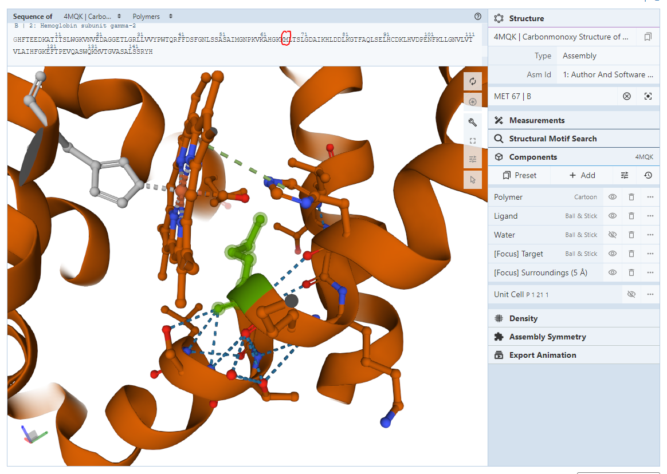

- What secondary structural element is this mutated amino acid located on?

- Identify any small molecules/ligands in the vicinity of M67 in the structure you are exploring. Provide their names and their role in the structure

- Based on the structure you are exploring, do you expect the V67M mutation to cause the γ-subunit to lose its capability of binding to heme? Why or why not?

Below is a screenshot of the oxygen binding pocket of the β-subunit from the human hemoglobin in the oxy-form (PDB ID:2DN1). Zoom into the same pocket using the structure you have been exploring and orient the helices and the heme group to match the orientation shown for 2DN1 below. Take a screenshot, include it in your jamboard and use it to answer question 13.
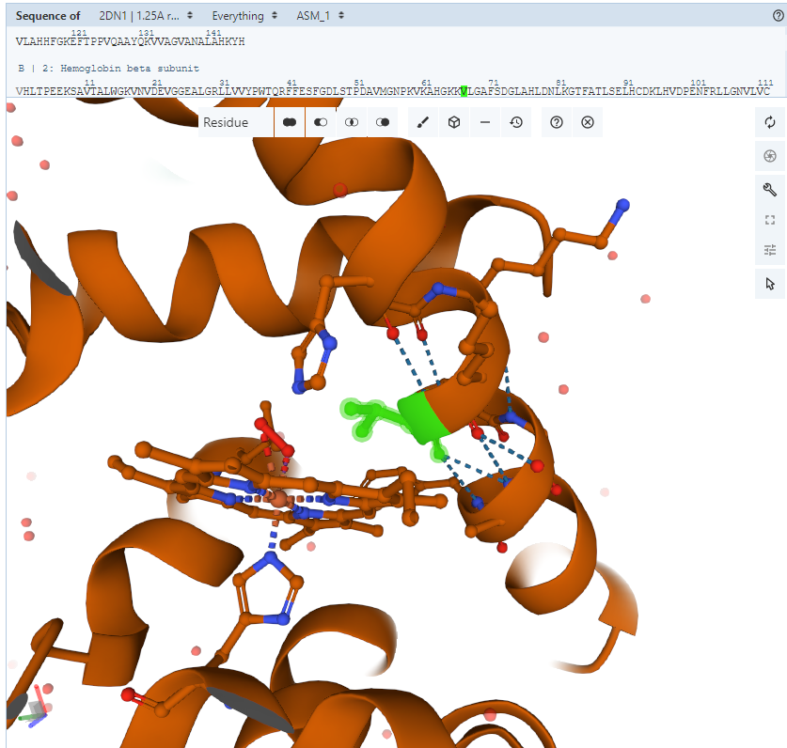
Oxygen binding pocket for Chain B of PDB ID:2DN1

- In both the β-subunit of human oxyhemoglobin (2DN1) and the γ-subunit of wild-type fetal hemoglobin oxygen enters the heme pocket and binds iron on the upper face of the heme ring next to the valine 67 side chain. Using this information and the differences you observe around V67 in 2DN1 and M67 in 4MQK explain why this mutation alters the ability of the γ-subunit to bind oxygen.

Box 2: Concepts
Biomolecular structural stability, interactions and functions are dependent on various non-covalent interactions. Some key interactions in molecular structures are:
Hydrogen bonds - formed between two partially negatively charged atoms with a hydrogen atom between and covalently linked to one of them. e.g. in structures look for examples of O/N … H__O/N, where … denotes hydrogen bond and __ denotes a covalent bond
Salt bridges or ionic interactions - formed between oppositely charged amino acid side chains and/or charged ligands/ions. e.g. in structures look for interactions between Lys/Arg/His and Glu/Asp. These interactions may also involve phosphate groups and ions such as K+, Na+, Cl- etc.
Hydrophobic interactions - formed between hydrophobic amino acid side chains positioned away from the aqueous environment. e.g. look for regions with large numbers of carbon and hydrogen atoms in close proximity. Aliphatic amino acids such as Ala, Leu, Val, Ile participate in hydrophobic interactions.
Pi stacking - seen between amino acids with aromatic side chains (e.g. Tyr, Trp, Phe). Pi clouds of aromatic rings interact with each other in staggered stacks, face to edge interactions, or interactions with positively charged amino acid side chains (pi-action interaction).
Make sure that your current structural view is centered around M67 from Chain B, by re-clicking on the residue in the sequence panel. In this view, on the components panel you should see a tab called “[Focus]Surroundings (5A). Click on this tab to re-zoom your view to include all side chains and small molecules/ligands within 5 A of M67. Take a screenshot, include it in your jamboard and use it to answer question 14.

14. List the names of the four amino acid residues with side chains located in the neighborhood of the mutated residue. What type of intermolecular interactions exist between the mutated residue and these residues? If necessary, click on the View button and use any appropriate options to view specific intramolecular interactions.

OPTIONAL: In a separate window view the structure of the wild-type Fetal Human Hemoglobin HbF (PDB ID 4mqj). In the wild-type protein, focus in on the same residues (V67 and its neighbors).
- Does the wild-type protein have the same interactions as seen in the mutant protein? Support your answer with suitable screenshot.

- Explain how the mutation in the Toms River baby girl (subject of this case) may interfere with normal function of the protein?

Happy Ending
The Toms River baby diagnosed with the cyanosis causing mutation. However, she grew up to be a healthy girl. In fact, by the time the doctors had completed all her tests, she was cured.
Part 4: What is the consequence of the (fetal) gamma globin V67M mutation?
In addition to solving the 3D structure of V47M, the authors examined the biochemical consequences of the hemoglobin mutation. They expressed the recombinant hemoglobin F (α₂γ₂) protein in an Escherichia coli expression system. The mutant hemoglobin F was produced at yields similar to those for wild-type hemoglobin F. Initial studies indicated that the oxygenated hemoglobin tetramer (α₂γV67M₂) was not excessively prone to oxidation, heme loss, or denaturation, as compared with wild-type hemoglobin F. The authors used partial laser photolysis and rapid mixing methods to measure the association (k′o2) and dissociation (ko2) rate constants for the last step of oxygen binding to individual globin subunits in wild-type and V67M γ-hemoglobin F. Data from the experiments are included in the table below:
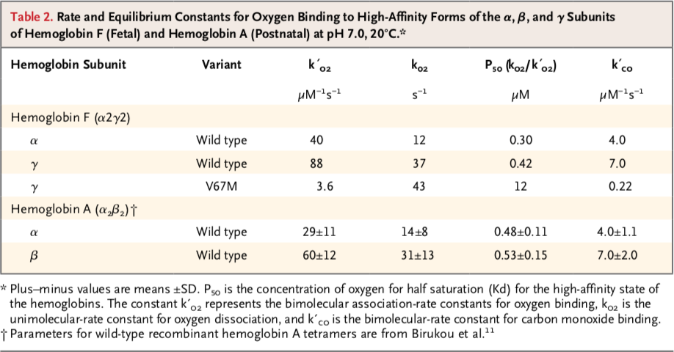
- What do the oxygen binding studies tell you about the V67M mutant’s oxygen binding and release ability, as compared to the wild type protein? Quote relevant binding constants to support your answer.

- Relate the oxygen binding studies to your structural explorations. Explain in 2-3 sentences the structural basis of the oxygen binding properties.

- The authors were also able to conclude that the mutation did not affect protein folding? Explain how it is possible for a protein to be fully folded but unable to bind its ligand.
Part 6: How did things turn out for the happy blue baby?
The infant received erythrocyte transfusions, which raised her hemoglobin oxygen saturation from approximately 80% to more than 90%. She was discharged home at 6 days of age, with oxygen saturation in the range of 90 to 95%. Her clinical course was unremarkable, and by 2 months of age, her hemoglobin oxygen saturation was consistently higher than 95%. The Toms River happy blue baby grew up to be a healthy girl.

Was the newborn girl cured of her genetic disease? (Hint: read https://patch.com/new-jersey/tomsriver/genetic-mutation-named-for-toms-river-may-shed-light-49e5fd1947 and refer to the NEJM article at https://www.nejm.org/doi/full/10.1056/NEJMoa1013579)

