**TOPHAT QUESTION 1:**

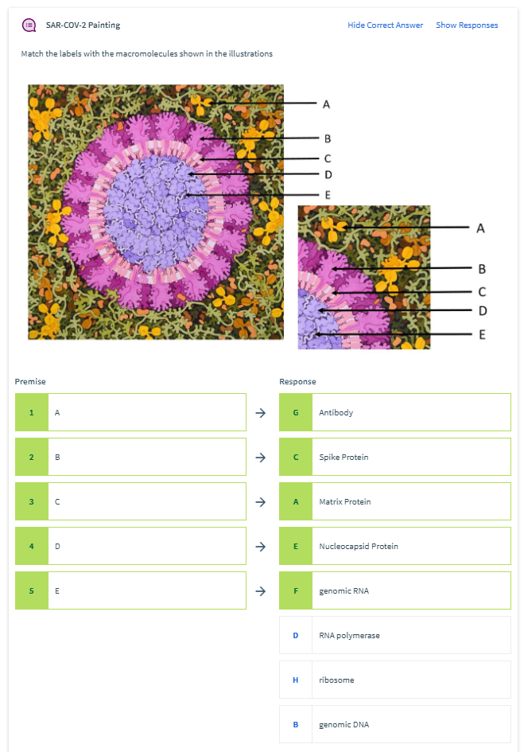

**TOPHAT QUESTION 2:**

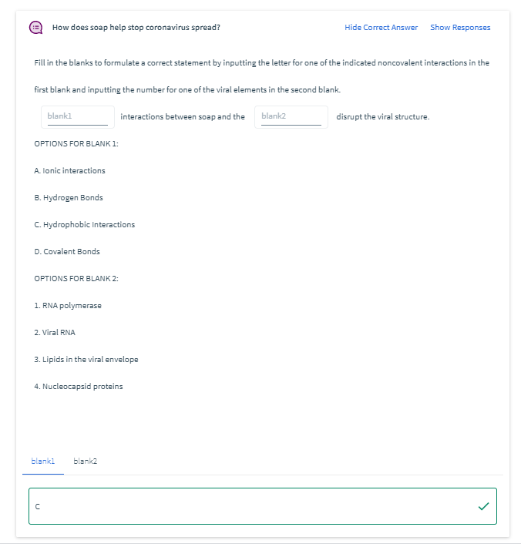 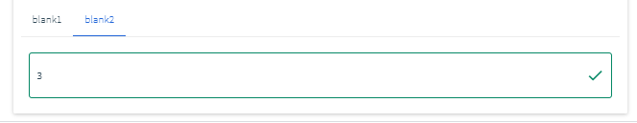

**TOPHAT QUESTION 3:**

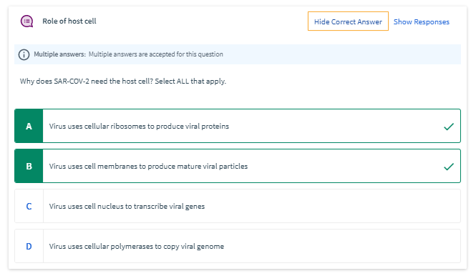

**TOPHAT QUESTION 4:** 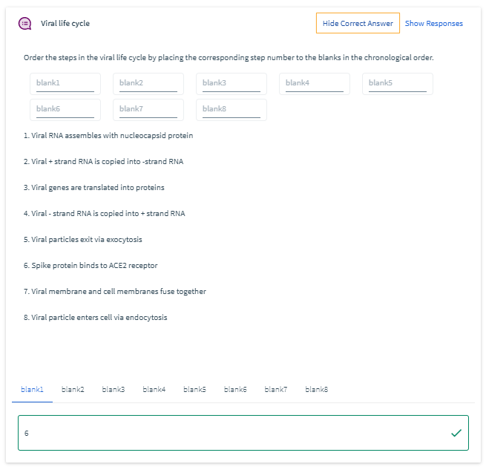



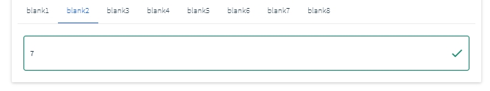

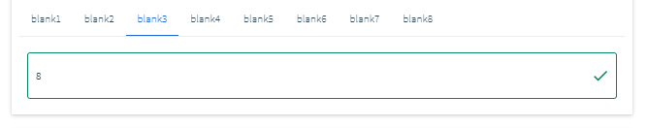

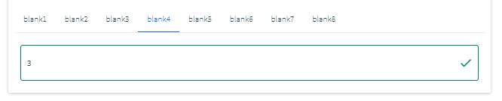

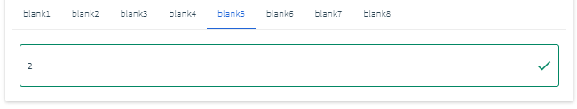

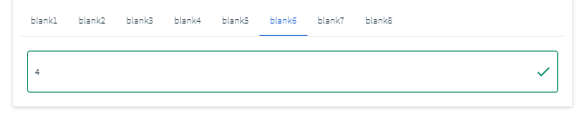

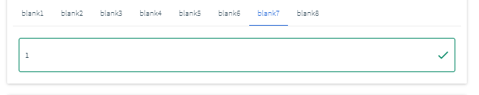

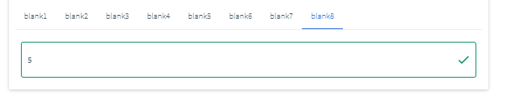

**TOPHAT QUESTION 5:**

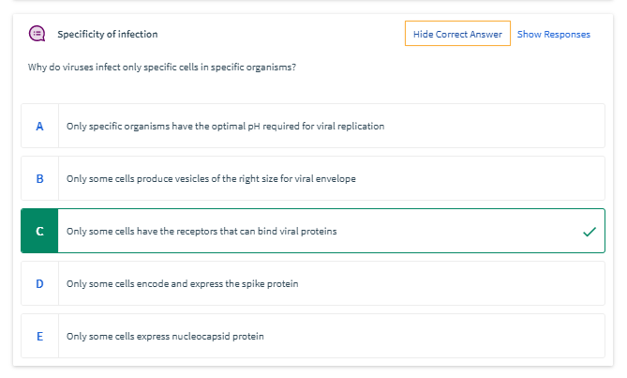

**TOPHAT QUESTION 6:**

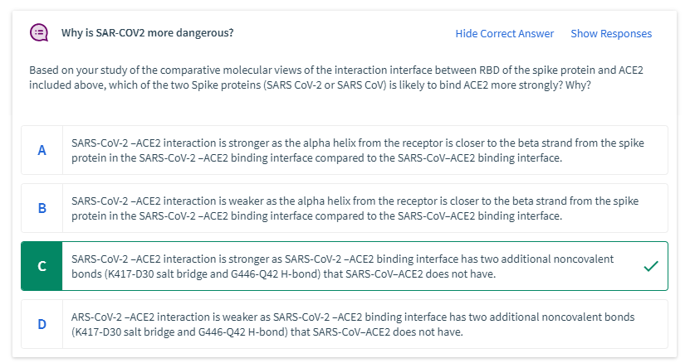

**TOPHAT QUESTION 7:**

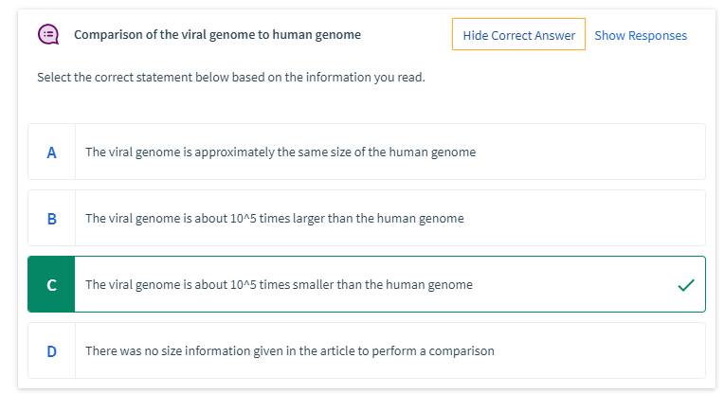

**TOPHAT QUESTION 8:**

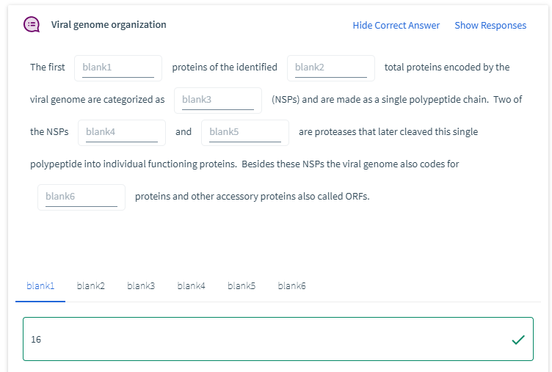

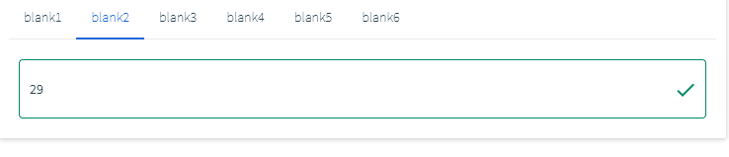

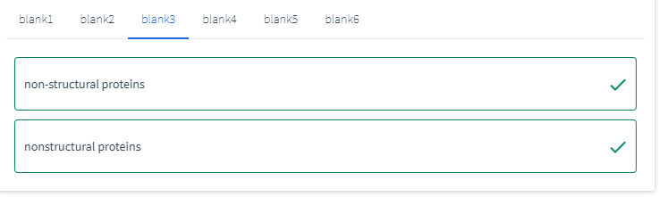

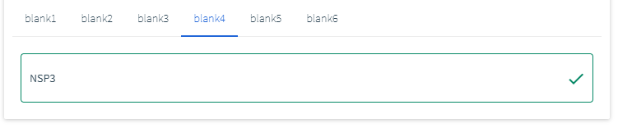

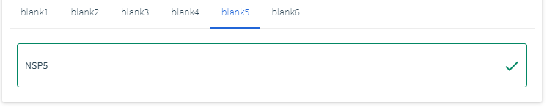

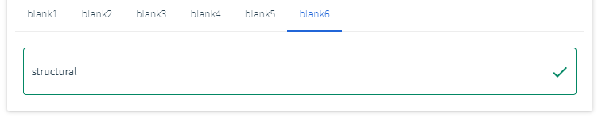

**TOPHAT QUESTION 9:**

