Five-Point Summary & Box-Whisker Plot

Directions for Instructors | 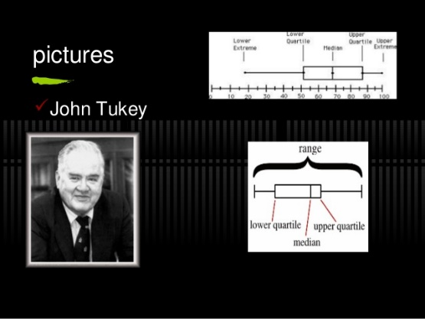

Introduction:
This activity can be used by both Biology and Math instructors, for Math students, to help them see the connections between how the material taught in Math can be used in Biology and for Biology students to see how Biology data can be analyzed and visualized by using Math skills.

Learning Objectives:

After completing this activity, students will be able to:
● Analyze biology data using a five-point summary and Box-whisker plot and interpret the results in the context of the problem
● Understand what a five-point summary is
● How to find the five-point summary in various ways- by hand, by Excel, and by graphing calculators such as TI 84
● What outliers are, their roles, when to include or not include them
● What is Box-whisker plot and how to draw them by hand, by Excel, and by graphing calculators such as TI 84
● How to interpret Box-whisker plot and compare and contrast the data sets using them
● Find outliers by IQR formula and by Box-whisker plot
● Understand Biological problems using Math skills

Goal 1: To analyze biological data by finding its center, variability, extreme values, by comparing & contrasting two sets of data using the five-point summary and Box-whisker plot. In other words, to integrate quantitative skills in Biological concept.

Five-Point Summary

- To begin with, lead students through to pick a data set of their interest. Explain what are the requirements for the data for the five-point summary.
- Explain what a five-point summary is, what is the significance of each number in the five-point summary.
- Discuss with students’ what outliers are and how to detect them using the IQR formula
- Explain why it is important to locate outliers and why they should or should not be included in the data analysis.

Box-Whisker Plot

- Explain what is a Box-Whisker Plot and if time left you can also talk about other ways to plot univariate data like scatter plot, line plot, etc.
- Show students various ways to draw the Box-Whisker plot. Encourage them to label their plots by showing them a labeled picture of Box -whisker plot. Explain why it is important to label it.
- Show how you can detect outliers of the data sets from reading the Box-Whisker plot.
- Encourage students to label the chart, axis, legends in Excel
- Explain the benefits and drawbacks of the Box-Whisker plot
----------------------------------------------------------------------------------------

Goal 2: The most important part of this activity is that students understand how to interpret the results in the context of the Biology problem and understand the role of graphing in mathematics and science contexts

- Encourage students to write the physical significance of their results in the context of the Biology problem, including for the outliers. Talk about the importance of using proper units. Explain why it is necessary to detect outliers and if you include them, what problems does that present?
- When or why do we use the Box-Whisker plot. Is there any advantage of using this over other ways of analyzing data? Are there limitations of Box-Whisker plots?
- Discuss how to interpret the Box-Whisker plot. Explain how they can use the Box-whisker plot to compare and contrast two series. Explain what is the physical significance of the length of the box, whiskers, median, skewness, etc. Interpret the results in the context of the biology problem.
-----------------------------------------------------------------------------------------

Some helpful videos and other resources for the instructors

You may watch one of these YouTube videos on how to find the five-point summary and draw a Box-Whisker plot, about Outliers and how to interpret them.

https://www.youtube.com/watch?v=tpToLyZibKM&ab_channel=SimpleLearningPro
https://www.youtube.com/watch?v=7fJpVQfeq4s&ab_channel=SheaffMath
https://www.youtube.com/watch?v=iBq23-eQhp8&ab_channel=PracticalReportingInc
Box and Whisker Plot Calculator - Free online Calculator (byjus.com)
Box and Whisker Plot/Box Plot - A Complete Guide | FusionCharts

This material is based upon work supported by the National Science Foundation under Grant No.1919613. Any opinions, findings, and conclusions or recommendations expressed in this material are those of the author(s) and do not necessarily reflect the views of the National Science Foundation.

