This activity is based on the Project EDDIE: Wind and Ocean Ecosystems module, Parts A and B.
Learning Objectives
The exercises over the next several weeks are designed to help you answer the question: how does wind impact ocean ecosystems? The questions you should answer directly in your copy of the google doc are highlighted in yellow below. When we reach the end of the activity today, you will be able to:
● generate a wind rose plot in Excel.
● explain how wind direction and strength influence physical and biological ocean processes.
● find a location on a map using latitude and longitude.
● explain the relationships between wind bearing and direction.
● convert between wind direction in degrees and wind direction using the cardinal and ordinal directions.
Why This Matters
This module reinforces the interdisciplinary nature of oceanography and integrates several topics we have covered to this point. Furthermore, by using existing oceanographic observing systems, this module allows you to experience authentic oceanographic research and garner a better understanding of how science is conducted in marine settings.
Exercise Instructions and Questions
- How do we find wind data?
As scientists, whatever your background, we always need sources of real-world data. For this exercise, we will explore how wind direction influences ocean ecosystems. In order to do this, we need to access data to explore patterns. How do we find ocean current data? This might be a challenge! Fortunately for us, the United States funds the National Oceanic and Atmospheric Administration (NOAA), which pilots multiple types of scientific exploration specifically related to ocean and earth systems. The National Data Buoy Center (NDBC) is a part of NOAA’s National Weather Service (NWS). The NBDC created a system of buoys throughout the world, and maintains this system, collecting data from buoys and coastal stations. We will access the NDBC to gather real time data from buoys in the Northern Atlantic to get information of wind direction and speed.
In order to start processing this data, we need to know information about latitude and longitude. As a review, latitude and longitude are a series of imaginary lines that create a grid over the surface of the Earth. Lines of latitude run north and south moving away from the Equator. At the equator, we say we are at 0° latitude. As we move away from the Equator, we go up in degrees of latitude until we reach the poles. At the poles, we say we are at 90° N/S latitude. When we navigate using longitude, we move east and west away from the Prime Meridian (In fact we call lines of longitude meridians). The Prime Meridian is 0° longitude. As we move east and west away from the Prime Meridian, we move around a circle (the Earth) and navigate up to 180° E/W latitude.
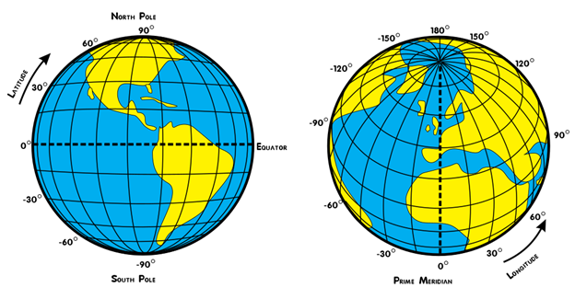
We can use latitude and longitude to give us absolute locations of our buoys.
- First navigate to https://www.ndbc.noaa.gov/.
- Notice in the upper left there is a search box.
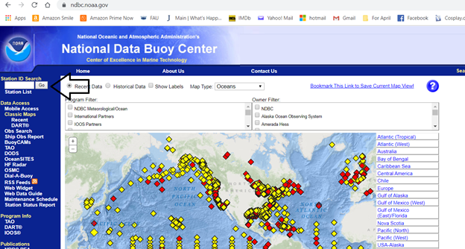
- Search for the following list of station ID’s and fill out their latitude and longitudes.
Name | Latitude | Longitude
Station 44137
Station 41001
Station 41002

- Plot these buoys in Google Earth/Arc/Google Maps and paste a screenshot of their location below:

II. How do winds influence ocean currents?
In this section we will explore atmospheric data collected from buoys to infer how wind direction and speed influences ocean circulation, specifically currents. Currents are continuous and consistent flows of water along the surface of the ocean. For this next activity, we will download data from the NDBC that gives you wind direction in degrees. We want you to practice converting from wind direction in degrees to wind direction in bearing (using the cardinal and ordinal directions). This might not be something you have ever utilized, but it is a basic mapping skill. To do this, we need to use a compass rose. A compass rose gives you the cardinal directions you are familiar with (north, east, south, and west), as well as the ordinal directions (northeast, southeast, southwest, and northwest) in degrees. We can once again imagine our directions as a circle ranging from 0° to 360°. Thus, each direction you move away from north (which is both 0° and 360°), gives you a degree around the circle. That means that true east is 90°, true south is 180°, and true west is 270°. North would be a range of numbers from 337.6° to 22.5°, northeast is 22.6° to 67.5°, east is 67.6° to 112.5°, southeast is 112.6° to 157.5°, south is 157.6° to 202.5°, southwest is 202.6° to 247.5°, west is 247.6° to 292.5°, and northwest is 292.6° to 337.5°.
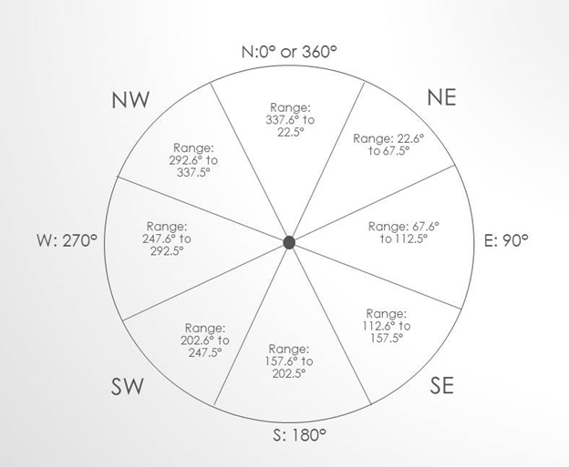
Wind direction can be described qualitatively. For example, wind blowing from the north can be described as northward or southerly. The “ly” denoted that wind is blowing from that direction. Similarly, wind that is blowing towards the east can be described as eastward or easterly. It is important to pay attention when wind direction is being described to ensure you know which way the wind is blowing. Wind direction is often shown using a wind rose. A wind rose is a figure that shows quantitative data pertaining to wind speed and direction. Look at the wind rose below:
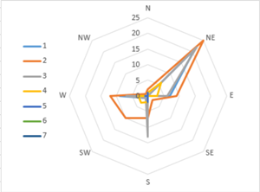
A wind rose looks like a compass. The lines radiating out from the center at regular intervals are reference lines, which denote the number of times wind measurements indicated the wind was blowing that speed. The lines extending from the center at irregular intervals represent data. The different colored lines denote different wind speeds. For example, the wind rose above shows that for this location the wind blew from the Northeast at 2 m/s 25 times during the measurement period. In contrast the wind blew from the south at 3 m/s almost 20 times during the data collection period.
- We will practice converting our wind directions in degrees to our cardinal and ordinal directions. Using the table below and the ranges/figure above, convert the degrees to cardinal/ordinal directions.
Degrees | Direction
145
230
93
3
201
278
112
250
242
357
315
33
153
296
181
- Now we will download buoy data for Station 41001 (this station is currently adrift, but the data we will look at was collected when it was stable). Navigate to https://www.ndbc.noaa.gov/ again and search for station ID 41001. Under Historical Data, click on data descriptions. This is metadata. Metadata is basically ‘data about data.’ In other words, where NOAA got this data, how it was processed, and what the categories mean.
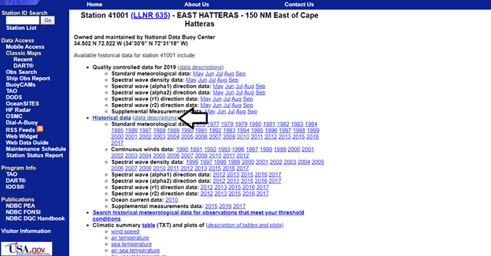
- Under Standard meteorological data, notice it lists several data categories with abbreviations. Notice MM, DD, WDIR, and WSPD. What do these abbreviations stand for?

- Your data will come from this database, from the year 2010. You’ve been provided an Excel file with this data, so you don’t have to download it. If you had accessed the data from the link above, the wind direction is given in degrees. However, in the data provided for you the wind direction has been converted into the cardinal and ordinal directions of N, NE, E, SE, S, SW, W, and NW. You will now make a wind rose plot in Excel from this data. Follow the instructions below to make the wind rose plot.
- Read through the column headers and scroll through some of the data to get a feel for how it is organized. Excel is organized into columns that are represented by letters and rows that are represented by numbers. Labels are at the top of each column. Each row represents one time period that data was collected.
- Play with scrolling so you understand the chart organization. The chart has been set up so that the labels stay where they are as we sort and process the data (the top rows are frozen). In addition, the data has been pre-sorted so all the measurements with like (same cardinal direction) wind speeds are grouped together and ordered by the wind speed, from slow to fast.
- There is a table in your excel sheet where you will input the number of times the wind was blowing from a certain direction at a certain speed. For example, the most upper left corner will contain the number of times the wind was blew from the N direction less than 2 m/s. Make sure you understand what this table is telling you.
- Instead of actually counting the number of times the wind was blowing from a particular direction within a specific range of speeds we can take advantage of the built in Excel “count()” function. In the cell representing the number of times the wind was blowing in the N direction less than 2 m/s type “=count(“. Now in the bottom pane highlight (click and drag) the wind speed data that is less than 2 in the E section. Be sure to only highlight the data in column H. When you have highlighted all of the data you need type “)” , hit tab on your key board. That cell now has the correct count of all the cells you highlighted.
- Repeat step “I” for all of you wind direction/wind speed combinations in the highlighted section of the excel sheet. The bottom rows have been completed for you already.
- You will now use the radar plot function in Excel to make your wind rose plot. Under the top tab “Insert” find the wind rose plot.
- A new blank rectangle will appear. Right click on the rectangle. If you are using a mac you can hold down “control” when clicking the mouse to do the same thing. A dialogue box will appear. Click on “Select Data”.
- A new dialogue box will appear. Underneath the blank box called “Legend entries (Series)” you will see a “+”. Click the “+”. A box called “Name” will appear on the upper right. Click the blank box so that a blinking cursor appears there. Then in your table in Excel click “<2”. Below that box there will be a box labeled “Y values”. Highlight the data below “<2” in your table.
- Repeat step “p” to add all of the windspeed data to the dialogue box.
- With the dialogue box still open click on the box labeled “Horizontal (category) Axis Labels”. Highlight the wind directions in your table in Excel. Click “OK”. Your wind rose plot is done! Paste it below:

6. Look at your wind rose plot. Describe the most common directions that the wind blows and the most common wind speeds:

7. Now find the approximate location at which this data was collected on Earth Null (off of Cape Hatteras, approximately within the Gulf Stream current). This site shows live 3-hr loops of atmospheric and ocean data: https://earth.nullschool.net/
- Does your wind direction match the direction of water currents at this location? I.e., how is the wind direction similar to and/or different from the current direction?

- Toggle the wind layer on and off and look at multiple days of data (go back in time using the controls on the left side of the screen). Move around the Atlantic and check out different locations. List several observations you notice. These could include: any repeating patterns in winds; consistent relationships between general wind direction and surface currents; and/or other features or patterns you notice in surface currents. Keyboard shortcuts for easier navigation on a laptop can be found here: https://earth.nullschool.net/about.html

