Group activity: Urban Stream Invaders

Working with your group members, respond to the following questions about the paper “Urbanization can increase the invasive potential of alien species” by Dr. Piatã Santana Marques and colleagues.

When answering, make sure you are using your own words. Paraphrase information from the paper (and don’t simply answer with direct quotes from the paper). Take turns being scribes and contributing to this document. This should be a collaborative effort - discuss your answers with each other!

- What is the overarching hypothesis that this study tests?

- What is the main message to draw from these figures (Figure 2a and 3b from the paper)? (Note that the statistical analysis of these results showed a significant effect of urbanization, but not fish biodiversity, on both dependent variables.)
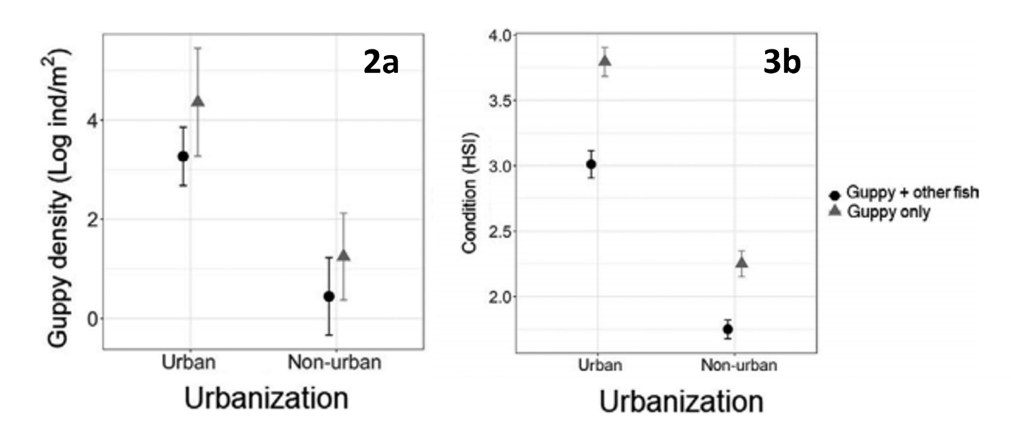

Fig. 2a. Guppy density estimated as mean number of individuals, both males and females, per metre square.
Fig. 3b. Comparing condition of urban and non-urban guppies. Guppy condition estimated for the female guppies using the mean hepatosomatic index (HSI).

In both treatments (urban and non-urban) guppies occur in stream reaches with other fish species (black circles, guppy + other fish) and in reaches where guppies are the only fish species (grey triangles, guppy only). Symbols represent the means and bars as the standard error of the mean. Data shown include two sampling years (2016 and 2017).

- What are chironomids? (look it up!) Why are they so abundant in urban streams? (Hint: see this image showing invertebrates that inhabit streams.)

- Examine Figs. 4 and 5 from the paper. How do these results relate to those shown in question #2?
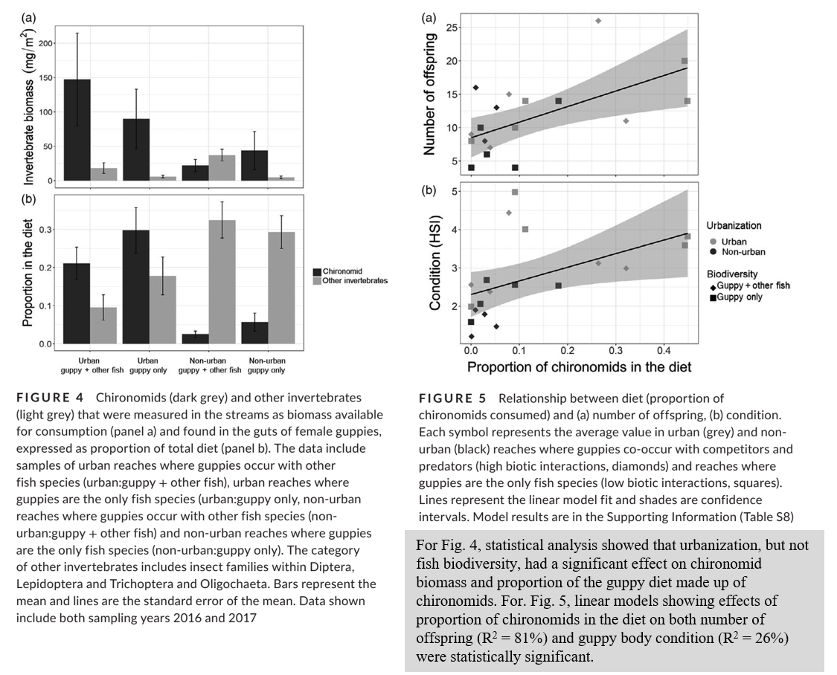

- This paper documented one way in which urban environments might differ from non-urban environments and the consequence of that difference. Can you think of other ways in which organisms face different conditions in urban vs. non-urban areas?

- Are you satisfied with the authors’ explanations for the success of guppies in urban environments? Are there other factors you would investigate? Or are there other questions raised by these results that suggest future research directions?

- Briefly describe another experiment or additional sampling you would perform to address one of the questions mentioned in #6 to build on the results of this study.

- Were there any results from the study that you didn’t understand or found confusing? You can each answer individually to this question.

