Lizard Cold Tolerance – Group Activity

Examine these figures from the paper you read by Campbell-Staton et al. (2017) (Figs 1-2) and another study we discussed in class (Campbell Staton et al. 2016, Figs. 3-4).

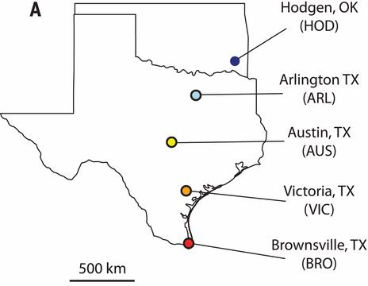
Fig. 1. Locations of the five anole populations in the cold tolerance study.

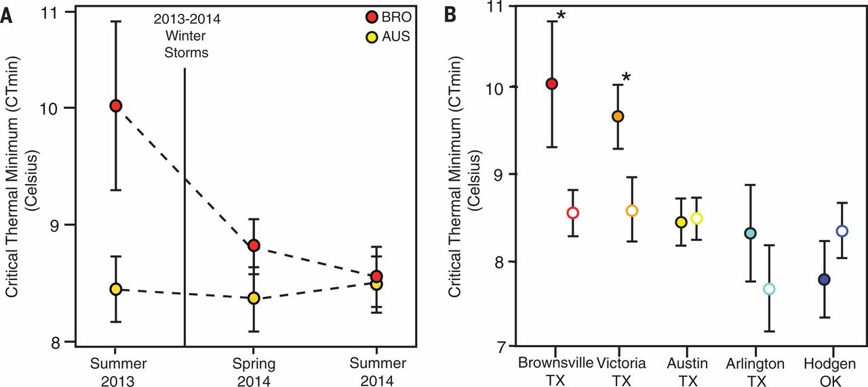

Fig. 2. A. Mean CT_{min} (critical thermal minimum, the temperature at which lizards lose their coordination) over time for two of the populations. Note that these are NOT the same individual lizards measured at different times B. Mean CT_{min} values for all five populations in the summer of 2013 (closed circles, before the severe winter storms) and summer of 2014 (open circles, after the severe winter storms). Asterisks indicate that the CT_{min} for a population was significantly lower in 2014 than in 2013, before the severe winter storms. Error bars represent the standard error of the mean (SEM).
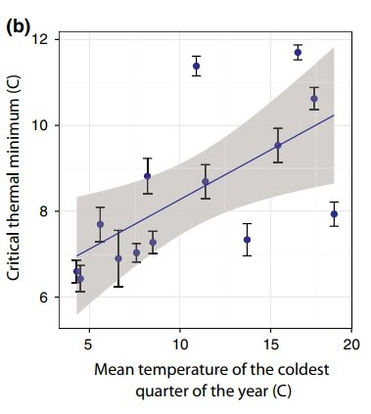
Fig. 3. Mean CT_{min} (± SEM) measured in anoles from populations throughout their native range as a function of the mean temperature in the coldest quarter of the year.
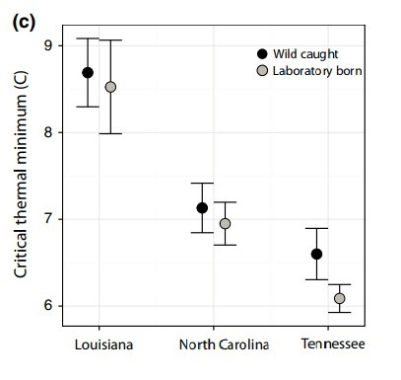
Fig. 4. Comparisons of cold tolerance between wild-caught (black) and laboratory-born and raised (grey) lizards from three populations across the A. carolinensis range. All points represent group means, and error bars indicate ± standard error.

As a group, discuss what these figures are telling us and respond to the following questions:

- How did the BRO and AUS populations differ in summer 2013 before the severe winter storms?

- Contrast how the severe winter storms affected the CT_{min} of BRO vs. AUS populations.

- Compare the five populations in Fig. 2B. Which populations had significantly different CT_{min} values before and after the severe winter storms of 2013-14? Why do you think these populations showed differences while others did not?

- What is the definition of natural selection? Do you think these data support the scientists’ hypothesis that the extreme cold winter of 2013-2014 led to natural selection on some of the lizard populations? Explain your answer based on the data.

- One of the postulates of evolution by natural selection is that variation for a particular trait is heritable; that is the variation has a genetic component and is not just caused by the environment. Do any of the data presented in the figures provide evidence for the heritability of cold tolerance? Explain.

- Do these results suggest that evolution of increased cold tolerance by natural selection has occurred in the Brownsville, TX (BRO) population? Or do we need more information? Explain your answer.

- Many extreme climate events are likely to become more frequent and severe due to climate change. How do you think climate change may affect the survival and distribution of different species?

8. Right now, Texas is having another period of extreme cold and unusual snowfall similar to the events of winter 2013-2014. If you were to build on the findings of this current study, what would you do next?

Fun fact about Dr. Shane Campbell-Staton - he co-hosts a podcast on the biology of superheroes. Check it out!

https://thebiologyofsuperheroespodcast.podbean.com/

References:

Campbell-Staton, S. C., Cheviron, Z. A., Rochette, N., Catchen, J., Losos, J. B., & Edwards, S. V. (2017). Winter storms drive rapid phenotypic, regulatory, and genomic shifts in the green anole lizard. Science, 357(6350), 495-498.

Campbell‐Staton, S. C., Edwards, S. V., & Losos, J. B. (2016). Climate‐mediated adaptation after mainland colonization of an ancestrally subtropical island lizard, Anolis carolinensis. Journal of evolutionary biology, 29(11), 2168-2180.

