Climate change and Strawberries: A real-life problem-based activity for teaching ANOVA
Nicole Hopkins¹, Holly Felker¹, Catharine Dickerson², Terry O’Brien¹, Dex Whittinghill², and Nathan Ruhl^{1*}
¹Department of Biological Sciences, Rowan University, Glassboro, New Jersey, USA 08028
²Department of Mathematics, Rowan University, Glassboro, New Jersey, USA 08028
* Corresponding author

Abstract
A common approach in statistical training is applied learning, whereby students demonstrate their mastery of the course material by completing relevant tasks, such as using a statistical platform to test a hypothesis or make a figure. While this approach emphasizes the development of useful skills, it lacks real-world authenticity and leads to a perception that statistics are extraneous to the conduct of experiments. Here we present a problem-based learning activity for teaching ANOVA using either R or the statistical program JMP that treats ANOVA as an integrated part of experimental design and evaluation. Problem-based learning is a student-centered, group-based approach that aims to achieve learning through solving real-life problems. This activity leverages a real example of a faulty methodological assumption from the scientific literature on how plants respond to climate change and challenges students to address the problem by proposing solutions. Through problem-based learning in this activity, students are able to authentically engage in the scientific process while simultaneously building applied statistical skills.

Description
ANOVA (analysis of variance) is a common statistical method that is often included in the undergraduate curriculum of science majors. This activity provides an interactive and an engaging way for students to apply both one-way and two-way ANOVA. The activity is laid out as an instructor-guided analysis of a problem from the scientific literature, in order to help familiarize students with these methods, before turning over the analysis to students, who work to produce solutions to the problem, and ultimately write a report on their findings.
We have included three different iterations of this activity: 1-Day JMP Activity, 2-Day JMP Activity, 1-Day R Activity. The two 1-Day versions have a partial problem-based learning (PBL) structure to them and only take one lab period to complete in JMP and RStudio, respectively, while the 2-Day version has a full PBL structure and takes two lab periods to complete in the JMP program.
The “problem” in this activity (Figure 1) is an interaction effect that prevents the interpretation of a two-way ANOVA, bringing some of the conclusions of De Kort et al. (2020a) into question. Developing solutions to this problem requires students to apply statistical concepts, perform data manipulation on the published dataset (De Kort et al., 2020b), write code in the 1-Day R version, and conduct additional statistical procedures (one-way ANOVA, two-way ANOVA, testing assumptions, post-hoc tests).
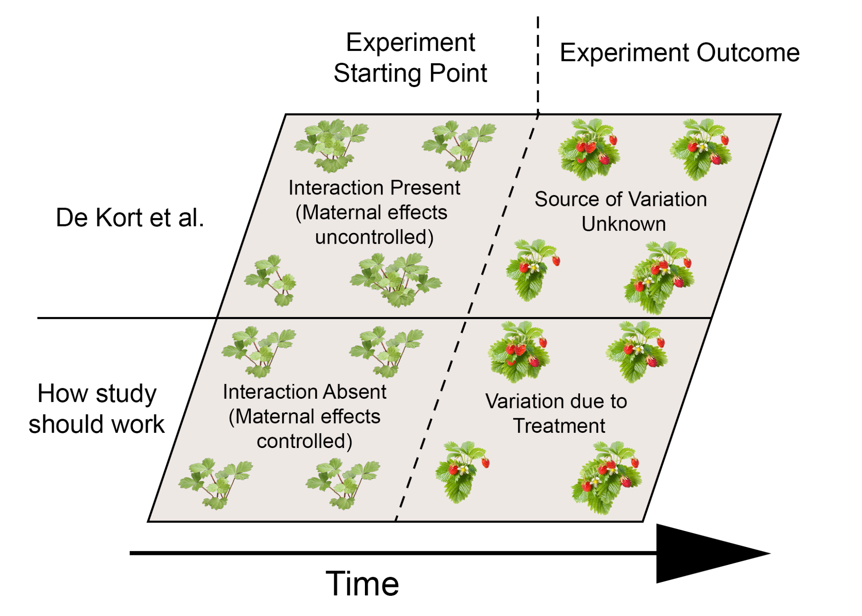
Figure 1: Illustration of the problem in De Kort et al. 2020a.

The objectives of this activity are as follows:
Writing hypotheses for ANOVA
Assessing data for assumptions of ANOVA
Conducting one-way and two-way ANOVA with Post-Hoc tests
Using statistical methods to critique the primary literature
Developing coding skills in the R language (1-Day R Activity only)
Developing scientific writing skills that incorporate statistical methods

This is an engaging and thought-provoking assignment relative to traditional application-based activities. Students gain valuable experience collaborating with peers to develop solutions to a real problem while reinforcing statistical concepts. Due to the nature of the problem being assessed, this activity also emphasizes that statistics are an integrated part of experimental design, peer review, and the process of science, not just a troublesome step to test hypotheses after an experiment concludes. Importantly, this activity is amenable to multiple learning modalities (e.g., in-person, online).

Citation:
De Kort H, Panis B, Helsen K, Douzet R, Janssens SB, and Honnay O. 2020a. Pre-adaptation to climate change through topography-driven phenotypic plasticity. Journal of Ecology, 108:4, 1465-1474. https://doi.org/10.1111/1365-2745.13365
De Kort H, Panis B, Helsen K, Douzet R, Janssens SB, and Honnay O. 2020b. Pre-adaptation to climate change through topography-driven phenotypic plasticity. Dryad, Dataset. https://doi.org/10.5061/dryad.5tb2rbp17
Authors
Nicole Hopkins, Holly Felker, Catharine Dickerson, Terry O’Brien, Dex Whittinghill, and Nathan Ruhl

Corresponding author:
Nathan Ruhl
Rowan University
Email: ruhl@rowan.edu

Change Notes
The number of columns in the original dataset (De Kort et al., 2020b) was reduced in the 1-Day JMP Activity, 1-Day R Activity, and 2-Day JMP Activity).
The linear models created within JMP and RStudio are different from one another, yet the same conclusions should be reached about the data.

