Phage Titer Quiz Questions
1. Josh did a titer assay with his phage lysate. He started with 100 µL of phage lysate (10⁰) and did 7 1:10 dilutions down to 10⁻⁷. He added 10 µL of each dilution to 250 µL of M. smeg and plated it on L-agar plates. His 10⁻³ plate had 102 plaques. What is the titer of his lysate?
A) 102 pfu/mL
B) 1.0X10⁵ pfu/mL
C) 1.0X10⁶ pfu/mL
D) 1.0X 10⁷ pfu/mL
Answer: D

2. Jack’s phage lysate has a titer of 3.9X10⁸ pfu/mL. He performed 5 1:10 serial dilutions of his phage into phage buffer and he plated 10 µL of the 10⁻⁵ dilution on a lawn of M. smeg. Approximately how many plaques would he expect to see on that plate?
A) there would be too many plaques to count – the plate would be cleared or a web pattern
B) 390
C) 39
D) 4
Answer: C

3. You have 100 µL of a 10⁻⁴ dilution of phage lysate. You plate 10 µL of this dilution on an L-agar plate and get 25 plaques. How many phage particles are in 100 µL of the 10⁻³ dilution?
A) 25
B) 250
C) 2,500
D) 25,000
Answer: C

4. You have a phage lysate and you need to determine the concentration of phage/mL. You do a set of serial dilutions as shown in the diagram below, each time you add 10 µL of phage solution into 90 µL of phage buffer and then use 10 µL of that solution and add it to the next tube containing 90 µL of phage buffer as shown below. You then plate 100 µL of this last dilution of phage on a lawn of bacteria and count the plaques—there are 750 plaques. What is the concentration of the phage in the original lysate?
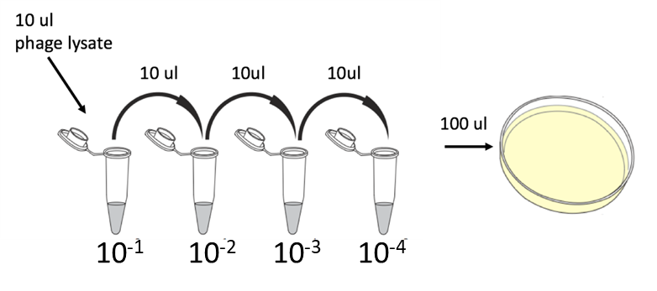
A) 7.5 x 10⁹ phage / ml
B) 7.5 x 10⁸ phage / ml
C) 7.5 x 10⁷ phage / ml
D) 7.5 x 10⁶ phage / ml
E) 7.5 x 10⁵ phage / ml
F) 7.5 x 10⁴ phage / ml
G) 7.5 x 10³ phage / ml
Answer: C

5. A high titer lysate was collected from a 10⁰ plate in a titer assay where the 10⁻² plate has 39 plaques. What is the titer of the high titer phage lysate?
A) 3.9 X 10⁶
B) 3.9 X 10⁵
C) 3.9 X 10⁴
D) 3.9 X 10³
E) cannot be determined from this assay
Answer: E

6. Phage "Snoopy" was purified in the Phage Lab. The 10⁻³ plate contained 52 plaques and was prepared using 10 µL of diluted phage. What is the titer (pfu/mL) of Phage Stock "Snoopy"?
A) 5.2 x 10³
B) 5.2 x 10⁴
C) 5.2 x 10⁶
D) 5.2 x 10⁶
Answer: D

7. Phage "Lolly" was purified in the Phage Lab. The 10⁻⁵ dilution plate contained 105 plaques and was prepared with 5 µL of diluted phage stock. What is the titer (pfu/mL) of phage stock "Lolly"?
A) 2.1 x 10⁵
B) 5.25 x 10⁵
C) 2.1 x 10⁹
D) 5.25 x 10⁹
Answer: C

