Linear Regression (Excel) and Cellular Respiration for Biology, Chemistry, and Mathematics

Student Activity

Learning Objectives:
Upon completion of this laboratory activity, the students will be able to:
- Describe the function of cellular respiration
- Identify the type of reaction of cellular respiration
- Identify the reactants and products of the cellular respiration reaction
- Interpret data sets to show the presence of CO₂ as a product in cellular respiration
- Perform linear regression analysis using MS Excel 365
  - Interpret the regression output using the correlation coefficient
  - Construct a scatter plot using Excel
  - Use R-squared to judge the fit of the regression line
  - Describe the relationship between the biological variables presented in this experiment.
  - Predict the value of an output variable (response) based on the input of an input (predictor) variable.

Background Information:

Biology Background Information:

Cell respiration refers to the process of converting the chemical energy of organic molecules into a form immediately usable by organisms. Glucose can be oxidized completely if sufficient oxygen is available.

All organisms, including plants and animals oxidize glucose for energy. Often, this energy is used to convert ADP and phosphate into ATP. There are several methods of indirectly measuring the rate of cellular respiration in organisms. One method involves monitoring changes in temperature; since the process of respiration is exergonic (produces heat). Another method is to measure either the oxygen consumption or the carbon dioxide production.

Amoeba Sisters Cellular Respiration Video
Chemistry Background Information:
In animal and plant cells, organic compounds release energy through the chemical process of cellular respiration. In this oxidation reaction, energy sources such as the sugar glucose (C₆H₁₂O₆) react with oxygen (O₂) to produce carbon dioxide (CO₂), water (H₂O) and energy (ATP):
https://commons.wikimedia.org/wiki/User:Christinelmiller
Attribution-ShareAlike 4.0 International (CC BY-SA 4.0)
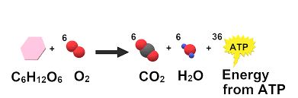
C₆H₁₂O₆ + 6O₂ → 6CO₂ + 6H₂O + energy (respiration)
Respiration is an exothermic process, and it provides the energy to make adenosine triphosphate (ATP) that is used as a main energy source for many other cell activities.

Mathematical Background Information:

Linear Regression Analysis is a statistical technique for analyzing the relationship between two variables. Regression Analysis is widely used to evaluate trends, make estimates, and for forecasting. In addition to applications in biology and chemistry, regression analysis is used in engineering, medicine, financial analysis, to name a few.

The regression model predicts the behavior of a dependent (target) variable using an independent (predictor) variable. We will use MS Excel 365 for graphing the scatter plot and performing linear regression on a data set. Excel was selected because it is available at no cost to students unlike graphing calculators. Further, proficiency in MS Excel is a useful skill for students’ future careers.
A scatterplot can be used to determine whether a linear correlation exists between two variables. Several types of correlations (r) are shown in the scatterplots below.
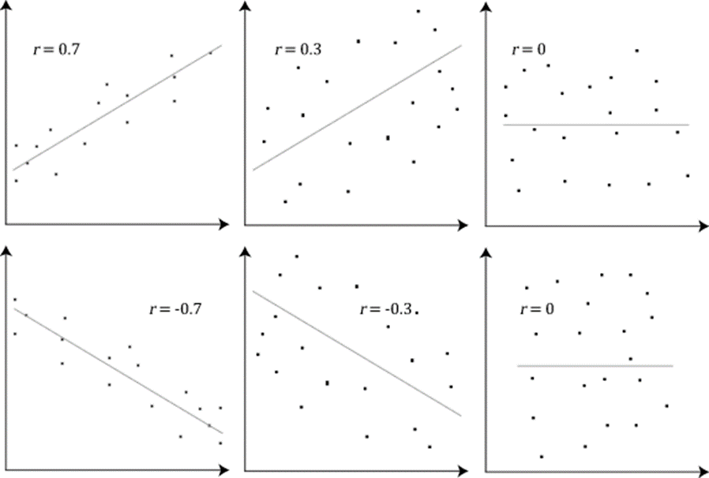
https://commons.wikimedia.org/wiki/File:Pearson_Correlation_Coefficient_and_associated_scatterplots.png

Introducing the Lab:

The Biology Lab: Cell Respiration Lab with Germinating vs Non Germinating Peas

Pre-Lab Activity with Excel Instructions:

A researcher wants to determine whether there is a linear relationship between a person’s age and the number of hours he or she exercises each week. The data are shown in the table below.
Age, x | 33 | 23 | 49 | 57 | 63 | 40 | 27
Hours of exercise, y | 6 | 6.5 | 3.5 | 3 | 1 | 4 | 6

- Calculate the correlation coefficient for the person’s age and the number of hours he or she exercises each week. Interpret the results in the context of the data.
Note: The correlation coefficient indicates the type and strength of the linear relationship between two variables, x and y. The correlation coefficient is a value between -1 and 1 inclusive.
- Display the data in a scatter plot and use the scatter plot to describe the type of correlation.
- Find the equation of the regression line for the person’s age and the number of hours he or she exercises each week. Add the regression line to the scatter plot. Report the R-Squared value and interpret.
Note: R-squared indicates how well the regression model fits the data set.
- Use the regression equation to predict y- values. Predict the number of hours a 45-year-old person will exercise per week.

Excel Instructions:

- To find the correlation coefficient:
Open the Excel and enter the data in two columns.
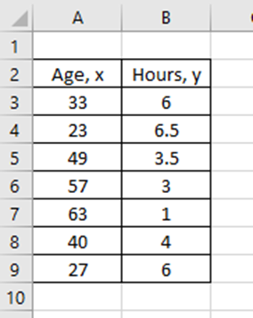
We can find the correlation coefficient if we use the “CORREL” function in Excel.
Write the phrase “Correlation Coefficient:” below the table.
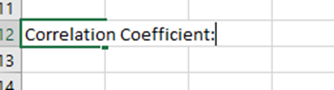
In the cell to the right of the phrase “Correlation Coefficient:” start typing =CORREL and you will get the function with parentheses opened that shows you how you need to input the data: (array 1, array 2
Highlight the first column (which in our example is column A from A3 to A9) and when you do this, the array 1 will be replaced by A3:A9
Do not highlight the title of the column!
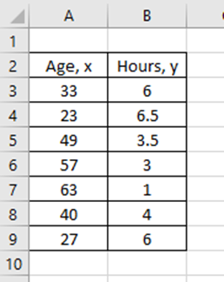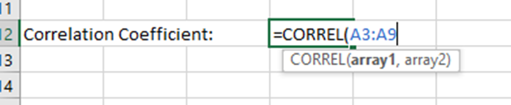

After A9 enter a comma , then repeat the highlighting of the second column of the data:
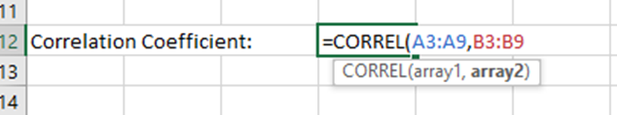

Now close the parentheses and then hit “Enter”, and you will get the following:
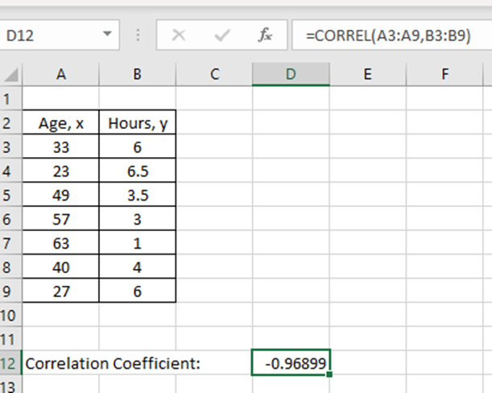

- To create the scatter plot:
Highlight both columns with the data then click the “Insert” tab on the top menu, then click the “Charts” tab.

Choose the first type of chart by clicking on it. This will give you the scatter plot.
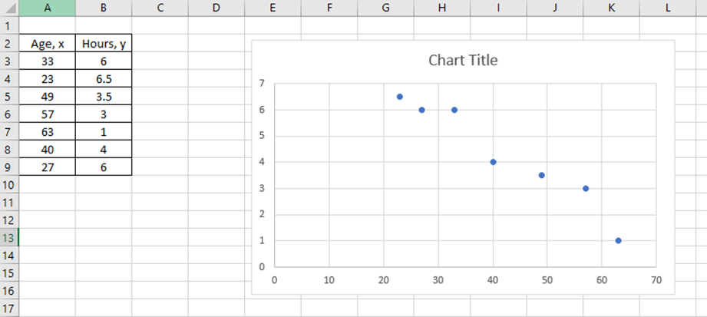

- To label the scatterplot, find the equation of the regression line, and the R-squared value (the coefficient of determination):
To label the scatterplot:
- Type in the Chart Title
- Titles of the axes (x- stands for the Age, y – stands for the Hours Exercised)
- Add the regression line, the equation, and the R-squared to your scatter plot
Click anywhere on the scatter plot, then click the (+) sign in the top right corner of the plot and check the boxes - Axis Titles and Trendline. This will also add the linear regression line to your scatterplot.
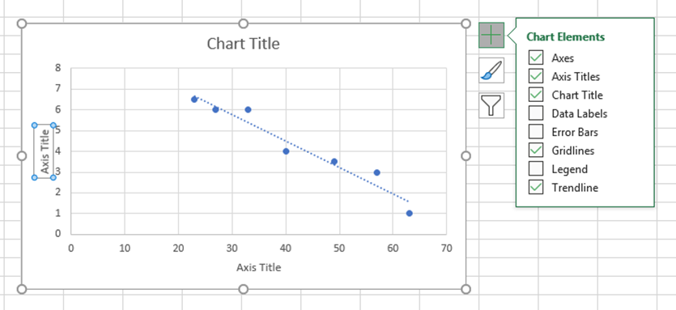

Next, add the equation of the regression line to the chart and the R-squared value by clicking More Options.
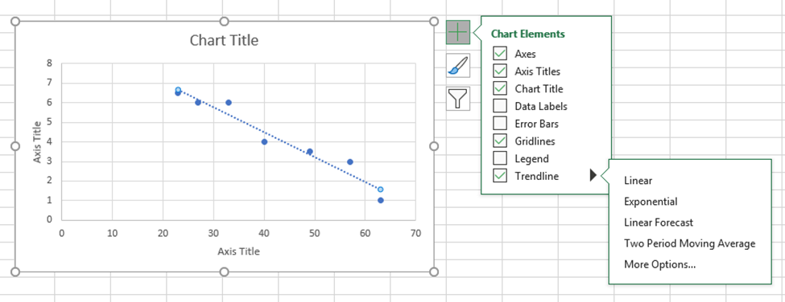

In the box to the right, check the boxes next to Display Equation on chart and Display R-squared value on chart.
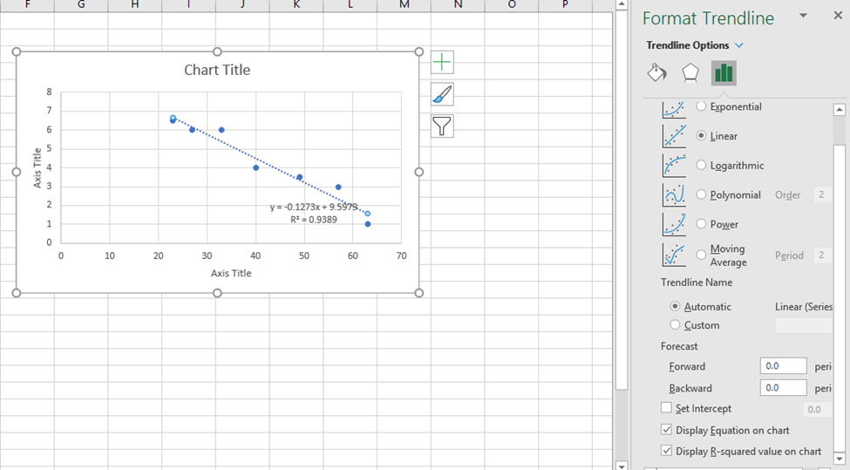

The linear regression equation and the R-squared will appear on the scatterplot.
Now you can type in the chart title and titles of the axes. You can also relocate the equation of the regression line.
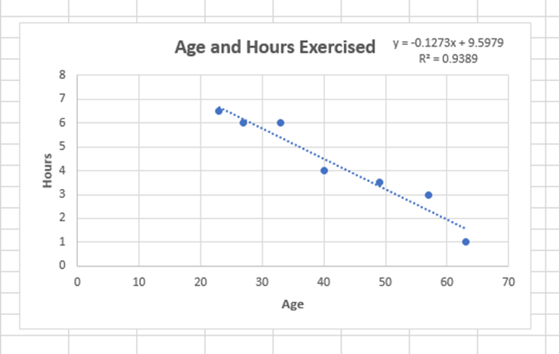
- Use the regression equation to predict y-values. Predict the number of hours a 45-year-old person will exercise per week.

Additional Resources:
- How to run a linear regression in EXCEL

- 365 Simple Regression Video

Experimental Activity:

We will utilize the germinating peas to examine the process of cellular respiration. Measuring the rate of respiration can rely on the amount of oxygen taken or the amount of carbon dioxide released by the peas.

There are two gases (oxygen and carbon dioxide) that are involved in cellular respiration. During cellular respiration these two gases are changing in volume.

During respiration, oxygen is consumed and its volume is reduced, while the carbon dioxide produced is converted into solid. Since the carbon dioxide is being removed, the change in the volume of gas will be directly related to the amount of oxygen consumed.

There are many ways to measure the rate of cellular respiration in an organism. One can use a respirometer to measure the gas volume changes based on the production or consumption of the gases. One can use a carbon dioxide gas sensor to monitor the amount of gas released by the germinating peas.

Step 1 Sample Data set given:
Cellular Respiration Data – obtained with a CO₂ probe
Germinating vs. Non-germinating peas
Carbon Dioxide (ppm) vs. Time
Time  (seconds) | Non-germinating peas  CO₂ (ppm) | Germinating Peas  CO₂ (ppm)
0 | 674 | 754
30 | 676 | 999
60 | 677 | 1076
90 | 677 | 1190
120 | 679 | 1240
150 | 681 | 1410
180 | 682 | 1558
210 | 685 | 1620
240 | 687 | 1750
270 | 690 | 1850

Step 2 Create a scatter plot and linear regression in MS EXCEL using the data from Step 1
Create a linear-regression equation of the form: 𝑦 = 𝑚x + 𝑏
where x is time in seconds, y is CO₂ concentration (ppm), m is the slope, and b is the y-intercept

Step 3 Answer the following Questions:

- Do you have evidence that cell respiration occurred in peas? Explain.

- What is the effect of germination on the rate of cellular respiration in peas?

- Would you consider non-germinated seeds “Alive”?

- Write a balanced chemical equation for cellular respiration.

- What are the reactants of cellular respiration?

- What are the products of cellular respiration?

- Cellular respiration is defined as ______ reaction.

- Determine the type of correlation between the variables by looking at the scatter plot. (For example, positive linear, negative linear, no linear correlation)

- Compute the value of the correlation coefficient, r, for x and y. Determine the type of correlation between the variables using the correlation coefficient.

- What is the expected CO₂ level for germinating peas after 300 minutes?

This material is based upon work supported by the National Science Foundation under Grant No.1919613. Any opinions, findings, and conclusions or recommendations expressed in this material are those of the author(s) and do not necessarily reflect the views of the National Science Foundation.

