Name: _________________________________________ Date: ____________________________

This Venn Diagram can be used to compare and contrast the math and science concepts in this contextual activity.

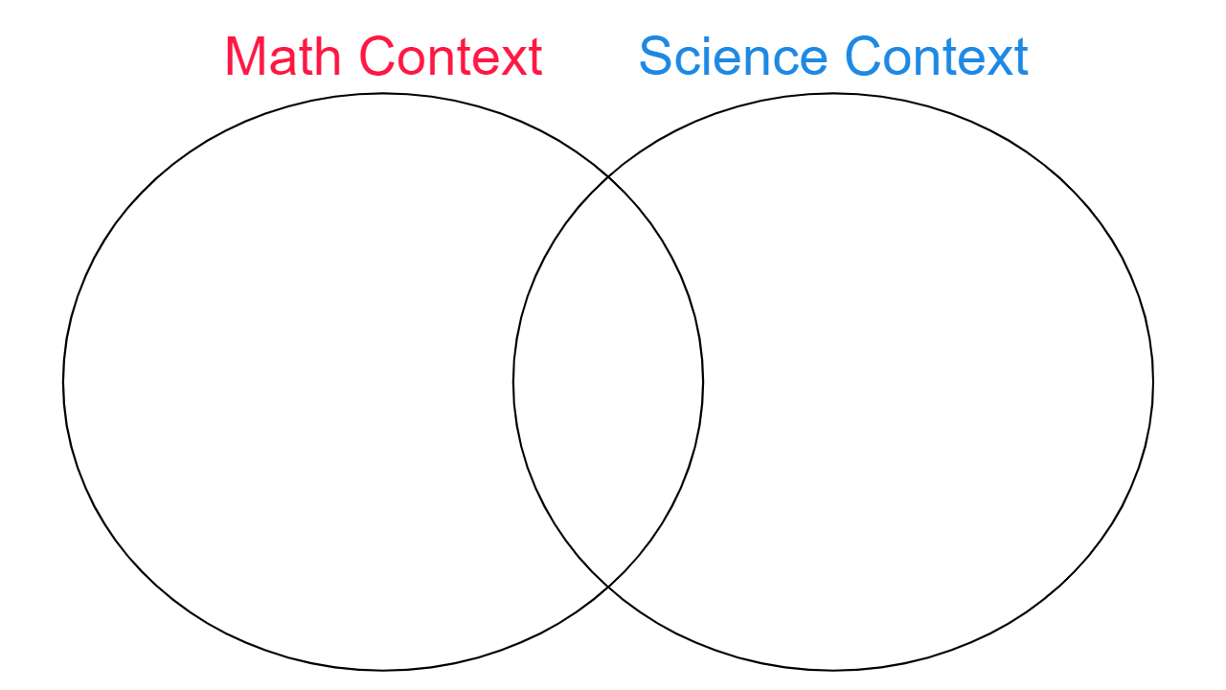
QB@CC Using Semi-log Graph to Demonstrate Bacterial Cell Growth

