STUDENT VERSION
The Good Kind of Virus: Oncolytic Viruses vs Cancer Cells
Iordanka N. Panayotova
Department of Mathematics
Christopher Newport University
Newport News VA USA

Maila Brucal-Hallare
Department of Mathematics
Norfolk State University
Norfolk VA USA

Abstract: In this project, students explore oncolytic virotherapy using systems of differential equations and numerical simulations. The first activity guides the students in simulating the dynamics between the uninfected cancer cells $x(t)$, the oncolytic virus-infected cancer cells $y(t)$, and the oncolytic viruses $v(t)$; the model consists of three differential equations. The second activity builds upon the previous model and guides the students in exploring the dynamics between $x\left(t\right), y\left(t\right), v(t)$, and the immune system cells $z(t)$; the model consists of four differential equations. The numerical simulation uses a Python code administered via an internet-based environment called Glow Script.
Keywords: virotherapy, oncolytic virus, cancer-immune dynamics, immune suppressor drug, Python
Tags: system, nonlinear, differential equations, numerical simulations, graphical analysis

SCENARIO DESCRIPTION
Due to COVID-19, the class of genetic materials called viruses got a bad reputation. In this activity, you will learn about a good kind of virus that research oncologists use to treat a disease that has been killing Americans for quite some time now. In fact, although the COVID-19 virus has claimed hundreds of thousands of lives in 2020, it currently ranks third, next to heart disease and cancer, in terms of death rates.
Oncolytic viruses are genetically modified viruses that are designed to infect cancer cells but not normal healthy cells. They are injected directly into the tumor. After entering a cancer cell, the virus begins to quickly replicate, and when the cancer cell dies, many virus particles burst out and proceed to infect other cancer cells. One example of a virus used as oncolytic virus is the Herpes Simplex Virus Type-1 (HSV-1). This virus is particularly useful for treating glioblastoma tumors, related to brain cancer, as it can pass the blood-brain barrier and infect and replicate in neural tissues [1]. Viruses depend on the cells (so-called hosts) for their survival and cannot reproduce on their own. Virotherapy is a very promising cancer treatment, in principle, but research is still needed to study its efficacy.
Mathematical models are useful tools that can be used to study the dynamics between viruses and cancer cells. While the complexity of this dynamics is well known, it is difficult to measure the contribution of each component of the oncolytic system. Mathematical and computational modelling can provide valuable information on the relative importance of different oncolytic components, how they are influenced by other components, and how these relationships may vary across conditions. Models can provide informed hypotheses for experimental testing and identify potential targets for clinical manipulation of the oncolytic response. Other cancer treatments that have been proven to be effective include surgery, radiotherapy, chemotherapy, and immunotherapy. Refer to another SIMIODE project of the authors to see an activity on an introduction to cancer treatment modeling [2].
Mathematical modeling of the treatment responses represents an attractive avenue towards narrowing the set of possibilities that should be tested in preclinical models and in the clinical setting. Here we show how mathematical models can be used to test different assumptions by varying the models’ parameters. In this way, they provide deeper insights into questions that cannot be addressed by clinical or experimental studies alone.
Activity I: Simulating virotherapy on cancer cells
A simple mathematical model that describes the dynamics between the population $x(t)$ of cancer cells, the population $y(t)$ of oncolytic virus-infected cancer cells, and the population $v(t)$ of oncolytic virus is given by the system of differential equations:
- $\left\{\begin{aligned}\frac{dx}{dt}=αx-βxv \\ \frac{dy}{dt}=βxv- δy \\ \frac{dv}{dt}=Nδy-γv\end{aligned}\right.$
where $x(0), y(0), v(0)$ are given initial conditions. Note that the parameter $β$ measures the efficacy of the process of infecting cancer cells with virus in killing the cancer cells. Observe, too, that the positive term in the third equation comes from the fact that oncolytic virus population cannot reproduce on its own and that it requires the infected cancer cells for its growth and replication. Parameter N is the replication number of a virus at the time of death of the infected cancer cell. For example, the replication number N for the Herpes Simplex Virus Type-1 (HSV-1) varies from 500 up to 1500 virions [1].
- It is very important to understand each term that comprise the equations in a mathematical model. Use the hints as a guide to describe each term in (1) as a rate.
Term | Rate description | Hints
$$αx$$ |  | Set $β=0$ in the first equation. Does the resulting equation look familiar?
$$βxv$$ |  | This term appears in the first equation, with a negative sign. It also appears in the second equation for $\frac{dy}{dt}$ but it does not involve $y$.
$$δy$$ |  | Set $β=0$ in the second equation. Why is this term negative?
$$Nδy$$ |  | $N$ is the replicating number of the oncolytic virus. Remember that a virus relies on the host cell for its survival!
$$γv$$ |  | Why is this term negative?

- Now that you have investigated a mathematical model of virotherapy, it is time to perform some numerical simulations. A Python code for system (1) is offered in www.glowscript.org. You must create an account in order to edit the code.
2a) Create an account in www.glowscript.org
2b) Click on the link to view the Python code:
https://www.glowscript.org/#/user/MailaNSUMath/folder/MyPrograms/program/VirotherapyDEMARC2021
2c) Create a copy of the program by clicking Create New Program and copying the provided code.
2d) Click “Run this program”.
2e) You should see time-evolution graph for the populations $x\left(t\right), y\left(t\right), v\left(t\right)$ with the given initial values, you should be able to get the graph:
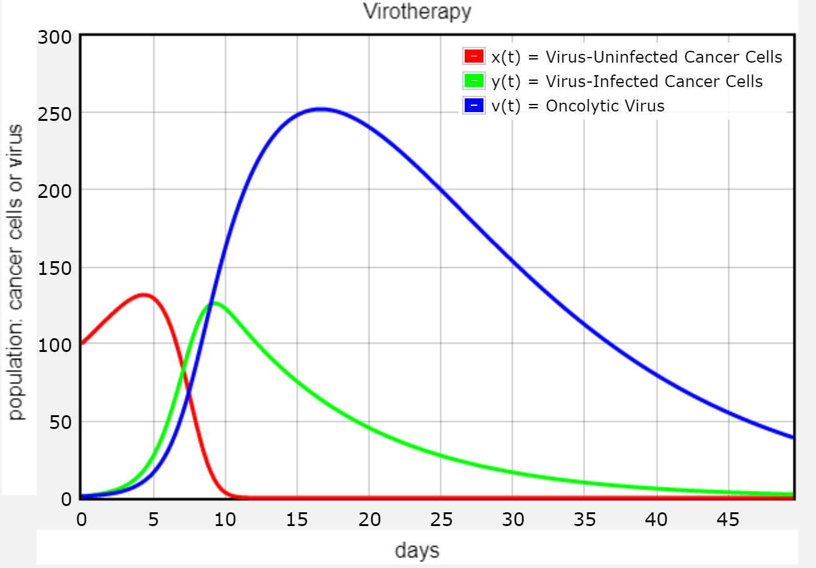
- Using the graph above, analyze each of the populations $x(t), y(t), v(t)$ by visually approximating:
- intervals of increase or decrease,
- intervals of upward concavity or downward concavity;
- locations of inflection points;
- time values when the populations reach maximum and approximate population values at these times;
- time values when the populations appear to reach zero.

- The next step allows you to modify some values in the given Python code. The current initial values are $x(0)=100$ uninfected cancer cells, $y(0)=1$ infected cancer cells, and $v\left(0\right)=1$ oncolytic virus. Play with the initial values for $x(t), y(t), v(t)$, run the simulation, and observe the resulting graphs. Analyze the graphs using the previous questions as a guide.
For example, fill in the table
Your chosen initial values  $x(0) =$  $y(0) =$  $v(0) =$ | Criteria | $$x(t)$$ | $$y(t)$$ | $$v(t)$$
 | Interval of increase
 | Interval of decrease
 | Interval of upward concavity
 | Interval of downward concavity
 | Point of inflection
 | Point of intersection
 | Maximum point
 | Zeros

- Refer to your chosen initial values in Exercise 4. What happens to the maximum points of each of the three populations when you double the number of infected cancer cells $y(0)$ and do not change the initial values for $x(0)$ and $v(0)$?
- Refer to your chosen initial values in Exercise 5. What happens to the zeros of the each of the three populations when you double the initial values for $v(0)$ and do not change the initial values for $x(0)$ and $y(0)$?
- Remember that $N$ is the replicating number of the oncolytic virus. Simulate the virotherapy model when N = 2, 4, and 6. The goal is to eradicate the cancer cells. Approximate the time it takes $x\left(t\right)$ and $y(t)$ to reach zero:
Initial values  $x(0) =$  $y(0) =$  $v\left(0\right)=$ | Replicating number values | Time it takes $x\left(t\right)=0$ | Time it takes $y\left(t\right)=0$
 | N = 2
 | N = 4
 | N = 6

Write a few sentences to summarize your observations.

Activity II: Simulating virotherapy with immune system effects
In experiments, viral therapy as described in Activity I was not initially successful because it failed to address the effect of the immune system [3]. Immune cells recognize the infected cancer cells as foreign bodies and hence, destroy them before the virus particles get a chance to replicate to their full potential. In the second part of this modeling activity, we will introduce the effects of the immune system by adding a fourth differential equation to the system (1) to include $z(t)$, the population of immune cells in the body. Moreover, the immune system must be suppressed using drugs; in the model, this is achieved by including an immune suppressing term $-ez$. The modified system is given below:

$\left(2\right)\left\{\begin{aligned}\frac{dx}{dt}=αx-βxv \\ \frac{dy}{dt}=βxv-syz- δy \\ \frac{dz}{dt}=syz- ωz^{2}-ez \\ \frac{dv}{dt}=Nδy-nvz- γv\end{aligned}\right.$
This system is a simplified version of the model suggested by Chou and Friedman [4]. The additional terms in this system are described in the table below:
$$syz$$ | stimulation rate of immune cells by infected cells
$$ωz^{2}$$ | clearing rate of immune cells
$$nvz$$ | killing rate of the virus by immune cells
$$ez$$ | death rate of immune cells due to immune-suppressor drug; $0 ≤ e ≤1$
In this second activity, you will explore effects of the parameters on immune-cancer interactions using another Python code that simulates these interactions under the virotherapy. As before, parameters are chosen for illustration purposes and are not based on real data.
- Click on the link to access the code:
https://www.glowscript.org/#/user/iordanka.panayotova/folder/MyPrograms/program/Virotherapy-4equations
Create a copy of this program. Run the new program to create time-evolution graphs for the populations $x\left(t\right), y\left(t\right),z\left(t\right),$and $v\left(t\right).$ Please note that there is no immune suppression in this case as parameter $e$ is set to zero. What can you say about the effectiveness of the virotherapy?

- Modify the program to include the suppression of the immune system by assuming $e = 0.5$. Run the program again. Make a statement about the goal of eradicating cancer cells with this value of $e$.

- Modify the program to simulate the effect of virotherapy when N = 6, 8, 10. time it takes $x\left(t\right)$ and $y(t)$ to reach zero:
Initial values  $x(0) =$  $y(0) =$  $z\left(0\right)=$  $v\left(0\right)=$  $e$ = | Replicating number values | Time it takes $x\left(t\right)=0$ | Time it takes $y\left(t\right)=0$
 | N = 6
 | N = 8
 | N = 10

- Repeat previous step when the chemotherapy dose is increased to $e= 1.$
- Repeat the analysis with modified initial conditions.
- Observe that the term $syz$ does not appear in the first model. Observe what happens when you vary the parameter $s$. Explain the significance of this term in the model.
- What is the effect of the parameter $β$ on the immune-cancer cells interactions? What does this mean for the effectiveness of the virotherapy?

References
[1] Rius-Rocabert S. et al. 2020. Oncolytic Virotherapy in Glioma Tumors. Intern. J. Mol.Sci. 21(20): 7604 www.ncbi.nlm.nih.gov/pmc/articles/PMC7589679/
[2] Brucal-Hallare M. and I. N. Panayotova. 2021. Should cancer therapy start before or after surgery? 150-T-CancerTherapy. https://www.simiode.org/resources/8479 .
[3] Z. Sheng Guo et al. The Combination of Immunosuppression and Carrier Cells Significantly Enhances the Efficacy of Oncolytic Poxvirus in the Pre-Immunized Host. Gene Therapy. 17 (12) 1465-1475. doi: 10.1038/gt.2010.104
[4] Chou, C.S. and A. Friedman. 2010. Introduction to Mathematical Biology: Modeling, Analysis, and Simulations. New York: Springer. 172 p.

