Pharmaceutical pollution in aquatic environments: History, pertinence, and connections to our dataset
By Leah Shotwell

Purpose and learning goals

Lesson Purpose
This lesson is designed to provide some background and context pertaining to the well-established problem of pharmaceutical pollution. Far from being a novel issue, the presence of pharmaceutical waste in aquatic environments has proven detrimental to the health of aquatic organisms including fish, algae, and crustaceans. By reading this material, students should understand the short and long-term effects of pharmaceutical ingestion as well as the susceptibility that specific creatures have to pharmaceutical pollution due to their biological processes. This lesson should serve as a preface/introduction to the focal publication by Peters et al. pertaining to the behavioral patterns of crabs exposed to fluoxetine.

Learning Goals
- Understand the history and ecological context of pharmaceutical pollution
- Analyze the study conducted in the focal paper and the statistical methods used
- Determine how pharmaceuticals (fluoxetine) impact estuarine organisms and brainstorm what can be done in the future to mitigate the negative effects

Background

Over the past few decades, scientists have expressed concern over increasing concentrations of pharmaceutical waste present in marine environments (Świacka et al., 2022). Since the 1990’s concentrations of drug waste have been on the rise and more than 100 have been detected solely in wastewater treatment plant (WWTP) effluent (Di Nica, 2016). This has led to various environmental challenges that start in the water and end with the decline (or even extinction) of certain species (Di Nica, 2016). For example, the population of vultures in Pakistan sharply declined after they began eating carcasses of animals that had ingested diclofenac (a common NSAID) (Di Nica, 2016). In fact, a study published in 2020 that the risk of pharmaceutical toxicity in scavenging birds was greater than the risk experience by their aquatic counterparts (Aranda-Lara & Gómez-Oliván). Additionally, β-blockers and fluoxetine have both been correlated with decreased photosynthetic output in algae (Di Nica, 2016). This has been exacerbated by recent upwards trends in medication use (Świacka et al., 2022). In fact, the embracing of modern medicine and de-stigmatizing of mental health conditions with medication has led to record high amounts of patients taking these substances (Świacka et al., 2022). To be more specific, the use of antihypertensives has increased by 70% just in the years 2000-2017 (Świacka et al., 2022). In that same period, the use of cholesterol-lowering agents rose by 300% and antidepressants by 200% (Świacka et al., 2022).
However, human waste is not the only source of these aquatic contaminants (Świacka et al., 2022). Veterinary waste and improper disposal of medications are both major contributors of pharmaceutical pollution in major waterways (Świacka et al., 2022). Medication (especially antibiotics) are often overprescribed for ailments in dogs and cats. In conjunction with the bathroom habits of these animals (often outdoors) and the nature of runoff/groundwater absorption, much of the overall pollution can be attributed to animal waste (Świacka et al., 2022). In terms of improper disposal of medicines, flushing unused medication down the toilet is the biggest contributor (Świacka et al., 2022). According to survey data, around 20% of people dispose of expired or unneeded medications in this manner (Świacka et al., 2022).

Current gaps in research
Historically, research addressing the effect of pharmaceuticals on aquatic life has been limited (Świacka et al., 2022). The quantity of datasets pertaining to fish and mollusks vastly outweighs those focused on shellfish and macroalgae, therefore prohibiting holistic approaches in management (Świacka et al., 2022). In addition, many current studies obtain their data from laboratory research, not real-life conditions (Świacka et al., 2022). In lab studies, exposure concentrations and methods often differ from situations observed in aquatic environments and real statistical effects are often overlooked due to the nature in which medications are stored and metabolized in each individual species (Świacka et al., 2022). In other words, medications that are fat soluble (stored in fat cells) and studied species that have longer lifespans tend to be overlooked (Świacka et al., 2022). Finally, research has always been concentrated on freshwater environments, mainly because human waste is most frequently dumped into rivers and bays (Świacka et al., 2022). Consequently, the oceans and estuaries were never seen as high priority locations for research (Świacka et al., 2022). Of course, It also didn’t help that a commonly held belief in terms of ocean pollution typically consisted of, “the solution to pollution is dilution” (Świacka et al., 2022). Hence, the rising concern over contamination in oceans and estuaries has been a relatively recent shift (Świacka et al., 2022).

Ecological consequences of pharmaceutical pollution

Negative effects of pharmaceutical ingestion
What impact does pharmaceutical waste typically have on an aquatic organism? Current research suggests that most organisms experience lower growth rates, higher mortality rates and increased oxygen consumption as an after-effect of chronic exposure (Świacka et al., 2022). Medications commonly used to treat blood pressure have also been proven to influence the adrenal function of fish and mollusks (Massarsky et al., 2011). This is because the adrenergic system of humans is structurally and functionally homologous to that of fish and mollusks (Massarsky et al., 2011). Studies of β-blockers indicate that the “reproduction, growth, heart rate, and hepatic fuel stores” of fish are impacted by chronic exposure (Massarsky et al., 2011). Additionally, β-blockers lower the ability of fish to respond to and cope with stress (Massarsky et al., 2011). In mollusks, β-blockers negatively impact reproduction and growth and affects the process of phagocytosis (Massarsky et al., 2011). In a study of NSAIDs (specifically paracetamol, ibuprofen, and diclofenac) on aquatic organisms, researchers deduced that the drugs could result in cellular damage, teratogenesis, and embryotoxicity in certain species of fish (Aranda-Lara & Gómez-Oliván, 2020).
Some examples of prominent contaminants are listed below:

Bioaccumulation + biomagnification
In a Chinese study conducted in 2014, researchers analyzed 7 different aquatic species (4 fish, 3 crustaceans) in the Liao River Basin to determine the biomagnification/bioaccumulation abilities of 19 different antibiotics (Świacka et al., 2022). Of these antibiotics, enrofloxacin exhibited the highest bio-concentration factor (BCF) (Świacka et al., 2022). According to the authors, the values ranged from 10047 for P. sinensis (crustacean) to 45407 for A. chankaensis (fish) (Świacka et al., 2022). Roxithromycin was found to bioaccumulate, but only in A. chankaensis (Świacka et al., 2022). None of the other medications were found to bioaccumulate in any of the species studied but concentrations of 13 antibiotics were found in the tissues of the organisms (Świacka et al., 2022). This research highlights the different ways in which organisms react to chemical compounds and metabolize them (Świacka et al., 2022). A medication that heavily impacts one species might not impact or even be present in another (Świacka et al., 2022). Therefore, any solutions designed to combat absorption of antibiotics cannot be applied to all medicines and species (Świacka et al., 2022).
In 2016, researchers tested the effects of 10 pharmaceuticals on Aliivibrio fischeri, a bioluminescent bacterium (Di Nica, Villa, & Finizio 2016). A. fischeri was specifically chosen because it has a comparable pharmaceutical sensitivity to other fish and reacts “typically” to narcotics (Di Nica, Villa, & Finizio 2016). Chlortetracycline showed enhanced toxicity, especially when not acting as the sole pharmaceutical pollutant (Di Nica, Villa, & Finizio 2016). More specifically, the authors warned that the mixture of pharmaceutical compounds together could potentially create a compounding effect, one that is much harder to study due to its complexity (Di Nica, Villa, & Finizio 2016). In Houston, Texas, a study of a tidally influenced marine ecosystem determined that the drug diphenhydramine had the capability to bioaccumulate in fish, especially those that preferred pelagic habitats (Du et al., 2016). It is important to consider the bioaccumulation and biomagnification of all drugs when discussing possible regulatory measures and timelines, as the effects of these drugs can persist well after they no longer exist environmentally in large amounts.

Our study – “prozac in the water”
‘Prozac in the water: Chronic fluoxetine exposure and predation risk interact to shape behaviors in an estuarine crab’ was published in Ecology and Evolution in 2017 (Peters et al., 2017). The article focused primarily on the Oregon shore crab Hemigrapsus oregonensis and how the species would behave when exposed to varying levels of fluoxetine, otherwise known as Prozac (Peters et al., 2017). The authors also decided to include the presence of a predator as a variable (Peters et al., 2017). In this case, the red rock crab Cancer productus served this role (Peters et al., 2017). In addition to conducting predator vs. no predator trials, they also controlled for time of day (day vs. night) and the different types of behaviors exhibited by the crabs (still, active, foraging, and social) (Peters et al., 2017). The researchers decided to observe the crabs under three different concentrations of fluoxetine: 0 ng/L, 3 ng/L, and 30 ng/L (Peters et al., 2017). This data is visually depicted in Figure 1 (Peters et al., 2017). All crabs were wild caught on the same day in Netarts Bay, Oregon (Peters et al., 2017). After transporting the crabs to Portland State University, the male H. oregonensis crabs were separated by the size of their carapace (Peters et al., 2017). This was done so one large male crab, one small male crab, and one female crab could be placed in each of the 30 housing tanks (Peters et al., 2017).
Research Question: Does the presence and concentration of the antidepressant fluoxetine alter the proportion of risk behaviors exhibited by Hemigrapsus oregonensis?

Crabs exposed to 30 ng/L of fluoxetine were significantly more likely to exhibit risky behaviors (general activity and agonistic behavior) and unsurprisingly more likely to fall victim to the predator C. productus (Peters et al., 2017). Additionally, these crabs were more likely to be active during the day, something considered unusual for a primarily nocturnal species (Peters et al., 2017). This is postulated to have increased their risk of fighting amongst their own species as well as interacting with predators (Peters, et al., 2017). The effects of fluoxetine exposure were most extreme in weeks 7-9 of each trial, indicating that chronic exposure is more disruptive to their behavioral patterns (Peters et al., 2017). Overall, exposure to 30 ng/L of fluoxetine was linked to greater incidences of intraspecific fighting as well as increased mortality rates due to predation (Peters et al., 2017). However, this is far from a death sentence for this species (Peters et al., 2017). Crabs exposed to 3 ng/L of fluoxetine exhibited similar behavioral patterns to the control group (Peters et al., 2017). This signifies that a pharmaceutical pollution management plan that seeks to reduce the concentrations of fluoxetine entering bodies of water may be enough to stop disrupting the circadian rhythms and behavioral patterns of the crabs (Peters et al., 2017).

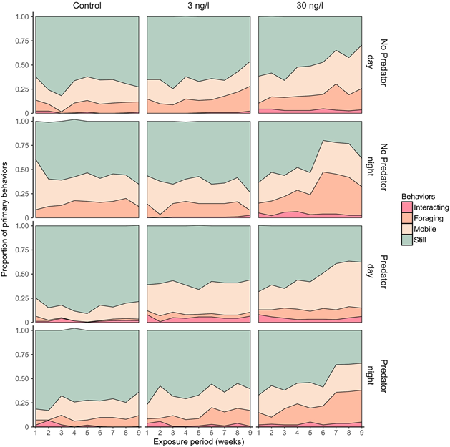
Figure 1: Graphic depicting the behaviors of the crabs demarcated by time of day and presence of predators. Taken from “Prozac in the water: Chronic fluoxetine exposure and predation risk interact to shape behaviors in an estuarine crab”
Citation: Ecology and Evolution, Volume: 7, Issue: 21, Pages: 9151-9161, First published: 30 September 2017, DOI: (10.1002/ece3.3453)

Statistical analyses
In this study, the authors used a relatively complex statistical approach (Peters et al., 2017). Their analysis consisted of two main portions, the first of which is quoted below:
For hypothesis testing, we used likelihood ratio tests (LRT) with chi-square test statistics to compare null models with each main term through stepwise selection of the best-fit model based on Akaike Information Criterion (AIC). If main terms significantly improved the model fit, they were included in the full model. Because our hypotheses centered on the interaction between experimental factors and fluoxetine treatment, we used LRTs to test each interaction with the full model, following the same stepwise procedure for main terms. Interactions that were significant were included in the final best-fit model. Model assumptions of normality and homoscedasticity were assessed through visual inspection of the residuals. Post hoc contrasts between experimental factors were then tested for significance with a Tukey HSD test using the lsmeans package (Lenth, 2016). (Peters et al., 2017)
Following the implementation of the likelihood ratio tests (LRT) and Akaike Information Criterion (AIC), the model of best fit was generated, and the authors moved on to comparing the agonistic and predator behaviors amongst the three different levels of fluoxetine treatment (Peters et al., 2017). They did this by creating a generalized mixed model (GLMM) fitted with a Poisson distribution (Peters et al., 2017).
While the statistical methods used by the authors are more than adequate for their analysis, they may be too complex for the purposes of this lesson. Therefore, we will be taking a simplified approach. More specifically, the activity located within the .Rmd document will guide the user through the process of creating a multiple linear regression model. This model will highlight the relationship between stillness/inactivity and the ratio of foraging & active behaviors. To accomplish this, we will filter the data contained in the original excel spreadsheet to include only a particular subset of crabs (dominant male crabs observed at night). This is accomplished using the following code:
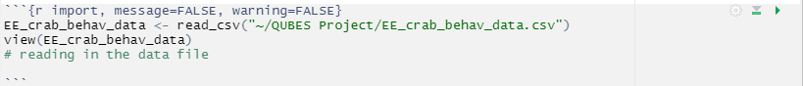
After obtaining the filtered version of our data, we will go through the assumptions that must be met before proceeding with the creation of our model. These assumptions are listed below alongside the accompanying code. The fourth assumption (homoscedasticity) will be excluded until the formation of the model is complete as it cannot be tested beforehand.
Independence of Observations
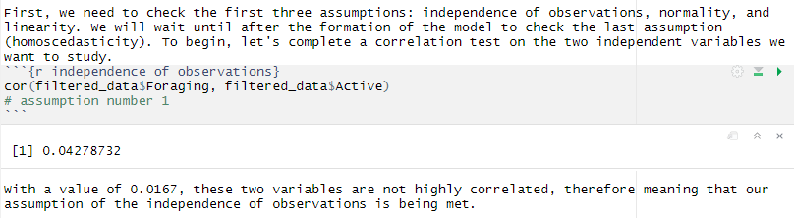
Normality
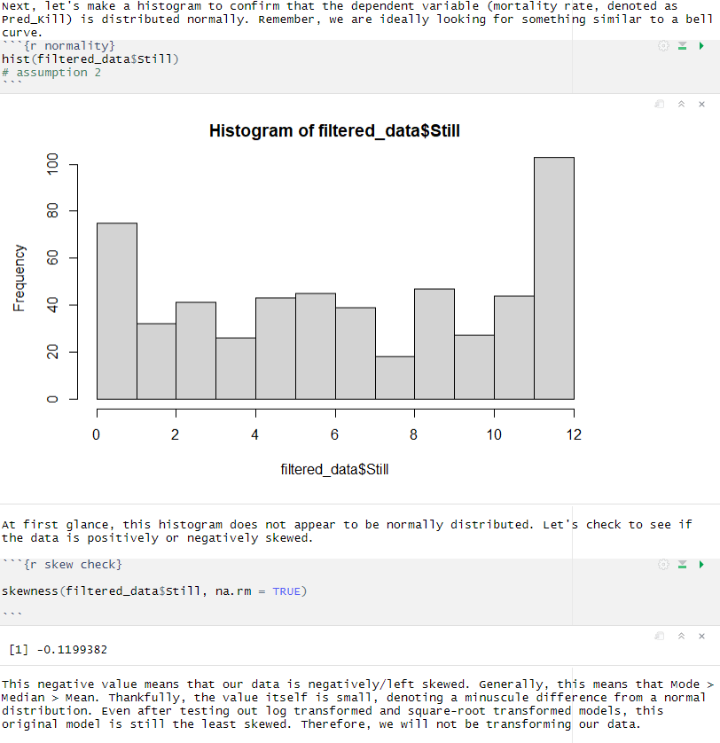
Linearity
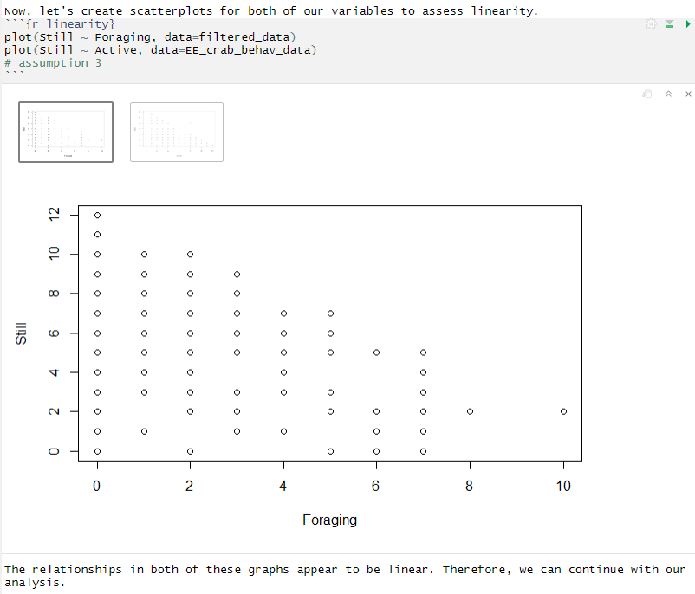

Formation of the model and testing the fourth assumption
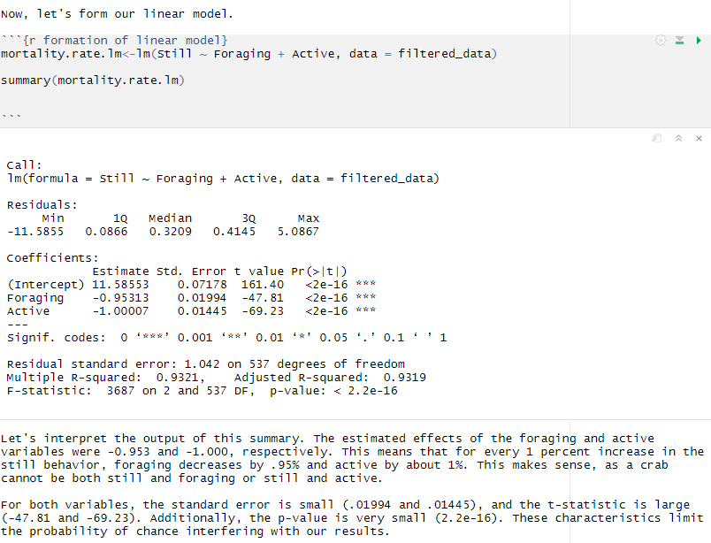

The most important parts of the R output in this section are the “Estimate” section, the standard error, and the t-statistic. This is because these metrics tell us the estimated effects and make us more confident that random chance is influencing these results. Finally, let’s test the fourth assumption.
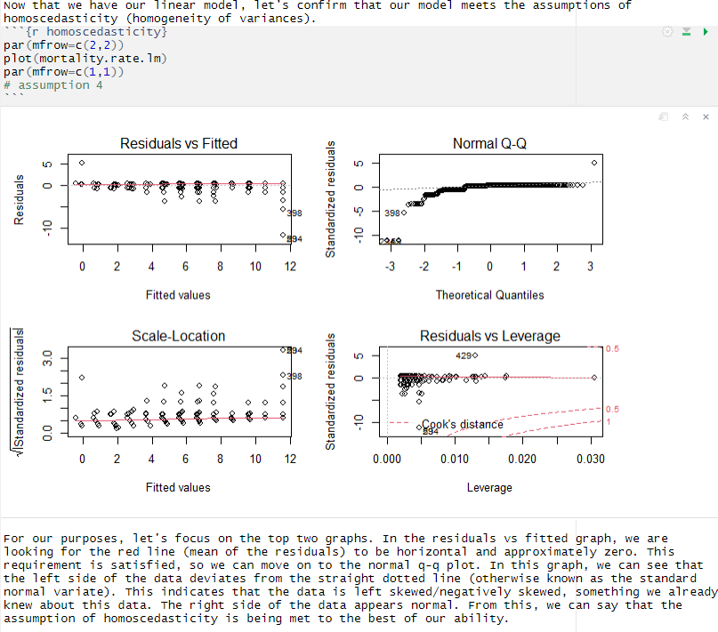

For additional information on any of the concepts presented in this publication, please consult the following webpages:
Used in Lesson
Multiple Linear Regression
Linear Regression in R

Used by Authors
Akaike Information Criterion
Generalized Linear Mixed Models

Additional Resources

Behavior of Hemigrapsus oregonensis
Hemigrapsus oregonensis was chosen because of its prevalence, behavioral patterns, and lifespan (Peters et al., 2017). H. oregonensis is one of the most common estuarine species inhabiting the West coast, with the range of the species stretching from Alaska to Mexico (Peters et al., 2017). The species is most active at night, using darkness as a form of concealment as they forage for diatoms, green algae, and carrion (Peters et al., 2017). When not foraging, H. oregonensis buries itself in sediment, rocks, and/or gravel (Peters et al., 2017). In the presence of predators, this species does not usually choose to fight (Peters et al., 2017). Instead, it stays buried and remains motionless, using its shell as further camouflage (Peters et al., 2017). In other words, this species typically does not exhibit exorbitant proportions of high-risk (mobile, foraging, species interactions) behavior (Peters et al., 2017).
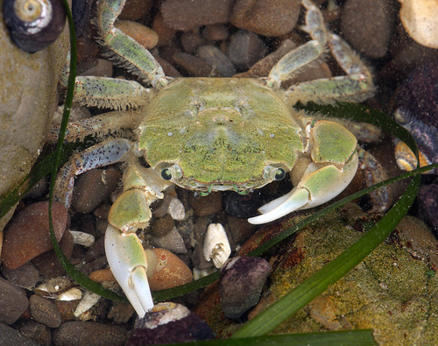
Questions?

Solutions
It is increasingly evident that pharmaceutical pollution in aquatic environments is harming organisms through the manipulation of behavioral patterns as well as direct metabolic effects (Peters et al., 2017). This problem is also an elusive one, as typical WWTPs were not designed to remove pharmaceuticals from wastewater effluents (Silva et al., 2015). WWTPs normally implement two different types of treatment: filtration to remove solids and sediment and subsequent removal of smaller biological materials through a reactor that utilizes activated sludge (Silva et al., 2015). Unfortunately, activated sludge is largely ineffective at removing pharmaceuticals and the presence of certain drugs can even inhibit the function of the microorganisms within the sludge (Silva et al., 2015). Silva et al. ascertain that a tertiary method on top of the other two established steps will be necessary to address this type of pollution and limit contamination of water bodies (Silva et al., 2015). The specifics of these methods will be discussed at greater length in the following paragraphs.
Amongst all available methods, activated carbon adsorption is one of the most efficient for removing pharmaceuticals from wastewater effluent (Silva et al., 2015). Activated carbon can be added in powdered or granular form both as a supplemental measure and as part of routine filtration of pharmaceuticals (Silva et al., 2015). It is a relatively low-cost option that is made more economically feasible when considering its potential for reuse through steam regeneration (Silva et al., 2015). Activated carbon can remove 92% of fluoxetine and 67-90% of diazepam when implemented as a tertiary step in the wastewater treatment process (Silva et al., 2015).
Membrane filtration processes are another viable way to remove some classes of pharmaceuticals from wastewater (Silva et al., 2015). Membranes typically act as a pressure-driven barrier to prevent metals, dissolved solids, and microorganisms from passing through (Silva et al., 2015). The specific type of membrane used depends on the size of the particles that need to be filtered out of the water (Silva et al., 2015). Microfiltration, ultrafiltration, nanofiltration, and reverse osmosis are all types of membrane filtration processes currently used in the wastewater treatment industry (Silva et al., 2015). However, microfiltration is the only category of membrane filtration that has been successful in the removal of pharmaceutical contaminants (Silva et al., 2015). This method is mainly used in conjunction with other methods to filter out pharmaceuticals in the carbamazepine drug category (Silva et al., 2015).
The final tertiary method of removing pharmaceuticals involves advanced oxidation processes (AOP) (Silva et al., 2015). This method involves the use of hydroxyl radicals to neutralize a plethora of organic contaminants through the process of hydroxylation or dehydrogenation (Silva et al., 2015). This typically results in the dissolution of pharmaceuticals and the creation of carbon dioxide or water as a byproduct (Silva et al., 2015). Photocatalysis and ozonation are widely regarded as the most popular types of AOP (Silva et al., 2015). Ozonation can remove 99% of carbamazepine, 91% of fluoxetine, and 81% of diazepam from wastewater effluent (Silva et al., 2015). AOP methods are favored by many water treatment specialists because they can be used to remove a wide variety of aromatics, pesticides, dyes, and volatile organic compounds in addition to pharmaceutical products (Silva et al., 2015).

Questions
- Is pharmaceutical pollution well-addressed in its current state? What methods currently exist as ways to filter out pharmaceuticals from wastewater effluent?
- What species of crab was of interest in the Peters et al. study? How did the behavior of the crabs change with the introduction of fluoxetine into the water?

- What are some examples of pharmaceuticals that most commonly pollute bodies of water?
- What are some of the limitations of conducting research in a controlled/lab environment?

continue to the r code for an activity + additional questions!

References

Aranda-Lara, L., & Gómez-Oliván, L. M. (2020). Non-steroidal anti-inflammatory drugs in water: Emerging contaminants and ecological impact (1st ed. 2020.). Springer. https://doi.org/10.1007/978-3-030-56294-6
Di Nica, V., Villa, S., & Finizio, A. (2017). Toxicity of individual pharmaceuticals and their mixtures to Aliivibrio fischeri: Experimental results for single compounds and considerations of their mechanisms of action and potential acute effects on aquatic organisms: Aquatic toxicity of pharmaceuticals. Environmental Toxicology and Chemistry, 36(3), 807–814. https://doi.org/10.1002/etc.3568
Du, B., Haddad, S. P., Luek, A., Scott, W. C., Saari, G. N., Burket, S. R., Breed, C. S., Kelly, M., Broach, L., Rasmussen, J. B., Chambliss, C. K., & Brooks, B. W. (2016). Bioaccumulation of human pharmaceuticals in fish across habitats of a tidally influenced urban bayou: Pharmaceutical bioaccumulation in an urban coastal ecosystem. Environmental Toxicology and Chemistry, 35(4), 966–974. https://doi.org/10.1002/etc.3221
Massarsky, A., Trudeau, V. L., & Moon, T. W. (2011). β-blockers as endocrine disruptors: The potential effects of human β-blockers on aquatic organisms. Journal of Experimental Zoology Part A: Ecological Genetics and Physiology, 315A(12), 251–265. https://doi.org/10.1002/jez.672
Peters, J. R., Granek, E. F., de Rivera, C. E., & Rollins, M. (2017). Prozac in the water: Chronic fluoxetine exposure and predation risk interact to shape behaviors in an estuarine crab. Ecology and Evolution, 7(21), 9151–9161. https://doi.org/10.1002/ece3.3453
Silva, Bruna., Costa, Filomena., Neves, I. C., & Tavares, Teresa. (2015). Psychiatric Pharmaceuticals as Emerging Contaminants in Wastewater (1st ed. 2015.). Springer International Publishing. https://doi.org/10.1007/978-3-319-20493-2
Świacka, K., Maculewicz, J., Kowalska, D., Caban, M., Smolarz, K., & Świeżak, J. (2022). Presence of pharmaceuticals and their metabolites in wild-living aquatic organisms – Current state of knowledge. Journal of Hazardous Materials, 424(Pt A), 127350–127350. https://doi.org/10.1016/j.jhazmat.2021.127350

