

**STUDENT VERSION**

**MODELLING OF ELECTRIC CIRCUITS**

**AND MODEL VALIDATION**

Chiu Choi

Electrical Engineering Program

University of North Florida

Jacksonville FL 32224 USA

[cchoi@unf.edu](mailto:cchoi@unf.edu)

**Abstract**: In this project students will establish a mathematical model for an electric circuit as a second-order ordinary differential equation with constant coefficients. They will derive the initial conditions for this differential equation by using circuit laws. They will obtain its closed-form solution and its graph. The students will construct the same electric circuit in NI’s Multisim circuit simulation software [1] running on a PC. They will obtain the graph of the same solution by computer simulation. Free trial versions of this software are available for download from NI’s website [2]. If laboratory resources are available, students are encouraged to construct the same electric circuit physically on a prototyping board and use laboratory instruments to obtain the graph of the same solution experimentally. The students will compare the three graphs obtained from the closed-form solution, Multisim computer simulation, and the physical circuit. Matching results among these three graphs will reflect the accuracy of the differential equation-based mathematical modeling of electric circuits.

**STATEMENT**

Students will analyze a series RLC circuit, model the circuit as a differential equation, derive the initial conditions for the differential equation, solve for the closed-form solution, and plot the graph of the closed-form solution. The solution is the voltage across the capacitor of the circuit. That voltage is the desired response in this project. Next, the students will simulate the circuit using NI’s Multisim™[1], a Windows-based circuit simulation software, and obtain the same desired response of the circuit by Multisim [1]. They will compare the Multisim response, which is a graph of the desired response, to the graph of the closed-form solution. They will observe that the significant parameters of the Multisim graph, e.g., the initial value, the steady-state value, the peak value, and the frequency of oscillation, are close to their counterparts from the closed-form solution. Lastly, if resources are available, the students may build the circuit on a breadboard and obtain the same desired response experimentally by using an oscilloscope, which is an instrument that can capture and record the graph of the desired response. This graph will be compared with the two graphs obtained from the closed-form and Multisim solutions. The agreement of the significant parameters of these three graphs will build students’ confidence in differential equation-based mathematical modeling of electric circuits.

**PARTS LIST**

The parts used in the experimental part of this project are provided in Table 1. A photo of these parts in Table 1 is shown in Figure 1.

|  |  |  |
| --- | --- | --- |
| Part | Label | Quantity |
| 220  resistor | R | 1 |
| 12 k resistor | R2 | 1 |
| 100 mH inductor | L | 1 |
| 0.1 F capacitor | C | 1 |
| SPST or SPDT switch | S1 | 1 |

Table 1. Parts List

**EQUIPMENT**

The equipment for the experimental part of this project include:

* Digital multimeter, e.g., Rigol DM 3058E.
* A two or four channel oscilloscope, e.g., Rigol DS1054Z.
* DC power supply.
* Breadboard or other prototyping board.

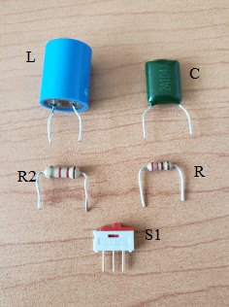

Figure 1. Photos of the parts

**PART 1: DEVELOPMENT OF THE DIFFERENTIAL EQUATION MODEL**

This project is suitable for those students who have taken introductory courses in differential equations or circuit analysis. Consider the circuit shown in Figure 2. The switch S1 has been closed for a long time and the circuit is under direct current (DC) condition.

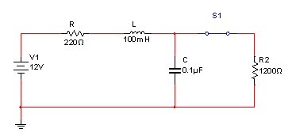

Figure 2. An electric circuit, S1 is closed

The switch S1 is opened as shown in Figure 3 at time t=0. This circuit at time t > 0 is a series RLC circuit driven by the 12 V source. The desired response of the circuit is the voltage across the capacitor vC(t) in Figure 3 for t > 0. The current through the series circuit is i(t).

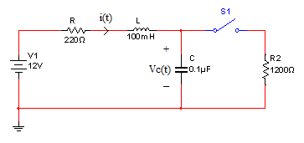

Figure 3. Switch opened at time t=0.

Find the differential equation governing vC(t). This differential equation is a mathematical model for this circuit. You can derive the differential equation by following the procedure below.

* Write down the voltage-current relationship for a capacitor. Express the current through the capacitor, i(t), in Figure 3, as a first-order derivative of vC(t).
* Write down the voltage-current relationship for an inductor. Express the voltage across the inductor as a second-order derivative of vC(t).
* Apply Kirchhoff’s voltage law to the series circuit in Figure 3 and you will obtain a second-order differential equation for vC(t).
* Apply circuit laws to derive the two initial conditions vC(0) and dvC(0)/dt for the second-order differential equation.
* Solve the second-order differential equation for vC(t). Consider using the characteristic equation and solve for the characteristic roots. Notice that the characteristic roots are a complex conjugate pair. This means that vC(t) is underdamped. Thus, the graph of vC(t) will contain oscillations. Such phenomena are described in the literature, e.g., [3, 4, 5]. Formulate the closed-form solution in terms of the characteristic roots. There will be two unknown constants in the closed-form solution. Use the two initial conditions to determine the values of the two unknowns in the solution.
* Plot a graph of the closed-form solution vC(t), t > 0. You may use mathematical software tools such as Mathematica or Matlab. This graph will be useful in the validation of the differential equation model for this circuit.
* Challenge. The same circuit can also be modelled as a linear system of first-order differential equations of the form:

; ,

where is the current (from left to right) through the inductor and u is the voltage source V1=12 V in Figure 3. (Note that Find the values of the parameters *a, b, c, d, e, f, v0,* and *i0* in this system of first-order differential equations.

**PART 2: COMPUTER SIMULATION**

The circuit in Figure 2 can be simulated, e.g., Multisim software with the switch S1 closed initially. During the simulation, the switch can be opened by hitting the space key on the keyboard. Virtual instruments can be used to find the initial conditions and the desired response, vC(t), of the circuit. Do the following tasks.

* Create the circuit in Figure 2 using Multisim. (Note that Multisim offers tutorials on how to create circuits.)
* Use Multisim to find the initial conditions *v0* and *i0* in the linear system of first-order differential equations in Part 1. Check if your derived initial conditions, *v0* and *i0* are close to those obtained by the probes. Hint: to obtain *v0*, place the voltage probe (the V probe) at the location as shown in Figure 4. To obtain *i0*, place the current probe (the A probe) at the location indicated in Figure 4. Notice that each of the two probes in Figure 4 measured five different circuit parameters. The parameter on the top for the voltage probe is the voltage across the capacitor and that value is the initial condition *v0* when the switch is opened. Likewise, that parameter on the top for the current probe is the current through the inductor and that value is equal to *i0*. The remaining four measurements made by each probe are the peak-to-peak value, the root-mean-square value, the DC level, and the frequency of the signal. These four parameters are not used in this project.

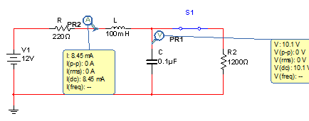

Figure 4. Measurement of the initial conditions.

* Activate a virtual oscilloscope in the Multisim software and connect it to the circuit as shown in Figure 5 but with S1 closed initially. Start the simulation with S1 closed and then hit the space bar on the keyboard to open S1. The virtual oscilloscope will capture the graph of vC(t) before and after the switch was opened. An example of that graph is shown in Figure 6. Your graph should look like Figure 6.

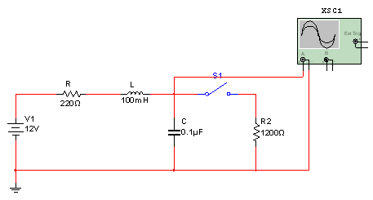

Figure 5. Using the virtual oscilloscope to measure vC(t).

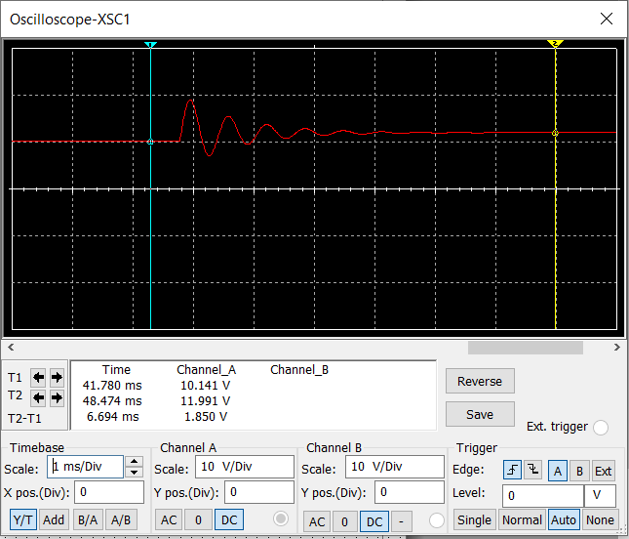

Figure 6. The graph of vC(t) obtained by Multisim simulation.

* Estimate the initial value and the steady-state value of your graph of vC(t). Hint: to estimate the initial value, place Cursor 1 (in cyan) at a point in time before the oscillations in Figure 6. As indicated in the table in Figure 6, that initial value is 10.141 V. To obtain the steady-state value, place Cursor 2 (in yellow) as shown in Figure 6 at a point in time after the oscillation is dissipated. That final value is 11.991 V in the same table. Compare your initial and steady-state values to those obtained from the closed-form solution. They will not be identical, but should be very close.
* Similarly, estimate the peak value as shown by Cursor 1 in Figure 7. The peak value is defined as the value at the highest peak of the waveform.
* Estimate the frequency of oscillation from the graph of vC(t) in Figure 6. Hint: Zoom into Figure 6 and place Cursors 1 and 2 at two successive peaks of the oscillation. An example is shown in Figure 7. Multisim will calculate the time period in between the two cursors. As shown in Figure 7, that time period is T2-T1=629.032 s. That is an estimate of the period of oscillation. The frequency of oscillation is equal to 1/629.032 s=1.589 kHz. Compare the theoretical frequency of oscillation from your closed-form solution with the frequency of oscillation from your Multisim simulation. The two values should be very close.

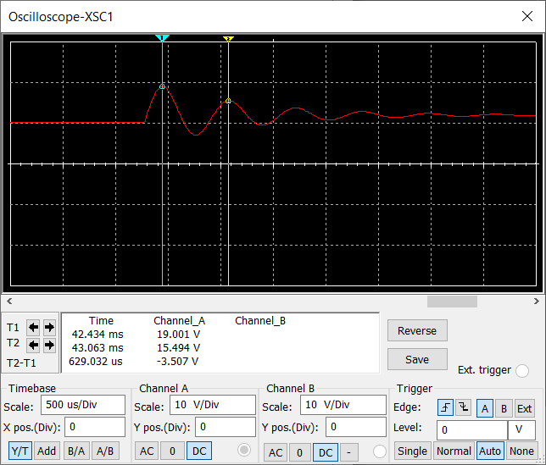

Figure 7. Estimation of the period of oscillation for vC(t).

**PART 3: EXPERIMENTAL INVESTIGATION**

You will be performing experiments in the lab for this Part 3 if you have access to laboratory resources. You will need a bench top general-purpose digital multimeter and an oscilloscope. These instruments are frequently used in circuit labs, e.g., in [4, 5].

* Build the circuit in Figure 2 on a breadboard. An example of the circuit wired together is shown in Figure 8.

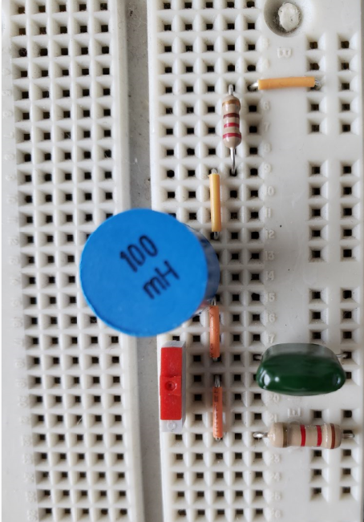

Figure 8. RLC circuit on breadboard

* Connect the voltage source to the circuit. An example is shown in Figure 9. The power supply (yellow knob) of a prototyping station was tuned to 12 V and was used to drive the circuit. You can use other power supplies.

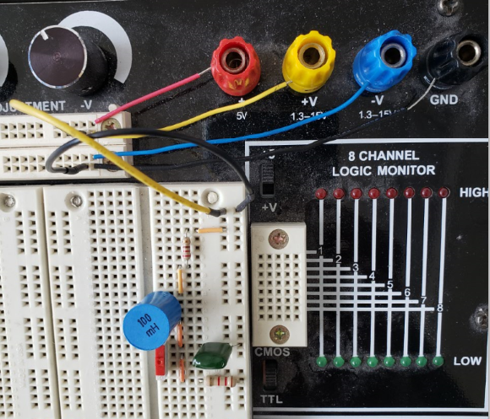

Figure 9. Power supply to the circuit

* Use the digital multimeter to make sure that you are driving the circuit with a voltage close enough to 12 V. As shown in Figure 10, the voltage measured by the digital multimeter is 12.0317 V.

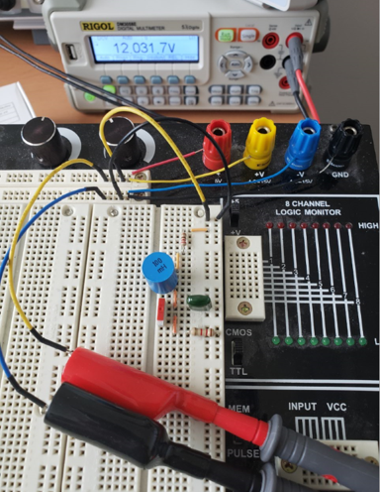

Figure 10. Checking the voltage to be close to 12 V

* Use a digital multimeter to measure the initial conditions *v0* and *i0*. Compare these two measurements with those obtained from Part 1. They should be very close.
* Use an oscilloscope to obtain the graph of vC(t). A photo of the oscilloscope used in this experiment is shown in Figure 11.

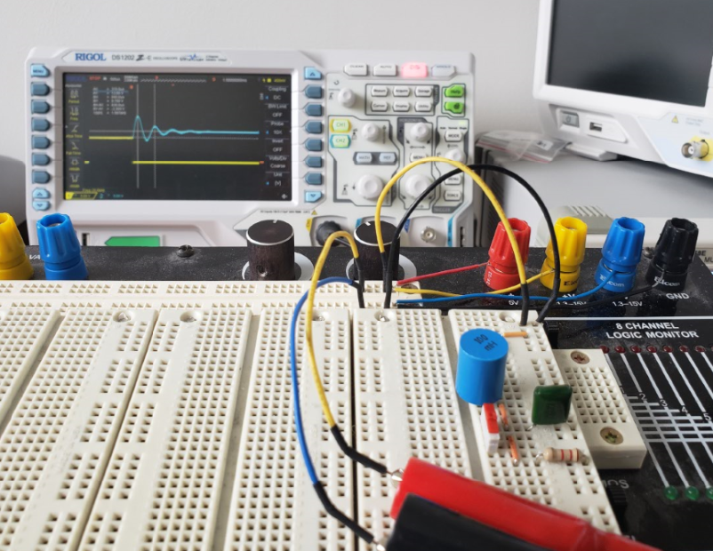

Figure 11. A photo of the oscilloscope used in this experiment

* Save the graph of vC(t) in a USB drive if your oscilloscope has such capability. An example of the saved graph is shown in Figure 12. If your oscilloscope does not offer such capability, you can take a close-up photo of the graph.



Figure 12. An example of the voltage waveform saved in the USB drive

* Use the horizontal cursors of the oscilloscope to find the initial and steady-state values. In the example shown in Figure 12, the measured initial value of 9.700 V is shown in the data table at the upper left corner. The steady-state value was 12.00 V. Notice that in measuring the initial and the steady-state values, the horizontal cursors should be placed on the horizontal portions of the waveform in Figure 12.
* Use a vertical cursor to estimate the peak value of the waveform.
* Use the vertical cursors of the oscilloscope to find the frequency of oscillation. Hint: place the two vertical cursors at two successive peaks as shown in Figure 12. The measured frequency of oscillation was 1.587 kHz and is shown in the same data table.

**PART 4: VALIDATION OF THE DIFFERENTIAL EQUATION MODEL**

You have obtained three graphs of vC(t) from Parts 1, 2 and 3. You have estimated the initial values, the steady state values, the peak values, and the frequencies of oscillation from those three graphs. Enter these values into Table 2 below.

|  | Initial value | Steady-state value | Peak value | Frequency |
| --- | --- | --- | --- | --- |
| Part 1: closed-form solution |  |  |  |  |
| Part 2: Multisim solution |  |  |  |  |
| Part 3: experimental solution |  |  |  |  |

Table 2: Measurements from Parts 1, 2, and 3

Calculate the percentage errors as defined in Table 3 below and populate the table with the calculated values.

|  |  |  |  |  |
| --- | --- | --- | --- | --- |
|  | Initial value | Steady-state value | Peak Value | Frequency |
| Percentage error between closed-form and Multisim solutions |  |  |  |  |
| Percentage error between analytic and experimental solutions |  |  |  |  |

Table 3: Percentage errors of the measurements

The parameters in Table 3 are defined as follows:

AI: initial value of the closed-form solution

AS: steady-state value of the closed-form solution

AP: peak value of the closed-form solution

AF: frequency of the closed-form solution

MI: initial value of the Multisim solution

MS: steady-state value of the Multisim solution

MP: peak value of the Multisim solution

MF: frequency of the Multisim solution

EI: initial value of the experimental solution

ES: steady-state value of the experimental solution

EP: peak value of the experimental solution

EF: frequency of the experimental solution

If the percentage errors in Table 3 are small, your differential equation model is a good approximation of the circuit. If the percentage errors were large, double check your derivation of the differential equation model. Re-do the measurements and calculations. The percentage errors should be small.

**PART 5: DELIVERABLES**

Summarize your work in Parts 1 through 4 in a report. Include in the report the three graphs of vC(t) obtained from Parts 1, 2, and 3. Also include the completed Tables 2 and 3. Describe whether the differential equation model matched the experimental and simulation results. If they do, your model is a good approximation of the actual circuit behavior.

**APPENDIX**

Multisim is a circuit simulation software program widely used in the industry [1]. It integrates industry-standard SPICE simulation with an interactive schematic environment to instantly visualize and analyze electronic circuit behavior. A free trial version of Multisim for education [2] can be downloaded from NI (formerly National Instruments). NI is a company that develops automated test and automated measurement systems for solving challenging engineering problems [8]. Such software has been frequently used in the literature, e.g., [9].

**REFERENCES**

[1] J. Nilsson and S. Reidel. 2019. *Introduction to Multisim for Electric Circuits,* 11th ed., Pearson.

[2] NI Multisim for education software download webpage. Available at <https://www.ni.com/en-us/support/downloads/software-products/download.multisim.html#312060>. Accessed July 2021.

[3] Charles Alexander and Matthew N. O. Sadiku. 2017. *Fundamentals of Electric Circuits*, 6th ed., McGraw-Hill.

[4] J. D. Irwin and R.M. Nelms. 2015. *Basic Engineering Circuit Analysis*, 11th ed., John Wiley.

[5] F.T. Ulaby and M.M. Maharbiz. 2013. *Circuits*, 2nd ed., NTS.

[6] Y. Tsividis. 2001. *A First Lab in Circuits and Electronics*, Wiley.

[7] D. Kaplan and C.G. White. 2003. *Hands-On Electronics: A Practical Introduction to Analog and Digital Circuits*, Cambridge.

[8] NI website. <https://www.ni.com/en-us.html>. Accessed July 2021.

[9] Virgil Ganescu. 2019. "3-067-S-RLCSeriesCircuit," <https://www.simiode.org/resources/6126>.

1. See Appendix for how to download a free trial copy of Multisim™ for education.