1. In this histogram of a sampling distribution of human heights (n = 30 sample means), how many people have heights less than 169.5? (Source: modified from anlayzemath.com)
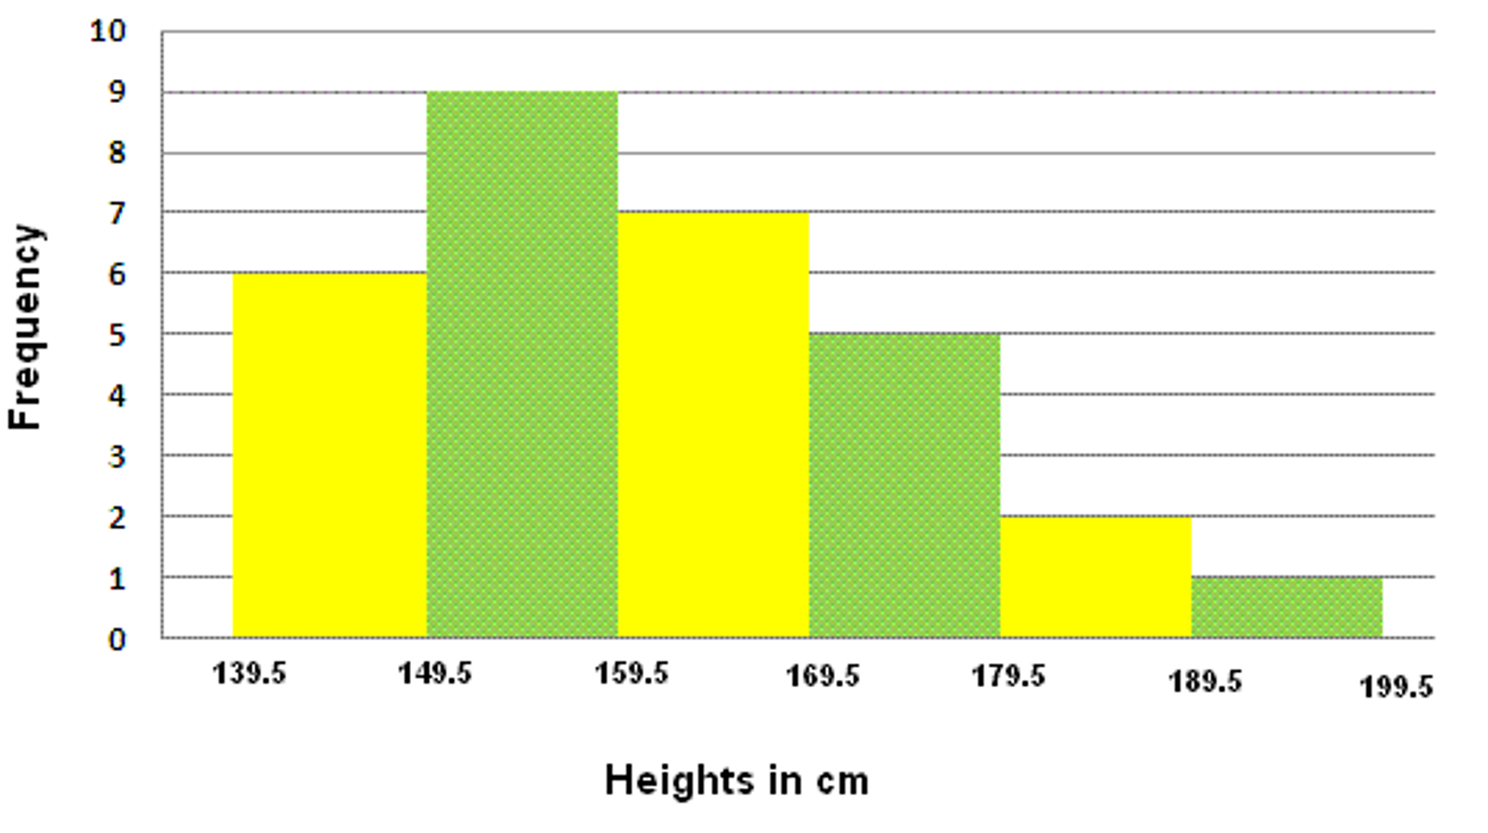
(A) 7 (B) 6 (C) 9 (D) 22 (E) 0
Answer: (D)
2. In this histogram of a sampling distribution of human heights (n = 30 sample means), what is the probability of the sample mean being between 169.5 and 179.5? (Source: modified from anlayzemath.com)
(A) 5 (B) 0.167 (C) 0 (D) 3 (E) 0.5
Answer: (B)
3. In the following sampling distribution based on 500 fish sampled from a simulated population where the true mean was 0.5 mg/kg, what would the p-value be for finding a sample mean of 0.6 mg/kg?
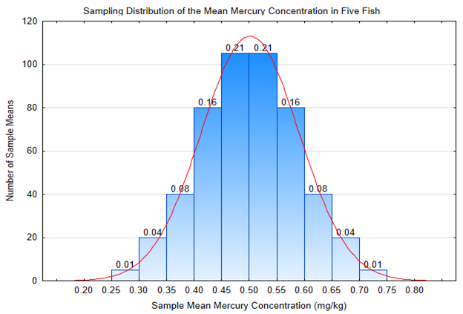

(A) 0.13 (B) 0.08 (C) 0.87 (D) 0.5
Answer: (A)

4. Refer to the p-value you determined in the problem 3. If α = 0.05, does this p-value support favoring the null hypothesis or the alternative hypothesis? Remember: H₀: μ = 0.5 H₁: μ > 0.5
(A) because p-value is ≥ α, the null hypothesis should be rejected in favor of supporting the alternative hypothesis
(B) because p-value is ≤ α, the null hypothesis should be rejected in favor of supporting the alternative hypothesis
(C) because p-value is ≥ α, the null hypothesis should be accepted
(D) because p-value ≤ α, the null hypothesis should be accepted
Answer: (C)
5. Suppose a study is conducted on 25 fish and the mean mercury content was found to be 0.54 with a sample standard deviation of 0.3. Assume that the value of µ is 0.5. What would the value of t be? Use the formula
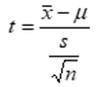
(A) 0.625 (B) 0.654 (C) 0.469 (D) 0.667
ANSWER: (D)

6. The maximum concentration of mercury in fish that was deemed safe for consumption in Canada was 0.5 ppm. This means that there would be how many mg of mercury in a 1 kg portion?
(A) 1,000,000 mg (B) 5,000,000 mg (C) 0.5 mg (D) 0.1 mg
Answer: (C)

7. A sample statistic, such as a sample mean, is a representation of a true population parameter, such as the population mean μ. A sample is comprised of
(A) more individuals than the actual population
(B) fewer individuals than the actual population
(C) individuals from a different population
Answer: (B)

8. Which of the following would be an example of a stochastic problem?
(A) With x = 5, m = .1, b = 5, the same equation of a line will always result from the equation y = mx + b.
(B) A simulated population growth model with constant input for r each generation is always predicted by the formula dN/dt = rN.
(C) The Hardy-Weinberg equilibrium prediction for starting and ending allele frequencies after reproduction in a population where genetic drift is possible.
(D) Conversion between one unit and another unit always yields the same answer.
Answer: (C)

9. A t-test was conducted on mercury concentration for a sample of 22 fish. In Excel, a T.DIST.RT(4.690, 21) entry produces a a resulting p-value of 0.00006. For the hypotheses, H₀: μ = 0.5 H₁: μ > 0.5, what would you conclude?
(A) Reject the null hypothesis.
(B) Accept (fail to reject) the null hypothesis.
Answer: (A)

10. For the conclusion you made in problem 9, what should you decide about eating the fish?
(A) It is OK to eat it.
(B) It is not OK to eat it.
Answer: (B)

