RANDOM PERTURBATION

Reza Ahangar
Mathematics Department
Texas A & M University Kingsville
Kingsville TX 78363 USA
Reza.ahangar@tamuk.edu

ABSTRACT: After a brief historical view of this problem, we will demonstrate the derivation of first order linear differential equations with random perturbations. Students in their semester research project under a course “special topics” or “independent study” will learn a past century's attempts to solve such differential equations. In addition, the concept of differentiability and integrability will be reviewed.
We will use the concept of “noise” to study the random perturbation on a differential equation as a nowhere differentiable function. The noise in historical Langevin stochastic differential equations will be treated as a model with Brownian motion. A short introduction of Wiener process leading to Ito's calculus is used in derivation of the mean and variance of the solutions to the Langevin Equations. A computational algorithm is developed and applied to study linear stochastic differential equations. Symbolic computation and simulation of a computer algebra system will be used to demonstrate the behavior of the solution to the Langevin Stochastic Differential Equation.

- Student Learning Objectives

- This project will help students to recognize some physical and biological applications of first order linear differential equations.
- Students will experience a random harvesting or immigration factor as a perturbation in the differential equations.
- The idea of random perturbation can be generalized to the case when additional term on the right-hand side is called noise.
- Students will be familiar with the historical attempt to solve this type of differential equations.
- This project will enhance the concepts of differentiability and integrability of mathematical functions.
(2) Statement of the Problem
In the first stage of the modeling is to describe the statement of the problem.

Robert Brown observed pollen grains immersed in water and they are randomly bombarded by the molecules of the surrounding medium. Brownian motion is named after Robert Brown, who first observed the motion in 1827, and was eventually explained by Albert Einstein that this motion is caused by random bombardment of heat excited water molecules on the pollen.
- Describe the random movement of particles in fluid due to collisions with the molecules of the fluid.
- Recognize all parameters: Students can recognize the following parameters:
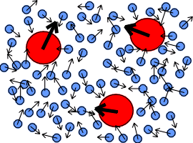
Figure 1. m = Mass of the particle and v(t) =Velocity of the particle at time t.
In Figure 1 what is the cause of motion: there are random collisions between molecules of fluids?
The force acting on the particle is written as a sum of a viscous force proportional to the particle's velocity (in physics called Stokes Law), and noise term called η(t) representing the effect of the collisions with the molecules of the fluid.
- Assumptions: Assume that the position and velocity of a particle in this experiment is denoted by $r\left(t\right) and v\left(t\right).$
The acceleration of a Brownian particle of mass m is expressed as the sum of
- a viscous force which is proportional to the particle’s velocity (Stokes' Law),
- a noise term representing the effect of a continuous series of collisions with the atoms of the underlying fluid

(iv) Modeling of the equation of motion: Langevin used these assumptions and came out with a first order linear differential equation which was involved a random force. The resulting equation named after his publication in 1908 [10]. This equation was modified by Norbert Wiener in 1923. where r represents the position of the particle, and m denotes the particle's mass.
Consider a colloidal particle suspended in a liquid. On its path through the liquid it will continuously collide with the liquid molecules. It will experience a systematic resistant force proportional to its velocity and directed opposite to its velocity. In addition, the particles will experience random forces with the resultant $\vec{F(t)}$.

Equation (1) can be translated to a linear system of differential equation

$\frac{\vec{dr(t)}}{dt}=\vec{v(t)}, \frac{\vec{dv(t)}}{dt}=\vec{R}+\vec{F(t)}=-β.\vec{v(t)}+\vec{F(t)}$ (1)
$$m\frac{dv(t)}{dt}=-av\left(t\right)+\vec{F(t)}$$

where a is assumed to be a constant real number. This leads to

$\frac{dv(t)}{dt}=-βv\left(t\right)+h(t)$ (2)
and $β=\frac{a}{m}$. Given that the initial velocity can be determined at the initial time: $v\left(t_{0}\right)=v_{0}$.

In hydrodynamics the constant of the friction force $β$ is given but h(t) is a random function.
The traditional first order linear differential equation (2) can be solved symbolically by

$v\left(t\right)=v_{0}e^{-βt}+\int_{0}^{t}{e^{-β\left(t-s\right)}h\left(s\right)ds .}$ (3)

One can integrate the first equation in (1) to evaluate the position vector $\vec{r(t)}$. This will be a deterministic solution of the system if we are certain about the average force function $\vec{F(t)}$. Due to the uncertainty nature of random forces generated by the collisions of particles, the Riemann integral on the right-hand side will not be well-defined.

We will call the random force $\vec{F(t)}=W_{t}$ a noise or perturbation which causes the solution integral to be undefined in the Riemann sense.

Student Activity (1):
- Assume that the constant number $β$ and random function h(t) in (3) are given. Determine the position and velocity. $β=2$ and $h\left(t\right)=e^{3t}$. Sketch the graph of v(t) and r(t) where v(0)=5 and r(0)=1.
- What are the conditions on the function h(t) so that the solution (3) exits?

Student Activity (2):
Challenging Analysis and the First Attempt or Motivational Approach

Many aspects of Langevin equation and its difficulties in using Lebesgue-Steiltjes integral have been studied [12, p. 6]. We would like to use a computational approach to simulate the solution of the following stochastic differential equation (SDE)

$d\left(y\left(t\right),t\right)=-β∙y\left(t\right)dt+h\left(t\right)dw(t)$ (4)

After a short review of the materials related to noise, nowhere differentiability, and stochastic calculus, we will use a maple computer algebra program to demonstrate and simulate the solution.

We are assuming that the general solution of the logistic SDE will be created by two forces deterministic force that can be predicted by Newton's law or any set of mathematics modeling postulates and the noise that is created by the stochastic force and represents the fluctuation.

Thus, the SDE model has a superposition property. That is, it is the sum of the deterministic and the stochastic solution.

Let us call the deterministic solution Y(t) and the solution by noise x(t), then the general solution z(t) can be expressed by the following:

Z(t) = past history of Z(t) up to the point $t_{0}+Y\left(t\right)+X(t)$.

A central notion for stochastic calculus is that of being continuous and semi-martingale: a random process Z(t) that can be written as the sum of a local Brownian motion or noise X(t) and a drift process Y(t) (a continuous process of locally bounded variation, typically the solution of some conventional differential equation).

The decomposition Z(t) = Z(0) + Y(t) + X(t) is unique and can be thought of as a decomposition of Z into signal Y plus noise X.

The following two examples demonstrates a nowhere differentiable noise.

Example (1)- (Weierstrass Function) On the advanced calculus level, it can be verified that a function

$w\left(t\right)=\sum_{k=1}^{∞}{a^{k}}cos⁡(b^{k}πt)$ (5)

is nowhere differentiable but continuous everywhere, where a and b satisfy certain relations $(0<a<1, b∈Z^{+}$ and $a*b>1+3*π/(2)$ [9, pp. 38-41] We like to experiment with a partial sum and observe the non-differentiable perturbation with constant parameters $a=\frac{1}{2}, b=2, and n=20.$

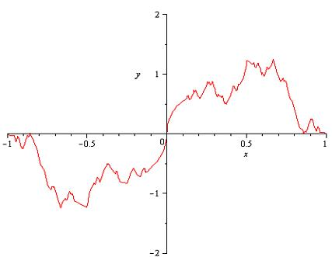

Figure 2. Sample path of a nowhere differential function.

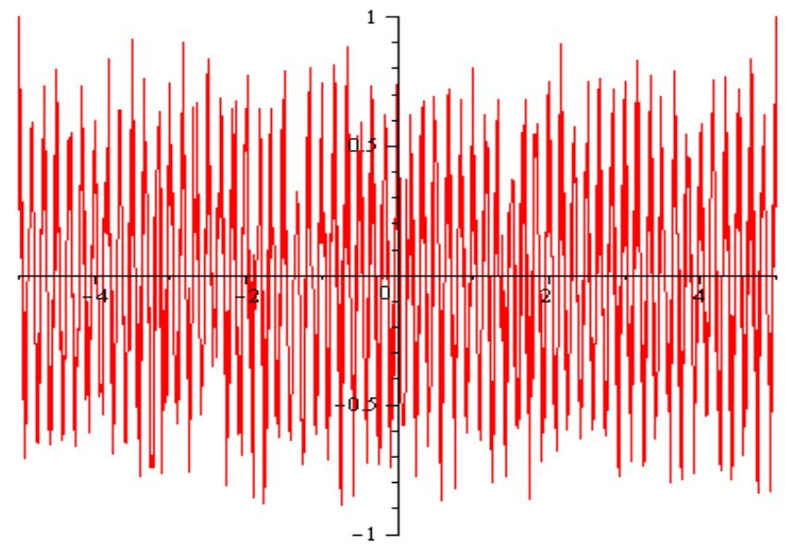
Figure 3. Sample path of the nowhere differentiable solution demonstrated unbounded variations.

Example (2) (van der Waerden function): The following function is continuous and nowhere differentiable and it is known as van der Waerden's function [19]:

$w\left(t\right)=\sum_{n-1}^{∞}{\frac{sin⁡(t ∙n^{2}∙π)}{n^{2}}}$ . (6)

- Density Independent Random Perturbation

The following Langevin differential equation with random coefficients b and c will be examined by random function w(t) at time $t=t_{0}$. All random initial values, drift coefficient, and diffusion will be assigned at the beginning of the simulation program. The solution may be considered a deterministic trajectory, even all initial parameters are selected randomly.

Student Activity (3):

In the following Maple program, we can observe a simulation program for the trajectories, animation, and their asymptotic limit.

> with(plots);
> SDE1 := diff(v(t), t) = -b*v(t)+c*w(t);
> soln1 := dsolve(SDE1, v(t));
> b := (1/100)*(rand(1 .. 9))(); c := (1/10)*(rand(1 .. 6))();
> w := proc (t) options operator, arrow; (rand(1 .. 6))() end proc;
> SDE2 := diff(v(t), t) = -b*v(t)+c*w(t);
> soln2 := dsolve(SDE2, v(t));
> soln3 := subs(_C1 = m, soln2);
> myplot1 := {seq(subs(m = i, rhs(soln3)), i = -10 .. 10)};
> plot(myplot1, t = -15 .. 150, v = -10 .. 50, color = blue);

Animation of Langevin Differential Equations:

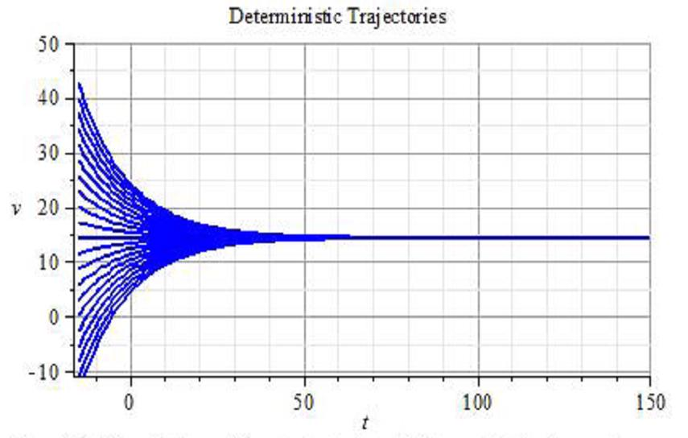

Figure 4. Simulation of the trajectories of deterministic Langevin Equation.

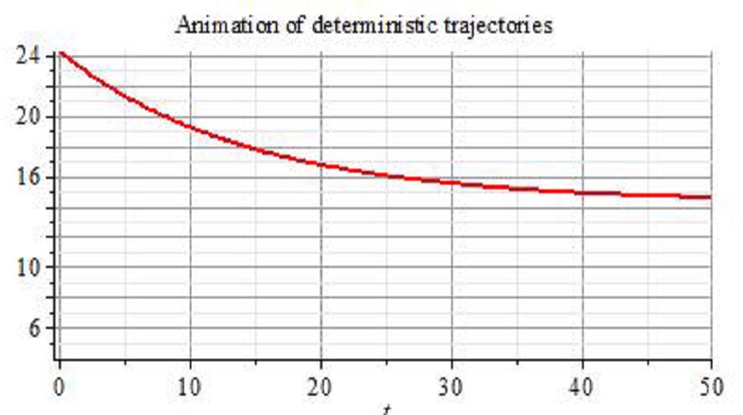

Figure 5. Animation of trajectories of the solutions to the deterministic Langevin Equation.

With the following Maple code we can observe the animation on general constant coefficients.

> animate(plot, [100/7+exp(-(7/100)*t)*m, t = 0 .. 50], m = -10 .. 10);

In the next step, we will study the differential equation (4) and demonstrate the concept of the solution. We define the density X_{t} as a solution of the random differential equation with two related values of expectation and variance:
$$E\left(X_{t}\right) and Var(X_{t})$$

Also, we investigate the solution of the equation (4) when the perturbation h(t) is in one of the following forms:

Case i) density independent perturbation h(t) = c for a constant number c.

Case ii) density dependent perturbation $h\left(t\right)=c∙X_{t}$ for a constant number c.

Student Activity (4)
Assume that the density X_{t} represents the solution of (4) and this Random Solution for Density Independent perturbation model. One can study the Mean, and Variance of the solution in two different cases.

Case (1): Assume that the random force function h$\left(t\right)=c$ (in the relation $\vec{R(t)}=c∙{dW}_{t})$ is proportional to the density function X_{t}. That is

${dX}_{t}={-bX}_{t}dt+c∙{dW}_{t}, X_{0}=X(t_{0})$ .

This is a symbolic form only in the Ito sense. Using a deterministic linear differential equation, the solution will be
$X_{t}=X_{0}e^{-bt}+\int_{0}^{t}{c}∙e^{-b(t-s)}{dW}_{s}, for all t≥0$ .

We will briefly demonstrate the density X_{t} as a solution with the associated mean and variance.

Since $E\left(X_{t}\right)=0$ at any moment t, then $E(\int_{0}^{t}{e^{-b(t-s)}{dW}_{s})=0.}$ As a result

$E\left(X_{t}\right)=E\left(X_{0}\right)∙e^{-bt}$ . (7)

To find the variance of the solutions, we will use V,
$Var\left(X_{t}\right)=E\left(X_{t}^{2}\right)-{\left[E\left(X_{t}\right)\right]}^{2}=E{\{X_{0}e^{-bt}+\int_{0}^{t}{c∙e^{-b\left(t-s\right)}{dW}_{s}\}}}^{2}-{\{{E(X}_{0})∙e^{-bt}\}}^{2}$

$$=E\left\{X_{0}^{2}e^{-2bt}+2∙X_{0}e^{-bt}∙\int_{0}^{t}{c∙e^{-b\left(t-s\right)}{dW}_{s}}+\left[c{\int_{0}^{t}{e^{-b\left(t-s\right)}{dW}_{s}}}^{2}\right\}-{[{E(X}_{0})]}^{2}∙e^{-2bt}\right\}$$
$=Var\left(X_{t}\right)=Var\left(X_{0}\right)∙e^{-2bt}+\frac{c^{2}}{2b}{[1-e}^{-2bt}]$ . (8)

- Density Dependent Perturbation

In Case (ii), we will assume that the force function in (4) is proportional to the density: $h\left(t\right)=c∙X_{t}$ .

Thus (4) can be expressed by

${dX}_{t}={-bX}_{t}dt+c∙X_{t}{dW}_{t}, X_{0}=X(t_{0})$ (9)
or
$\frac{dX_{t}}{X_{t}}=-bdt+c∙{dW}_{t}, X_{0}=X(t_{0})$ . (10)
It is reasonable to assume $Y=\ln\left(X_{t}\right)=f(t,X_{t})$ and use Ito's chain rule formula to substitute dX_{t} ,

$dY_{t}=\frac{∂f}{∂t}dt+\frac{∂f}{∂X_{t}}dX_{t}+\frac{1}{2}[\frac{∂^{2}f}{{∂X_{t}}^{2}}({{dX}_{t})}^{2}]$ . (11)

Using Table (1) in Appendix, of Ito's calculus and integrating both sides, will give us the following result:

$X_{t}=X_{0}e^{cW_{t}\left(b+\frac{c^{2}}{2}\right)t}$ . (12)

Mean of the solution of the Langevin Equation:

Let us use Ito's method to integrate the relation (9) and simplify

$X_{t}=X_{0}+ \int_{0}^{t}{-bX_{t}dt+\int_{0}^{t}{cX_{s}dW_{s}}}$ (13)
According to the postulates of the Brownian motion the expectation is,

$E(\int_{0}^{t}{cX_{s}dW_{s})=cE(\int_{0}^{t}{X_{s}dW_{s})}}$ . (14)

Assuming that the properties of Weiner Process this term will be equal to zero. To find the expectation of (13), use the linearity of the operator E,

${E(X}_{t})={E(X}_{0})+ \int_{0}^{t}{-bE\left(X_{t}\right)dt}$ . (15)

If we take the symbolic derivative of both sides and solve for $E\left(X_{t}\right)$, we get the following,

$E\left(X_{t}\right)=E\left(X_{0}\right)∙e^{-bt} for t≥0$ . (16)

Variance of the Solution of Density Dependent Solution:

$Var\left(X_{t}\right)=e^{-2bt}(e^{c^{2}t}-1){X^{2}}_{0}$ . (17)

Finding a closed formulation for Variance of $X_{t}$ is challenging. We will show that it can be evaluated using $Var\left(X_{t}\right)=E\left({X_{t}}^{2}\right)-{\left[E\left(X_{t}\right)\right]}^{2}$ and using analytical solution.

$X_{t}=X_{0}e^{-bt}+\int_{0}^{t}{c}∙e^{-b(t-s)}{dW}_{s}, for all t≥0$ . (18)

For details see [5] and [8] and a brief demonstration in Appendix.

- Numerical Approximation to the Nowhere Differentiable Perturbed Langevin Equation

A set of random variable$\left(X_{t}\right)$s indexed by real number $t≥0$ is called a continuous -time stochastic process. We use $\left(W_{t}\right)$ as a Wiener process that is a continuous time stochastic process with the following properties:

- For every t, the random variable $\left(W_{t}\right)$ is normally distributed with mean zero and variance t$.$
- For $t_{1}≤t_{2}$ the variation increment $W_{2}-W_{1}$ is also normally distributed is independent of all $\left(W_{t}\right)$ for $0≤t_{1}≤t_{2}$
- The Wiener process $\left(W_{t}\right)$ can be represented by continuous paths $.$

- A Dynamic Random Algorithm for Stochastic Wiener Process

The following Computational Algorithm is developed to satisfy the stochastic process. In the initial step, parameters are selected randomly and will not stay constant for the next step of time increment. In fact, the position at the end of each step will be considered an initial position for the next step. We call this algorithm a dynamic random algorithm. The following Maple program was used to approximate the solution to the random perturbed differential equations.

Density Dependent Random Linear Perturbed Differential Equation (Langevin Type Equation)

> restart;
> Langevin := proc (b, ic1, n)
local i, eq, s, c, ic, f, g;
c[1] := 0; ic[1] := x(c[1]) = ic1;
for i to n do eq := diff(x(t), t) = -b*x(t)+(1/100)*(rand(1 .. 9))()*x(t);
s[i] := rhs(dsolve({ic[i], eq}, x(t)));
c[i+1] := 150*i/n;
ic[i+1] := x(c[i+1]) = evalf(subs(t = c[i+1], s[i]));
f[i] := s[i]*Heaviside(t-c[i])*(1-Heaviside(t-c[i+1]))
end do;
g := seq(f[i], i = 1 .. n)
end proc;
> plot([Langevin(0.45e-1, 2.5, 150)], t = -20 .. 150, discont = true);

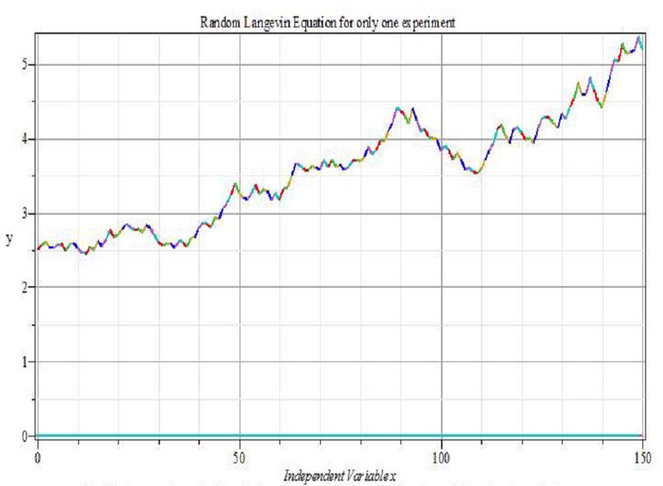

Figure 5. One sample path of the solution of Langevin
Differential Equation with Random Perturbation.
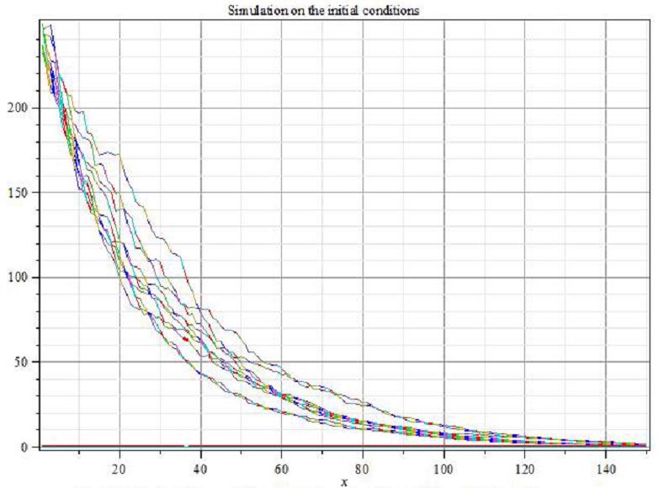

Figure 6. In this simulation we depict 10 trajectories
with 10 different initial conditions.

Simulation on the Initial Conditions:
> c[1] := 250;
> for i to 10 do c[i+1] := c[i]+.2; f[i] := Langevin(0.85e-1, c[i], 150) end do;
> g := seq(f[i], i = 1 .. 10);
> plot([g], x = 1 .. 150, discont = true);

The following Maple code is for simulation of the trajectories of stochastic Langevin equation.
> b[1] := 0.4e-1; b[2] := 0.7e-1; b[3] := 0.9e-1; b[4] := .17; b[5] := .28;
> for i to 5 do f[i] := Langevin(b[i], 100, 150) end do;
> g := seq(f[i], i = 1 .. 5);
> plot([g], x = 1 .. 150, discont = true);

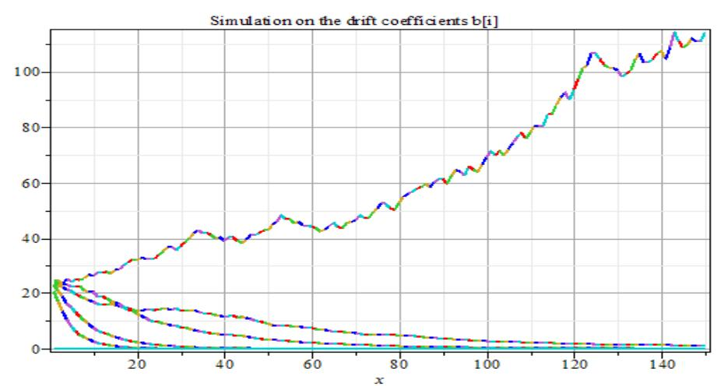

Figure 6. Draft coefficients b[i] ranging from 0.004
with the increment of 0.025 to create sample path.

- Simulation of the Solution of the Langevin Equation

For a deterministic initial value problem there exists a trajectory as a solution to the differential equation. On the contrary, this is not the case for a stochastic differential equation. In fact for any initial value, there will be infinite possibilities for the random choice of trajectories.

To create some algorithm to represent this phenomenon, we used a Maple procedure to have a random choice for a certain time interval $[t_{i},t_{i+1}]$

Applications of Langevin Equations: Louis Bachelier, a Ph.D. student of Henri Poincare, introduced Brownian Motion in 1900 as a model for the dynamic behavior of the Paris stock market. Notice that it took place 5 years before Albert Einstein developed a physical model of Brownian motion to describe small particles suspended in a liquid, and 23 years before Norbert Wiener gave the first rigorous mathematical construction of Brownian motion. For that reason, Bachelier is now considered by many as the founder of modern Mathematical Finance. See the article Jarrow, R. and P. Protter. 2004. A short history of stochastic integration and mathematical finance: the early years, 1880–1970. Institute of Mathematical Statistics Lecture Notes - Monograph Series. 45: 75-91 for the historical summary.
Brownian motion is among the simplest of the continuous-time stochastic (or probabilistic) processes and in mathematical language is called stochastic process, whose time derivative is everywhere infinite.
Random Walk is a good example of a two-dimensional discrete Brownian motion that can be considered as a "drunk man wandering around the road to his home". More precisely, each of his steps (in both x- and y-directions) are independent normal random variables.

- Discussion

A quick review of the history of research on the evolution of stochastic differential equations will guide us through a variety of views and application of Langevin's equation which may be considered a simplest form of the stochastic differential equations. In addition, this rich history will show how this problem imposed many challenges for integration theory, analysis, and probability theory for many brilliant mathematicians for centuries. These problems are also linked to the many disciplines of physics, mathematics, business, and economics. The theoretical nature of nowhere differentiability and integrability of this phenomenon might not be possible to explain for lay people in application to predict on a certain level, however it is possible to present and demonstrate the solution by computational approach or simulation. Mathematically, we created, imposed, and added a nowhere differentiable perturbation on a differential equation in an arbitrary small subinterval. We solved the differential equation in that subinterval and continued this process in the next time interval. The algorithm designed and presented in the article connects all piecewise solutions for random initial points, random parameters, and random perturbations. Numerical computations can be achieved by a computer algebra system (CAS) or any spreadsheet. We presented our approach with Maple.

Further Research: - Notice that the random noise is not selected from a certain random probability distribution. To meet the conditions of Wiener processes, it could be selected from a normal distribution N(0,1).
- The original Langevin equation has a perturbation which is density independent noise. To study a perturbation, the function h in the Langevin differential equation (2) may be selected h(t,y(t)) as a function of t and density y(t).
- According to the Chebychev's theorem, for some positive k:
$p\left[μ+k∙σ≤X_{t}≤μ+k∙σ\right]≤1-\frac{1}{k^{2}}$ . (14)

- Further study may be useful to find a confidence interval type to demonstrate the solutions within k sigma standard deviation from the mean solution.
- Readers who are interested in developing the research further may apply this dynamic algorithm to other linear or nonlinear perturbed differential equations.

REFERENCES

[1] Ahangar R., S. Singh, and R. Wang R. 2010. Dynamic Behavior of Perturbed Logistic Model. JCMCC. 74: 295-311.

[2] Ampere, A. M.. 1806. Recherches sur quelques points de la theorie des functions derives. Ecole Polytechnique. 6: fasc.13.

[3] Apostol, Tom M. 1974. Mathematical Analysis, Second Edition. Reading PA: Addison Wesley Publishing Company 1974.

[4] Bachelier, Louis. 1900. Theorie de la Speculation. Annales Scientifique de l'Ecole Noormale Superieure. 3 $e$ Serie, Tome 17, 21-86.

[5] Cyganowski, Sasha. 2019. MAPLE for Stochastic Differential Equations. (School of Computing and Mathematics, Deakin University, Geelong 3217, Australia, e-mail: sash@deakin.edu.au).

[6] Hildebrandt, T. H. 1938. Definitions of Stieltjes Integrals of the Riemann Type. The American Mathematical Monthly. 45 (5): 265—278.

[7] Hille, Einar and Ralph S. Phillips. 1974. Functional analysis and semi-groups. Providence RI: American Mathematical Society.

[8] Kloeden, P.E. and E. Plaen. 1992. Numerical Solution to Stochastic Differential Equations. New York: Springer Verlag.

[9] Körner, T.W. 1988. Fourier Analysis. Cambridge UK: Cambridge University Press.

[10] Langevin, P. 1908. On the Theory of Brownian Motion. C. R. Acad. Sci. (Paris). 146: 530-533.

[11] McShane, E. J. 1952. Partial orderings and Moore-Smith limit. The American Mathematical Monthly. 59: 1-11.

[12] Natanson, I. P. 1955. Theory of Functions of Real Variables. Translated from the Russian by Leo F. Boron and Edwin Hewitt. New York: Frederick Ungar Publishing Co.

[13] Pollard, Henry. 1920. The Stieltjes integral and its generalizations. Quarterly Journal of Pure and Applied Mathematics, 19.

[14] Riesz, F. and B. Sz. Nagy. 1990. Functional Analysis. New York: Dover Publications

[15] Schuss, Z. 1980. Theory and Applications of Stochastic Differential Equations. New York: Wiley Series in Probability and Mathematical Statistics.

[16] Shilov, G. E. and B.L. Gurevich. 1978. Integral, Measure, and Derivative: A Unified Approach. Richard A. Silverman, trans. New York: Dover Publications.

[17] Stroock, Daniel W. 1998. A Concise Introduction to the Theory of Integration (3rd ed.). Basel Switzerland: Birkhauser.

[18] Vasconcelos, Giovani L. 2004. A guided walk down Wall Street: an introduction to Econo-physics. Braz. J. Phys. [online]. 34(3b): 1039-1065. http://www.scielo.br/scielo.php. Accessed 5 December 2019.

[19] Waerden, B.L. van der. 1930. Ein einfaches Beispiel einer nichdifferenzierbaren stetigen Function. Math. Zeitschr. 32: 474-475.

[20] Young, L.C. 1936. An inequality of the Hölder type, connected with Stieltjes integration. Acta Mathematica. 67 (1): 251-282.

COMMENTS

- Nowhere Differentiability and Integrability

It is natural to ask the question under what conditions the Lebesgue - Stieltjes (LS) integral exists. A criteria for existence of the LS-integral can be expressed in the form of: The integral $\int_{a}^{b}{f\left(t\right)dw(t)}$ exists if the function f(t) is continuous on [a,b] and w(t) is of finite variation on [a, b] [12, p.230].

The best simple existence theorem states that if the function f is continuous and w is of bounded variation on [a, b], then the integral exists. A function w is of bounded variation if and only if it is the difference between two monotone functions. If w is not of bounded variation, then there will be continuous functions which cannot be integrated with respect to w. In general, the integral is not well-defined if f and w must share any points of discontinuity, but this sufficient condition is not necessary.

How do we integrate $\int_{a}^{b}{f\left(t\right)dw(t)}$ when the function w(t) is not of finite variation?

Integrability in Riemann- Steiltjes (RS) sense

Under what conditions are the following expressions equivalent? We apply the basic ideas behind the Fundamental Theorem of differential and integral calculus in all areas of computational science, engineering, and mathematics. If a function f is a function of bounded. Or in general form

$dy\left(t\right)=f\left(t,y\left(t\right)\right)+g\left(t\right)dw\left(s \right) if and only if$ (1.1)
$y\left(t\right)=y\left(t_{0}\right)+\int_{t_{0}}^{t}{f\left(s,y\left(s\right)\right)ds}+\int_{t_{0}}^{t}{g\left(s)dw(s\right)}$ . (1.2)

In the sense of Lebesgue-Stieltjes the integrands g should be continuous and w(t) should be absolutely continuous (or a function with bounded variation). As a conclusion the following is a relation that may be used in the algorithm for computation:

$\int_{a}^{b}{g\left(s)dw(t\right)=g\left(b\right)w\left(b\right)-g\left(a\right)w\left(a\right)-\int_{a}^{b}{w\left(t\right)dg(t)}}$ (1.3)

Important Note: One can demonstrate that if w is differentiable then Lebesgue-Stieltjes integral can be expressed in pure Riemann integration in the following form, that is

$\int_{a}^{b}{f\left(t\right)∙dw\left(t\right)=\int_{a}^{b}{f\left(t\right)∙w^{'}\left(t\right)dt}}$ . (1.4)

Let us assume that the symbol ND represents a class of functions continuous and nowhere differentiable.

It can be verified that

- If a function $w∈ND and$ f is differentiable on R, then $f+w∈ND$.
- If a function $w∈ND$ and is differentiable on R, and $f(x)≠0,∀x∈R,$ then $f⋅w∈ND.$

Thus, the integrand in the second integral (1.2) in integration by part, will not be differentiable. This should not prevent us to realize that the integral does exist.

- Nowhere Differentiable Perturbation and Noise

The concept of the continuous nowhere differentiable function was first explored by Andre Marie Ampere in 1806 and he was unsuccessful in his attempt to demonstrate by example. The first example was presented by Weierstrass fifty years later.

In practical application of SDE, one characteristic of the random perturbation is the nowhere differentiability of the noise. We would like to present a few examples.

Stochastic Integral Calculus: Suppose that f(t) is a stochastic process and W$t$ is a Wiener process, then the stochastic integral of f(t) with respect to a process W$t$ is a random variable defined as
$I=\int_{[a,b]}{f(t)dW_{t}}=\overset{}{lim}\sum_{i=1}^{n}{f(t_{i-1})ΔW(t_{i})s}$ , (2.1)

where $ΔW_{t_{i}}=W(t_{i})-W(t_{i-1}).$ It makes a difference how $τ_{i}$ in $[t_{i-1},t_{i}]$ is selected.

Stochastic Integral is not consistent with the classical integration methods.
Example: Assume $g(t)=W_{t}$ is the Wiener Process (standard Brownian motion). Compute $\int_{0}^{1}{}W_{s}dW_{s}$ using a stochastic integral.

- Using left hand point:

$I_{1}=\int_{[0,1]}{g(t)dW_{t}}=\lim_{n→∞}{\sum_{i=1}^{n}{g(t_{i-1})ΔW(t_{i})}}=\lim_{n→∞}{\sum_{i=1}^{n}{W_{t_{i-1}}⋅ΔW(t_{i})}}$ .

- Using right hand end point:

$I_{2}=\int_{[0,1]}{g(t)dW_{t}}=\lim_{n→∞}{\sum_{i=1}^{n}{g(t_{i})ΔW(t_{i})}}=\lim_{n→∞}{\sum_{i=1}^{n}{W_{t_{i}}⋅ΔW(t_{i}) }}.$

It can be proved by indirect computation that

$I_{2}-I_{1}=\lim_{n→∞}{(}\sum_{i=1}^{n}{W_{t_{i-1}}⋅ΔW(t_{i})}-\sum_{i=1}^{n}{W_{t_{i}}⋅ΔW(t_{i})})$
${= lim}_{n→∞}{(}\sum_{i=1}^{n}{\left(W_{t_{i}}-W_{t_{i-1}}\right)⋅ΔW\left(t_{i}\right)}=\lim_{n→∞}{(}\sum_{i=1}^{n}{(ΔW_{t_{i}})^{2}}$ ,

with $I_{1}(t)=\frac{1}{2}(W_{t}^{2}-t)$ and $I_{2}(t)=\frac{1}{2}(W_{t}^{2}+t)$ . This computation shows the inconsistency with the classical integral calculus that $\int_{0}^{t}{xdx}=\frac{1}{2}x^{2}.$

Thus, these two computations lead not only to the same result but $I_{2}=I_{1}+t.$ Now use the telescope law and we will get the following result:

$\int_{0}^{1}{W_{s}dW_{s}}$ $=\frac{1}{2}\sum_{i=1}^{n}{}[(W^{2}(b)-W^{2}(a))-\frac{1}{2}[b-a]^{2}$ .

- Brownian Motion and Wiener Process:

In mathematics, Brownian motion is described by the Wiener process; a continuous-time stochastic process named in honor of Norbert Wiener. It is one of the best known Lévy processes (stochastic processes with stationary independent increments) and occurs frequently in pure and applied mathematics, economics and physics.

Let X(t) be the coordinate of a free particle on a real line. In modeling the stochastic process Einstein was able to show the following properties for Brownian motion:

The increment $X(t_{1})-X(t_{2})$ has a normal distribution for every $t_{1}$ and $t_{2}$ on the real line with the expectation $E\{X(t_{1})-X(t_{2})\}=0$ and variance $E\{[X(t_{1})-X(t_{2})]^{2}\}=2D⋅|t_{1}-t_{2}|,$ where D is a physical constant. Two consecutive events $X(t_{i-1},t_{i})$ and $X(t_{i},t_{i+1})$ are statistically independent.
A sample path or trajectories of Wiener process was demonstrated and development by P. Levy in 1948 that are continuous but almost all non-differentiable functions.

 | ∆t | ∆w
∆t | $$(Δt)^{2}→0$$ | $$(Δt)(ΔW)→0$$
∆w | $$(ΔW)(Δt)→0$$ | $$(ΔW)^{2}→dt$$

Table 1. Changes in the Brownian motion W_{t}
caused by changes on the t time increment $∆t$.

Our objective is to use Lebesgue -Steiltjes integral to solve stochastic differential equations. It will be interesting to examine SDE with nowhere differentiable perturbation.

Ito’s Calculus

According to Ito, for the Brownian motion $W_{t}$ the Langevin stochastic differential equation will be used symbolically:
$d\left(X_{t},t\right)=-b\left(t\right)∙X_{t}dt+h(t)∙dW_{t}$ (3.1)

if the following integral does exist

$X_{t}=X_{t_{0}}+\int_{t_{0}}^{t}{-b(s)∙X_{s}ds+\int_{t_{0}}^{t}{h(s)}∙dW_{s}}$ . (3.2)

Ito's Chain Rule Formula:

Considering Taylor's expansion of a multivariable function Y=f(t, X) deterministic calculus and expanding $Y_{2}=f(t_{2},X_{2})$ about a point $(t_{1},X_{1})$ produces
$f(t_{2},X_{2})=f(t_{1},X_{1})+\frac{∂f}{∂t}Δt+\frac{∂f}{∂X}ΔX+\frac{1}{2}[\frac{∂^{2}f}{∂t^{2}}(Δt)^{2}+\frac{∂^{2}f}{∂t∂X}Δt⋅ΔX+\frac{∂^{2}f}{∂X^{2}}(ΔX)^{2}]+. . .$ .

Assume $Δt→0,$ thus the Taylor's expansion will be

$dY=\frac{∂f}{∂t}dt+\frac{∂f}{∂X}dX+\frac{1}{2}[\frac{∂^{2}f}{∂t^{2}}(dt)^{2}+\frac{∂^{2}f}{∂t∂X}dt⋅dX+\frac{∂^{2}f}{∂X^{2}}(dX)^{2}]+...$ .

Apply Table (1) as a principle of Brownian motion X in the Taylor's formula

$dY=\frac{∂f}{∂t}dt+\frac{∂f}{∂X}dX+\frac{1}{2}[\frac{∂^{2}f}{∂t^{2}}(dt)^{2}+\frac{∂^{2}f}{∂t∂X}dt⋅dX+\frac{∂^{2}f}{∂X^{2}}(dX)^{2}]+...$

and use $(dt)^{2}→0$, $dt⋅dX→0,$ and $(dX)^{2}→dt:$

$dY=\frac{∂f}{∂t}dt+\frac{∂f}{∂X}dX+\frac{1}{2}[\frac{∂^{2}f}{∂X^{2}}(dX)^{2}]+...$ .

This relation is known as Ito's chain rule formula for stochastic differential equations.

$dY_{t}=\frac{∂f}{∂t}dt+\frac{∂f}{∂X_{t}}dX_{t}+\frac{1}{2}[\frac{∂^{2}f}{∂X_{t}^{2}}(dX_{t})^{2}]$ . (3.3)

Case (I) - Density Independent Model
We assume that the random force function $g(t)=$ c (in the relation $\overset{↔}{R(t)}=c⋅dW_{t})$ is proportional to the density function Y. That is

$dX_{t}=-bX_{t}dt+c⋅dW_{t}, X_{0}=X(t_{0})$ . (3.4)

This is a symbolic form only in the Ito sense. Using deterministic linear differential equation the solution will be
$$X_{t}=X_{0}e^{-bt}+\int_{0}^{t}{c⋅e^{-b(t-s)}dW_{s}},\text{ for all }t≥0 .$$

Since $E(W_{t})=0$ at any moment t, then $E(\int_{0}^{t}{e^{-b(t-s)}dW_{s}})=0.$ As a result

$E(X_{t})=E(X_{0})⋅e^{-bt}$ . (3.5)

To find the variance of the solutions, we will use V,

$Var(X_{t})=E(X_{t}^{2})-[E(X_{t})]^{2}=E\{X_{0}e^{-bt}+\int_{0}^{t}{c⋅e^{-b(t-s)}dW_{s}}\}^{2}-\{E(X_{0})⋅e^{-bt}\}^{2}$
= $E\{X_{0}^{2}e^{-2bt}+2⋅X_{0}e^{-bt}⋅\int_{0}^{t}{c⋅e^{-b(t-s)}dW_{s}}+[c\int_{0}^{t}{e^{-b(t-s)}dW_{s}}]^{2}\}-[E(X_{0})]^{2}⋅e^{-2bt}\}$
=$Var(X_{t})=Var(X_{0})⋅e^{-2bt}+\frac{c^{2}}{2b}[1-e^{2bt}]$ . (3.6)

Case (II)- Density Dependent Perturbation:
We assume that in the second case the perturbation function is $h\left(t\right)=c∙X_{t}$.
This (3.1) can be expressed by the following
$$\frac{dX_{t}}{X_{t}}=-bdt+c⋅dW_{t}.$$

It is reasonable to assume $Y=\ln{(}X_{t})=f(t,X_{t})$ and use Ito's chain rule formula to substitute $dX_{t}.$

$dY_{t}=\frac{∂f}{∂t}dt+\frac{∂f}{∂X_{t}}dX_{t}+\frac{1}{2}[\frac{∂^{2}f}{∂X_{t}^{2}}(dX_{t})^{2}]$ .

Using Table (1) of Ito's calculus and integrating both sides, will give us the following result:

$$X_{t}=X_{0}e^{\int{-(b+\frac{c^{2}}{2})dt}+\int{c⋅dW_{t}}}=X_{0}⋅e^{c⋅W_{t}-(b+\frac{c^{2}}{2})t}$$
$X_{t}=X_{0}⋅e^{c⋅W_{t}-(b+\frac{c^{2}}{2})t}$ . (3.7)

Mean of the solution of the Langevin Equation:

Assume that the perturbation function $g(t)=$ cX_{t} (in the relation $\overset{↔}{R(t)}=c⋅dW_{t})$.

Let's use Ito's method to integrate the relation (3.2) and simplify

$X_{t}=X_{0}+\int_{0}^{t}{-bX_{t}dt}+\int_{0}^{t}{cX_{s}dW_{s}}$ .

According to the postulates of the Brownian motion the expectation of

$E(\int_{0}^{t}{cX_{s}dW_{s})=cE(\int_{0}^{t}{X_{s}dW_{s})}} .$ (3.8)

Assuming that the properties of Weiner Process this term will be equal to zero. To find the expectation of the relation (8), thus
$E\left(X_{t}\right)=E\left(X_{0}\right)+\int_{0}^{t}{-bE\left(X_{t}\right)dt}$ .

If we take the symbolic derivative of both sides and solve for $E(X_{t})$ we have,

$E(X_{t})=E(X_{0})e^{-bt},\text{ for }t≥0$ .

Proof of the Variance of the Solution for Density Dependent Solution

$Var(X_{t})=e^{-2bt}(e^{c^{2}t}-1)X_{0}^{2}$ .

Finding a closed formulation for Variance of $X_{t}$ is challenging. It can be evaluated using $Var(X_{t})=E(X_{t}^{2})-[E(X_{t})]^{2}$ and analytical solution
$X(t)=X_{0}⋅e^{-βt}+\int_{0}^{t}{e^{-β(t-s)}dW_{s}}$,
$E(X_{t})^{2}=E(X_{0}⋅e^{-βt}+\int_{0}^{t}{e^{-β(t-s)}dW_{s}})^{2}$ .

To find the variance of the solutions, we will use the variance properties:

$Var(X_{t})=E(X_{t}^{2})-[E(X_{t})]^{2}=E\{X_{0}e^{-bt}+\int_{0}^{t}{c⋅e^{-b(t-s)}dW_{s}}\}^{2}-\{E(X_{0})⋅e^{-bt}\}^{2}$
$=E\{X_{0}^{2}e^{-2bt}+2⋅X_{0}e^{-bt}⋅\int_{0}^{t}{c⋅e^{-b\left(t-s\right)}dW_{s}}+[c\int_{0}^{t}{e^{-b\left(t-s\right)}dW_{s}}]^{2}\}-[E(X_{0})]^{2}⋅e^{-2bt}\}$
$=Var(X_{0})⋅e^{-2bt}+\frac{c^{2}}{2b}[1-e^{2bt}]$ .

And so we have
$Var\left(X_{t}\right)=Var\left(X_{0}\right)∙e^{-2bt}+ \frac{c^{2}}{2b}[1-e^{2bt}]$ . (3.9)

For further information see [5, 8].

- Discussion

In a traditional course of differential equations, students study first order linear differential equations on a simple level.

Imposing a random force on the system can be interpreted as a perturbation on the right-hand side of the differential equation. We observed that the traditional differential and integral calculus does not work when the perturbation in the system is a nowhere differentiable function.

The model for the first order linear case is named after Langevin which was investigated in this paper.

This study can be developed further for differential equations with perturbation in nonlinear systems of differential equations like logistic models.

As a result, the Langevin Equation (3.1) has a solution $X_{t}$with mean and variance for a perturbation with density independent:
$E\left(X_{t}\right)=E\left(X_{0}\right)∙e^{-bt} for t≥0$ , (4.1)
$Var\left(X_{t}\right)=Var\left(X_{0}\right)∙e^{-2bt}+\frac{c^{2}}{2b}[1-e^{-2bt}]$ . (4.2)

For a case of perturbation with density-dependent the mean and variance will be:

$E\left(X_{t}\right)=E\left(X_{0}\right)∙e^{-bt} for t≥0$ , (4.3)
$Var\left(X_{t}\right)=e^{-2bt}(e^{c^{2}t}-1)∙{X_{0}}^{2}$ . (4.4)

