Summary of Excel Spreadsheet Tutorial Implementation
- In the BIO165L Anatomy and Physiology I Laboratory
- In the BIO362L Histology Laboratory

- BIO1765L Anatomy and Physiology I Laboratory, Fall 2017
- I used the first spreadsheet Tutorial 1 – Formulae Functions and Averages
- This was used in two sections of BIO165 Anatomy and Physiology I Laboratory for a total of 40 students who are non-majors (mostly pre-nursing students).
- The tutorial was used during the first laboratory of the semester. It helped with the goal of teaching students data collection and analysis part of scientific method.

- 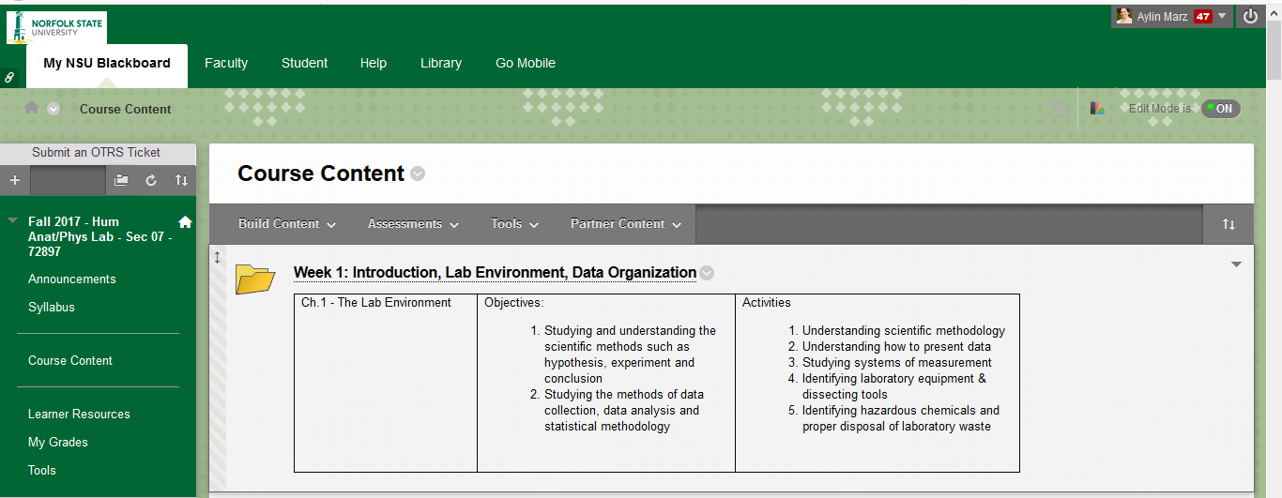
- I modified the tutorial to have data and one example that is relevant to Anatomy and Physiology class interests. In the Organize, Format, Formulae, Functions, and Ranges tabs, I used student height and weight of students. I altered the data in the Exercise to have the number of Ki67 positive cells in different lymphoma patients.
- I made the modified tutorial available on Blackboard and walked the students through all the tabs of it in the laboratory. Students had access to their own electronic devices while I walked them through the material, including the Exercise with lymphoma data.
- I then assigned extra credit homework for the following:
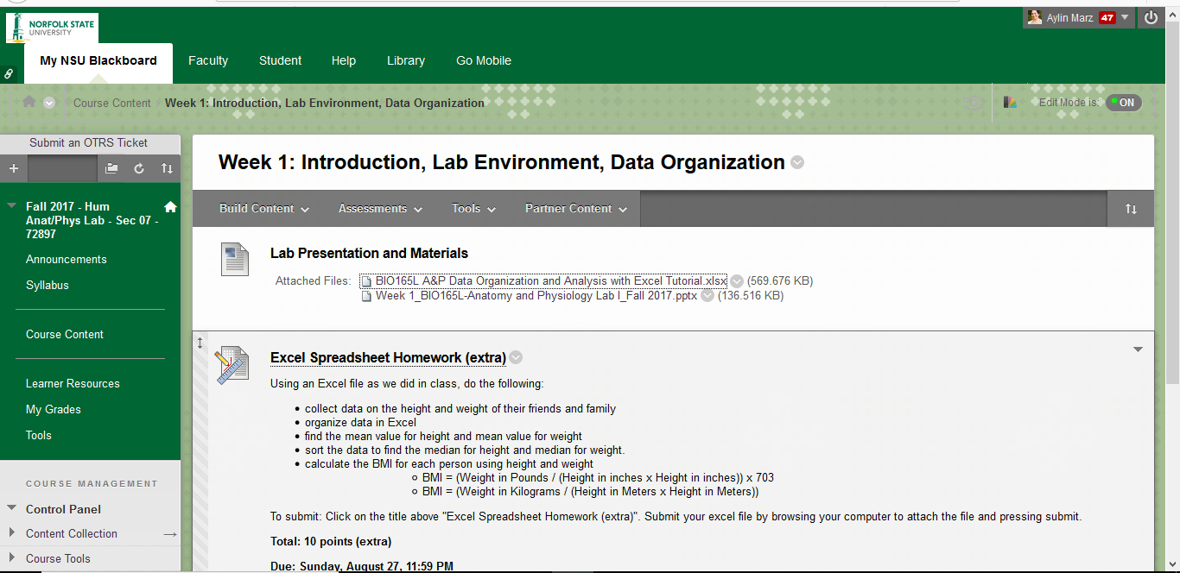

- I had 9 out of a total of 40 students submit the extra credit assignment. The parts they did well in were data organization, finding the mean, and sorting. The challenge was to use a function in Excel to find the BMI. Some just used a web site on the internet to find the BMI and entered the value. Next time, I have to be more specific on how I expect them to calculate the BMI using functions in Excel.

- BIO362L Histology Laboratory, Fall 2017
- This is an elective class for Biology majors and had 13 students in their senior year in Fall 2017.
- I made available all five excel spreadsheet tutorials, the statistics guide, and a link to the Biointeractive site for statistics on Blackboard in the Reference Materials folder for this lab.
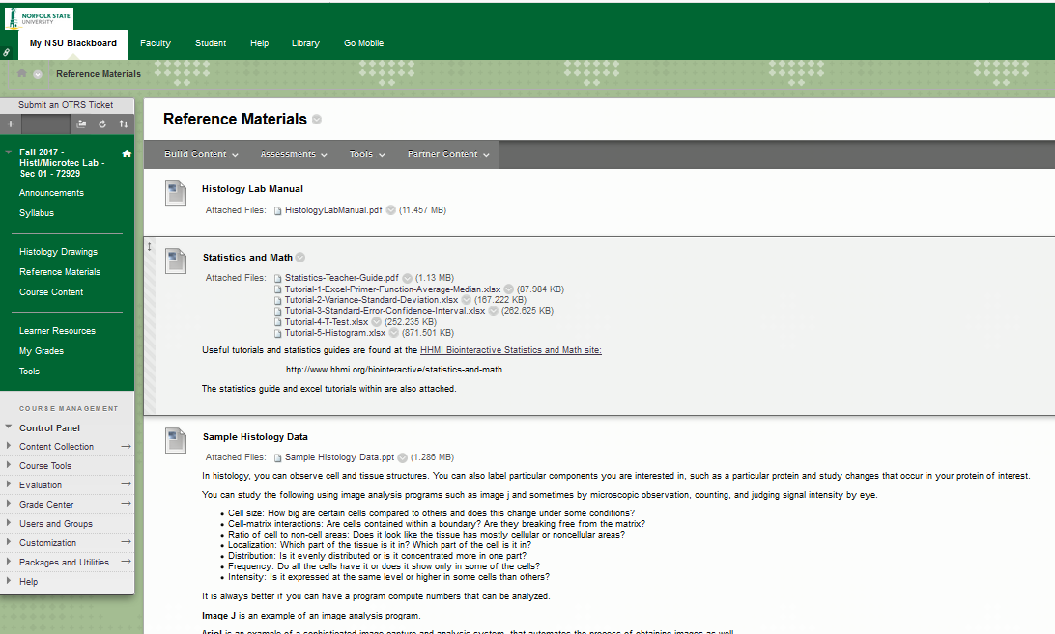

- During the first laboratory session (2 hrs 50 min), I worked with the students to go through the tutorials, do the examples and exercises. Students each had their own laptops or tablets to work on. Most made it through Tutorial 3. Few made it all the way through tutorial 5.
- I did not assign any homework or collect the lab work for this exercise. However, as senior biology students, this group had prior experience using Excel. One student had some technical difficulties on his tablet. These students were familiar with most of the statistics but found some of the Excel functions they had not used before helpful. Excel use competence varied among students.

