Area: Microbial Growth
Microorganism: Streptococcus thermophilus
Reference: Wa, Y, Zhang C, Sun G, Q H, Chen D, Huang Y, and Gu R. 2022. Effect of amino acids on free exopolysaccharide biosynthesis by Streptococcus thermophilus 937 in chemically defined medium. Journal of Dairy Science 105:6460-6468.

The bacterium Streptococcus thermophilus is widely used by the dairy industry in the production of yogurt. It grows anaerobically by a process of fermentation and during its growth, it produces a mixture of extracellular polysaccharides that improve the viscosity, texture, and mouth-feel of the yogurt. These exopolysaccharides also act as probiotics and may be useful as antioxidants and anti-inflammatory agents. Wa et al. (J. Dairy Sci. 105: 6460-6468, 2022) recently studied the growth and extracellular polysaccharide formation by S. thermophilus in a chemically defined medium.

To study the growth of Streptococcus thermophilus under carefully controlled condiitons, Wa et al. first developed a chemically-defined medium containing a mixture of 42 different nutrients. The pH of the medium was adjusted to 6.7 and the solution sterilized by filtration. The composition of the medium is shown in the next table.
Table 1. Composition of the chemically defined medium
Constituent | Concentration
Lactose | 20 g/L
NH₄-citrate | 0.6 g/L
Urea | 0.24 g/L
l-Alanine | 1 mM
l-Arginine | 1 mM
l-Asparagine | 1 mM
l-Aspartic acid | 1 mM
l-Cysteine | 1 mM
l-glutamate | 1 mM
l-Glutamine | 1 mM
Glycine | 1 mM
l-Histidine | 1 mM
l-Leucine | 1 mM
l-Isoleucine | 1 mM
l-Lysine | 1 mM
l-Methionine | 1 mM
l-Phenylalanine | 1 mM
l-Proline | 1 mM
l-Serine | 1 mM
l-Threonine | 1 mM
l-tryptophan | 1 mM
l-Tyrosine | 1 mM
l-Valine | 1 mM
Ascorbic acid | 0.5 g/L
Biotin | 0.01 g/L
Calcium pantothenate | 0.001 g/L
Folic acid | 0.001 g/L
Niacin | 0.001 g/L
Pyridoxine hydrochloride | 0.005 g/L
Riboflavin | 0.001 g/L
Thiamine hydrochloride | 0.001 g/L
Uracil | 0.01 g/L
Adenine | 0.01 g/L
Guanine | 0.01 g/L
Thymine | 0.01 g/L
KH₂PO₄ | 3 g/L
K₂HPO₄ | 3 g/L
MgCl₂ | 0.2 g/L
CaCl₂ | 0.05 g/L
NaH₂PO₄ | 30 mM
Na₂HPO₄ | 30 mM
Na-acetate | 1 g/L

1. Based on what you know about milk and its nutrients, what is the primary carbon source for the bacteria in this medium?

a. lactose
b. urea
c. ascorbic acid
d. KH₂PO₄

To study the growth and formation of exopolysaccharides in this medium, Wa et al. grew cultures of Streptococcus thermophilus at 42ºC, some in the standard medium (CDM) and some in a modified medium in which the concentrations of the amino acids histidine, isoleucine, and glutamate were increased to 15 mM (CDM+ HIG). They periodically measured the turbidity of the cultures at 600 nm and the number of viable cells/ml. They also removed 5 ml samples for free exopolysaccharide analysis. The bacteria were removed from the 5 ml samples by centrifugation and the proteins precipitated with trichloroacetic acid. The polysaccharides in the supernatant fraction were precipitated with ethanol, washed, and quantified using a colorimetric assay for sugars. The results are shown in the next figure.

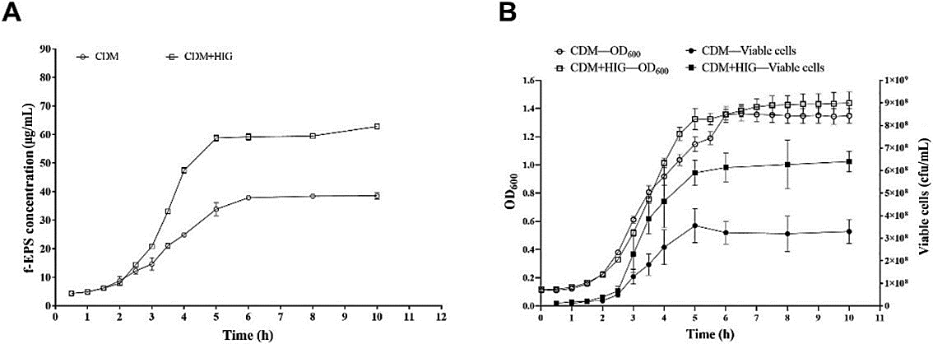

2. Both plots show curves typical of a bacterial growth curve. What are the major phases of this curve in the currect order?

- stationary phase, lag phase, exponential phase
- lag phase, stationary phase, exponential phase
- lag, phase, exponential phase, stationary phase
- exponential phase, lag phase, stationary phase.

3. Look first at panel B. What can you conclude from these data?

a. The addition of the extra amino acids had a small effect on both the number of viable cells/ml and the turbidity.
b. The addition of the extra amino acids had a greater effect on the number of viable cells/ml than on the turbidity.
c. The addition of the extra amino acids had a greater effect on turbidity than on the number of viable cells/ml.
d. The addition of the extra amino acids greatly increased the growth rate during exponential phase

4. Now look at panel A. What can you conclude from these data?

a. The addition of the extra amino acids increased the amount of exopolysaccharide that was formed.
b. The addition of the extra amino acids had no effect on the amount of exopolysaccharide that was formed.
c. The addition of the extra amino acids decreased the amount of exopolysaccharide that was formed.
d. The addition of the extra amino acids shifted exopolysaccharide formation from exponential phase to stationary phase.

To study the basis of these results, Wa et al. measured the levels of transcription of several genes involved in exopolysaccharide formation. These genes were pgm, galM, galK, galT, galU, galE, epsA, and epsB. The next figure shows a comparison of the transcripts after growth for 3 hours in CDM and CDM + HIG.

5. What can you see in this image?

- The level of transcription of all of the genes was the same and did not change with the growth medium
- The level of transcription of the genes was variable but was consistently higher in bacteria growth in CDM + HIG.
- The level of transcription of the genes was variable but was consistently higher in CDM.
- The level of transcription of epsA and epsB was consistently lower than the other genes.

The metabolism of Streptococcus thermophilus like that of many lactic acid bacteria involves the uptake the lactose, the hydrolysis of lactose into D-glucose and D-galactose, and the formation of lactic acid as a product. Wa et al. measured concentrationw of lactic acid, lactose, and D-galactose in the medium of CDM and CDM + HIG cultures after 3 hours and 5 hours. The results are shown in the next figure.

6. What do these result indicate about the metabolism of the bacteria in the two media?

- After 3 hours, the bacteria in CDM have formed more lactic acid and degraded more lactose than those in CDM + HIG.
b. After 3 hours, the bacteria in CDM + HIG have formed more lactic acid and degraded more lactose than those in CDM.
c. After 5 hours, the differences in the concentrations of lactic acid and lactose presist and become more dramatic.
d. The concentration of D-galactose is a good indicator of lactose metabolism.

7. In the original paper, Wa et al. states that they found in a previous study that the addition of histidine, isoleucine, and glutamate to the chemically defined medium led an increase in turbidity and to an increase in exopolysaccharide formation. Why might these three amino acids be specifically required?

a. These amino acids might be incorporated into the free exopolysaccharides.
b. These amino acids might be converted to the sugars used in the free exopolysaccharides.
c. These amino acids might be degraded as additional nitrogen sources by the bacteria.
d. These amino acids might be taken up in small amounts by the bacteria and so this limits growth.

Written by:
Charles E. Deutch, Microbion Research
February 8, 2023
Charles.Deutch@asu.edu

