Polyploidapalooza
Module 4: Polyploid phylogenetics

Kaitlin E. Allen & David C. Blackburn

Abstract
Polyploidy plays an important role in the evolution of life but is often overlooked in undergraduate classrooms. In this series of modules, we explore how polyploid species are formed, how they evolve and adapt, and their economic and conservation importance. Module 4 explores how to read and understand polyploid phylogenetic trees and how the genomic structure of polyploid organisms impacts phylogenetic analysis.

Objectives
- Conduct an overview of how to read and understand basic phylogenies
- Explore polyploid phylogenies in the form of multi-labeled trees - including the difference between allopolyploid and autopolyploid topographies
- Explore allopolyploid phylogenies in the form of species networks

Logistics
Department: Biology
Level: Upper undergraduate
Prep time: 0 hours
Class time: 1-2 hours

Pre-module preparation
List of terms - come back to these terms if you need to while reading the text.
Phylogenetic tree—diagram showing the bifurcating evolutionary relationships
between species
Phylogenetic network—diagram showing evolutionary relationships between species
that also includes species formed through hybridization
Lineages—representation of a species on a phylogenetic tree, the length can
correspond
to the amount of evolutionary divergence between species
Node—a representation of the most recent common ancestor on a tree, the point where two lineages come together.
Clade—two or more lineages that share a node form a clade
Sister species—species connected by a node, the closest relative of a species or
clade
Bifurcating—Splitting into two lineages from a node

Introduction
Phylogenetics is the study of how living organisms are related to each other. You can think of it as similar to a family tree, where each species or population in the tree is descended from a common ancestor. These relationships are often determined using similarities in morphology or genetics. Typically, these relationships are represented as bifurcating, meaning that when new species are formed the ancestral species (represented as a node) splits into two lineages. In the first activity of this module, we will explore how to read and interpret a bifurcating phylogenetic tree.
Polyploid species exhibit more complicated phylogenetic relationships than diploid species because they have more than one genome, each undergoing its own evolutionary processes. When the evolutionary relationships of genes from each genome are plotted in a bifurcating phylogenetic tree, the two categories of polyploids (autopolyploids and allopolyploids) show different patterns. Autopolyploids, which are polyploids with duplicated genomes of the same species, show branching patterns where the two genomes are closely related to each other. Meanwhile, allopolyploids, which are polyploids formed by hybridization between two distinct species, will show branching patterns where the two genomes are found separately in the tree and are most closely related to the species that hybridized to form the polyploid. Because polyploid species are represented multiple times in the phylogeny, due to their multiple genomes, these trees are called multi-labeled gene trees. This will be covered in the second activity of this module. In allopolyploids, these trees can be redrawn as reticulating Phylogenetic networks to represent the hybridization that formed the species (activity 3).

Activity 1: How to read and interpret phylogenetic trees
Before we get into how to work with polyploid multi-labeled trees and networks, we will quickly review the basics of how to read and interpret phylogenies in general. Below is a tree with five species (labeled A, B, C, D, & E). Each ancestral node splits into two lineages, meaning that this tree is bifurcating. The species that are most closely related to each other (called sister species) are connected by a node (labeled 1–4). Species like C are said to be sister to the lineage containing both species A and B. Together these three species share a common ancestor at node 2. Species C is equally related to A and B, just as your cousin would be equally related to you and your sibling. Groups of species that are closely related to each other by a common node are called clades, so A and B are a clade joined by node 3; A, B, and C are a clade joined by node 2, and A, B, C, D, and E are a clade joined by node 1. Species that are not joined by a common node do not form clades, so A and D do not form a clade unless all of the other species that are connected by that node are included.
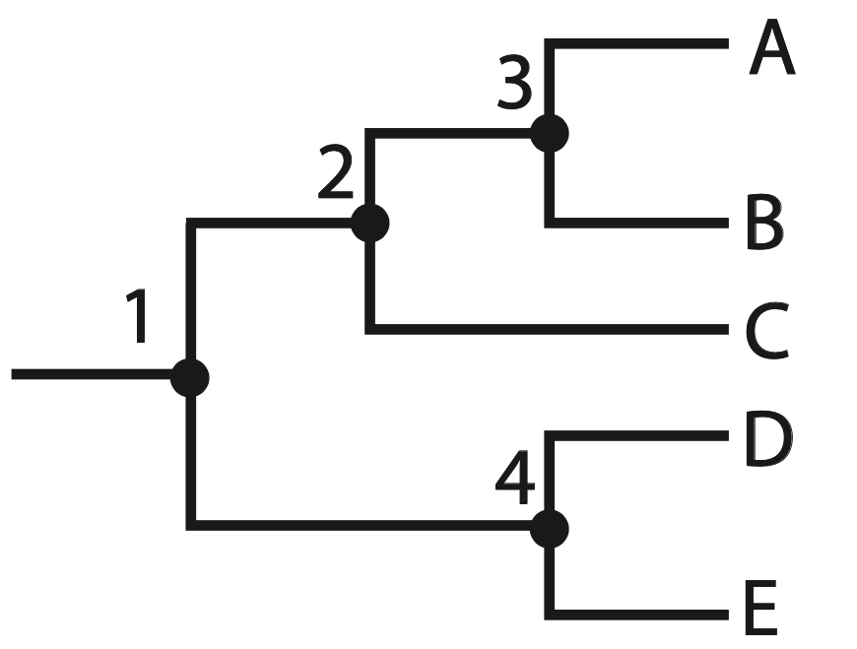
Using the phylogeny above, answer the five (5) questions below to check your comprehension of phylogenetic relationships before moving forward to apply these concepts to polyploid phylogenies.

- Using the terminology above, what is D's relationship to E?

- What node joins species D and E?

- What node joins D and E with A, B and C?

- Do C and E form a clade? Why or why not?

- Do D and E form a clade? Why or why not?

Activity 2: Multi-labeled trees
Now that we have reviewed the basics of reading phylogenies, we will apply these concepts to polyploid phylogenies. There are two types of polyploids that we will cover in this activity: autopolyploids and allopolyploids. These are formed in different ways and show different phylogenetic patterns. Autopolyploids are formed through genome duplication within a single species. In a phylogenetic tree showing the evolutionary relationship between the genomes of autopolyploids and other closely related species, their duplicated genomes will appear as each other's closest relatives, and each will be labeled with the same species name since they come from the same species. In the first phylogeny below, species A is an example of an autopolyploid with two sub-genomes (A1 and A2). Allopolyploid species are formed through hybridization between two distinct parental species. In a bifurcating phylogenetic tree showing the evolutionary relationships between the genomes of different closely related species, the genomes of the allopolyploid species will each appear as more closely related to the species that hybridized, rather than to each other, as in an autopolyploid. Like autopolyploids, each lineage associated with the allopolyploid will be labeled as the same species since they come from the same species. In the second phylogeny below, species B is an allopolyploid with sub-genomes B1 and B2.
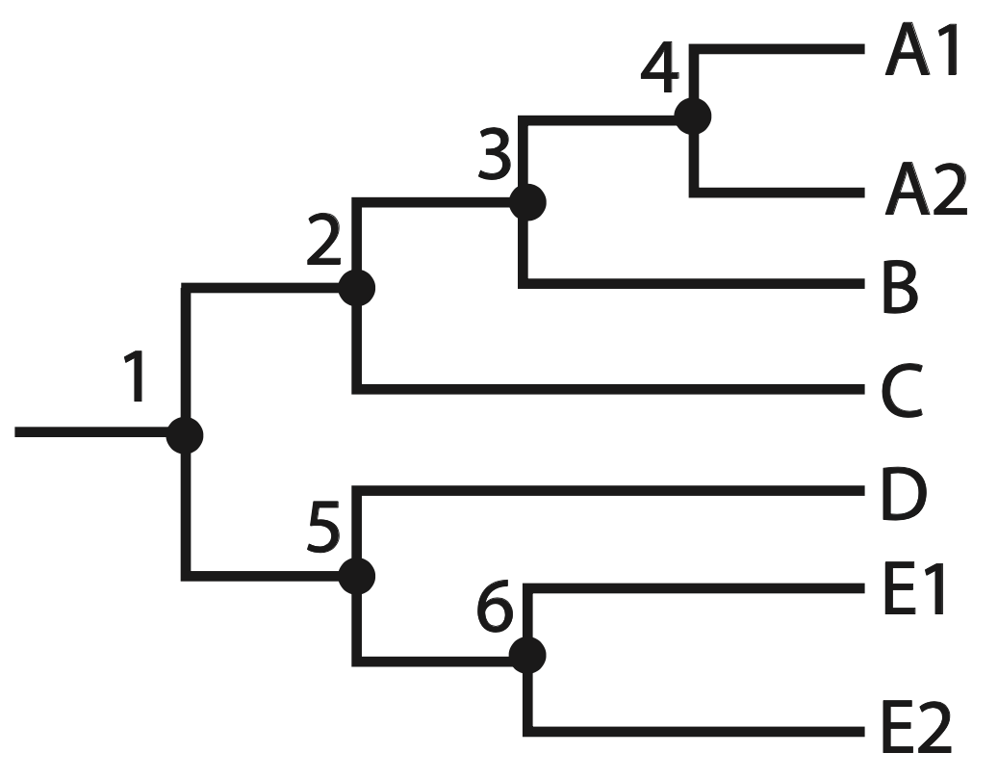

Tree 1: autopolyploid multi-labeled phylogenetic tree
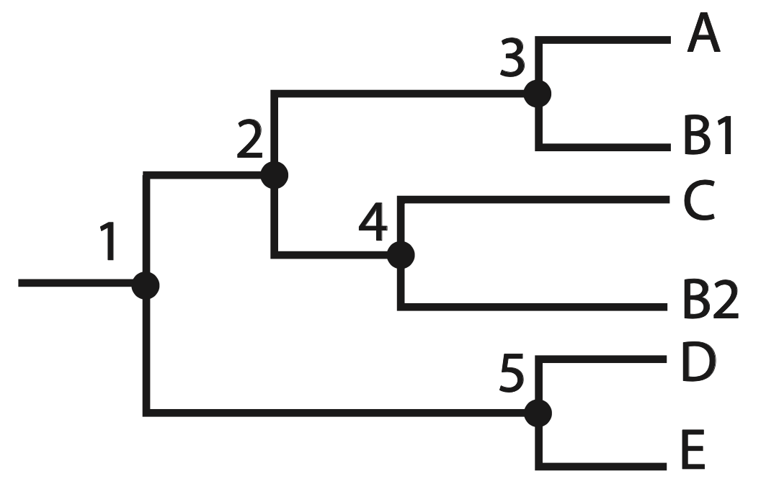
Tree 2: allopolyploid multi-labeled phylogenetic tree

For this exercise use the phylogenies above to answer the following four (4) questions.

- List two species in the above trees that are autopolyploid based on their phylogenetic relationships

- List one species in the above trees that is allopolyploid based on its phylogenetic relationship

- How can you tell that tree 1 represents autopolyploids while tree 2 represents allopolyploids?

- What is the biological difference between auto and allopolyploids that causes the differences in phylogenetic patterns?

Activity 3: Allopolyploid species networks
As we reviewed above, allopolyploids are formed through hybridization and their genomes appear in the phylogenetic tree closest to the hybridizing species. Because of this, the hybridization pattern that created the allopolyploid can be deciphered from the relationships in the phylogenetic tree. This tree can then be redrawn as a phylogenetic “network” where lineages can be shown coming back together into the polyploid species, which, even though it shares the genomes of other species in the tree, is now on its own evolutionary path. Below you can see the same tree with the allopolyploid species B as determined in activity 2.

From this phylogeny representing parts of the genome, you can see that one sub-genome from species B is most closely related to species A and the other sub-genome is more closely related to species C. This means that B is an allopolyploid through an hybridization event between these species A and C. A network representing relationships among species can be drawn to show this hybridization pattern, as below.
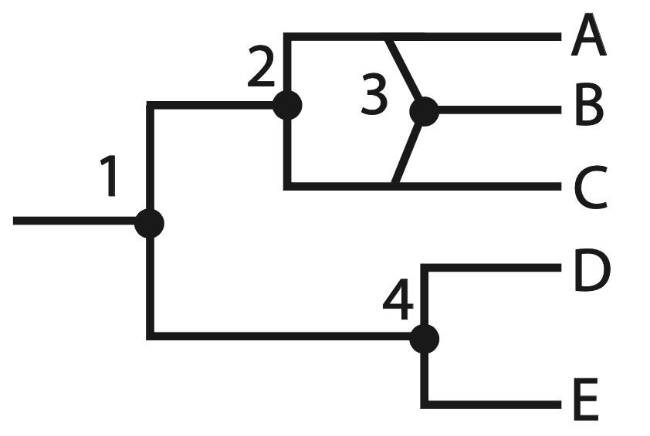

Next, take a look at the phylogenetic tree below and answer the following three (3) questions, including one which will have you practice drawing a phylogenetic network on your own.
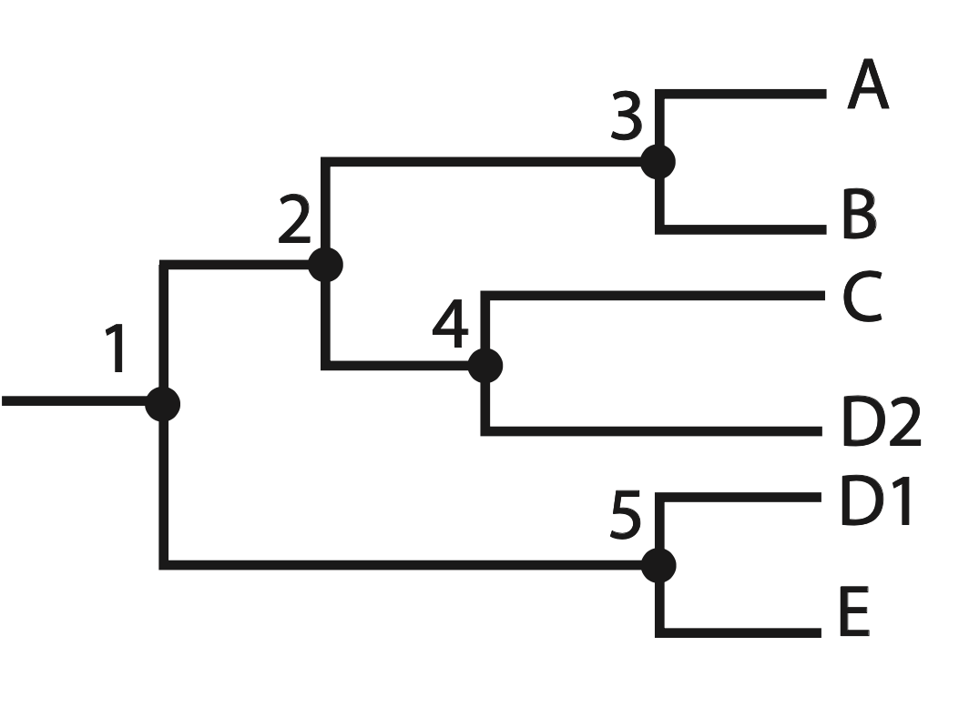

- Which species is allopolyploid in this phylogeny?

- Which two species are the allopolyploid species most closely related to?

- Draw the phylogenetic network based on this phylogeny in a style similar to that above.

Acknowledgments

We would like to thank Makenzie Mabry, Michelle Gaynor, Libby Ellwood, and Alva Mihalik for their thoughtful feedback on these modules.

References

Phylogenetic tree figures created by Kaitlin Allen

