Systems-thinking concept mapping exercise

Read the one-page news story about pollination in China below

Working in small groups of 4, spend 20 mins starting to map out the ecosystem services issue as a system presented here:

Pull out elements (concepts) into boxes

Connect each concept with an arrow and label it with the relationship/connection

Then spend 10 mins rotating to a new group to evaluate how they approached their concept map – What is clear? What is different to how you approached it?

Remember the example:

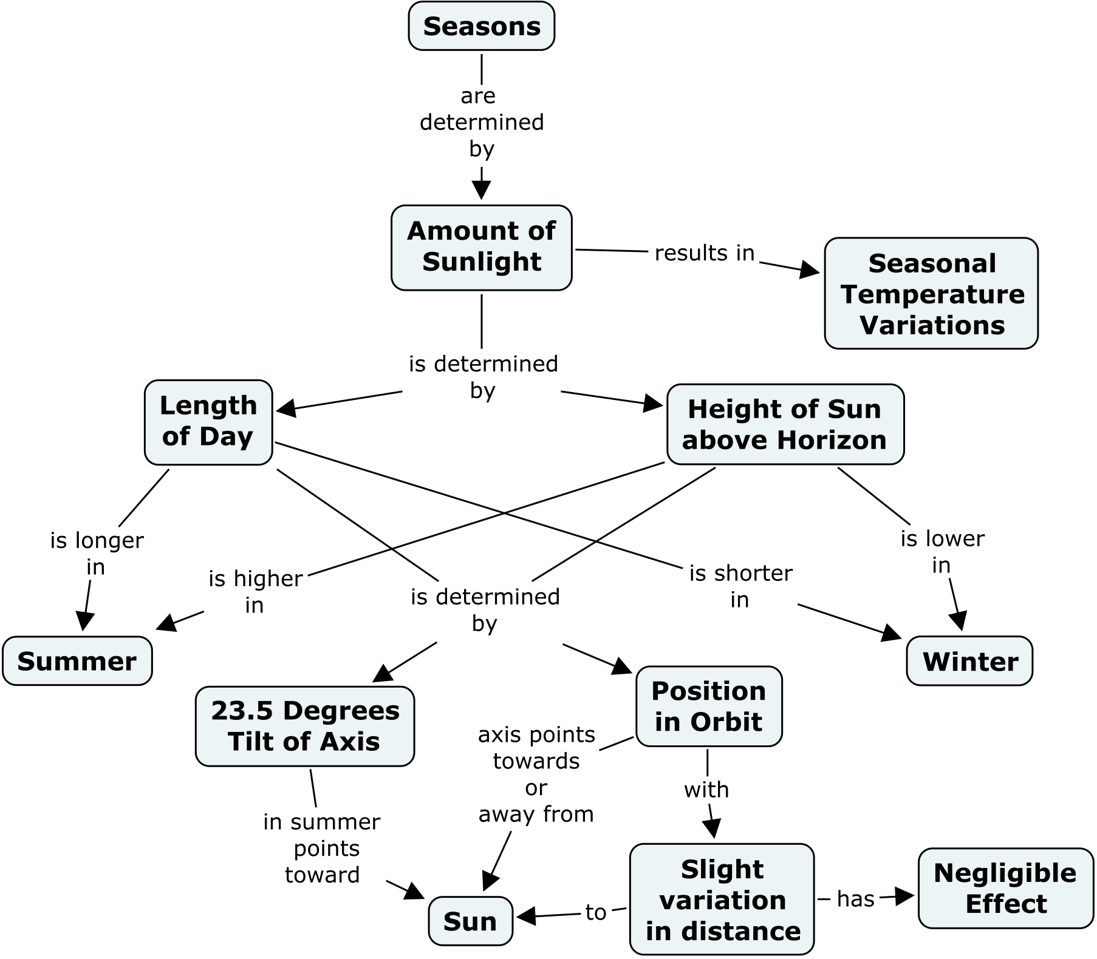

After Bee Die-Off, Chinese Apple Farmers Resort to Hand Pollination

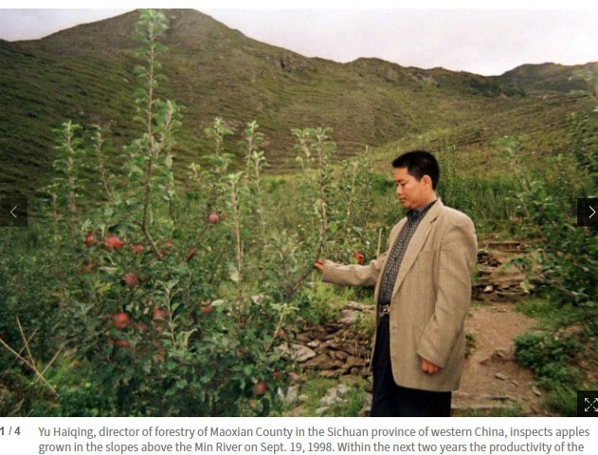
By Stuart Liess, Epoch Times

Studies abound that document the problem of bee decline around the world. For example, the rusty patched bumble bee, an important pollinator of wildflowers, cranberries, blueberries, and apples, was once abundant throughout the United States, but it is now threatened with extinction, according to Xerces, a nonprofit conservation group.

Reasons for the decline, often dubbed “colony collapse disorder,” are many, but look to be largely of our own making. They include new and potentially bee-harming pathogens and parasites, a lack of bee nutrition due to a reduction in available
pollen sources, and the harmful effects of toxic pesticides sprayed on crops and ingested by bees, according to the
U.S. Department of Agriculture.

While the problem exists worldwide, nowhere is it more disturbing than in China’s mountainous Maoxian region, in Sichuan Province, where farmers were forced to pollinate their apple orchards by hand after experiencing the loss of their entire wild bee population. The pollination of apples in Maoxian has to be completed within five days in order for the trees to bear fruit—so every year thousands of villagers arrive for the arduous task of meticulously pollinating every single blossom by hand, according to Dave Goulson, writing for chinadialogue, an independent nonprofit with offices in London and Beijing. Using homemade pollination sticks made from chicken feathers and cigarette filters dipped into plastic bottles filled with pollen, a single person can pollinate 5 to 10 trees in a day.
Children also participate by climbing the trees to reach the higher branches.

The population of Maoxian is around 91,200, with a 6,437-hectare growing area approximately three times the size of Manhattan Island, New York. Apple production in the Maoxian valley began in 1946 with 400 trees. By the 1980s, the region boasted over 200,000 trees and apples were the county’s leading cash crop. By 1998 Maoxian had reached it’s peak, producing 30,000 tonnes a year with a total value of 40 million yuan (US$6.4 million). The Maoxian apples, known as “maowen apples,” became famous throughout China and beyond, but by 1990, a 50% decline in overall productivity was attributed to the mysterious bee loss phenomena.

As part of its investigation into the reasons for bee declines globally, the nonprofit BioProfit went to China in 2001 to investigate the loss of bees in Sichuan valley. While they were unable to confirm the exact cause of the disappearance, researchers attributed it to a combination of factors. Of large concern throughout China is its huge pollution problem, and over pesticide use is a major contributing factor. Since the 1970s, the heavy-handed use of chemical pesticides has proven very popular with Chinese farmers as they strive to protect their crops from insects. The standards of use set by the ministry of agriculture tend to be ignored by farmers, and the laws are a lot more lenient in China than in more regulated countries where the distribution of pesticides would be in the hands of companies certified to do so, according a report by Yang Meng of chinadialogue. Also, when a biological or natural pesticide costs 10 times the amount of its chemical counterpart, the money-conscious farmer would tend to pick the latter.

Temperatures and changing weather conditions also likely played a role. The farmers regularly reported fluctuations in the weather, characterized by quick temperature changes, and rain and hailstorms during the blossoming periods.

Example of student concept map:
