Worsheet Part I
Module: Separation of Variables
Ebola Outbreak in West Africa

Modeling an Epidemic
An Ebola outbreak in West Africa began in 2014 and spread through Guinea, Liberia, and Sierra Leone. There was a scare that the disease would spread to other parts of the world. We will use data on the number of cases of Ebola from the World Health Organization (WHO) (and published on Wikipedia) to model the outbreak and predict future numbers of cases.

1. The number of cases of persons in West Africa infected with the Ebola Virus grows exponentially like the function:
N(t) =N₀e^{rt}

where t is time in months and N(t) is the number of cases at time t. Let t = 0 represent March 2014 and use the following data to determine the constants N0 and r.
In March 2014 there were 49 cases of Ebola and after 3 months, there were 528 cases. Round r to the nearest ten-thousandth.

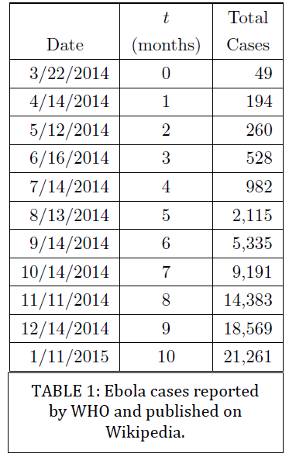

2. Interpret and verify the model.
a. Use your exponential growth model to estimate the time it will take for the outbreak to reach a total number of 5,000 cases.

b. Comment on how well your answer to the previous part matches the data in Table 1.

c. Use your model to estimate the number of cases after 5, 6, 7, and 10 months. Compare the values predicted by your model to the actual observed values in Table 1.

After 5 months: Model estimate: _______________ Actual number of cases: _______________

After 6 months: Model estimate: _______________ Actual number of cases: _______________

After 7 months: Model estimate: _______________ Actual number of cases: _______________

After 10 months: Model estimate: _______________ Actual number of cases: _______________

d. Remark on whether you expect this model to be accurate for the duration of the epidemic.

3. Further Examine the Scenario: In September 2014, the Center for Disease Control (CDC) cited different model predictions for the number of Ebola cases that reached as high as 550,000 cases by January 20, 2015 in Liberia and Sierra Leone alone [CDC]. When the model was corrected for under reporting, the number of cases jumped to 1.4 million. At the time of the prediction, Liberia and Sierra Leone combined for 2,407 cases while the model fairly accurately estimated 2,618 cases [CDC].

a. Consider the above predictions by the CDC for Liberia and Sierra Leone for January 2015. How do your prediction and the actual data for all three countries compare to the prediction of the CDC?
  - b. Consider factors that may affect the behavior of the epidemic and its growth. Describe at least four such factors and identify whether the influences are environmental, economic, social, cultural, political, or other.

  - c. Describe the behavior you may expect for the epidemic as time progresses. Sketch a rough graph to illustrate your expectations. While the horizontal axis of your graph is time, what does the vertical axis represent?

