NIQB Cell Biology CYTOSKELETON - Microtubule Dynamics in the Cell Cycle

Biological Pre-work for Cell Module on Microtubules

Microtubules are the largest sized cytoskeletal component with a diameter of 25 nm and serve a variety of different roles within eukaryotic cells. They are responsible for the transport and organization of organelles and other molecules within the cell, the separation of chromosomes equally into two daughter cells during mitosis, and even serve as the structural foundation for external motile structures like cilia and flagella.

Microtubules are composed of tubulin proteins. Tubulin proteins are heterodimers with alpha and beta subunits that are bound through non-covalent interactions. These dimers will stack together to form extending linear protofilaments with the beta-tubulin subunit of the previous dimer always interacting with the alpha-tubulin subunit of the next dimer. Thirteen of these protofilaments interact with each other to form a hollow, cylindrical tube (See Figure 1). Each of the protofilaments with the microtubule and the microtubule as a whole has structural polarity. The end of the microtubule with exposed alpha-tubulin is called the minus end, while the end of the microtubule with exposed beta-tubulin is called the plus end.
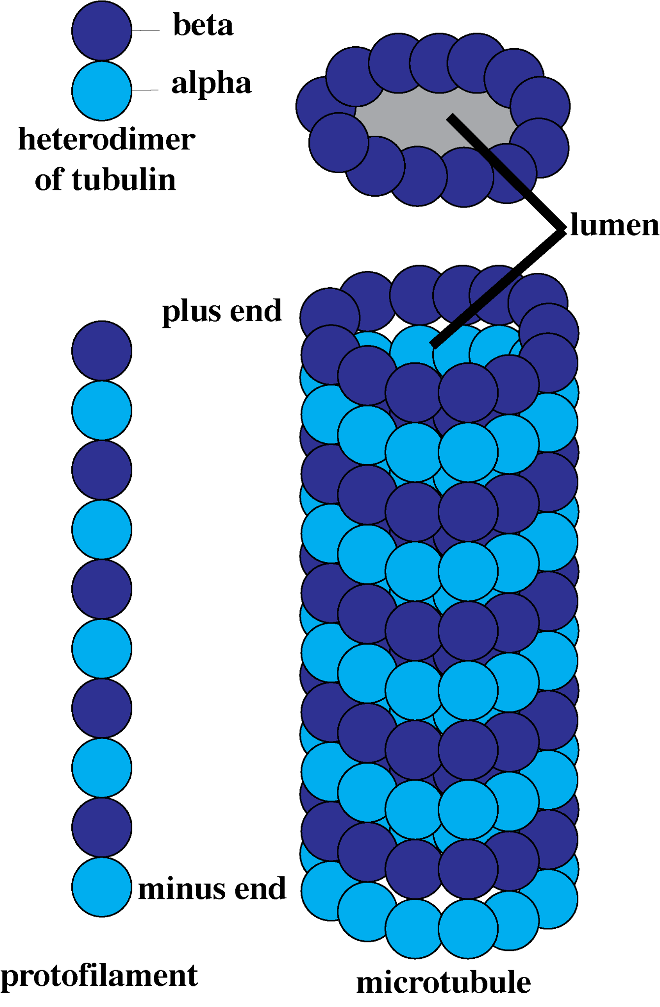
Figure 1. A microtubule consisting of 13 protofilaments of alternating heterodimers of beta and alpha tubulin subunits with a hollow lumen center.

Microtubules are dynamic molecules in that they can grow or shorten in length depending on the situation. The minus ends of the microtubules embed into organizing centers called the centrosome and new dimers are added to grow the plus end outward into the cytosol. The growth of the microtubules by adding new dimers to the plus end is called polymerization. The microtubules can also shrink in size by the release of tubulin dimers to shorten the length of microtubule back towards the minus end, which is referred to as depolymerization. Whether a microtubule will undergo polymerization or depolymerization is dependent on the rate of hydrolysis of guanosine triphosphate (GTP) compared to the addition of new dimers. Each tubulin dimer contains a single GTP molecule bound to the beta-tubulin subunit. Shortly after this dimer is added to the microtubule, this GTP molecule will be hydrolyzed into GDP and a phosphate group resulting in the GDP binding tightly to the beta-tubulin. GDP bound dimers associate less tightly to each other than GTP bound dimers. During polymerization, new dimers are added to the microtubule faster than the previously added dimer’s GTP molecule can be hydrolyzed, which creates what is called a GTP cap. As long as there is a GTP cap, the microtubule will continue to undergo polymerization. However, if the end dimer’s GTP is hydrolyzed faster than a new dimer can be added on, the process becomes unstable and will trigger a depolymerization event. Given that GDP bound dimers associate less tightly to each other, the loss of the GTP cap will result in a rapid dissociation of dimers from the positive end and the shrinking of the microtubule back towards the minus end.

In this module, you will be exploring this process of polymerization and depolymerization of microtubules specifically within the context of mitosis. During the preparations before mitosis, the cell duplicates its centrosome in order to form two distinct mitotic spindles within early mitosis that contain their own aster of microtubules. These mitotic spindles will migrate to the two separate poles of the cell and are responsible for moving chromosomes during mitosis.

1. Based on what you previously have learned about mitosis, explain whether you think polymerization or depolymerization is responsible for moving the chromosomes to the metaphase plate during metaphase.

2. Based on what you previously have learned about mitosis, explain whether you think polymerization or depolymerization is responsible for moving the chromosomes to one pole or the other during anaphase.

Mathematical Pre-work for Cell Module on Microtubules

1. Dimensional analysis: Oftentimes it is hard to compare quantities that are measured in different units. For instance, is 45 micrometers per minute faster or slower than 45 nm per second. To compare these two quantities we must compare them in the same unit of measurement. Some useful pieces of information are:

1 micrometers= 1x10⁻⁶ meters
1 nanometer= 1x10⁻⁹meters
60 seconds = 1 minute

We perform the following calculation:

45 microns = 45 microns x 1x10⁻⁶ meters x 1nm x 1 min = 750 nm
1 min 1 min 1 micron 1x10⁻⁹meters 60 sec sec

In the calculation above, 45 microns per minute is multiplied by various forms of the number 1: 1 micron = 1x10⁻⁶ meters means that 1x10⁻⁶ meters /1 micron is equivalent to the number 1. From a unit analysis perspective, the micron unit on top cancels with the micron unit in the denominator, the meters unit in the numerator cancels with meters unit in the denominator, and the min unit in the numerator cancels with the min unit in the denominator, so we are left with nm in the numerator and sec in the denominator.

Test your knowledge: What value is the acceleration of 45 microns/min² in the units of nm per seconds squared?

2. Slopes of Line and Rates: Rosa makes necklaces by placing beads on a string. She can put the 20 beads on the string in 1 minute. However, if Rosa accidentally (and catastrophically) drops one end of the string, then the beads come off the string at a rapid rate of 5 beads in 1 second. We refer to the rate at which Rosa adds beads to the string as the beading rate and the rate at which beads fall off the string the “debeading” rate. Note that the beading rate adds beads to the string and the “debeading” rate is the rate at which beads are removed from the string. Both correspond to positive numbers, but the beading rate corresponds to adding beads to the string and the “debeading” rate corresponds to removing beads from the string.

Test your knowledge:

2a. If there are 120 beads on each necklace, then based on the beading rate, how long would it take Rosa to make 6 necklaces?

2b. Assume that the beads are 0.5cm in diameter. Assuming that there are no catastrophes, that is the beads don’t fall off the string, how much string is needed to make the 6 necklaces?

2c. Consider a plot of time on the x-axis and number of beads on the y-axis. What is the slope of the line on the graph in the time interval t=[0,6]? How does the slope correspond to the rate of beading?
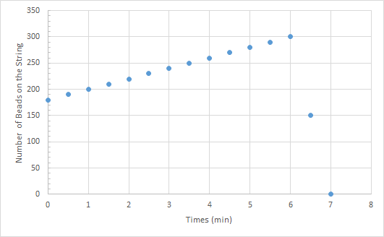

2d. On the same plot that you considered in 2c, what is the slope of the line on the time interval t=[6,7]? How does the slope correspond to the rate of debeading? Explain why the rate of debeading is a positive number.

