CURE in Traits and Species Distributions
Cartography and Spatial Analysis

Overview
In this tutorial students will use locality data from herbarium specimens to generate maps and calculate the total range size of species. Before beginning this tutorial students should have generated a trait dataset and downloaded and installed QGIS (https://www.qgis.org/en/site/).

Learning Objectives
Upon completion of this tutorial students will be able to:
- Manipulate vector data in QGIS
- Change symbology of layers and add a legend and scale bar to generate an informative map
- Create a minimum convex hull and retrieve the total area that the polygon encompasses
- Integrate area data into a larger dataset

Definitions
- Shapefile – a series of files that store information about points, lines and polygons, including where they are located spatially along with other attributes. Shapefiles are comprised of five different files that all must be located in the same folder. The file endings are shp, shx, cpg, dbf, and prj.
- Minimum convex hull – The smallest possible polygon that includes all of a given set of points.

Part I. Preparing and loading data
- Download and install QGIS, a free, open source mapping and spatial analysis program (https://qgis.org/en/site/). Download spatial data you need for this tutorial here (https://www.dropbox.com/sh/h2otlmld1fy3mv2/AAAvBlRYGH2ZD50s6Pd2w1GKa?dl=0).
- Create a folder structure on your local computer to manage the data and files associated with this project. First, creat a folder that contains all of the files related to this project labeled something like ‘Lichen CURE,’ then make a subfolder in that folder called ‘Mapping.’ Within that folder create three folders: Exported_raw_data and Distribution_shapefiles.

Your folder structure should look something like this:

Lichen_CURE
Mapping
Exported_raw_data
Distribution_shapefiles

- Export your data sheet for each species as a csv file. To do this, navigate to the tab with the data that you want to export, then click File > Download > Comma Separated Values (.csv). Move the exported files to the following location: Lichen_CURE/Mapping/Exported_raw_data/
Repeat this process for every species that you are working with.
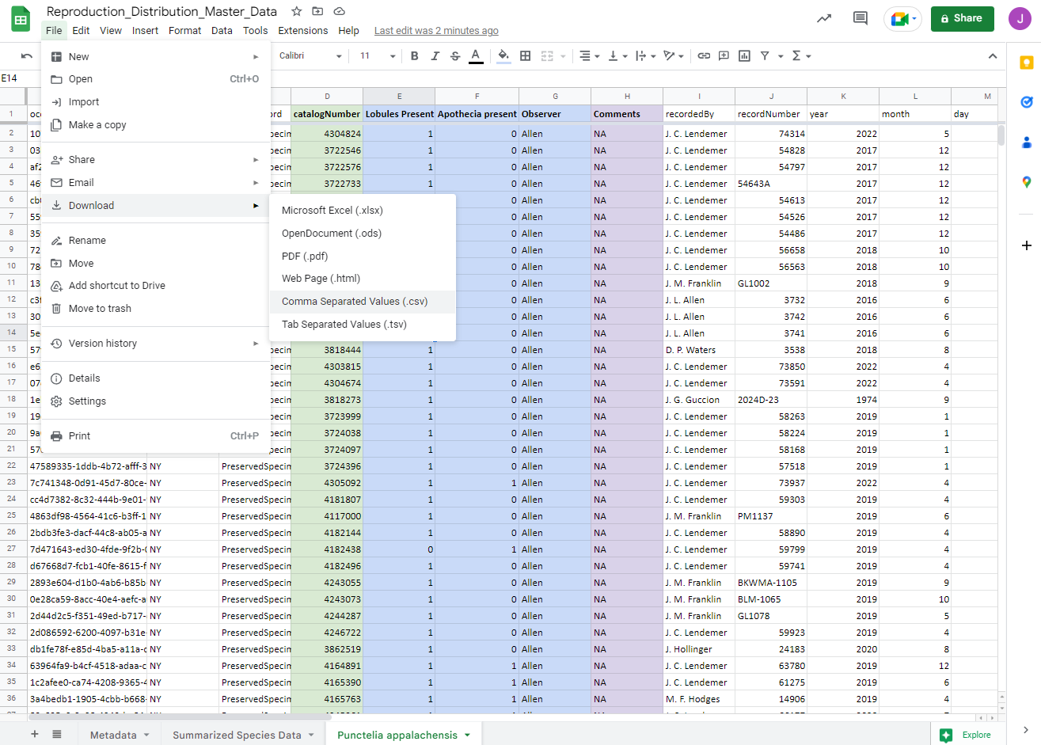

- Download the zipped folder called ‘Baselayers’ from the project on Canvas. Save this zipped folder in /Lichen_CURE/Mapping/ then right click and select ‘Extract all’ and extract to the current location. Note that some of these files are shapefiles which are comprised of up to five files, each of which has a different extension: .cpg, .dbf, .prj, .shp, .shx. All of the files have to be in the same folder location for it to be opened by QGIS.
Once you extract all of the files from the folder you should have the following folder structure: /Lichen_CURE/Mapping/Baselayers. The Baselayers directory should include all of the following files.
State_borders_Albers.dbf
State_borders_Albers.prj
State_borders_Albers.qpj
State_borders_Albers.shp
State_borders_Albers.shx
world_borders_Albers.cpg
world_borders_Albers.dbf
world_borders_Albers.prj
world_borders_Albers.shp
world_borders_Albers.shx

- Open QGIS and create a new project. Save the project as ‘CURE_mapping_area_calculations’ in the /Lichen_CURE/Mapping/.

- Click the ‘Add data’ button on the top left of the main screen.
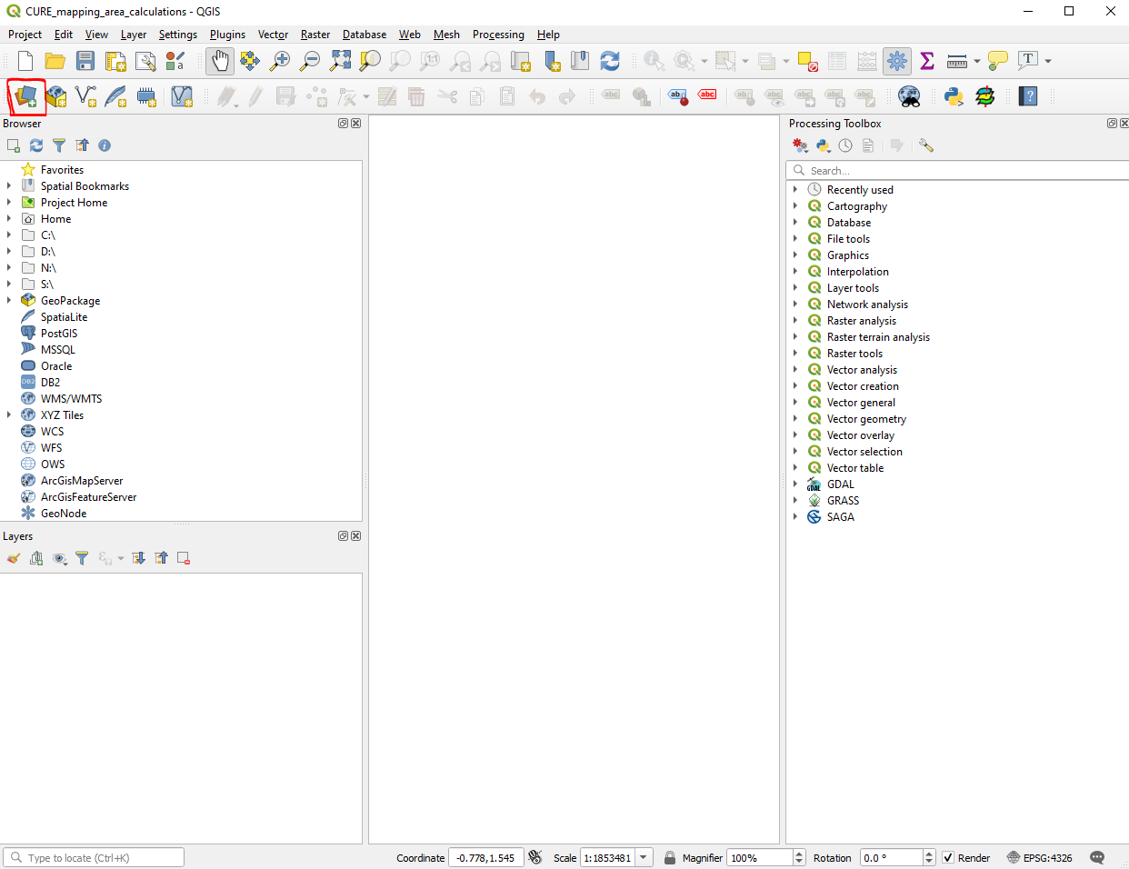
- Click ‘Vector,’ the button with three dots to the right of the source box, then select with ‘states_wgs.shp’ and ‘world_borders_WGS84.shp’ at the same time by holding town ‘CTRL’ while clicking them. Click ‘open’ then ‘add.’
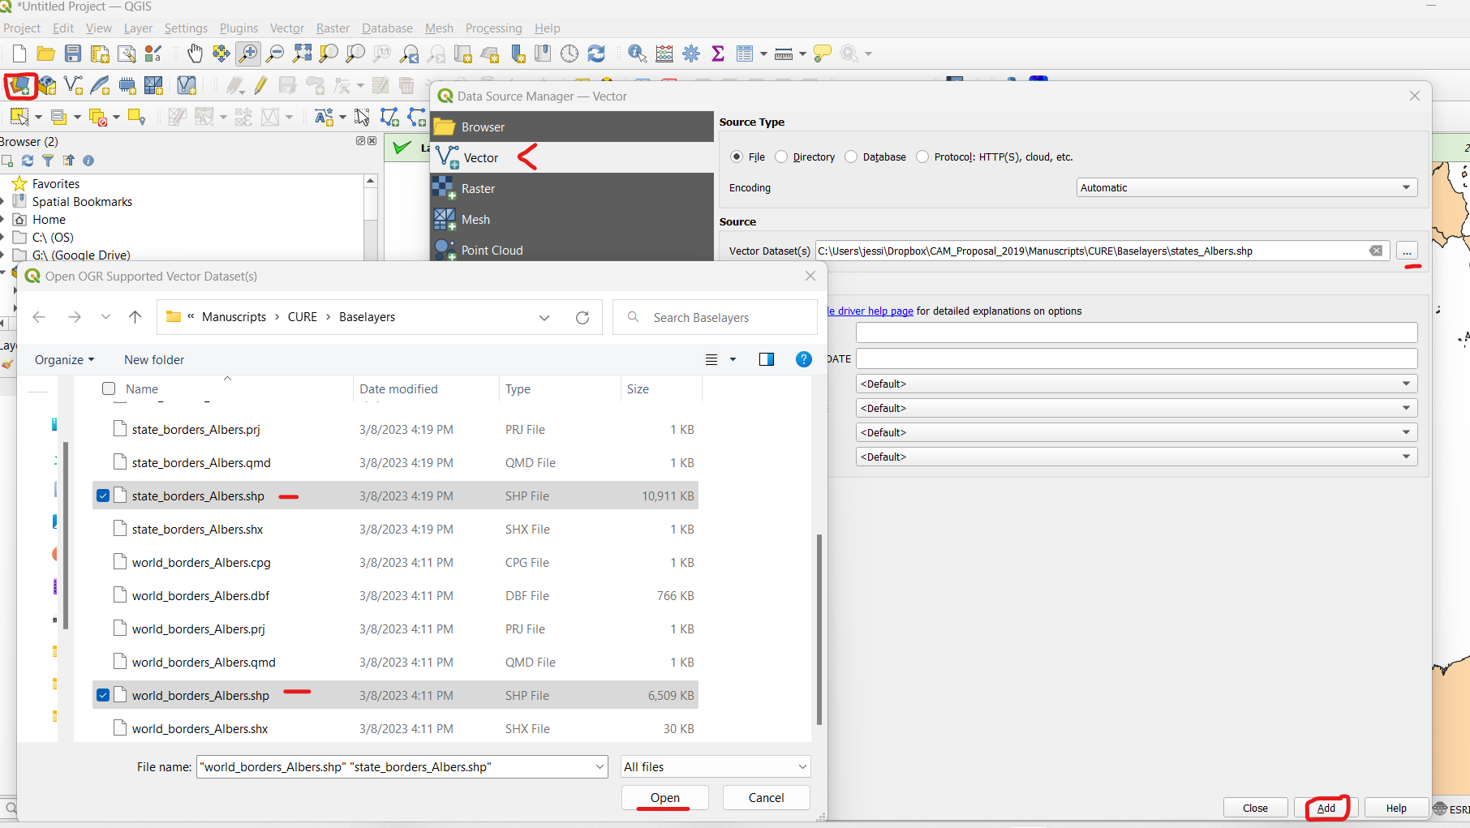

Your map should now look like the following. Push Ctrl+s to save your work so far.

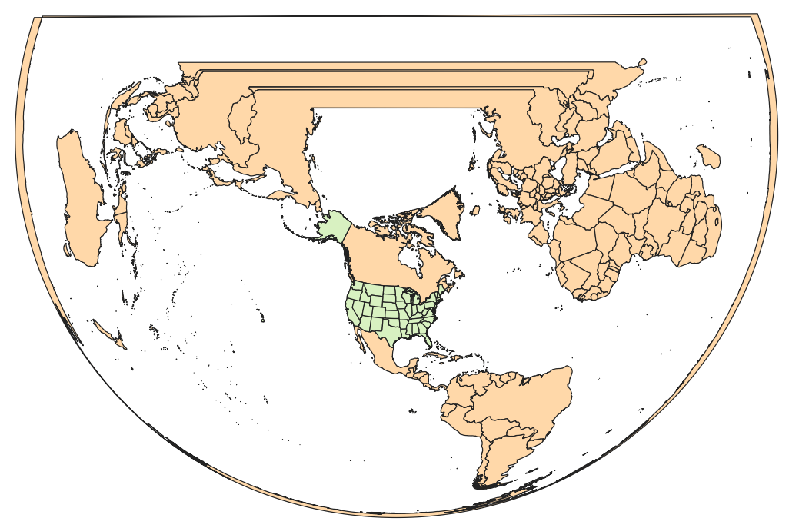
Part II. Creating a Map
- We will sort out the symbology of the map thus far before adding the location data.
  - Change the color fill for both the state and world border files to a sensible fill color while leaving the boundaries black. To do this double click on the ‘state_boundaries_Albers’ layer. This will open the ‘Layer Properties’ menu. Click ‘Symbology’ on the left menu.
Click the arrow to the right of the color bar and select a suitable color, then click ‘OK.’ Repeat this same process for the world borders layer.

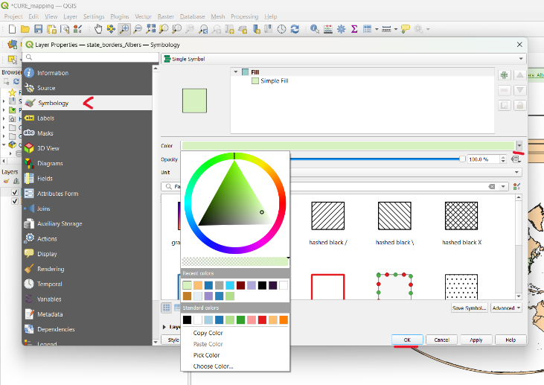

- To add the point data, click the ‘Add Data’ button, then select ‘Delimited Text,’ use the three dot button to the right of the File name box to select your downloaded .csv file. Then, change the file name to the species name followed by the word ‘raw.’ Check that X field is set to decimalLongitude and Y field is set to decimalLatitude. Then click ‘Add’ followed by ‘Close.’

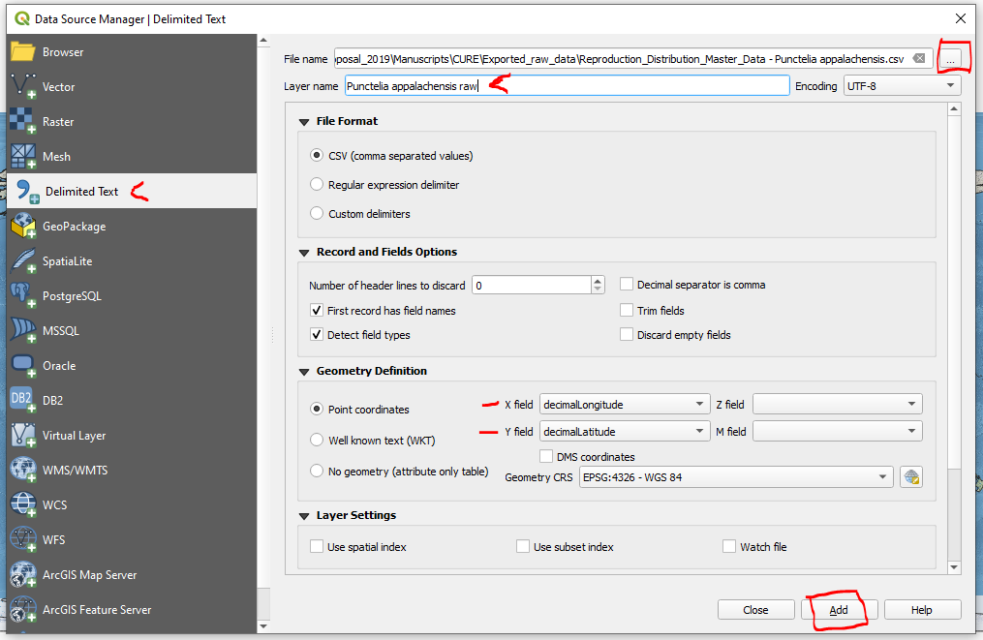

- To get a better look at your points click the ‘Zoom in’ button, which looks like a magnifying glass with a plus sign in it. Then click and drag a box over where you want to zoom in. You can drag and move the point layer to rearrange its order and change the color as we did with the other layers if needed.

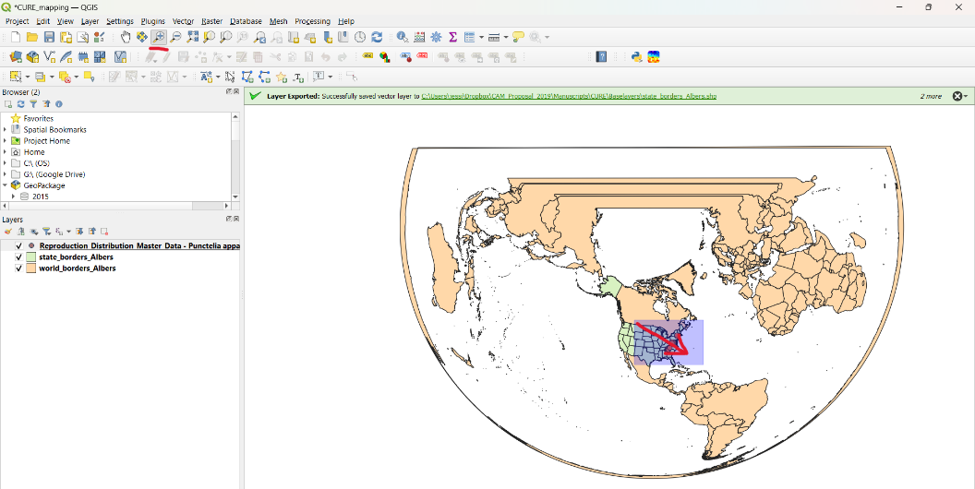

- We will save the point files as shapefiles before proceeding further. Right click the point layer, hover over ‘Export’ then click ‘Save Feature As…’ Give your new file a sensible name that includes the species name and that is point data. NOTE: do not include any spaces in the file name!. Change the CRS to ESRI:102008 (this is very important for downstream analyses!), then click ‘OK.’
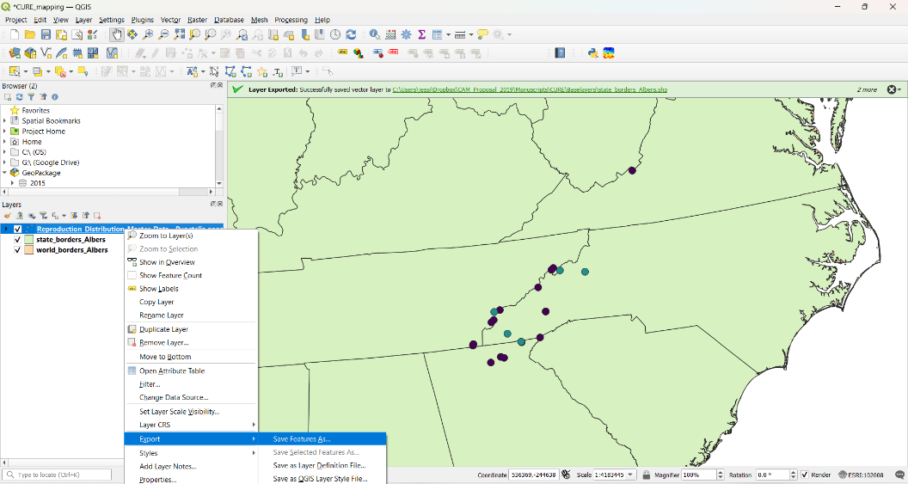

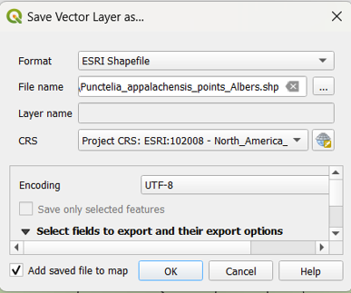
- You can change the symbology to color points by their reproductive structures or other attributes. To do so navigate to the Layer Properties, then click Symbology and at the top use the upper most dropdown to switch from ‘Single’ to ‘Categorized.’ Then select the value you would like to categorize with, in this case I chose ‘Apothecia.’ Select a color ramp then click ‘Classify’ and ‘OK.’

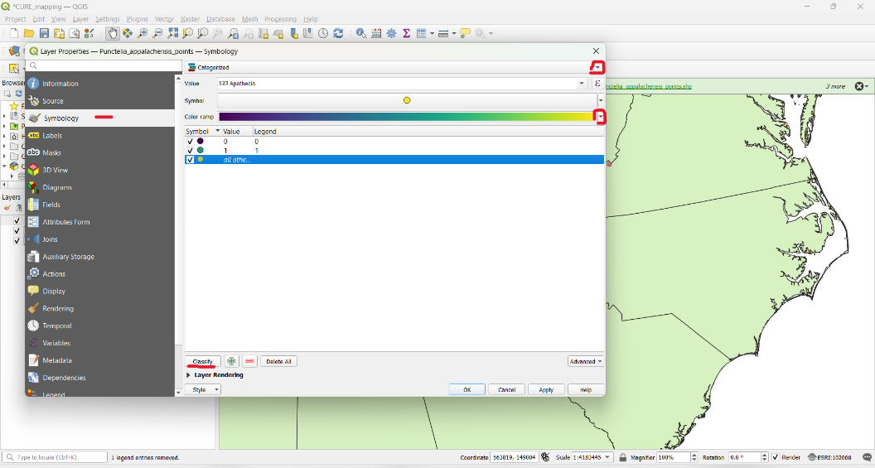

Click the ‘all other points’ option then click the red minus sign at the bottom of the screen to remove any points for which the reproductive structure has been classified.

You can also change the size of the points by clicking the big box where you see the point symbol. In the box that pops up you can increase the size of the point, then click ‘OK.’ Click ‘OK’ in the main box to apply all of your changes and close the Layer Properties box.

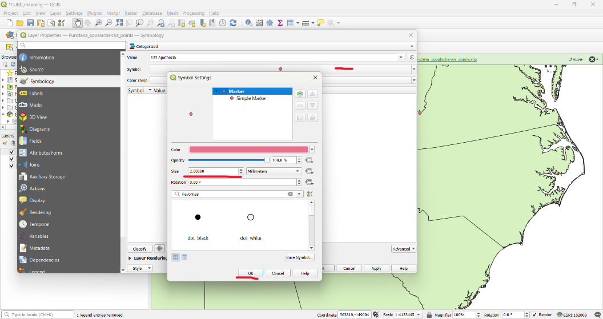

- To create a map figure to include in your paper and presentations, click the ‘New Print Layout’ button. Give the print layout a name and click ‘OK.’

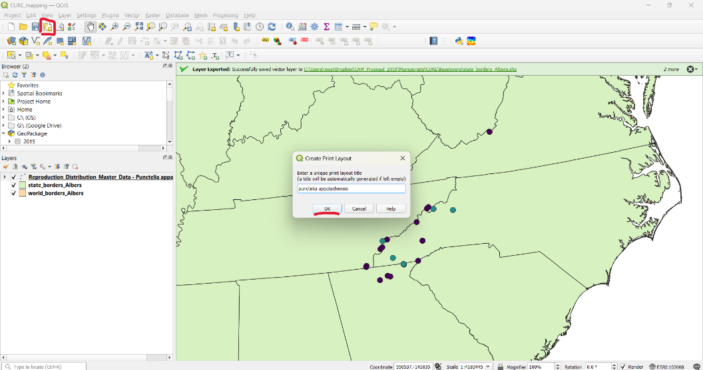

- Click ‘Add Map,’ then click in the top left of the white box and drag to the opposite corner.

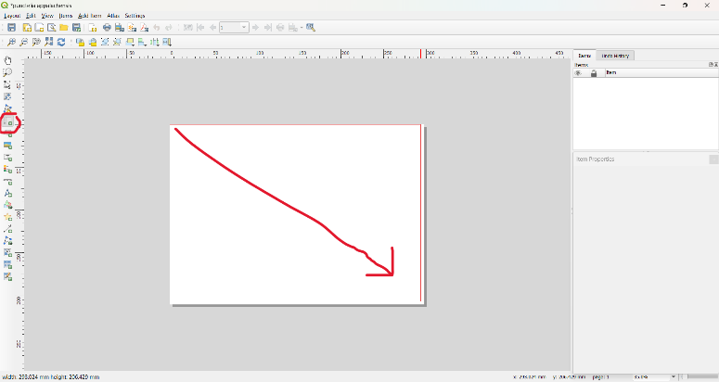

When you release your mouse the map should look as follows.

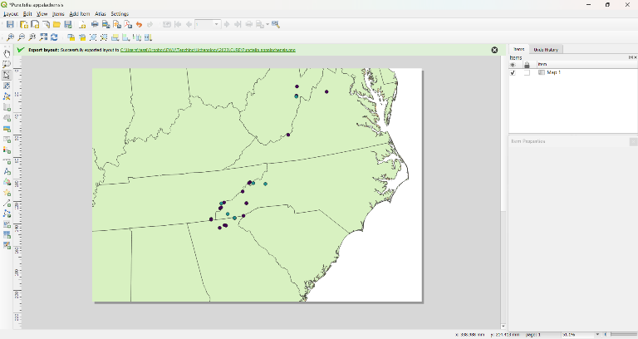

- To complete the map add a legend and scale bar. Click the respective buttons for each element, then click in the map area to generate each time. You can click and drag the legend and scale bar and place them in a suitable place. Once you are content with your map layout click Layout > Export Image. Give the image a name and click ‘Save.’

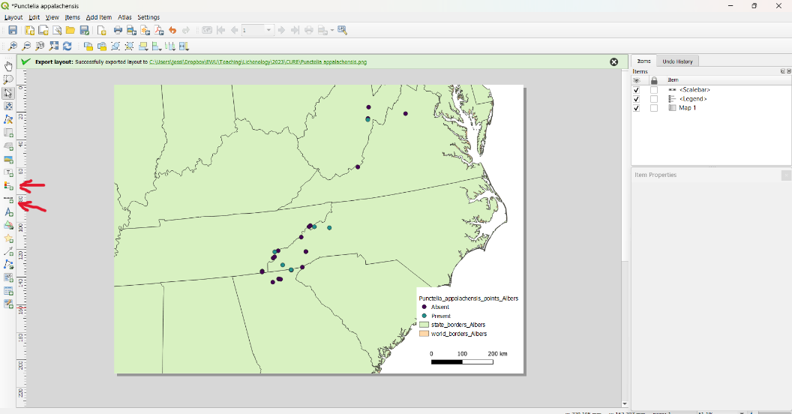

Part III. Calculating Range Sizes
- Click ‘Processing’ then ‘Toolbox.’
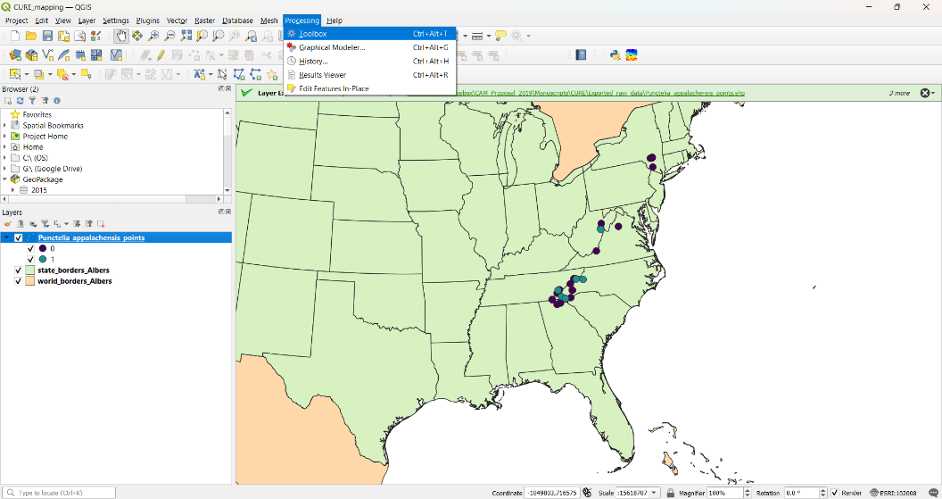
- Click the arrow next to ‘Vector Geometry’ then scroll down until you find ‘Minimum Bounding Geometry’ and double click to open the tool.
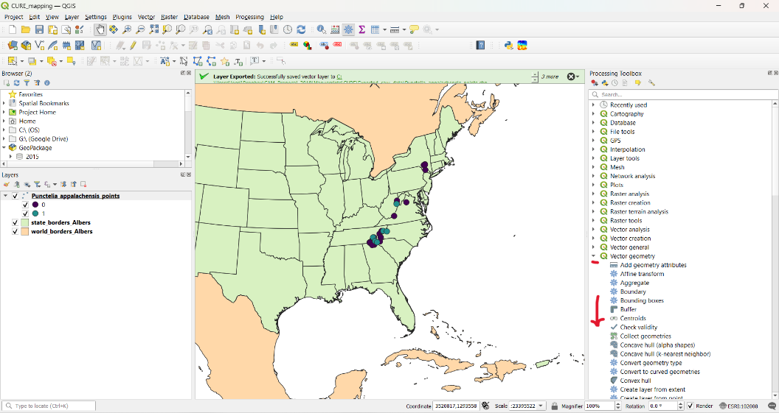

- Select your species’ point shapefile in the Albers Equal Area project as the input layer. Use the dropdown under Geometry type to select Convex Hull. Then give the output file a sensible name and save it in the same place as all of the data you are generating. Here I named my file ‘Punctelia_appalachensis_MCH.shp’ Then click ‘Run’ followed by ‘Close’ once the operation is complete.
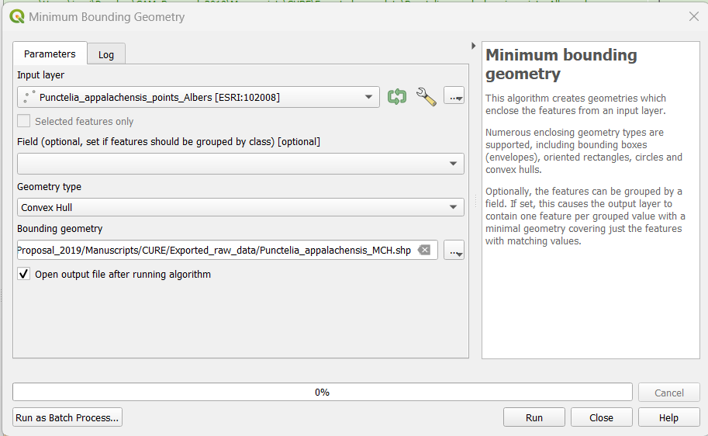

The resulting shapefile should look as follows.

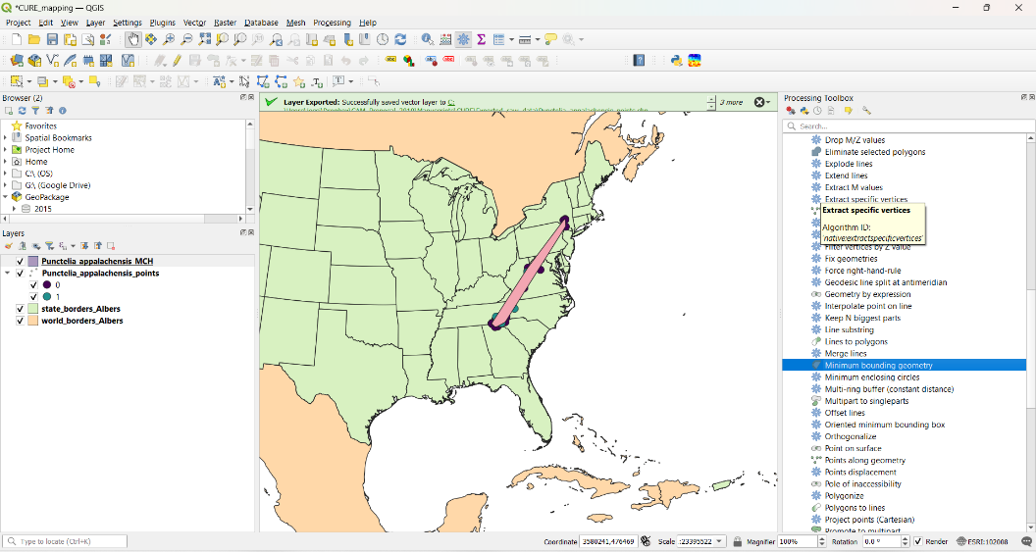

- To see the total area of the resulting shapefile click the attribute table button then check the area column. You can select and right click the area value then past it into your spreadsheet. The units for the area are square meters. You will likely want to convert that value into square kilometers in your dataset.
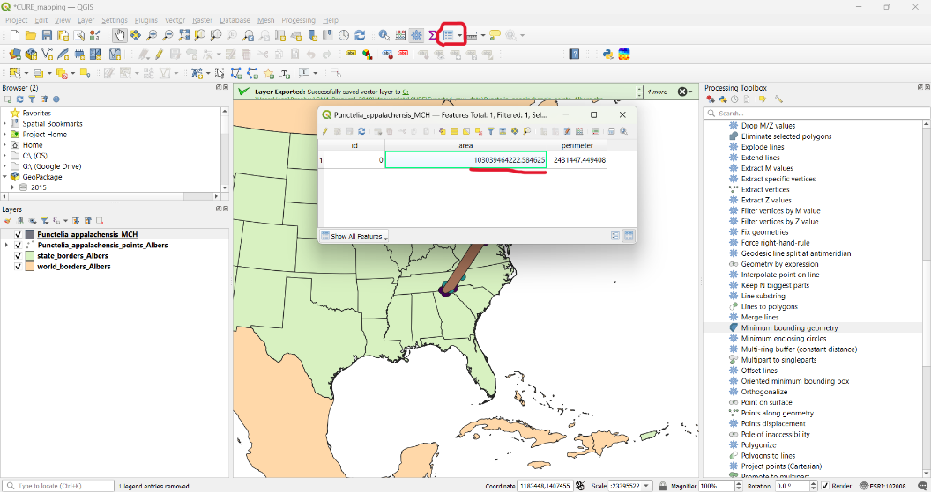
- Enter the area in square meters into you master data sheet. To calculate square kilometers divide square meters by 1,000,000. You can use the equation =[click the cell with the area in square meters]/1000000.
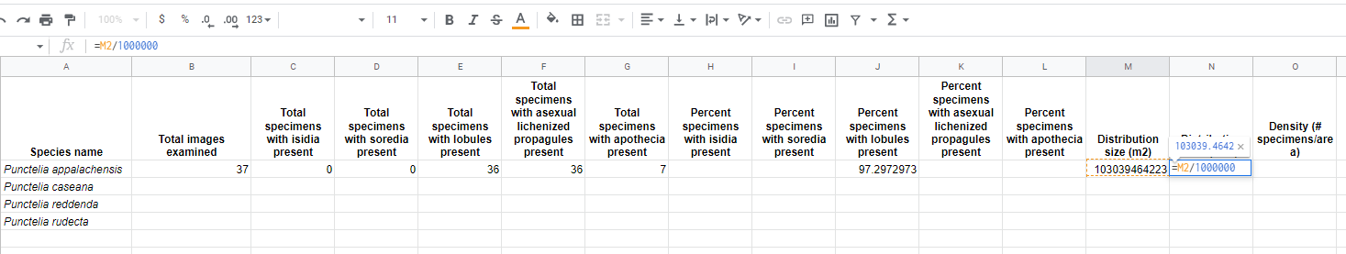
- To calculate density you can use the following equation: =[click cell with total number of specimens included in the area from which the minimum convex hull was created]/[click the cell with the area in square kilometers].
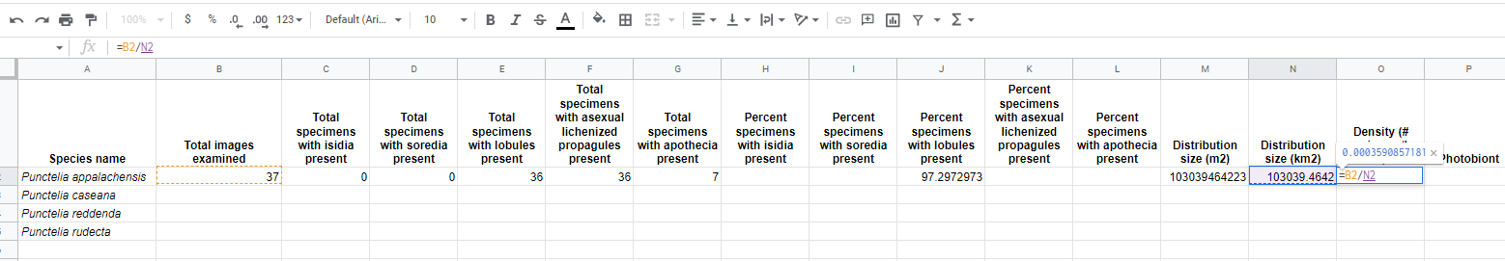
- Repeat these steps for all of the species you examined to complete your dataset.

