Module 1 Introduction

Learning Objectives:
By the end of this module students will be able to:
- Identify and read scientific literature
- Use scientific literature to develop a research question and hypothesis about intraspecies variation
- Use morphological characteristics to test that hypothesis
2. Understand how to structure data
4. Choose between a t-test and a correlation to help test a hypothesis driven question

Vocabulary:
Categorical variable —Quantitative variables that fall into distinct groups based on a characteristic, such as color or phylum
Correlation — Statistical measure of how much two variables are linearly related
Intraspecific variation —variation within a species
Numerical variable —Values that describe a quantity as a number. These can either be continuous (how wide is the skull?) or discrete (how many specimens are in the jar?)
P-value —Probability that results of a hypothesis test were due to random chance. In ecology, a p-value of 0.05 is used most often. This means that if the p-value from your statistical test is less than 0.05, your results are statistically significant (we would say there is less than a 5% chance that our results occurred due to random chance). If the p-value from your statistical test is greater than 0.05, no statistically significant differences were found
T-test—Statistical test that measures the means and spread of data between two groups to determine if there is a difference between the groups (here we use a 2-sample t-test; there are other types of t-tests that you may use in other studies)
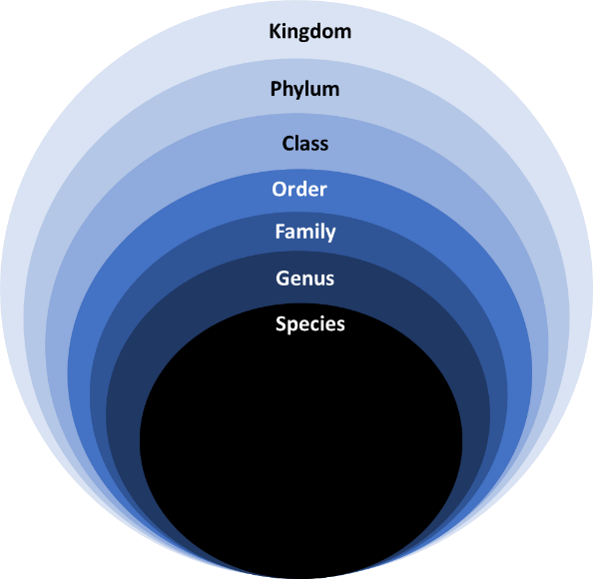
Scientific Classification—Scientists group animals based on characteristics and relatedness using a particular system of organization or classification. This classification system has different levels, each becoming more specific in the criteria an organism must meet in order to be placed in that category. Kingdom (the least specific category) -> Phylum -> Class -> Order -> Family -> Genus -> species (the most specific category).

Scientific Name (or binomial name)—made of the genus and species names of an organism, this term is what scientists use to identify an animal with much greater specificity than the common name.

Introduction to the use of museum specimens:
Museum specimens are of interest not just to students on class field trips. Scientists rely on these collections in many ways, too! For example, by observing and measuring multiple museum specimens, we can draw conclusions about intraspecific variation (variation within a species).
What distinguishes museum specimens from a regular collection? Museum specimens have data associated with them, such as location, date collected, and information obtained from the collector. Physical specimens, such as mammal skins, and skulls are preserved in a uniform way to allow researchers to study physical attributes long after the specimen has been collected. In addition, specimens can be either physical artifacts as described above, but can also be digital images of artifacts/specimens. These images aren’t just regular photos. They are images taken at very high resolution at the same distance from each physical specimen and have a standardized viewpoint. Often, physical specimens and museum images can be used together in a study to provide, much more specific information can be gathered about organisms than from regular photographs or field notes. This information can be used to address many different hypotheses, to confirm findings from other studies, and to test how broadly study conclusions can be applied.

Introduction to the use of scientific naming:
When we talk about organisms in our day-to-day lives, we use what is known as the common name. For example, I think that most of us have heard of the animal the coyote. Most of us even picture some sort of mid-to-large-sized dog-like predator. Some of us may have seen or heard coyotes in the dusk, dawn, or evening hours either around campus, or out among the many local trails. But, when scientists refer to this creature, we use their genus (Canis) and their species (latrans) to be more specific. Here, even if a scientist has never seen a coyote (perhaps they hail from a part of the world where the word “coyote” has no meaning), Canis indicates that this creature is wolf-like or dog-like in their nature. Latrans lets a scientist know that it is not a gray wolf (Canis lupus), a domestic dog (Canis familiaris), or a golden jackal (Canis aureus).

Quick coyote facts:
Range: most of North America and ranging down into Central America
Diet: predominately carnivorous (meat eater). This creature is a predator!
Size: 7-20 kg (depending on various factors…finding out about those will be up to you!)
Activity: predominately crepuscular, though may be active at night in urban areas.

