**Mentoring with Diversity, Equity, Inclusion, and Justice (DEIJ) empowers mentees to succeed**

**Pankaj Mehrotra1, Will Murphy 2, Megan L Vosk 3**

**1 - University of the People, Pasadena, California, United States of America**

**2 & 3 - Association of Middle Level Education, Columbus, Ohio, United States of America**

**Email :** [**mehrotra85pankaj@gmail.com**](mailto:mehrotra85pankaj@gmail.com)

**Abstract:**

This article examines the important role of mentoring in retaining new teachers, especially teachers of color, through the lens of Diversity, Equity, Inclusion, and Justice (DEIJ). It discusses recent teaching retention statistics and outlines the three phases of the Teacher Mentoring Process: pre-implementation, implementation, and post-implementation. By emphasizing trust, open communication, and integrating DEIJ principles, the article advocates for a more equitable educational environment that supports the growth of all educators.

***Sections:***

1. Introduction - What is mentoring and why is it important?
2. Why is DEIJ important in mentoring?
3. What are the roles of mentors and mentees in the mentoring process?
4. How can Diversity Equity Inclusion Justice (DEIJ) be woven into the Teacher Mentoring Process (TMP)?
5. Phases of the Teacher Mentoring Process and DEIJ Integration In Each Phase:
6. Conclusion

**I. Introduction:**

**What is mentoring and why is it important for educators?**

Mentoring is a professional relationship and interaction between a mentor and a mentee. Mentoring provides a teaching and learning opportunity that enhances the professional development of both mentors and mentees. Mentors benefit from faculty growth and mentees benefit from many aspects of mentorship such as career planning, advancement, promotion, and improvement. This collaboration is mutually beneficial to both the leader and the learner.

According to The Association for Middle Level Education (formerly National Middle School Association), mentorship for new teachers is crucial. One of the characteristics of a successful middle school is “organizational structures that foster purposeful learning and meaningful relationships.” (NMSA, 2010). Strong mentoring bonds between teacher leaders and new teachers give new teachers the hope to persevere, even when things seem hard. As AMLE states on its website, “We know it is essential to our mission to support early career educators. We also know what a challenge those initial years in the classroom can be.” (AMLE.org).

**Why is mentoring with DEIJ in mind important?**

Mentoring with DEIJ in mind is of the utmost importance if we want to retain new teachers - and especially teachers of color - in the profession. According to recent data collected by Education Research Strategies, the number of new teachers leaving the field has increased markedly in recent years post-Covid. The data shows, "After the 2022-23 school year, 30% of new teachers left their school, and 26% of teachers with 3-7 years of experience left their school during that time, compared to 17-20% of more experienced teachers.” (ERS, 2024).

Additionally, teachers who work with students in high-poverty areas are more likely to leave the profession, as are teachers of color. For example, in Pennsylvania, “Black teachers were more than twice as likely to leave the profession as white teachers after the 2021-22 school year, Hispanic and multiracial teachers had a similar ratio, of around twice as likely.” (AP News, 2023).

The data regarding new teacher retention rates for teachers in high-poverty areas and teachers of color points to the importance of educating new teachers about DEIJ topics and supporting new teachers who identify as BIPOC. The utilization of DEIJ practices during the mentoring phase may benefit the mentoring process in developing the most effective educators who can identify initial barriers and the need to understand the importance of DEIJ in the early phase of a career to be a successful teacher.

**II. The Teacher Mentoring Process:**

**What are the roles of mentors and mentees in the mentoring process?**

As an experienced practitioner, the mentor provides guidance, modeling, counseling, and advice to inexperienced mentees to achieve goals, enhance critical thinking, and improve reasoning abilities through feedback (Murphy et al., 2005). Some other descriptions of mentor, mentee, and mentoring outcomes are “the relationship between experienced personnel and less inexperienced personnel for the advancement of career and to achieve mastery in the profession” (Ragins et al., 2016).

Teacher mentors as leaders and teacher mentees as learners are part of a Teacher Mentoring Process (TMP) in which the teacher leader takes full responsibility for supporting the new teacher to adapt to a new learning environment (Wong et al., 2004). During the mentoring phase, a teacher leader builds a professional learning environment where the new teacher attains behavioral and emotional skills, as well as greater self-efficacy. The new teacher is then more able to teach effectively, respond to challenges, and build relationships at school and outside school which results in developing cognitive and affective domains under the personal guidance of their mentor. (Wong et al., 2004 ; Black et al., 2016).

The chart in Figure 1 below shows the cyclical nature of the mentoring cycle, and how mentees are supported throughout the mentoring cycle by their mentors (Fig 1.1).

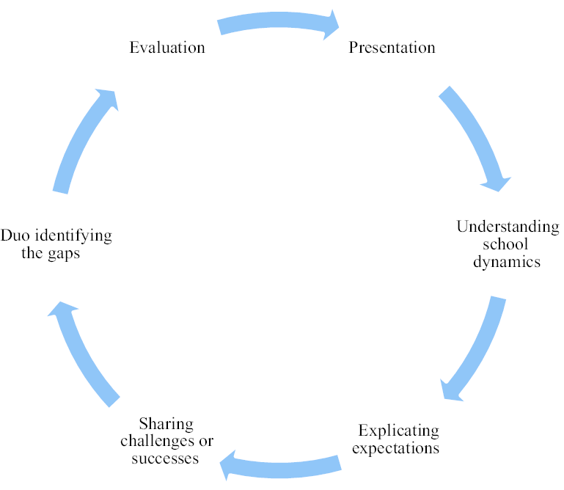

# [The mentoring cycle (Msila, 2014).](https://www.researchgate.net/figure/The-mentoring-cycle-Msila-2014_fig1_280878991)

**Figure 1. The above figure represents the components and process of the mentoring cycle.**

In particular, during the mentoring cycle, attention should be paid to the sharing of challenges (Hudson et al., 2016), as many of the challenges faced by new teachers may be related to issues of DEIJ or due to a lack of cultural understanding between the teacher and the students. Issues related to racial and ethnic identity, as well as linguistic backgrounds of students often come up in discussions between mentees and mentors. Developing strong bonds of trust between the mentor and the mentee is paramount so that the mentee feels comfortable sharing openly and honestly about their experiences as BIPOC or with students who are culturally, racially, or linguistically different from them in the classroom.

The need for new teachers to have an understanding of inclusive practices is particularly important in middle levels because of how crucial this time can be developmentally for students to understand their identities and their concept of self within a group. This goes back to the responsive and equitable attributes in AMLE’s *This We Believe.* Sharing experiences with another teacher, specifically one with varied experiences, can offer insights that intuition alone may fail to see.

**How can Diversity Equity Inclusion Justice (DEIJ) be woven into the Teacher Mentoring Process (TMP)?**

As teacher mentoring is an ecosystem of teacher leaders and teachers, teacher leaders need to be open to bringing DEIJ concepts into the Teacher Mentoring Process. Issues related to DEIJ should be discussed frequently in the mentoring relationship. The AMLE mentoring program framework for discussion talks about inclusivity and affirming identities in a way that mirrors *This We Believe*. New teachers need to be able to apply these concepts at their schools to be effective teachers. They need to be aware of how their backgrounds and biases may influence their views on students. This is especially salient for white teachers working with students of color. According to recent research collated by the American Institute for Boys and Men, most teachers in the United States are white women. However, most students are not. The research found that “White girls and boys represent about a quarter of students each, while more than half of all teachers (56%) are white women and 17% are white men. By contrast, over a quarter (26%) of all students are boys of color; but just 6% of teachers are men of color.” (AIBM, 2024).

Teacher leaders should use diverse ways and resources to mentor new teachers from diverse contexts, especially if the teacher leader and mentee are from different backgrounds. The nature of mentoring should be inclusive; the mentoring process from teacher leaders should be equitable and explicitly anti-racist. The acknowledgment of potential barriers will make the Teacher Mentoring Process more beneficial for both mentors and mentees. Mentees should be able to discuss their classroom community and school environment openly with their mentors so that an appropriate mentoring plan can be developed.

Additionally, there should be in-group mentors and out-group mentors. Ideally, an educator will have someone in their community or school with institutional knowledge and experience to shape part of their development. Still, they should also seek mentors who belong to a different building, district, or school system so that they can widen the sphere of influence and have a space to feel safe to share their experiences honestly. This belief was the impetus for the AMLE mentorship program (AMLE, 2024), which is focused on connecting new teachers with mentors from around the country.

**III. Phases of the Teacher Mentoring Process and DEIJ Integration In Each Phase:**

The teacher mentoring process can be divided into three phases: pre-implementation, implementation, and post-implementation.

1. **Pre-Implementation:** The pre-implementation phase is the initial phase of mentoring in which teacher leaders give opportunities to new teachers to go through a process of inquiry-based learning. Teacher leaders may ask new teachers about mentoring, their classroom community, and the school environment. This is the time for the teacher leader to uncover any assumptions that the new teacher might have about their students. New teachers can then ask their mentors questions, share their experiences working with students who may be racially, linguistically, or culturally different from them, and explain any problems they may be having in their classrooms.
2. **Implementation:** The implementation phase is the phase in which teacher leaders guide all aspects of mentoring including utilization of resources, DEIJ practices, and constant feedback. During this phase, new teachers must be encouraged to reflect on any personal biases or stereotypes they might be bringing into the classroom. (Will, 2009). As new teachers often struggle with classroom management, they need to be made explicitly aware of the fact that they may be biased against students of color (Clifton, 2025). These uncovered biases can then be the basis for teacher leaders to create problems of practice with their mentees. The teacher leaders can gently work to uncover and highlight the biases shared by the new teachers in chronological order and then co-create and discuss a weekly plan of action, application of DEIJ practices, and formative evaluation.
3. **Post-Implementation:** The post-implementation phase is the last phase of the Teacher Mentoring Process. In this phase, the teacher leader evaluates both formative and summative assessments of mentee learning outcomes and provides opportunities for the new teacher to reflect on their growth. For example – new teachers will think about what they thought of mentoring before and what they think of it now, and reflect on how mentoring has changed their views as a teacher. They may also reflect on how their understanding of students from different backgrounds has deepened and changed. Similarly, the mentor's role can be evaluated based on the mentee's experience and the effectiveness of the goals laid out at the onset of the relationship.

The pyramid below (Fig 1.2) sheds light on the different phases of the mentor/mentee relationship and explains how mentees are supported in each phase. Careful attention needs to be placed on establishing the mentee's needs, especially if the mentee is one of the only people of color on their faculty or if the mentee is working in a cultural context different from their own. If DEIJ topics are not overtly discussed or considered during the mentoring period, the new teacher could feel isolated and stressed, as many recent studies have shown (Achinstein et al., 2010).

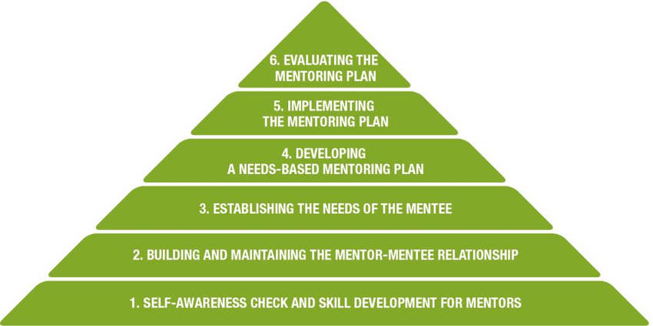

# [MBT Model – Six Stages of Mentoring (QUT, 2014)](https://www.researchgate.net/figure/MBT-Model-Six-Stages-of-Mentoring-QUT-2014_fig1_311880841)

**Figure 1.2 - The above figure represents the six stages of mentoring.**

# **Conclusion:**

# A strong mentor-mentee ecosystem creates a mentoring learning space that fosters personal success, academic achievement, developmental growth, and experiential learning. A mentoring phase integrated with DEIJ practices also enhances cultural sensitivity for both the mentor and the mentee(s). DEIJ practices result in holistic development for both mentors and mentees (Stuchineret al., 2022). DEIJ aims to serve all, so identifying the needs of the mentoring community early on can foster a better mentoring relationship, mutual trust, and bond for which a better mentoring relationship plan will emerge.

# All stages of the Teacher Mentoring Process should be planned out thoughtfully by trained teacher leaders, who seek to integrate DEIJ practices into their pedagogy and remove cultural biases for both new teachers and students. DEIJ practices implemented during the mentoring process will enhance the mentoring relationship and increase both mentors' and mentees’ abilities to integrate DEIJ practices within their classrooms and to share these with other teachers and administrators to bring equity to the institution.

**References and Bibliography:**

1. Achinstein, B., Ogawa, R. T., Sexton, D., & Freitas, C. (2010). Retaining teachers of color: A pressing problem and a potential strategy for "hard-to-staff" schools. Review of Educational Research, 80(1), 71â€“107. <https://doi.org/10.3102/0034654309355994>
2. AMBM. (2024) American Institute of Boys and Men <https://aibm.org/>
3. AMLE (2024) Association for Middle Level Education <https://www.amle.org/early-career-educators/>
4. Black, G. L., Olmsted, B. and Mottonen. A. (2016). Associate Teachers’ Perceptions of Effective Mentorship Professional Development. The New Educator 12(4), pp: 322-342. <https://doi.org/10.1080/1547688X.2016.1207828>
5. Stuchiner, Emily R., Lin Hunter., Danielle E., Neuwald, Jennifer L., Webb, Colleen T., Balgopal., Meena M. (2022). Intentional mentoring should increase inclusivity in ecology <https://doi.org/10.1002/ecs2.3902>
6. Hudson, P., & Hudson, S. (2016). Mentoring beginning teachers and goal setting. Australian Journal of Teacher Education, 41(10). <https://doi.org/10.14221/ajte.2016v41n10.4>
7. Murphy, K. L., Mahoney, S. E., Chen, C., Mendoza-Diaz, N. V. and Yang, X. (2005). A Constructivist Model of Mentoring, Coaching, and Facilitating Online Discussions. Distance Education 26(3), pp: 341-366. <https://doi.org/10.1080/01587910500291454>
8. National Middle School Association. (2010). This We Believe: Keys to educating young adolescents. Westerville, OH: Author
9. Parker, Clifton B. (2015). Teachers more likely to label black students as troublemakers <https://news.stanford.edu/stories/2015/04/discipline-black-students-041515>
10. Ragins, B. R. (2016). From the Ordinary to the Extra-ordinary: High-quality Mentoring Relationships at Work. Organizational Dynamic 45, pp: 2 28-244. <https://doi.org/10.1016/j.orgdyn.2016.07.008>

# [Will, Madeline](https://www.edweek.org/by/madeline-will) (2020) Teachers Are as Racially Biased as Everybody Else, StudyShows- [ttps://www.edweek.org/teaching-learning/teachers-are-as-racially-biased-as-everybody-else-study-shows/2020/06](https://www.edweek.org/teaching-learning/teachers-are-as-racially-biased-as-everybody-else-study-shows/2020/06)

1. Wong, H. K. (2004). Induction Programs that Keep New Teachers Teaching and Improving. NASSP Bulletin 88(638), pp:41-58. <https://doi.org/10.1177/019263650408863804>