**Trail Cameras/Camera Traps Lesson**

**Module 4: Data Visualization & Analysis**

**Microsoft Excel - Creating graphs**

Now that all the data is logged, it is time to display findings in a visual format by creating graphs. Graphs are a perfect tool to summarize your findings into a few graphics. Readers can better understand your analysis and research when there are visual components. You will be sharpening your graphing skills in Microsoft Excel since it is easier to manipulate data on that software. Screenshots are provided to complement the written instructions.

1. Download the class data Google Sheet into a Microsoft Excel sheet by clicking on the “File” tab located in the left-hand corner. Then click on “Download” and “Microsoft Excel (.xlsx)”. Open the Excel file.

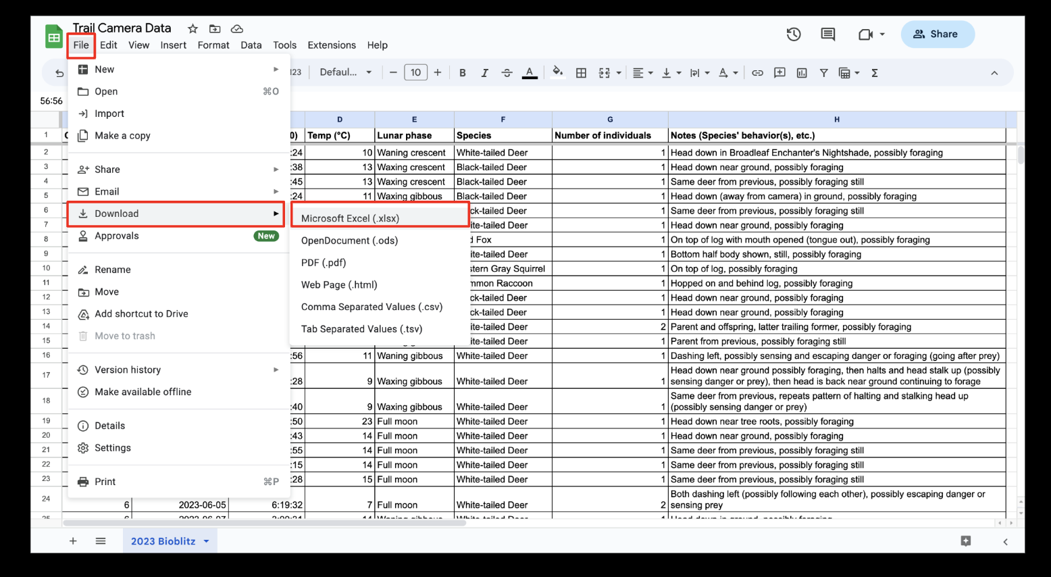

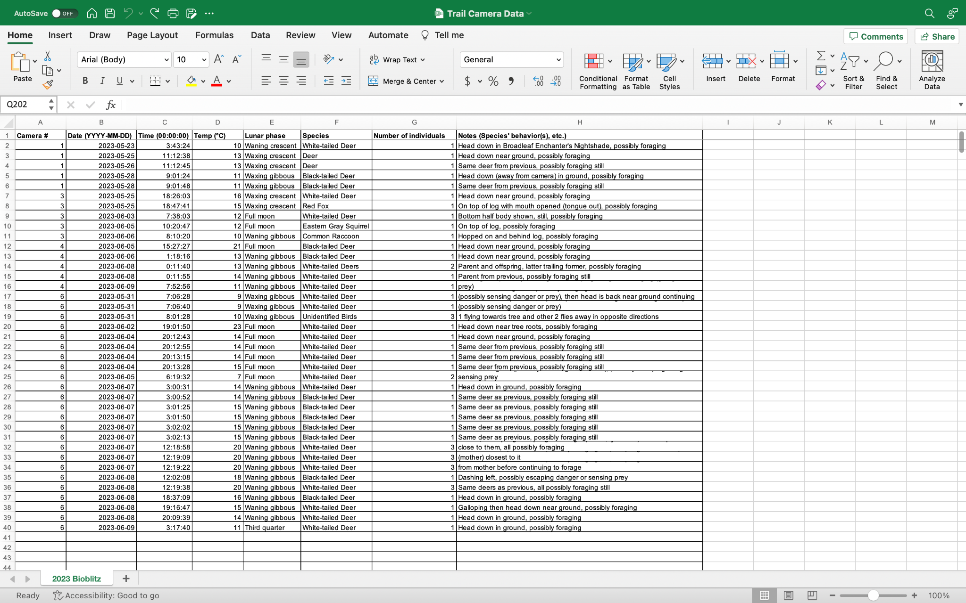

To manipulate the variables to produce desired graphs, a PivotTable needs to be made. A PivotTable is a tool used to calculate, summarize, and analyze data so that you can view comparisons, patterns, and trends in your data. With it, you can easily move certain variables into different PivotTable fields according to what you want to measure. A separate table will be produced which can then be used to create graphs.

1. Select the entire data table by clicking on any cell within the table and pressing Command+A (on Mac). Click on the “Insert” tab located in the left-hand corner and “PivotTable”. A banner will appear. Double-check that the “Select a table or range” highlights your entire data table and that your PivotTable is created in a “New worksheet”.

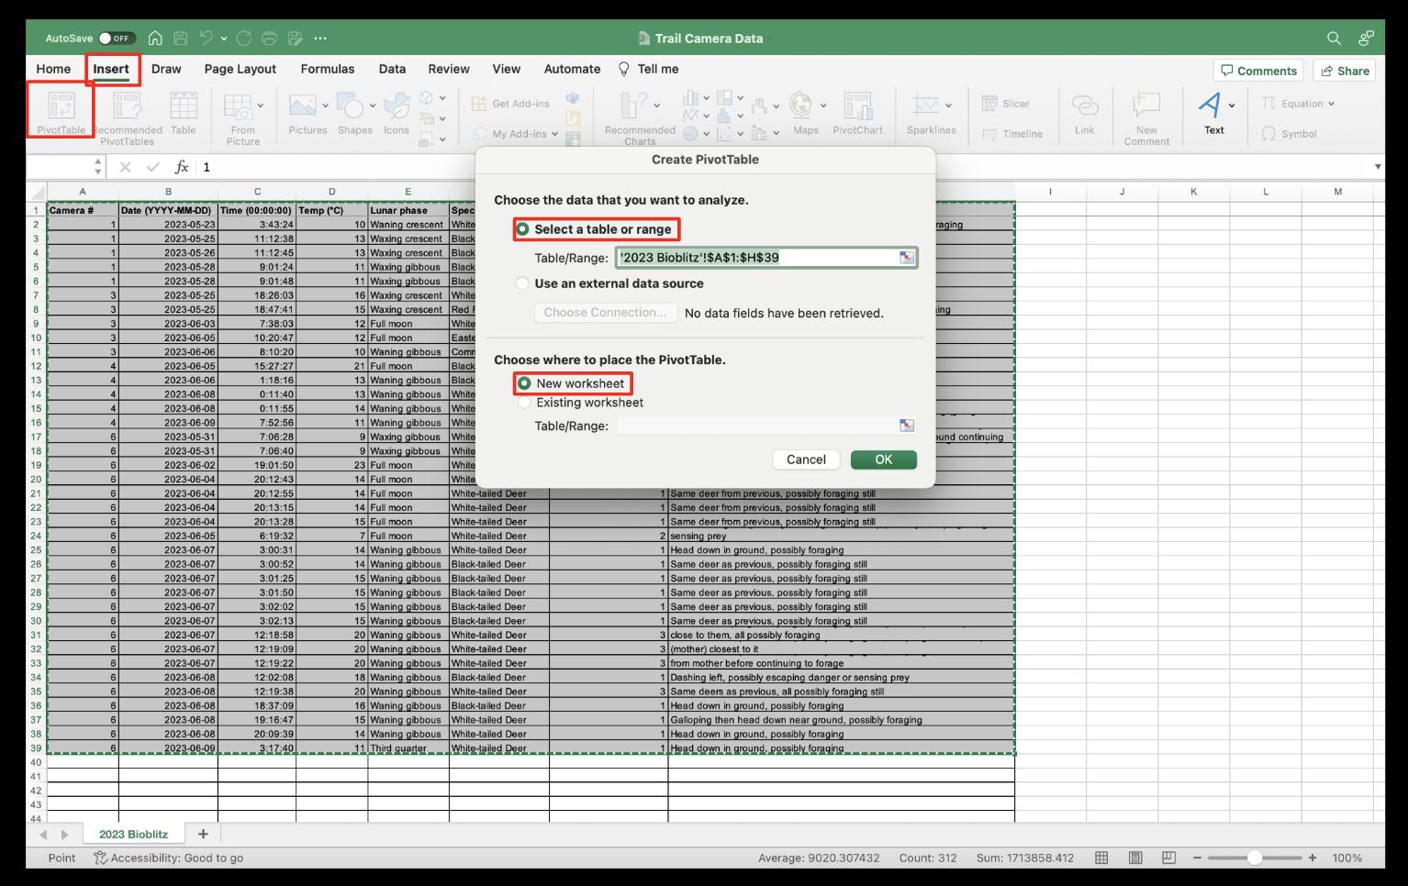

1. An empty PivotTable will appear along with the PivotTable Fields on the right side. Figure out exactly which variables you want to use to display your data. Keep in mind that the use of graphs is to explore patterns in the data (i.e., number of species, time of day, etc.) which you will document in your reflection/synthesis and determine if the data supports or disputes your hypothesis.

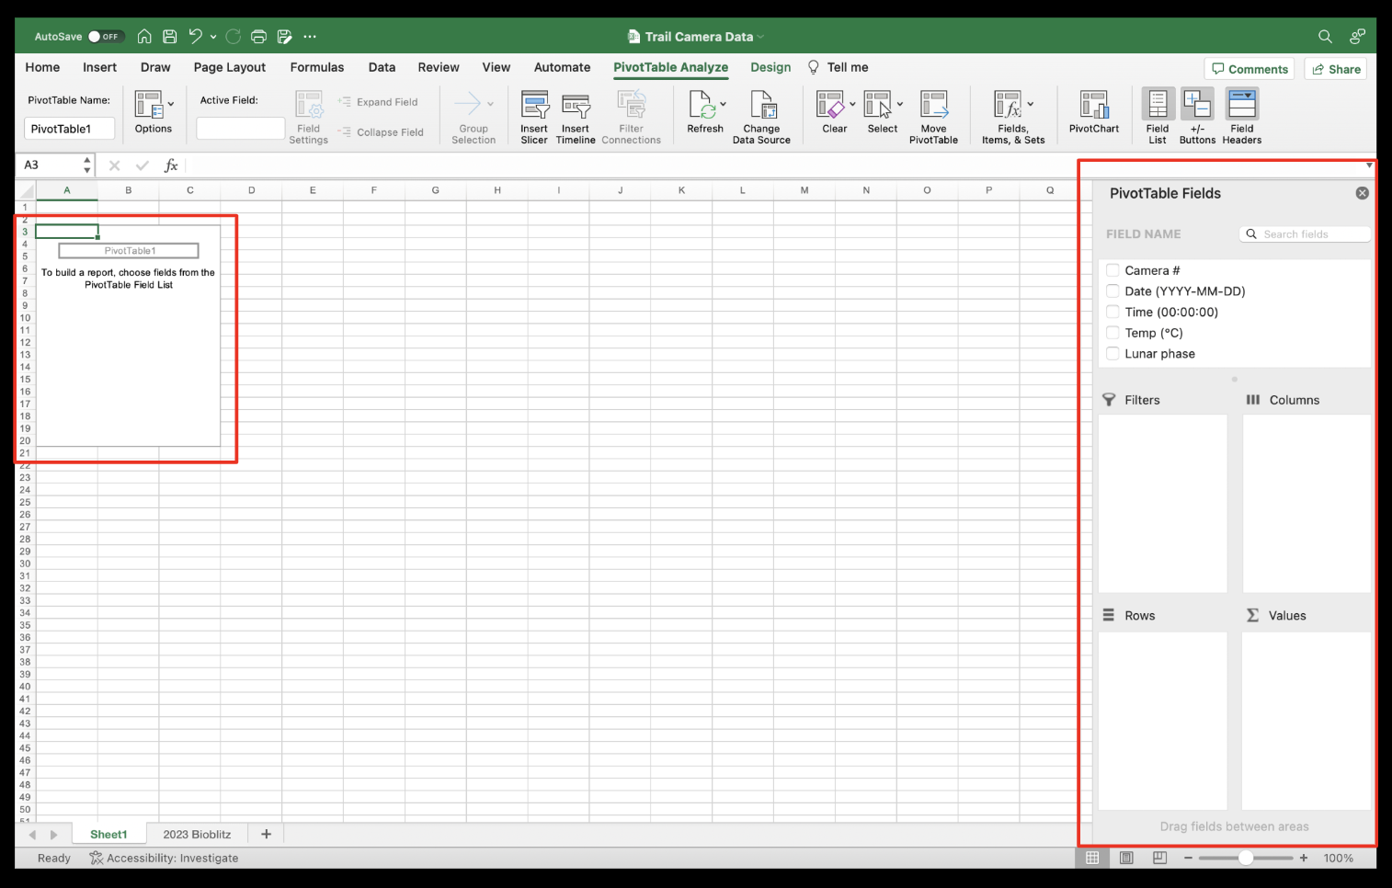

My hypothesis is that there are more species seen during the day (6 am-6 pm) than at night (7 pm-5 am). I need to determine which variables will be used to best visualize my findings and produce a data table that will be used to create my graph.

1. To create a data table, drag the desired variables into the correct PivotTable field. Since I want to determine time vs. observations count, I put “Time (00:00:00)” under “Rows” and “Number of individuals” under “Values”. The default setting will display the latter variable as the “Sum” which is NOT what I want to show. To change it, click on the gray “i” icon which will prompt a banner, and under the “Summarize by” tab, click on “Count” and “OK”.

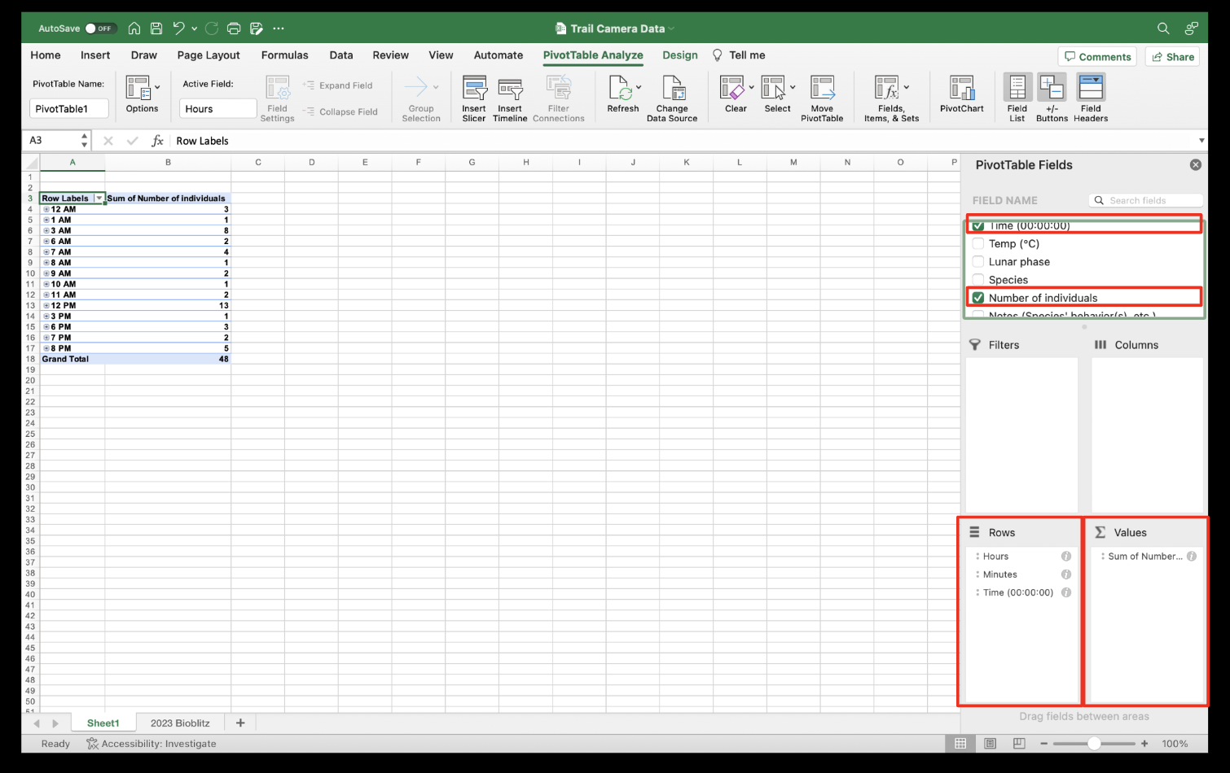

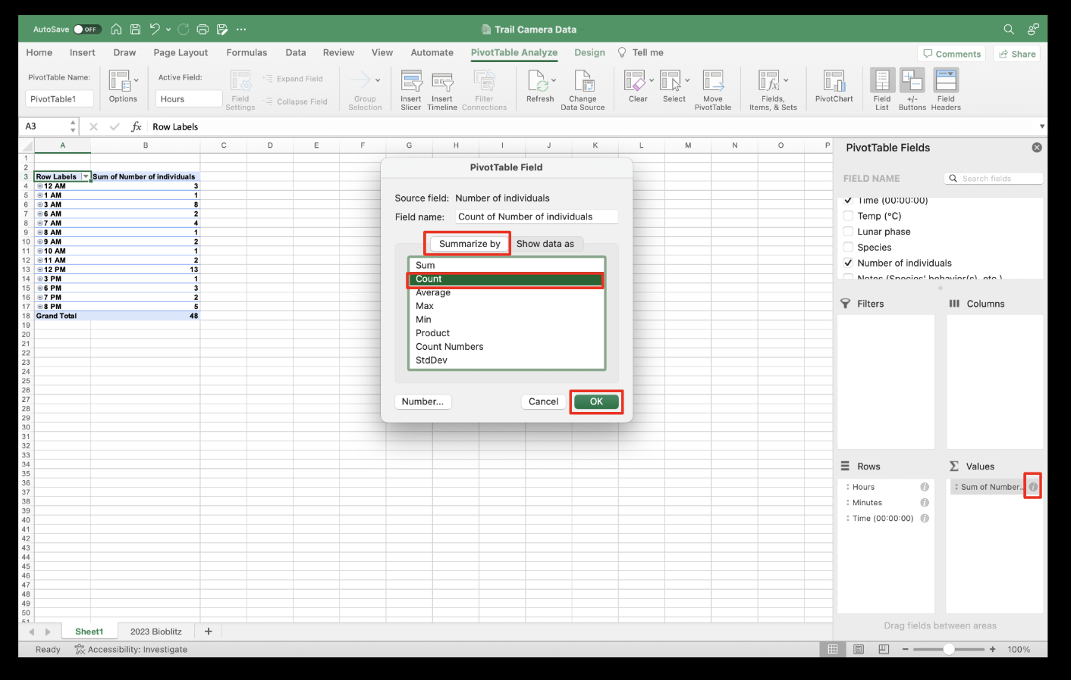

1. Because Excel does not allow axes to be labeled on graphs made from the PivotTable, you need to make a copy of the data table. Highlight the desired variables and values in the data table, making sure to NOT include the “Grand Total” if there is one. Press Command+C (on Mac) to copy the table. Click on any empty cell below the data table. Then press Control+Right Click on the mousepad (on Mac). Hover over “Paste Special” and select “Values”. This will keep all the numerical values in the correct column and row in the new table.

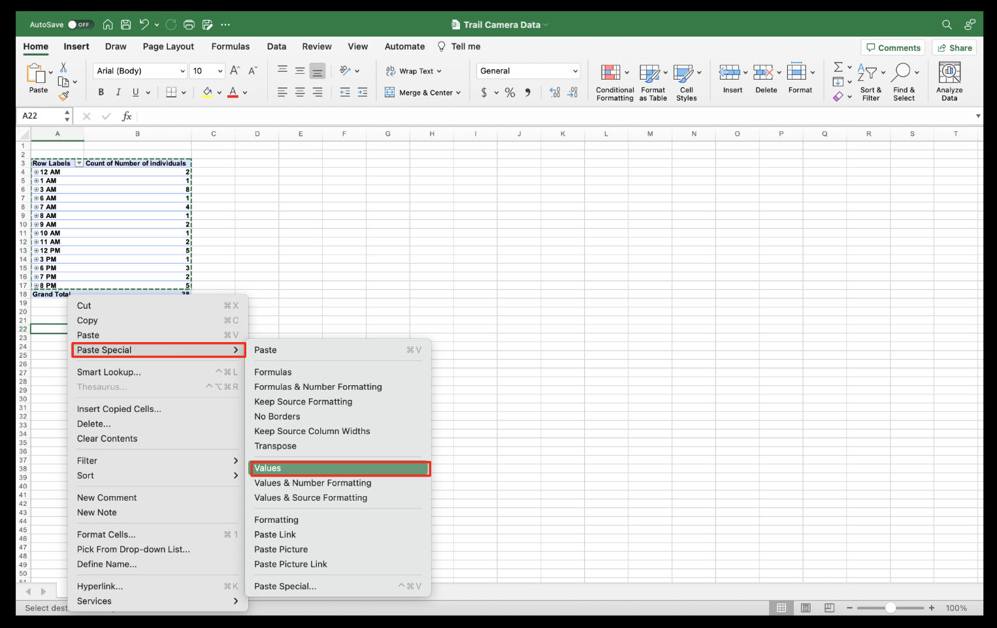

1. Now it is time to create graphs. Since I want to compare the total number of observations during day vs. night, I will make a bar graph. Highlight the new data table. Click the “Insert” tab, hover over the Column icon (histogram with different color bars), go under “2-D Column” and select the first option (“Clustered Column”).

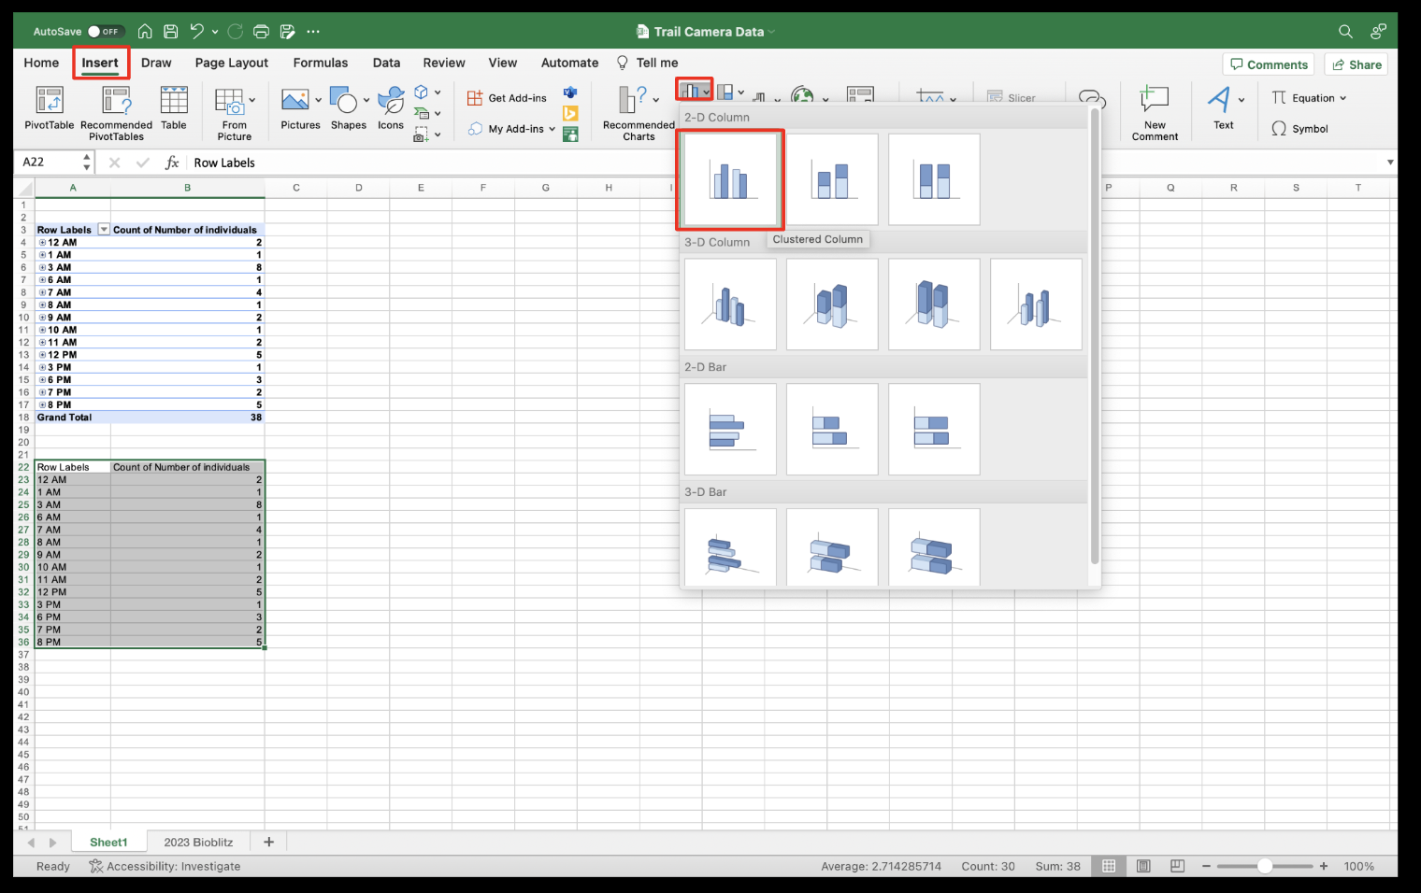

1. The graph is missing x- and y-axis labels, which are vital to graph literacy and interpretation. To add them, click “Chart Design” and “Add Chart Element”. Hover over “Axis Title” and click on both “Primary Horizontal” and “Primary Vertical” to enable both features on the graph.

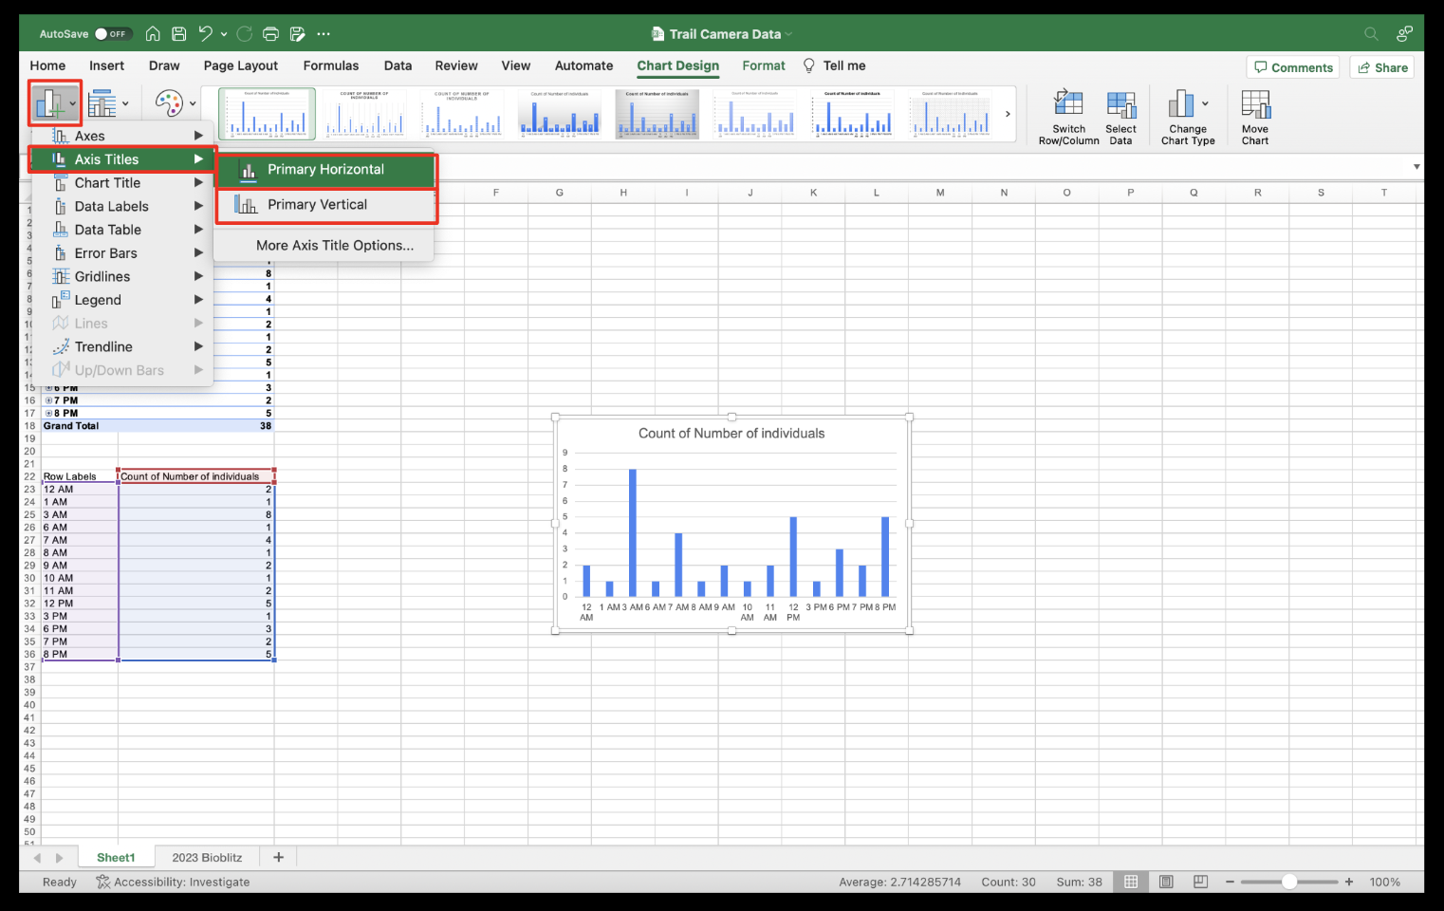

1. Name each one to correspond to the variable that is being displayed on the graph. In my case, the x-axis is the “Time (Hour)” and the y-axis is the “Count of Observed Animals”. Make sure to also title your graph. Typically it is based on the two variables you are measuring but ensure it makes sense so that the reader can understand what is being displayed. I titled my graph “Count of Observed Animals Captured on Trail Cameras During Night vs. Day”.

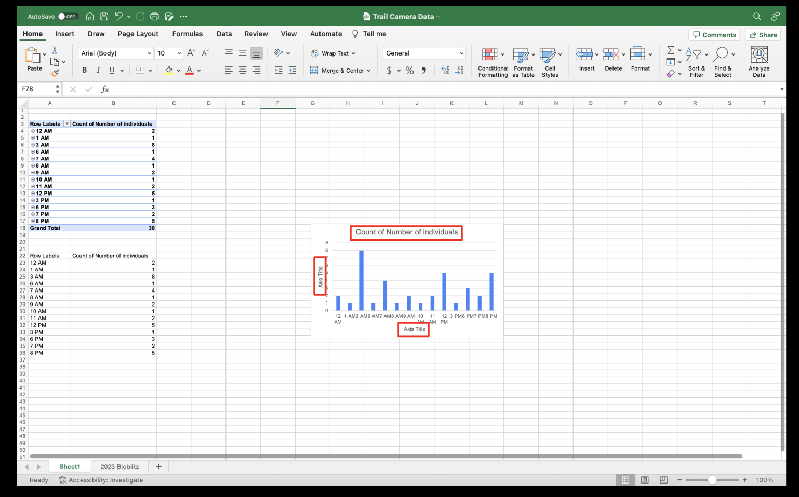

1. The gray column on the right side allows you to play around with the graph and polish everything up. You may want to consider these factors: resizing your graph, adding different colors to your graph (if applicable), etc.

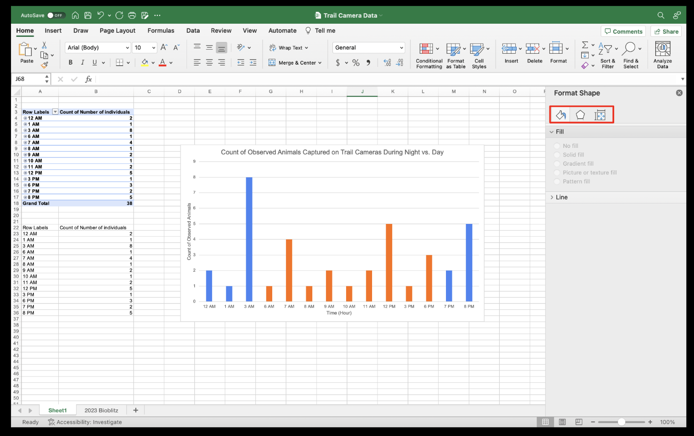

1. Once finished, you can make another graph or as many as you need for your final reflection/synthesis where you will be tying together everything that you collected and analyzed. You can make a copy of the worksheet for each different graph you make to keep everything organized. Right-click on the “Sheet1” tab, select “Move or Copy”, mark the “Create a copy” checkbox, and “OK”. Delete the old graph and data table in the new copy of the worksheet. To reset the PivotTable, uncheck the variables in the bank. Rename the worksheet tabs to correspond with the graph by double-clicking on the tab name.

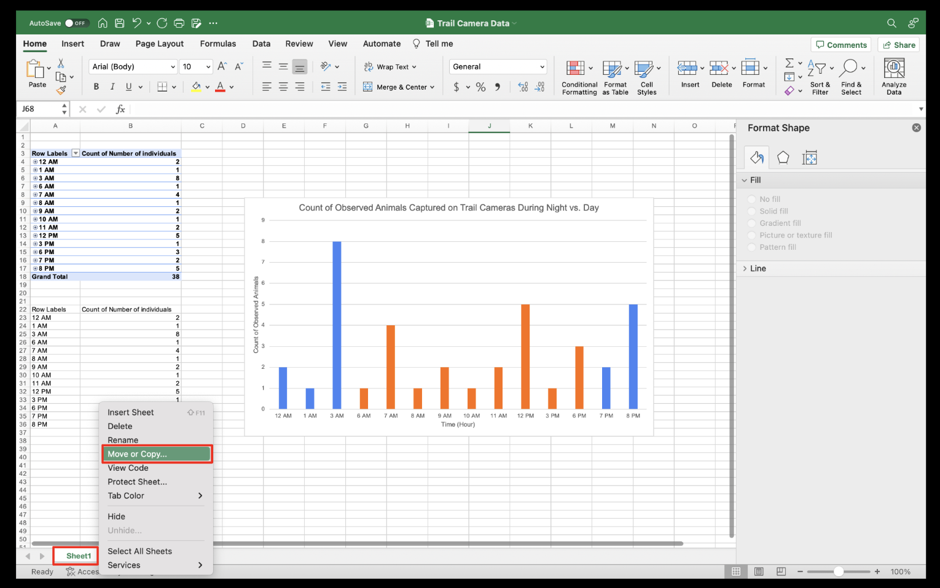

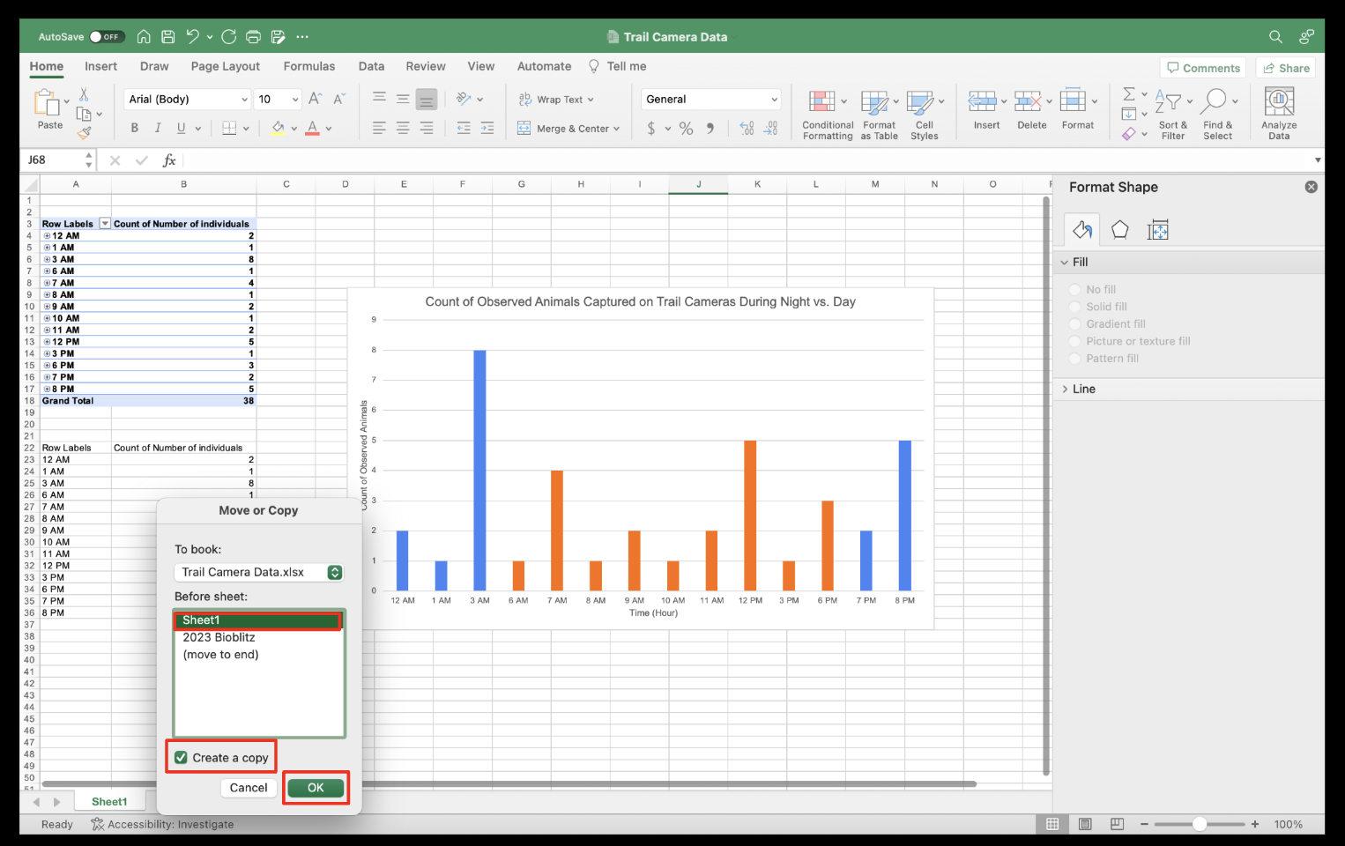

1. If you want to showcase which species was the most and least photographed, a pie chart will be your best friend. I made one to highlight common mammals spotted at the VCU Rice River Center. Below are the two graphs I created which I will use to back up my analysis for my reflection/synthesis module which is the last component of this entire study/lesson.

