Trophic Cascade Pre-Test NAME:____________________________
Please write the letter of the best answer on the line provided.
______1. When was the keystone species concept first described?
- 1858 B. 1917 C. 1942 D. 1969
______2. Who discovered the keystone species concept?
- Rachel Carson B. Paul Ehrlich C. Robert Paine D. Sergei Winogradsky
______3. Which of the following functions as the keystone species in a Pacific tidal pool environment?
- Gooseneck barnacle
- Starfish
- Mussel
- Algae
- Sea snail
______4. The diagram at right illustrates: 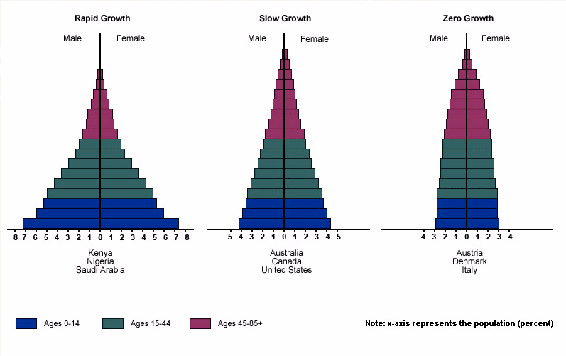
- A population growth curve.
- Growth rate predictions.
- An age structure diagram.
- A population projection.

Circle the word that best completes the sentence:
5. With the removal of a predator, you would anticipate biodiversity will ( increase / decrease ).
6. A cougar feeding on a mule deer could have a ( direct / indirect ) effect on the butterflies in the community.
7. You would predict moose herbivory to ( increase / decrease ) soil nutrient levels.
8. In a riparian ecosystem, you would predict the presence of apex predators to ( increase / decrease ) soil erosion on stream banks.

