- Go to http://data.usanpn.org/npn-viz-tool/
- Click on the data visualization tool link.
- Click on the magnifying glass. Choose the years 2008-2018.
- Draw a bounding box around our local region to restrict data to this area only.
- Add a pair of organisms that might interact. Choose from the list below
  - Monarch–Milkweed(forb)
  - Hummingbird–Lilac(deciduous)
  - Woodchuck–Dandelion(forb)
  - Bee–Lilac(deciduous)
- Make a scatterplot with trendlines for both species over the years 2008-2018. Be sure to check the box for “Use Individual Phenometrics” to get the most data.
- Plot the last 3 years on activity curves (both species at same time on 3 different graphs).
- Make a “poster” plan that summarizes your work (see below for some guidance).
  - This should be something you can draw on the board in 5 minutes or less
  - Be able to…
    - Describe the phenology of your two species
    - Describe if their phenology changed over the last 10 years.
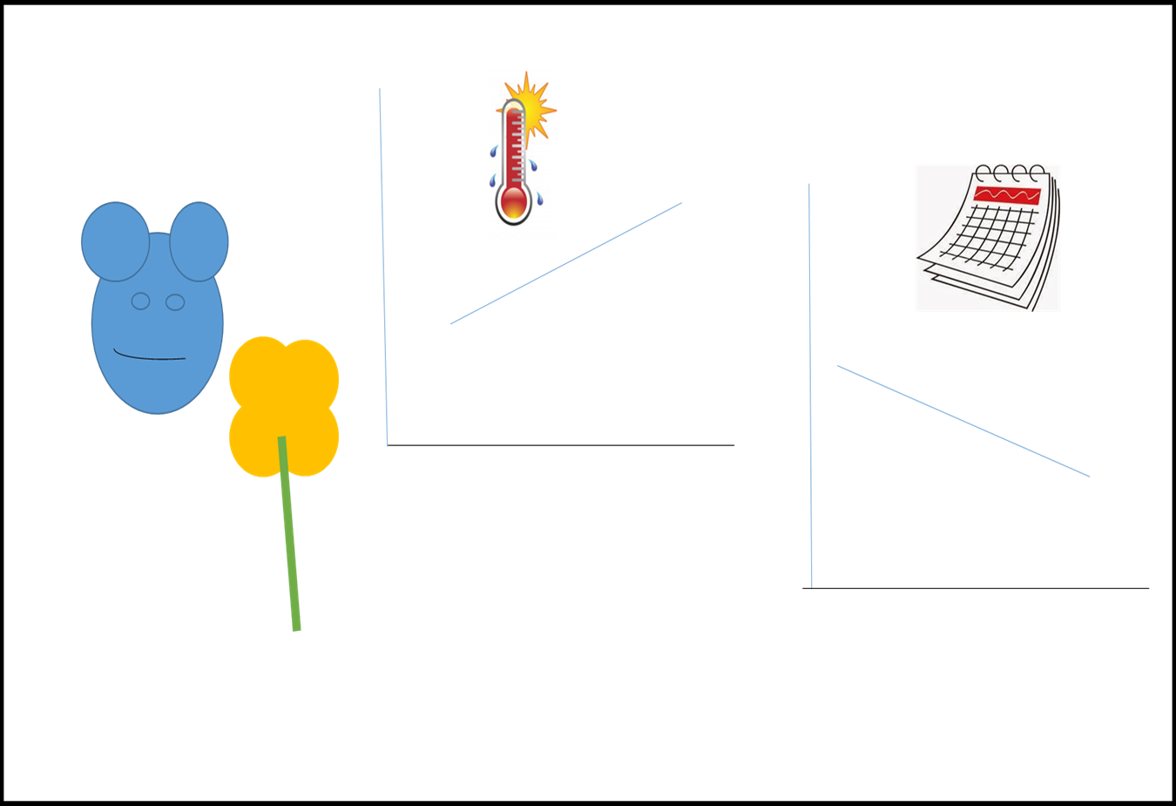
    - Describe how their phenology may affect how they interact with each other, and how changes to their phenology might break the connection.

