regulation across scales: Lac operon

Background Information:
Organisms rely on complex interactions and pathways to maintain homeostasis. While regulatory systems may take a variety of forms, fundamentally a component in a system can have either a positive or negative effect on the abundance or activity of another component when they directly interact. Your goal is to use the information in the provided diagrams and figures to produce a simple pathway diagram on the interactions between the major components in your provided system.

System:
The lactose operon allows bacteria to digest lactose when glucose in unavailable through the production of β-galactosidase. The activity of the lac operon is determined by a repressor protein. Using the figures below, determine the effect of lactose concentration on the repressor protein and the generation of mRNA for the production of β-galactosidase.

- What is the product or endpoint being regulated in your system?

- Illustrate the relationships between the three underlined components above with a simple pathway diagram. Use the information in the figures to determine whether the relationships between these components are positive or negative.

- At what biological scale is your system operating?

- What additional questions or observations arose from your figure?

Lac Operon Figure:
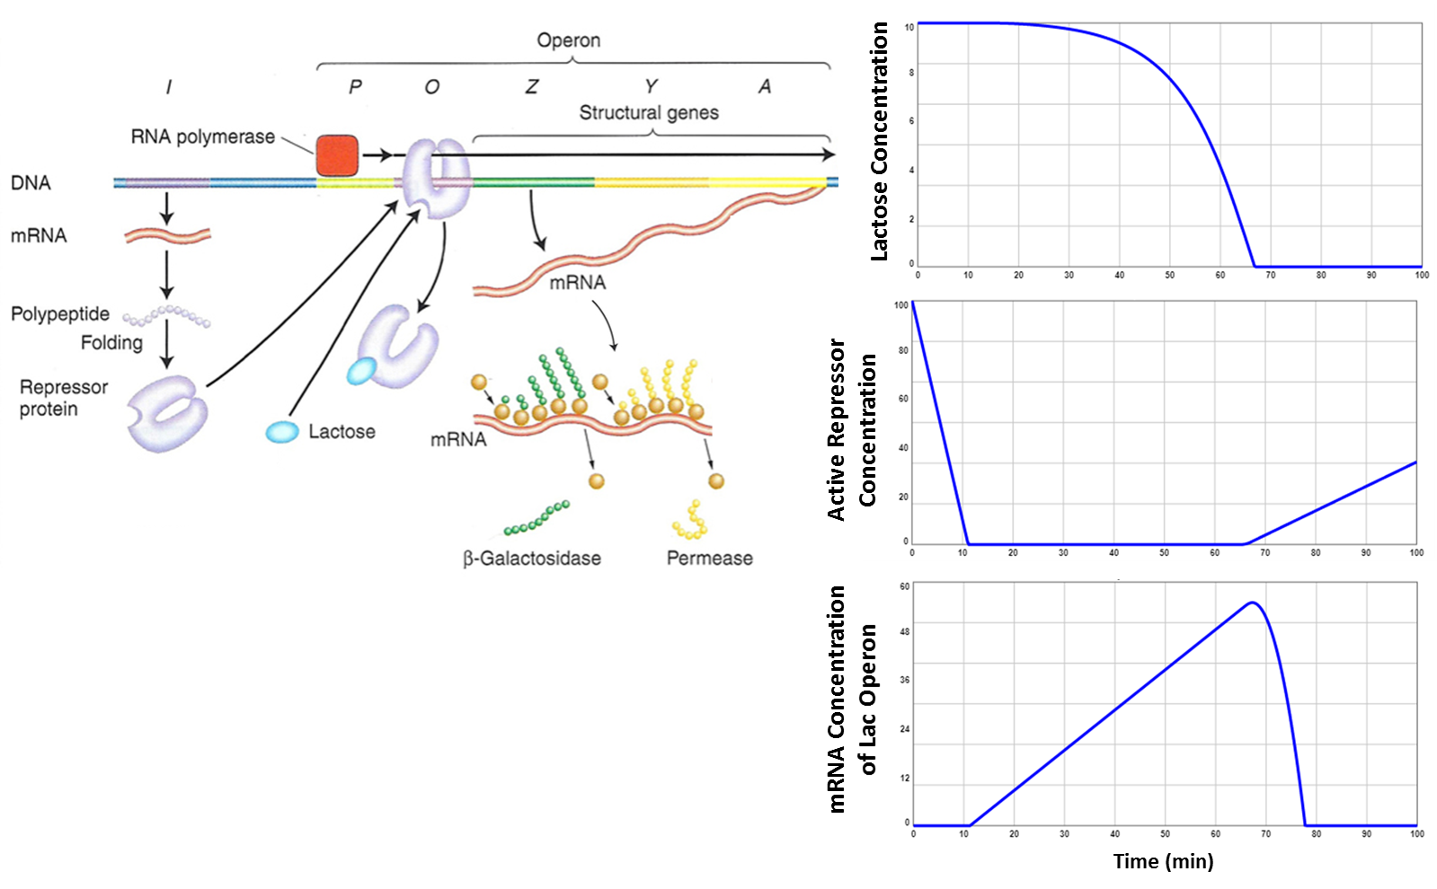
Figure Legend: In the absence of glucose, the simulated responses in E.coli of lac operon components after an infusion of lactose (top panel). The generation of mRNA from the lac operon codes for the production of β-galactosidase, the enzyme that catalyzes the synthesis of lactose. Based on the foundational experiments of Jacob and Monod (1961) and simulated by ISEE Systems.

regulation across scales: Cholesterol in the human body

Background Information:
Organisms rely on complex interactions and pathways to maintain homeostasis. While regulatory systems may take a variety of forms, fundamentally a component in a system can have either a positive or negative effect on the abundance or activity of another component when they directly interact. Your goal is to use the information in the provided diagrams and figures to produce a simple pathway diagram on the interactions between the major components in your provided system.

System:
Housed in the membrane of the endoplasmic reticulum is HMG-CoA reductase, the rate-controlling enzyme for cholesterol synthesis, which is a pathway involving over thirty enzymes. When cholesterol levels are low, cells will also draw cholesterol out of the bloodstream through the internalization and degradation of low density lipoprotein (LDL) via LDL receptors on the cell surface. Using the figures below, determine the effect of reductase activity on LDL receptor expression and circulating plasma LDL levels.

- What is the product or endpoint being regulated in your system?

- Illustrate the relationships between the three underlined components above with a simple pathway diagram. Use the information in the figures to determine whether the relationships between these components are positive or negative.

- At what biological scale is your system operating?

- What additional questions or observations arose from your figure?
Cholesterol Figure:
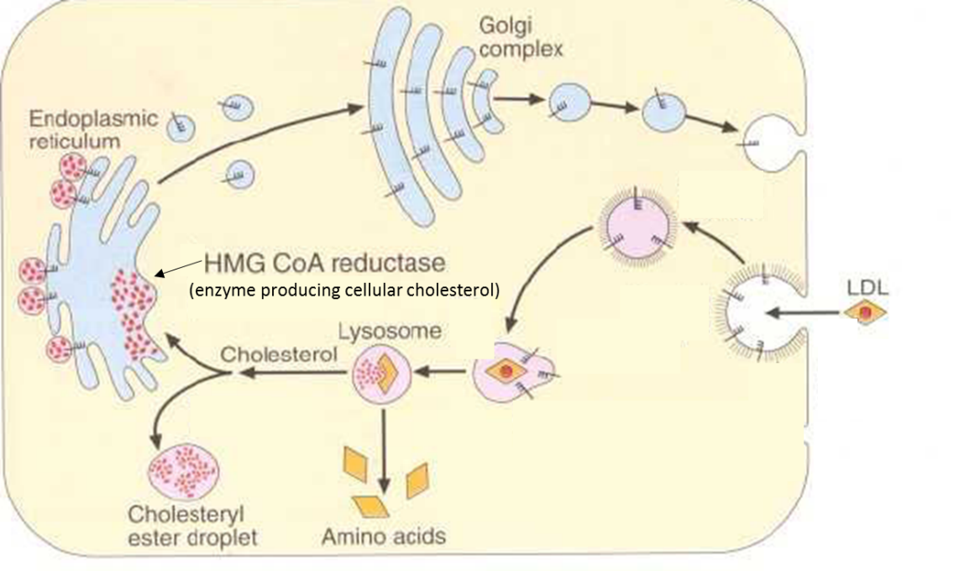
This diagram shows the internalization of LDL circulating in the plasma by LDL receptors (indicated by the toothbrush-looking symbol). The level of cellular cholesterol is determined by a separate pathway controlled by HMG CoA reductase, and the level of reductase activity (generating cellular cholesterol – indicated by the red dots) has an effect on LDL receptor generation and transport activity.
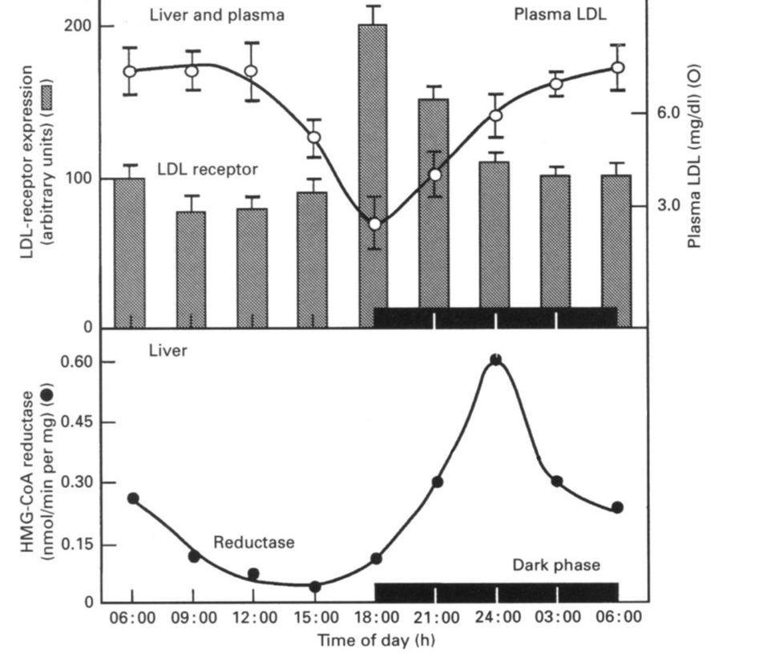
Figure Legend: Daily changes in the activities of HMG-CoA reductase, liver cell LDL receptors, and the cholesterol concentration of plasma. Groups of six rats each adapted to repetitive dark and light cycles for 2 weeks were killed every 3 h during the 24 h period. Blood was collected and microsomal membrane fractions were prepared from the livers (Balasubramaniam et al. 1994).
regulation across scales: Yellowstone National park

Background Information:
Organisms rely on complex interactions and pathways to maintain homeostasis. While regulatory systems may take a variety of forms, fundamentally a component in a system can have either a positive or negative effect on the abundance or activity of another component when they directly interact. Your goal is to use the information in the provided diagrams and figures to produce a simple pathway diagram on the interactions between the major components in your provided system.

System:
Wolves were historically ranged throughout North America from the Arctic to Mexico, but habitat loss and extermination programs led to their absence across much of the United States by the early 1900s. Wolves were exptirpated from Yellowstone National Park by the 1920s. After seven decades of absence, wolves were reintroduced in Yellowstone in 1995 and 1996. Using the figures below, determine the effect of wolf abundance on elk populations and stands of aspen trees.

- What is the product or endpoint being regulated in your system?

- Illustrate the relationships between the three underlined components above with a simple pathway diagram. Use the information in the figures to determine whether the relationships between these components are positive or negative.

- At what biological scale is your system operating?

- What additional questions or observations arose from your figure?

Yellowstone Figure:
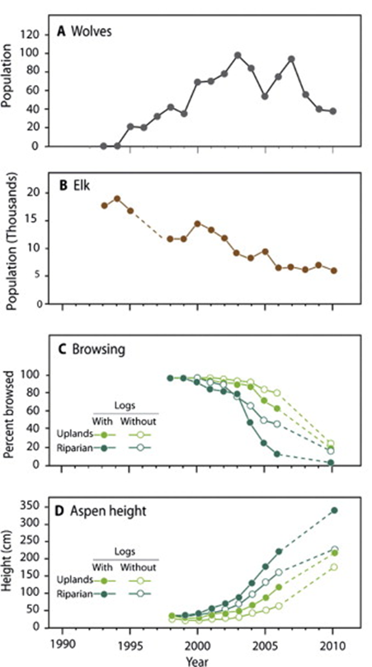 | 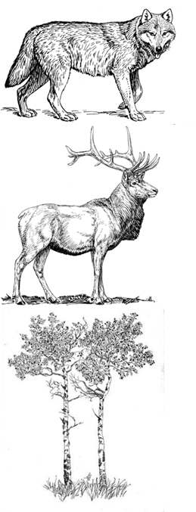

Figure Legend: Trends in (A) wolf populations, (B) minimum elk populations from annual counts, (C) percentage of aspen leaders browsed, and (D) mean aspen heights (early springtime heights after winter browsing but before summer growth). Dashed lines represent time periods with at least 1 year of missing data. The presence and absence of downed logs (aspen and conifer >30 cm in diameter) was recorded because downed logs represent potential impediments for ungulates, potentially causing less browsing and more aspen growth (Ripple and Beschta 2012).

Next stage: Jigsaw the groups and put up the following questions
Explain your system and figure to your other group members. Do you agree with the pathway sketched by the group and the interactions identified?

How do the regulatory scales differ across your groups?

What are the common themes in your pathways?

End goal for the board:
Lactose concentration

Repressor protein

mRNA (β-galactosidase production)
____________________________________________________________
Reductase activity (cellular cholesterol)

LDL receptor expression

Circulating plasma LDL levels
________________________________________________________________
Wolves

Elk

Aspen

